FMUSER FUQ-4419BX ATSC Modulator 256 IP Inputs 8 RF Outputs GE Ports ATSC A-53 8VSB RS(208-188) Encoding Multiplexing Web-Based Control for Broadcasting and STB Testing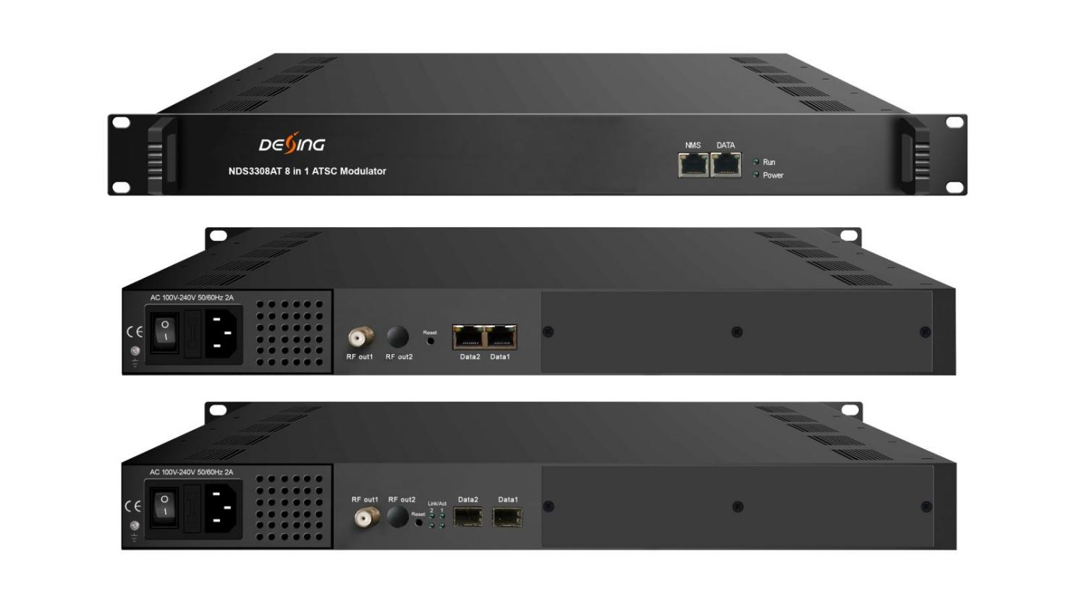Product Overview
The FMUSER FUQ-4419BX is an ATSC modulator supporting up to 256 IP inputs via three GE ports and delivering 8 RF output channels. It performs multiplexing and modulation compliant with ATSC A/53, including 8VSB and RS(208,188) encoding, with web-based network management for control. Ideal for ATSC broadcasting network setup and set-top box testing.
Key feature
Supports high-capacity IP input with up to 256 streams via three GE ports
Provides robust ATSC modulation compliant with ATSC A/53, featuring 8VSB and RS(208,188) encoding
Enables advanced signal processing including PID remapping and PSI/SI editing
Features web-based network management for remote control and monitoring
Inner Principle Chart
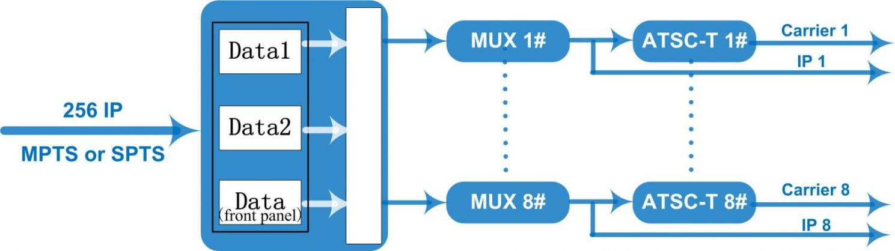
Carrier Setting Illustration

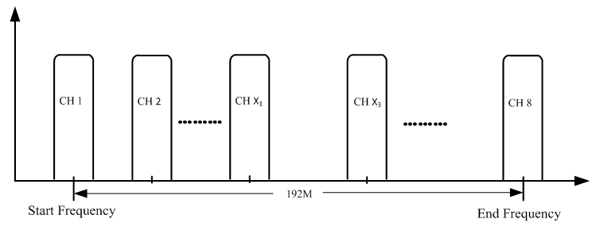

Specifications
Input | Input | Max 256 IP input through 3 (front-panel Data port, Data 1 and Data 2) 100/1000M Ethernet Port (SFP interface optional). Each Data1 or Data 2 port can input max 256 IP, while front-panel Data port can input max 128 IP
Input | Transport Protocol | TS over UDP/RTP, unicast and multicast, IGMP V2/V3
Input | Transmission Rate | Max 840Mbps for each input channel
Mux | Input Channel | 256
Mux | Output Channel | 8
Mux | Max PIDs | 180 per channel
Mux | Functions | PID remapping(auto/manually optional)
Mux | Functions | PCR accurate adjusting
Mux | Functions | PSI/SI table automatically generating
Modulation  Parameters | Channel | 8
Modulation  Parameters | Modulation Standard | ATSC A/53
Modulation  Parameters | Constellation | 8VSB
Modulation  Parameters | Bandwidth | 6MHz
Modulation  Parameters | FEC | RS(208 188)+Trellis
RF Output | Interface | F typed output port for 8 non-adjacent carriers
RF Output | RF Range | 50~960MHz, 1kHz stepping
RF Output | Output Level | -20~+10dbm (for all carriers), 0.5db stepping
RF Output | MER | ≥ 40dB
RF Output | ACL | -55 dBc
TS output | 8 IP output over UDP/RTP/RTSP, unicast/multicast, 2 100/1000M Ethernet Ports
System | Web-based Network management
General | Demission | 420mm×440mm×44.5mm (WxLxH)
General | Weight | 3kg
General | Temperature | 0~45℃(operation), -20~80℃(storage)
General | Power Supply | AC 100V±10%, 50/60Hz or AC 220V±10%, 50/60Hz
General | Consumption | ≤20W

About Us
FMUSER is a company specializing in broadcasting and television transmission systems and integrating hotel IPTV systems. The company was established in 2009 and has served over 180 countries worldwide. More than 20,000 television stations, radio stations, and hotel clients from different.

Contact:Tomleequan Email：sales@fmuser.com whatsapp: +8613922702227

