FMUSER FUQ-4419R V2 DVB-T Modulator 8-16 Carriers 1024 IP Inputs 6 ASI Inputs ETSI EN300 744 PID Remapping Web-Based Management for DTV Headends 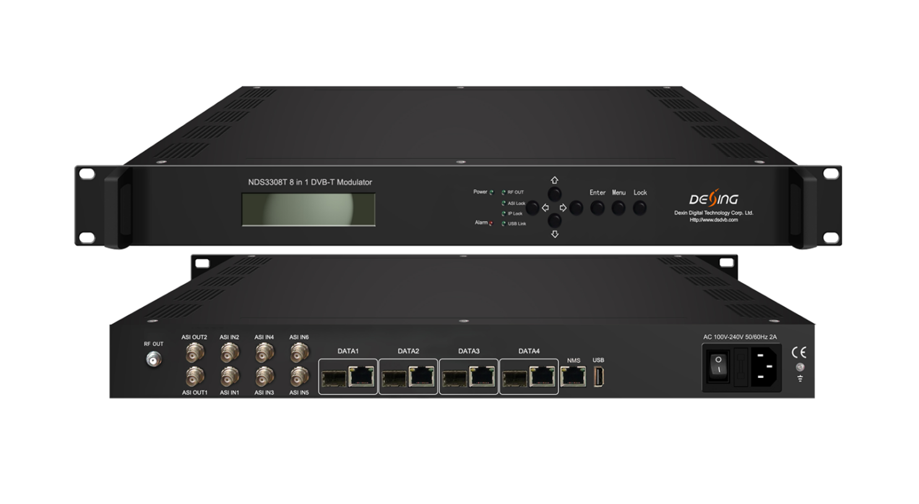Product Overview
The FMUSER FUQ-4419R (V2) is a high-density DVB-T modulator converting IP inputs to RF outputs. It processes signals via modulation with inputs including max 1024 IP streams through 4 GE/SFP ports and 6 ASI inputs. Controlled through web-based management for seamless operation. Ideal for next-generation DTV broadcasting systems and cable headends.
Key feature
Supports high-capacity input with up to 1024 IP streams via 4 GE/SFP ports and 6 ASI inputs.
Delivers flexible modulation for 8 or 16 DVB-T carriers compliant with ETSI EN300 744.
Enables advanced processing including PID remapping, PCR adjustment, and PSI/SI editing.
Features web-based management for easy configuration and monitoring.
Inner Principle Chart
For 8 carriers out:
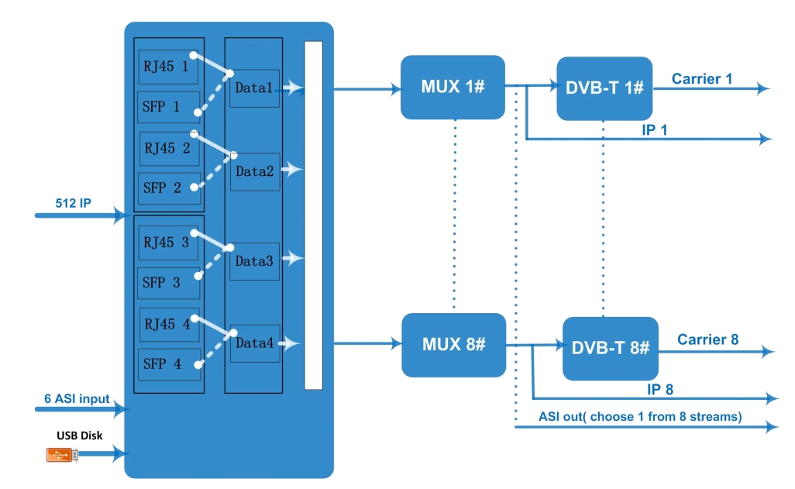

For 16 carriers out:
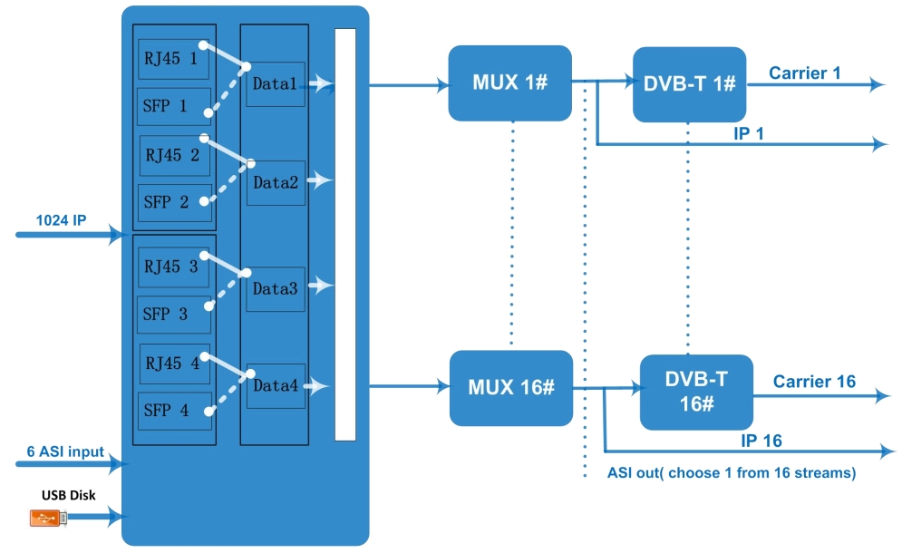

Carrier Setting Illustration:
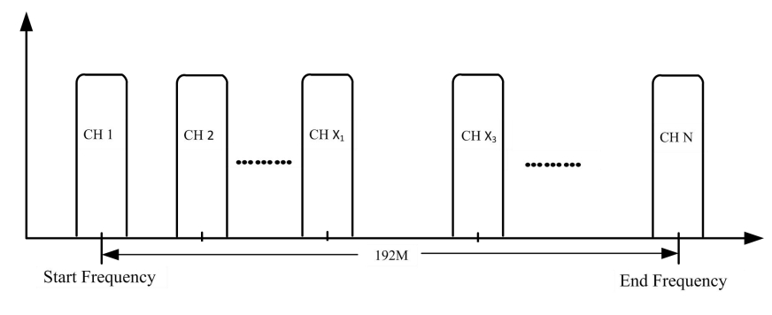

Specifications
Input | Input | 8 DVB-T carriers: Max 512 IP input through Date1-Date4 100/1000M Ethernet Port (or SFP interface optional). Each Data port can input max 512 IP.  16 DVB-T carriers: Max 1024 IP input through Date1-Date4 100/1000M Ethernet Port (or SFP interface optional). Each Data port can input max 1024 IP.
Input | Input | 6 ASI input, BNC interface
Input | Transport Protocol | TS over UDP/RTP, unicast and multicast, IGMP V2/V3
Input | Transmission Rate | Max 840Mbps for each input channel
Mux | Input Channel | 512(or 1024)
Mux | Output Channel | 8 (or 16)
Mux | Max PIDs | 256 per channel
Mux | Functions | PID remapping(auto/manually optional)
Mux | Functions | PCR accurate adjusting
Mux | Functions | PSI/SI table automatically generating
Modulation  Parameters | Channel | 8(or 16)
Modulation  Parameters | Modulation Standard | ETSI EN300 744
Modulation  Parameters | Constellation | QPSK/16QAM/64QAM
Modulation  Parameters | Bandwidth | 6/7/8 MHz
Modulation  Parameters | Trans mode | 2K/4K/8K
Modulation  Parameters | FEC | 1/2,2/3,3/4,5/6,7/8
RF Output | Interface | F typed output port for8(or 16) non-adjacent carriers
RF Output | RF Range | 50~960MHz, 1kHz stepping
RF Output | Output Level | -20~+10dbm(for all carriers), 0.5db stepping
RF Output | MER | ≥ 40dB
RF Output | ACL | -55 dBc
TS output | 8 (or 16) IP output over UDP/RTP/RTSP, unicast/multicast, Data1 100/1000M Ethernet Ports
TS output | 2 ASI output, one as mirror
System | Web-based Network management
General | Demission | 420mm×440mm×44.5mm (WxLxH)
General | Temperature | 0~45℃(operation), -20~80℃(storage)
General | Power Supply | AC100V±10%, 50/60Hz or AC 220V±10%,50/60Hz

About Us
FMUSER is a company specializing in broadcasting and television transmission systems and integrating hotel IPTV systems. The company was established in 2009 and has served over 180 countries worldwide. More than 20,000 television stations, radio stations, and hotel clients from different.

Contact:Tomleequan Email：sales@fmuser.com whatsapp: +8613922702227

