FMUSER FUQ-4419U DVB-T Modulator 256-512-768 IP Input to 8-16-24 RF Output GE-SFP Interface TS over UDP-RTP QPSK-16QAM-64QAM ETSI EN300 744 PID Remapping PSI-SI Editing Digital TV Broadcasting Cable Headend IPTV 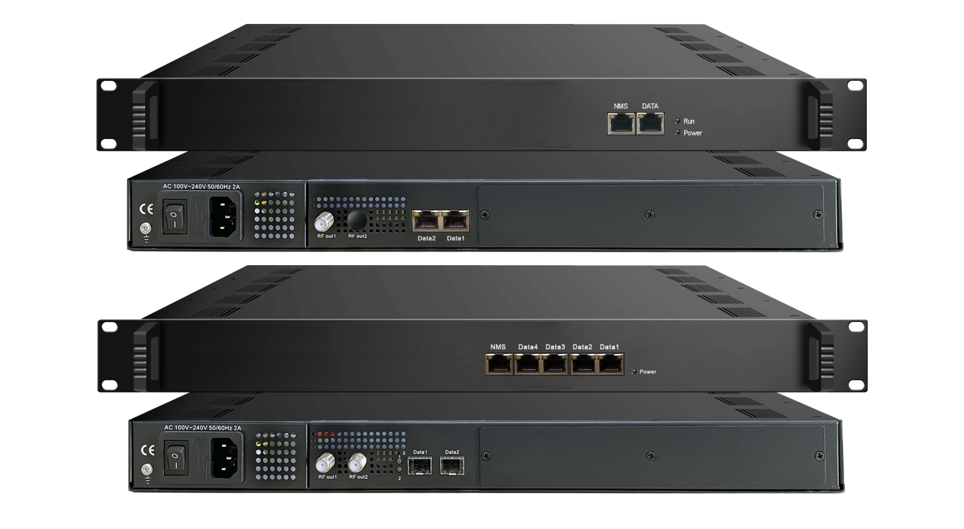Product Overview
The FMUSER FUQ-4419R is a DVB-T modulator that accepts up to 768 IP inputs via GE/SFP ports and outputs 8, 16, or 24 non-adjacent RF carriers (50-960MHz). It processes IP streams through multiplexing and modulation into DVB-T compliant signals. With high integration, low cost, and web-based network management, this device is ideal for digital TV broadcasting, cable headends, and IPTV systems.
Key feature
Supports up to 768 IP inputs via GE/SFP ports with max 840Mbps per input.
Features PID remapping, PSI/SI editing, and outputs DVB-T carriers compliant with ETSI EN300 744.
Enables web-based network management for easy configuration and monitoring.
Inner Principle Chart
Version I & II - For 8&16 carriers out):
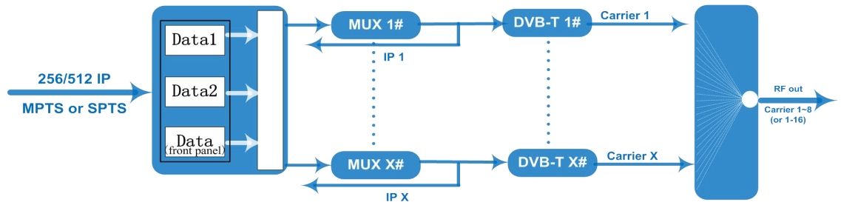

Version III - For 24 carriers out)::
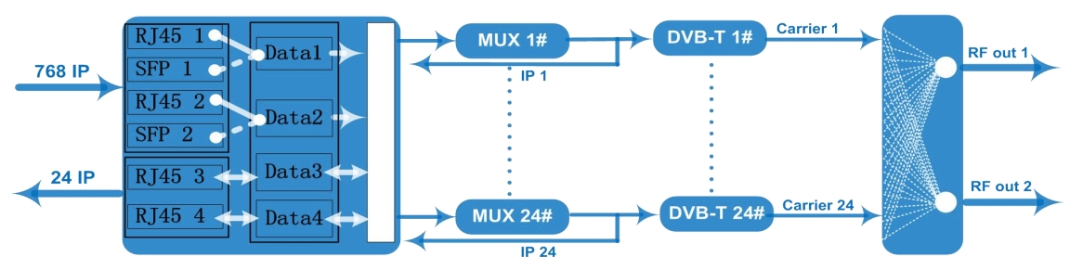

Carrier Setting Illustration
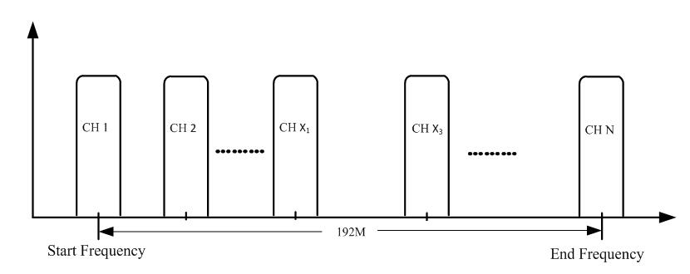

Specifications
Input | Input | Max 256/512 IP input through 3 (front-panel Data port, Data 1 and Data 2) 100/1000M Ethernet Port (SFP interface optional). - For Version I & II  Max 768 IP input through data ports 1 to 4 100/1000M Ethernet Ports (RJ45 and SFP interface alternative). –For Version III
Input | Transport Protocol | TS over UDP/RTP, unicast and multicast, IGMP V2/V3
Input | Transmission Rate | Max 840Mbps for each input channel
Mux | Input Channel | 256 IP streams - Version I  512 IP streams - Version II  768 IP streams - Version III
Mux | Output Channel | 8 (or 16, or 24)
Mux | Max PIDs | 180 per channel
Mux | Functions | PID remapping(auto/manually optional)
Mux | Functions | PCR accurate adjusting
Mux | Functions | PSI/SI table automatically generating
Modulation  Parameters | Output Channel | 8 non-adjacent carriers output - Version I  16 non-adjacent carriers output - Version II  24 non-adjacent carriers output - Version III
Modulation  Parameters | Modulation Standard | ETSI EN300 744
Modulation  Parameters | Constellation | QPSK/16QAM/64QAM
Modulation  Parameters | Bandwidth | 6/7/8 MHz
Modulation  Parameters | Trans mode | 2K/4K/8K
Modulation  Parameters | FEC | 1/2, 2/3, 3/4, 5/6, 7/8
RF Output | Interface | F typed output port for 8 (or 16) non-adjacent carriers
RF Output | RF Range | 50~960MHz, 1kHz stepping
RF Output | Output Level | -20~+10dbm (for all carriers), 0.5db stepping
RF Output | MER | ≥ 40dB
RF Output | ACL | -55 dBc
TS output | 8 (or 16, or 24) IP output over UDP/RTP/RTSP, unicast/multicast, 2 100/1000M Ethernet Ports
System | Web-based Network management
General | Demission | 420mm×440mm×44.5mm (WxLxH)
General | Temperature | 0~45℃(operation), -20~80℃(storage)
General | Power Supply | AC 100V±10%, 50/60Hz or AC 220V±10%, 50/60Hz

Order Guide:

 | Version I | Version II | Version III
256 IP input to 8ch DVB-T carriers out, 8 IP out | x
512 IP input to 16ch DVB-T carriers out, 16 IP out |  | x
768 IP input to 24ch DVB-T carriers out, 24 IP out |  |  | x

About Us
FMUSER is a company specializing in broadcasting and television transmission systems and integrating hotel IPTV systems. The company was established in 2009 and has served over 180 countries worldwide. More than 20,000 television stations, radio stations, and hotel clients from different.

Contact:Tomleequan Email：sales@fmuser.com whatsapp: +8613922702227

