FMUSER FUQ-4427 IP QAM Modulator 512 IP Inputs-16 QAM Outputs GE Ports DVB-C J.83 A-B Multiplexing Scrambling CATV Headend System 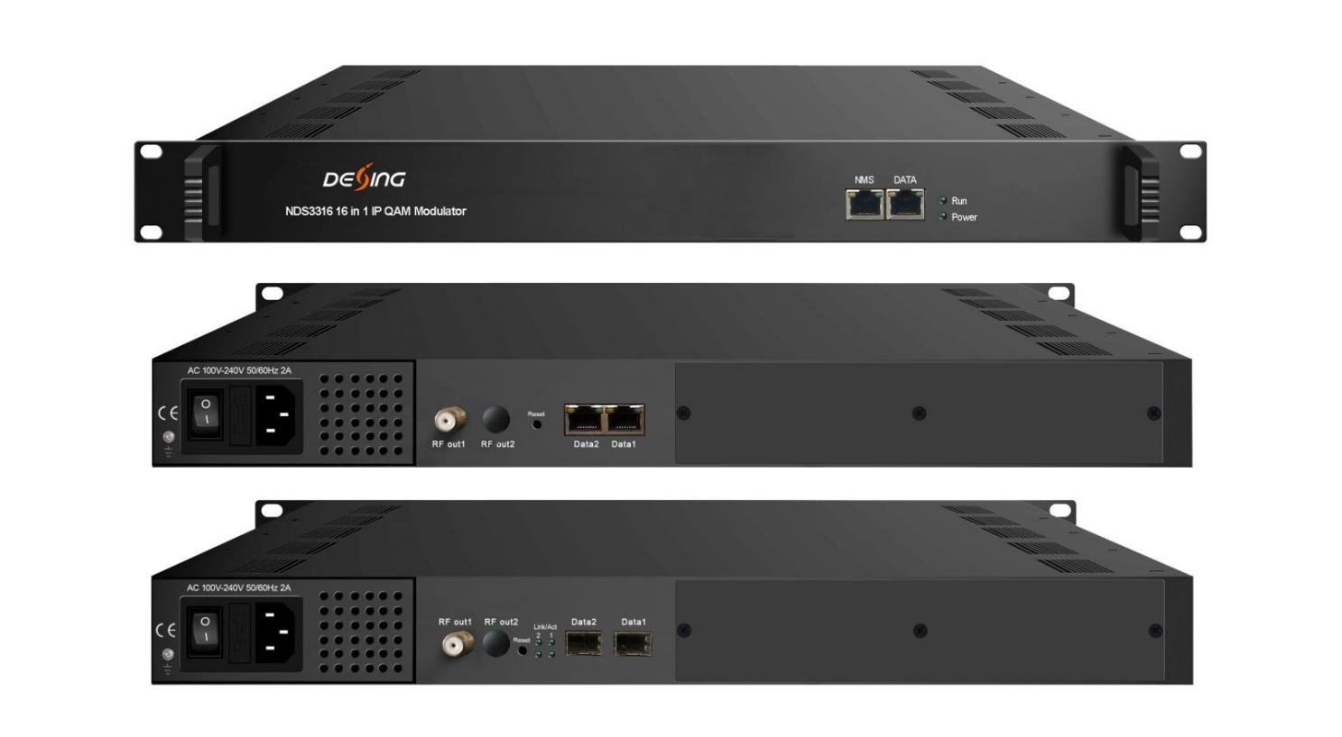Product Overview
The FMUSER FUQ-4427 is a 16-channel IP QAM modulator integrating multiplexing, scrambling, and modulating functions. It accepts up to 512 IP inputs via three GE ports and outputs 16 non-adjacent RF carriers compliant with DVB-C and ITU-T J.83 A/B standards. Managed through web-based network management, it enables easy configuration and monitoring. Ideal for CATV broadcasting and digital headend applications.
Key feature
Supports up to 512 IP inputs through three GE ports with 840Mbps per port.
Delivers 16 non-adjacent RF carriers compliant with DVB-C (EN 300 429) and ITU-T J.83 A/B standards.
Features DVB scrambling systems including ETR289, ETSI 101 197, and ETSI 103 197.
Enables web-based network management for configuration, monitoring, and control.
Supports PID remapping (up to 180 per channel), CA filtering, and PSI/SI editing.

Inner Principle Chart
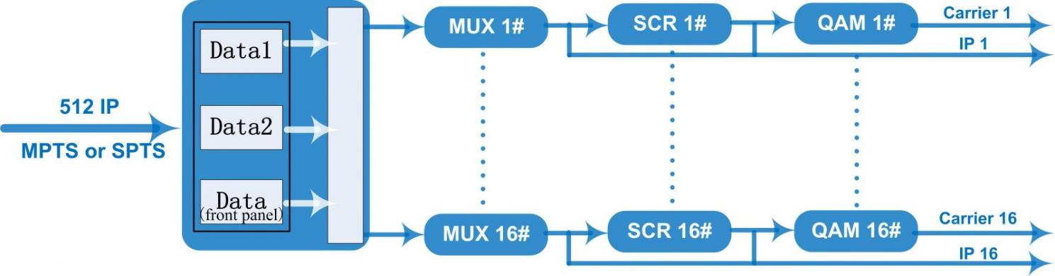

Carrier Setting Illustration
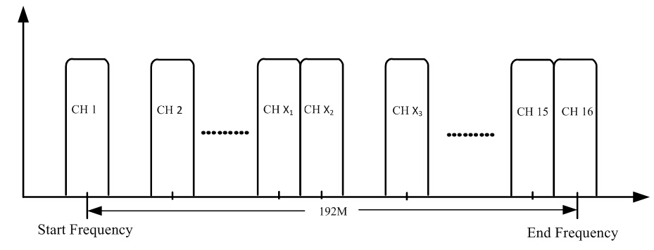

Specifications
Input | Input | Max 512 IP input through 3 (front-panel Data port, Data 1 and Data 2) 100/1000M Ethernet Port (SFP interface optional). Each Data1 or Data 2 port can input max 512 IP, while front-panel Data port can input max 128 IP
Input | Transport Protocol | TS over UDP/RTP, unicast and multicast, IGMP V2/V3
Input | Transmission Rate | Max 840Mbps for each GE input
Mux | Input Channel | 512
Mux | Output Channel | 16
Mux | Max PIDs | 180 per channel
Mux | Functions | PID remapping(auto/manually optional)
Mux | Functions | PCR accurate adjusting
Mux | Functions | PSI/SI table automatically generating
Scrambling  Parameters | Max simulscrypt CA | 4
Scrambling  Parameters | Scramble Standard | ETR289, ETSI 101 197, ETSI 103 197
Scrambling  Parameters | Connection | Local/remote connection
Modulation  Parameters | DVB-C Modulator Sectioon | J.83A | Constellation : 16/32/64/128/256QAM
Modulation  Parameters | DVB-C Modulator Sectioon | J.83A | Bandwidth :8M
Modulation  Parameters | DVB-C Modulator Sectioon | J.83B | Constellation : 64QAM/ 256QAM
Modulation  Parameters | DVB-C Modulator Sectioon | J.83B | Bandwidth :6M
Modulation  Parameters | QAM Channel | 16 non-adjacent carrier
Modulation  Parameters | Modulation Standard | EN300 429/ITU-T J.83A/B(DVB-C)
Modulation  Parameters | Symbol Rate | 5.0~7.0Msps, 1ksps stepping
Modulation  Parameters | FEC | RS (204, 188)
RF Output | Interface | 1 F typed output port for 16 carriers, 75Ω impedance
RF Output | RF Range | 50~960MHz, 1kHz stepping
RF Output | Output Level | -20dBm~+10dBm(87~117dbµV), 0.1dB stepping
RF Output | MER | ≥ 40dB
TS output | 16 IP output over UDP/RTP/RTSP, unicast/multicast, 2 (Data1& Data2) 100/1000M Ethernet Ports
System | web-based Network management
General | Demission | 420mm×440mm×44.5mm (WxLxH)
General | Temperature | 0~45℃(operation), -20~80℃(storage)
General | Power Supply | AC 100V±10%, 50/60Hz or AC 220V±10%, 50/60Hz

System Connection Sample (IP Based)
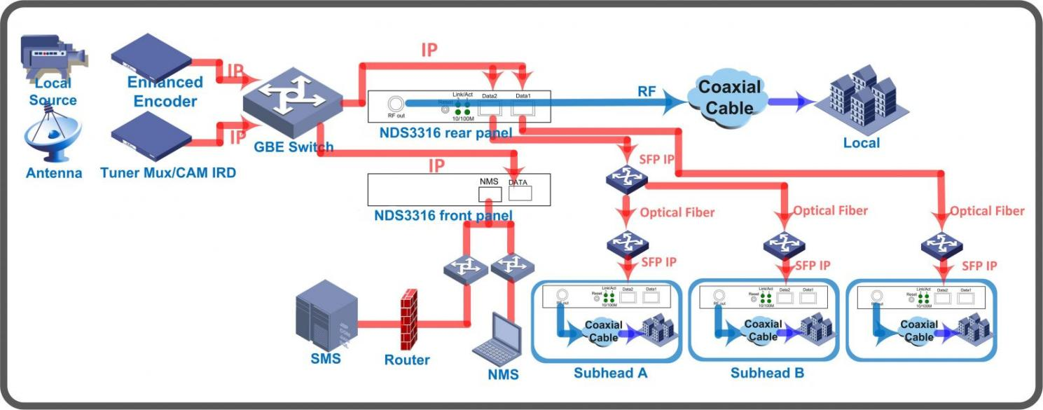

About Us
FMUSER is a company specializing in broadcasting and television transmission systems and integrating hotel IPTV systems. The company was established in 2009 and has served over 180 countries worldwide. More than 20,000 television stations, radio stations, and hotel clients from different.

Contact:Tomleequan Email：sales@fmuser.com whatsapp: +8613922702227

