FMUSER FUQ-4443 IP QAM Modulator 1024 IP Inputs 32 QAM Outputs DVB-C RS(204-188) 3 GE Ports Multiplexing Scrambling CATV Broadcast Headend 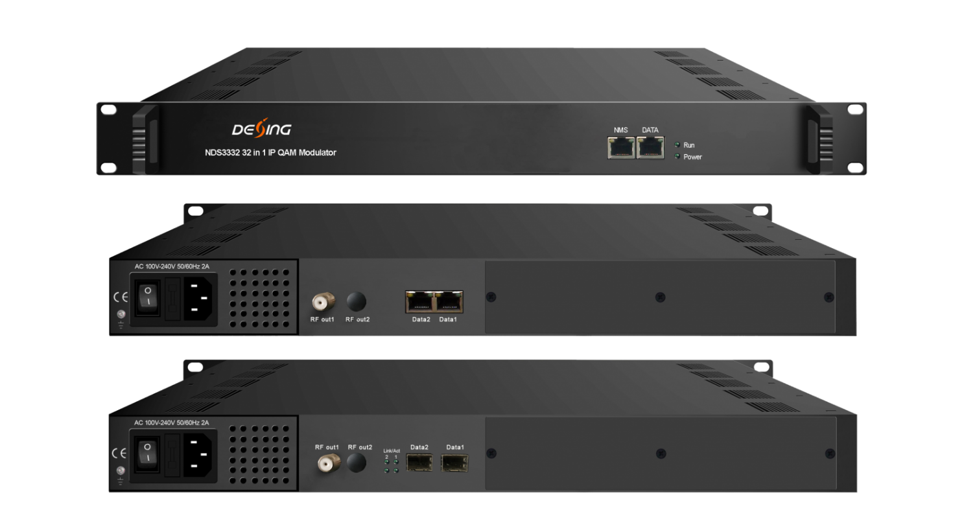Product Overview
The FMUSER FUQ-4443 is an all-in-one IP QAM modulator integrating multiplexing, scrambling, and modulation, with three GE ports for up to 1024 IP inputs and a single RF interface for 32 QAM outputs. It processes signals by encoding and modulating them into DVB-C compliant formats. The device supports web-based network management and RS (204,188) encoding. Ideal for modern CATV broadcasting systems, it ensures scalability and high performance in cable TV headends and digital video distribution.
Key feature
- Supports up to 1024 IP inputs via three GE ports, each at 840Mbps.
- Outputs 32 non-adjacent QAM carriers compliant with DVB-C (EN 300 429) and ITU-T J.83 A/B.
- Enables PID remapping, PCR adjusting, CA filtering, and PSI/SI editing.
- Provides 32 IP outputs over UDP/RTP/RTSP via Data1 & Data2 ports.
- Includes web-based network management and RS (204,188) encoding for error correction.

Inner Principle Chart
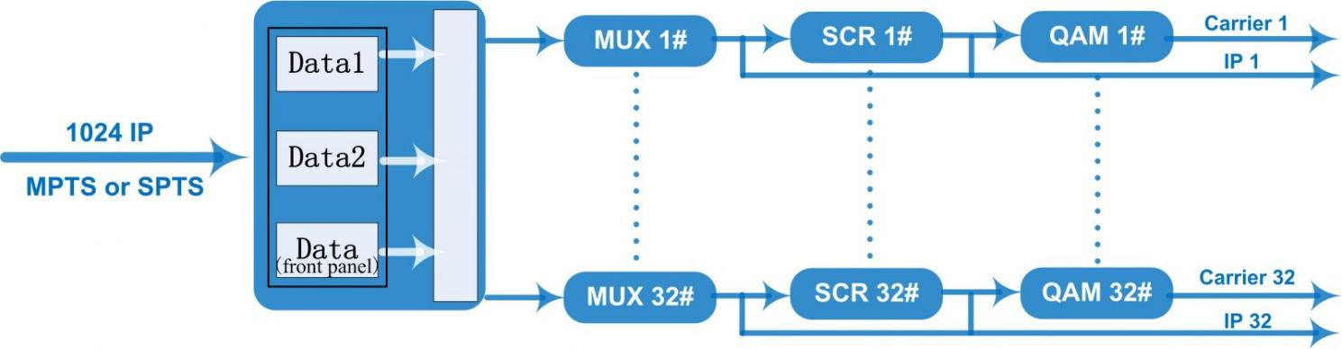

Carrier Setting Illustration
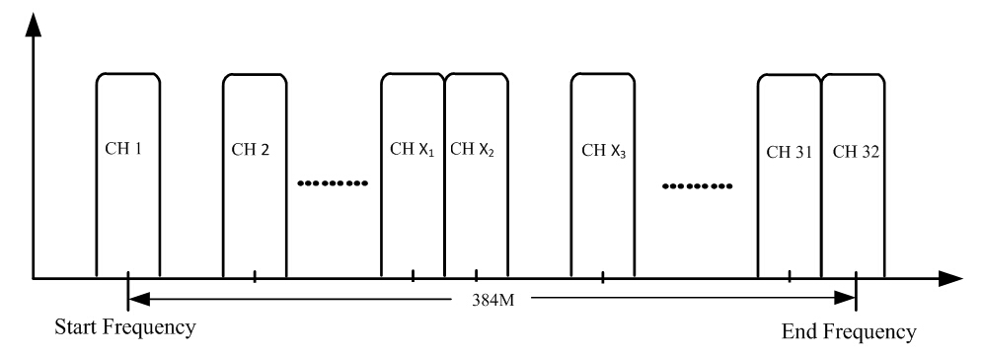

Specifications
Input | Input | Max 1024 IP input through 3 (front-panel Data port, Data 1 and Data 2) 100/1000M Ethernet Port (SFP interface optional). Each Data1 or Data 2 port can input maximum 512 IP, while front-panel Data port can input maximum 128 IP
Input | Transport Protocol | TS over UDP/RTP, unicast and multicast, IGMP V2/V3
Input | Transmission Rate | Max 840Mbps for each GE input
Mux | Input Channel | 1024
Mux | Output Channel | 32
Mux | Max PIDs | 256 per channel
Mux | Functions | PID remapping(auto/manually optional)
Mux | Functions | PCR accurate adjusting
Mux | Functions | PSI/SI table automatically generating
Scrambling  Parameters | Max simulscrypt CA | 4
Scrambling  Parameters | Scramble Standard | ETR289, ETSI 101 197, ETSI 103 197
Scrambling  Parameters | Connection | Local/remote connection
Modulation  Parameters | DVB-C Modulator Section | J.83A | Constellation : 16/32/64/128/256QAM
Modulation  Parameters | DVB-C Modulator Section | J.83A | Bandwidth :8M
Modulation  Parameters | DVB-C Modulator Section | J.83B | Constellation : 64QAM/ 256QAM
Modulation  Parameters | DVB-C Modulator Section | J.83B | Bandwidth :6M
Modulation  Parameters | QAM Channel | 32 non-adjacent carrier
Modulation  Parameters | Modulation Standard | EN300 429/ITU-T J.83A/B(DVB-C)
Modulation  Parameters | Symbol Rate | 5.0~7.0Msps, 1ksps stepping
Modulation  Parameters | Constellation | 16, 32, 64 , 128, 256QAM
Modulation  Parameters | FEC | RS (204, 188)
RF Output | Interface | 1 F typed output port for 32 carriers, 75Ω
RF Output | RF Range | 50~960MHz, 1kHz stepping
RF Output | Output Level | -20dBm~+10dBm(87~117dbµV), 0.1dB stepping
RF Output | MER | ≥ 40dB
TS output | 32 IP output over UDP/RTP/RTSP, unicast/multicast, 2 (Data1& Data2) 100/1000M Ethernet Ports
System | Network management software (NMS) supporting
General | Demission | 420mm×440mm×44.5mm (WxLxH)
General | Temperature | 0~45℃(operation), -20~80℃(storage)
General | Power Supply | AC 100V±10%, 50/60Hz or AC 220V±10%, 50/60Hz

System Connection Sample (IP Based)
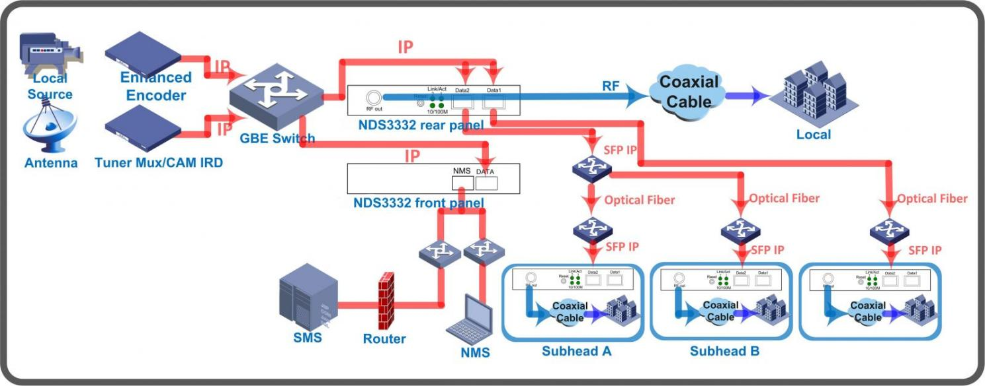

About Us
FMUSER is a company specializing in broadcasting and television transmission systems and integrating hotel IPTV systems. The company was established in 2009 and has served over 180 countries worldwide. More than 20,000 television stations, radio stations, and hotel clients from different.

Contact:Tomleequan Email：sales@fmuser.com whatsapp: +8613922702227

