FMUSER FUQ-4443 IP QAM Modulator 1024 IP Inputs 32 RF Outputs GE Ports with SFP DVB-C ITU-T J.83 A-B Multiplexing Scrambling Headend Broadcast System 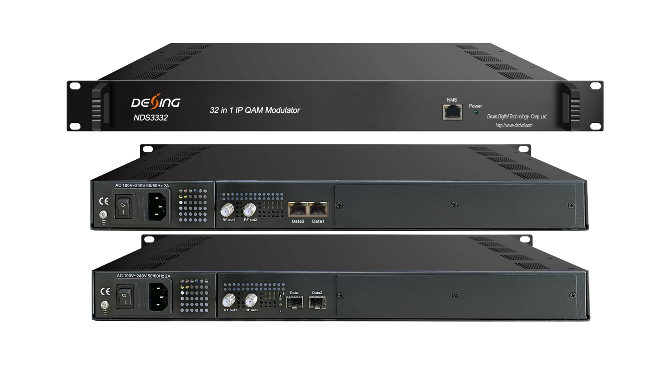Product Overview
The FMUSER FUQ-4443 is an IP QAM modulator with 32-channel multiplexing, scrambling, and modulation, supporting up to 1024 IP inputs via GE ports at max 840Mbps each and outputting 32 non-adjacent carriers through dual RF ports (50-960MHz). It processes signals using PID remapping, PCR adjusting, and PSI/SI editing for optimization. This unit features web-based network management for remote control. Ideal for broadcast applications such as cable TV headends and secure broadcasting systems.
Key feature
Supports up to 1024 IP inputs via dual GE ports with optional SFP interface, max 840Mbps per port over UDP/RTP.
Outputs 32 non-adjacent QAM carriers via dual RF ports (50-960MHz), compliant with DVB-C (EN 300 429) and ITU-T J.83 A/B.
Integrates 32-channel multiplexing, scrambling, and modulation with PID remapping (up to 256 per channel), PCR adjusting, and PSI/SI editing.
Complies with DVB scrambling standards including ETR289, ETSI 101 197, and ETSI 103 197.
Features web-based network management for remote control and monitoring.

Inner Principle Chart
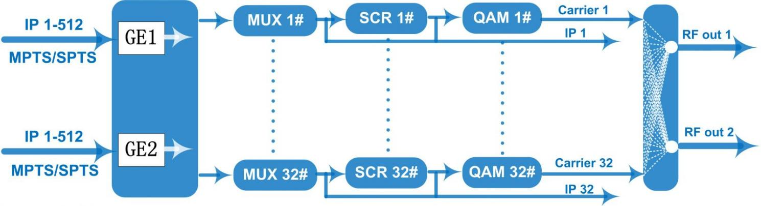
Carrier Setting Illustration
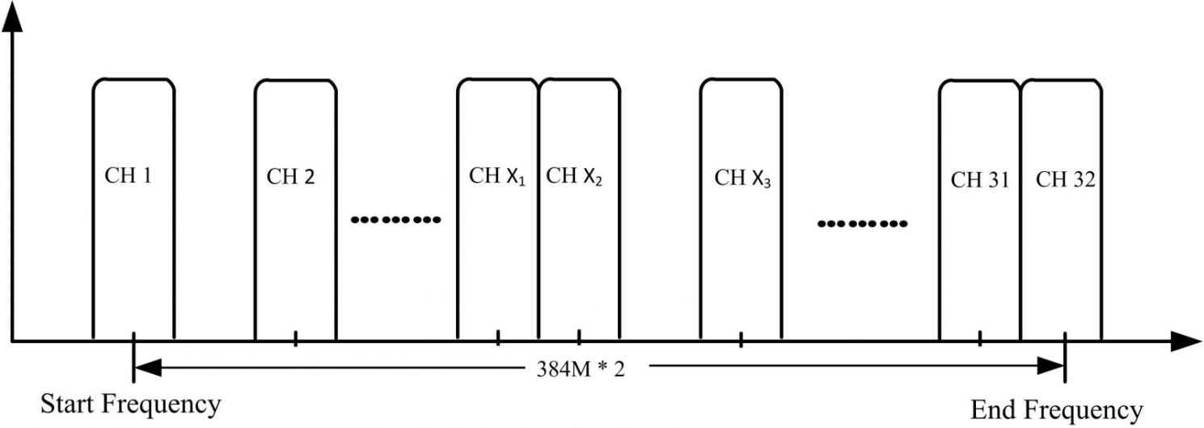

Specification
Input | Input |  | 512×2 IP input, 2*100/1000M Ethernet Port(SFP interface optional)
Input | Transport Protocol |  | TS over UDP/RTP, unicast and multicast, IGMP V2/V3
Input | Transmission Rate |  | Max 840Mbps for each GE input
Mux | Input Channel |  | 1024
Mux | Output Channel |  | 32
Mux | Max PIDs |  | 256 per channel
Mux | Functions |  | PID remapping(auto/manually optional)
Mux |  |  | PCR accurate adjusting
Mux |  |  | PSI/SI table automatically generating
Scrambling  Parameters | Max simulscrypt CA |  | 4
Scrambling  Parameters | Scramble Standard |  | ETR289, ETSI 101 197, ETSI 103 197
Scrambling  Parameters | Connection |  | Local/remote connection
Modulation  Parameters | DVB-C Modulator Sectioon |  | J.83A | Constellation :16/32/64/128/256QAM
Modulation  Parameters |  |  | J.83A | Bandwidth :8M
Modulation  Parameters |  |  | J.83B | Constellation :64/256QAM
Modulation  Parameters |  |  | J.83B | Bandwidth :6M
Modulation  Parameters | QAM Channel |  | 32 non-adjacent carrier
Modulation  Parameters | Modulation Standard |  | EN300 429/ITU-T J.83A/B
Modulation  Parameters | Symbol Rate |  | 5.0~7.0Msps, 1ksps stepping
Modulation  Parameters | Constellation |  | 16, 32, 64 , 128, 256QAM
Modulation  Parameters | FEC |  | RS (204, 188)
RF Output | Interface |  | 2 F type output ports for 32 carriers, 75Ω
RF Output | RF Range |  | 50~960MHz, 1kHz stepping
RF Output | Output Level |  | -20dBm~+10dBm(87~117dbµV), 0.1dB stepping
RF Output | MER |  | ≥ 40dB
RF Output | ACLR |  | -60 dBc
TS output | 32 IP output over UDP/RTP/RTSP, unicast/multicast, 2*100/1000M Ethernet Ports (SFP)
System | Network management software (NMS) supporting
General | Demission | 420mm×440mm×44.5mm (WxLxH)
General | Weight | 3kg
General | Temperature | 0~45℃(operation), -20~80℃(storage)
General | Power Supply | AC 100V±10%, 50/60Hz or AC 220V±10%, 50/60Hz
General | Consumption | 15.4W

About Us
FMUSER is a company specializing in broadcasting and television transmission systems and integrating hotel IPTV systems. The company was established in 2009 and has served over 180 countries worldwide. More than 20,000 television stations, radio stations, and hotel clients from different.

Contact:Tomleequan Email：sales@fmuser.com whatsapp: +8613922702227

