FMUSER FUQ-4443 V2 IP QAM Modulator 1024 IP + 6 ASI Inputs 16-32 DVB-C Outputs IP-ASI-RF Interfaces ITU-T J.83 A-B Multiplexing Scrambling for Cable Headends Hotel IPTV
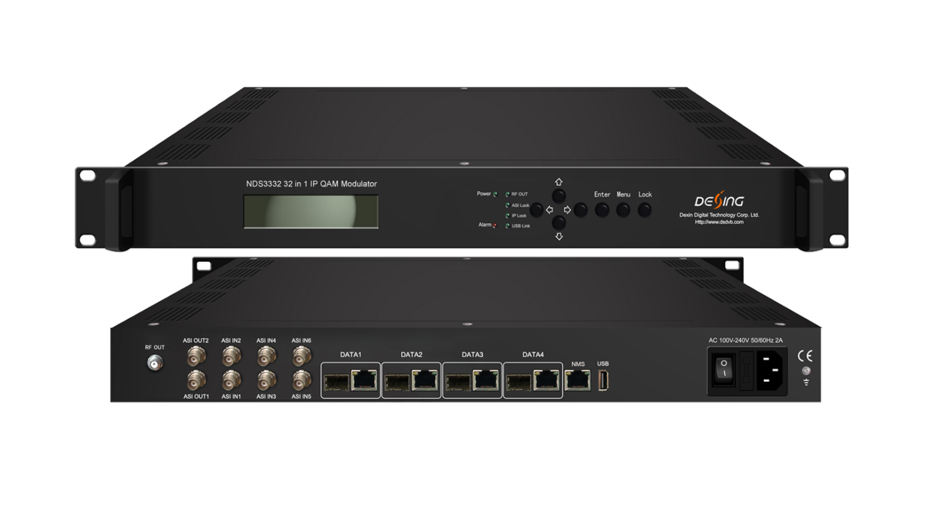Product Overview
The FMUSER FUQ-4443 (V2) is an IP QAM modulator with inputs via 4 GE/SFP ports for up to 1024 IP streams and 6 ASI inputs. It processes signals by modulating them into 16 or 32 non-adjacent DVB-C carriers. Featuring web-based network management, this device is ideal for cost-effective DTV broadcasting systems.
Key feature
Enables web-based network management for remote monitoring and control.
Principle Chart
For 16 carriers out:
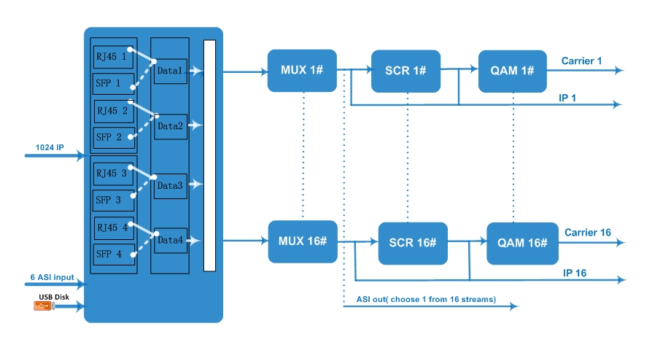

For 32 carriers out:
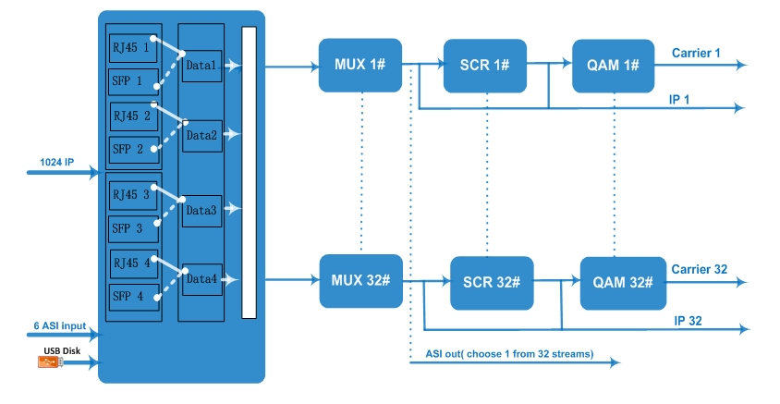

Carrier Setting Illustration:
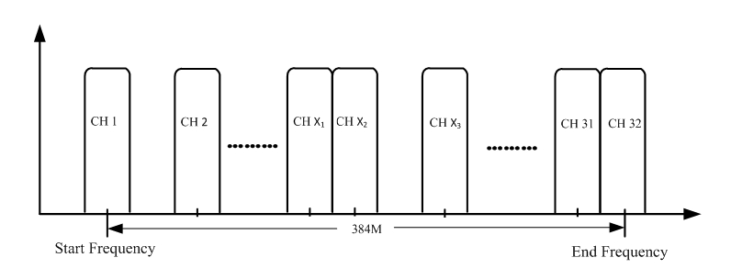

Specifications
Input | Input | 16/32 DVB-C carriers: Max 1024 IP input through Date1-Date4 100/1000M Ethernet Port (or SFP interface optional). Each Data port can input max 1024 IP.
Input | Input | 6 ASI input, BNC interface
Input | Transport Protocol | TS over UDP/RTP, unicast and multicast, IGMP V2/V3
Input | Transmission Rate | Max 840Mbps for each GE input
Mux | Input Channel | 1024
Mux | Output Channel | 16/32
Mux | Max PIDs | 256 per channel
Mux | Functions | PID remapping(auto/manually optional)
Mux | Functions | PCR accurate adjusting
Mux | Functions | PSI/SI table automatically generating
Scrambling  Parameters | Max simulscrypt CA | 6
Scrambling  Parameters | Scramble Standard | ETR289, ETSI 101 197, ETSI 103 197
Scrambling  Parameters | Connection | Local/remote connection
Modulation  Parameters | DVB-C Modulator Section | J.83A | Constellation : 16/32/64/128/256QAM
Modulation  Parameters | DVB-C Modulator Section | J.83A | Bandwidth :8M
Modulation  Parameters | DVB-C Modulator Section | J.83B | Constellation : 64QAM/ 256QAM
Modulation  Parameters | DVB-C Modulator Section | J.83B | Bandwidth :6M
Modulation  Parameters | QAM Channel | 16/32 non-adjacent carrier
Modulation  Parameters | Modulation Standard | EN300 429/ITU-T J.83A/B(DVB-C)
Modulation  Parameters | Symbol Rate | 5.0~7.0Msps, 1ksps stepping
Modulation  Parameters | Constellation | 16, 32, 64 , 128, 256QAM
Modulation  Parameters | FEC | RS (204, 188)
RF Output | Interface | 1 F typed output port for 16/32 carriers, 75Ω
RF Output | RF Range | 50~960MHz, 1kHz stepping
RF Output | Output Level | -20dBm~+10dBm(87~117dbµV), 0.1dB stepping
RF Output | MER | ≥ 40dB
TS output | 16/32 IP output over UDP/RTP/RTSP, unicast/multicast, Data1 100/1000M Ethernet Ports
TS output | 2 ASI output, one as mirror
System | Network management software (NMS) supporting
General | Demission | 420mm×440mm×44.5mm (WxLxH)
General | Temperature | 0~45℃(operation), -20~80℃(storage)
General | Power Supply | AC 100V±10%, 50/60Hz or AC 220V±10%, 50/60Hz

About Us
FMUSER is a company specializing in broadcasting and television transmission systems and integrating hotel IPTV systems. The company was established in 2009 and has served over 180 countries worldwide. More than 20,000 television stations, radio stations, and hotel clients from different.

Contact:Tomleequan Email：sales@fmuser.com whatsapp: +8613922702227

