FMUSER FUQ-4454B-C 4-Channel Encoder Modulator 4x CVBS-YPbPr-S-Video Input DVB-C Tuner & IP Re-Mux MPEG-2 Encoding QAM Modulation for CATV and IPTV Headends 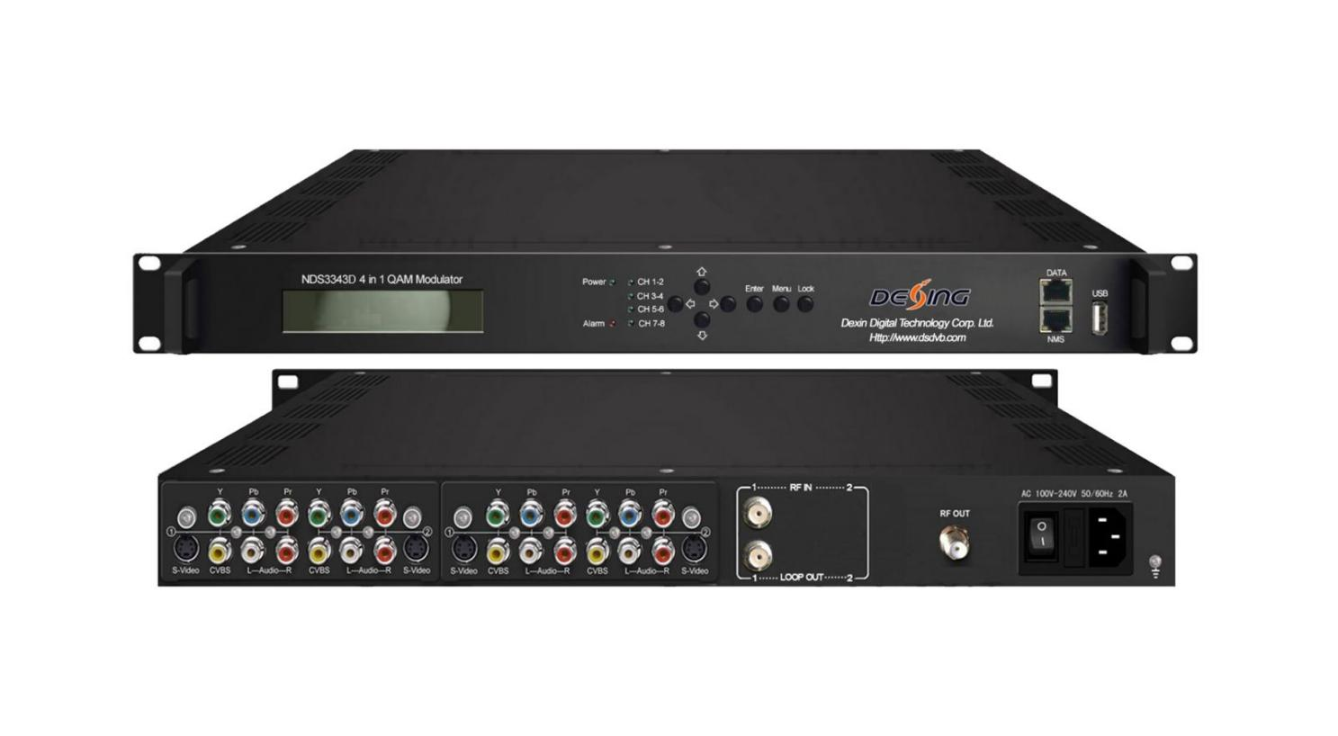Product overview
The FUQ-4454B-C is a 1RU 4-in-1 mux-scrambling encoder modulator with 4× CVBS/YPbPr/S-Video inputs, 1-2× DVB-C tuners, and 2× IP interfaces. It performs MPEG-2 encoding, ETSI-compliant scrambling, and 16-256QAM modulation in a single pass. The unit features 30–999 MHz RF output with web/USB management and complies with DVB-C (EN300 429) and ITU-T J.83A/B/C. Ideal for CATV digital migration and IPTV edge QAM deployments.
Key feature
Modular upgradability: Features pluggable modules and dual web/USB control for future-proof operation.

Specifications

Input | 1 or 2 DVB-C Tuner input for remux; 2 IP input for re-mux
Input | 4 CVBS/YPbPr/S-Video Input for encoding
Tuner Input | DVB-C | Standard | J.83A(DVB-C), J.83B, J.83C
Tuner Input | DVB-C | Input Frequency | 30MHz-1000Mhz
Tuner Input | DVB-C | Constellation | 16/32/64/128/256 QAM
Encoding | Video | Format | MPEG-2 MP@ML (4:2:0)
Encoding | Video | Interface | S-Video/YPbPr/CVBS*4
Encoding | Video | Bitrate | 1-19.5Mbps
Encoding | Video | Resolution | 720*480_60i, 720*576_50i
Encoding | Video | Rate mode | VBR/CBR
Encoding | Video | Chroma | 4:2:0
Encoding | Video | Aspect | 16:9,4:3, 1:1, 2.21:1
Encoding | Audio | Format | MPEG1 Layer II, AC3
Encoding | Audio | Sampling | 48KHz
Encoding | Audio | Bitrate | 64kbps,96kbps,128kbps,192kbps,256kbps,320kbps
Multiplexing | Maximum PID Remapping | 128per input channel
Multiplexing | Function | PID remapping (automatically or manually)
Multiplexing | Function | Accurate PCR adjusting
Multiplexing | Function | Generate PSI/SI table automatically
Scrambling | Maximum simulcrypt CA | 4
Scrambling | Standard | ETSI 101 197, ETSI 103 197
Scrambling | Connection | Local/remote connection
Modulation | QAM Channel | 4
Modulation | Standard | EN300 429/ITU-T J.83A/B/C
Modulation | MER | ≥40db
Modulation | RF frequency | 30~999MHz, 1KHz step
Modulation | RF output level | -20~0dbm(87~107 dbµV),0.1db step
Modulation | Symbol Rate | 5.0Msps~9.0Msps, 1ksps stepping
Modulation | Constellation | 16/32/64/128/256QAM
Modulation |  | J.83A |  | J.83B | J.83C
Modulation | Constellation | 16/32/64/128/256QAM |  | 64/256 QAM | 64/256 QAM
Modulation | Bandwidth | 8M |  | 6M | 6M
System | Local interface | LCD + control buttons
System | Remote management | Web NMS
System | Stream Out | 4*MPTS IP over UDP out (RJ45, 1000M, Unicast/Multicast)
System | Language | English
System | Software Upgrading | Web and USB port
General | Dimension  (W*D*H) | 482mm×300mm×44.5mm
General | Weight | 3.7kg
General | Temperature | 0~45℃(Operation) ; -20~80℃(Storage)
General | Power | AC 100V±1050/60Hz;  AC 220V±10%, 50/60HZ
General | Consumption | 25W

Working Principle

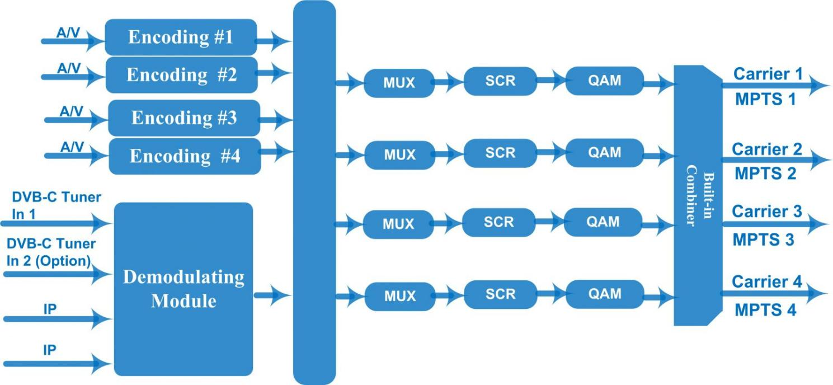

About Us
FMUSER is a company specializing in broadcasting and television transmission systems and integrating hotel IPTV systems. The company was established in 2009 and has served over 180 countries worldwide. More than 20,000 television stations, radio stations, and hotel clients from different.

Contact:Tomleequan Email：sales@fmuser.com whatsapp: +8613922702227

