FMUSER FUQ-4454E QAM Modulator 8 Tuners-6 ASI-256 IP Inputs 4 RF Outputs DVB-C-EN300 429 ITU-T J.83 Mux Scrambling CATV Broadcasting 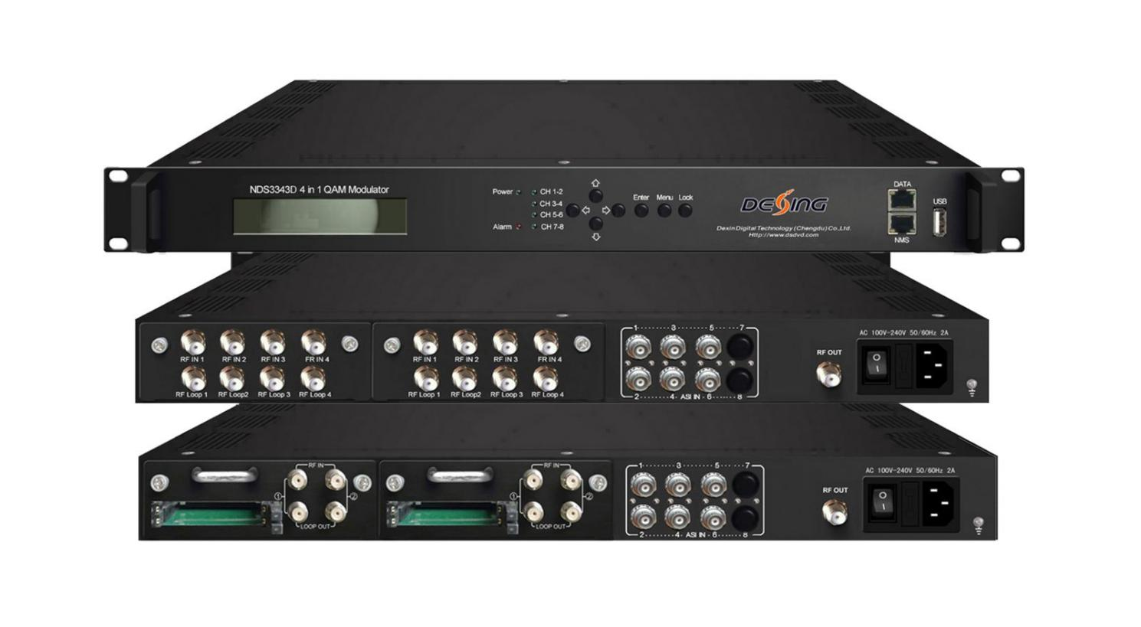
Product overview
The FUQ-4454E is a high-performance mux-scrambling QAM modulator featuring multiple input options including tuners, ASI, and IP ports, and 4 RF outputs. It processes signals through multiplexing, scrambling, and QAM modulation. With pluggable module design, UDP output support, and Web NMS, it ensures flexible control. Designed for modern CATV systems and broadcast applications, it delivers efficient signal distribution.
Key feature
Supports flexible input configurations with optional versions: Version 1 (8 tuners + 6 ASI + 256 IP) or Version 2 (4 tuners with CAM + 6 ASI)
Integrates 4-channel multiplexing, scrambling, and QAM modulation compliant with DVB-C and ITU-T J.83A/B/C
Delivers superior RF output with MER ≥40dB and adjustable frequency/level
Provides advanced output options including 4MPTS over UDP and BISS descrambling (Version 2)
Features user-friendly management via LCD display, keyboard, and Web NMS
Working Principle
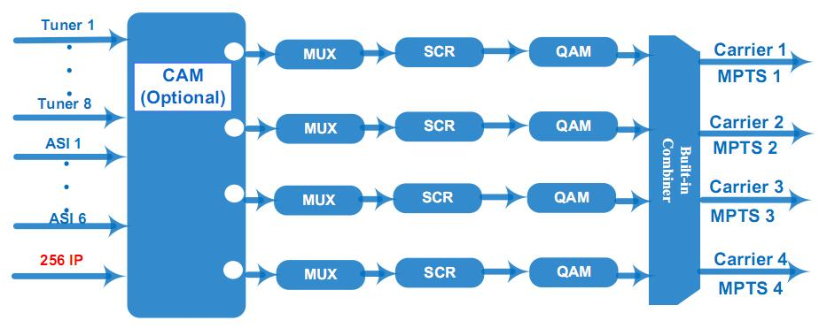

Key feature
* Multiple Input ports optional:
8 DVB-C/T/(T)/ISDBT/S/S2/S2X/ATSC FTA Tuner + 6 ASI input ports+256 IP input (Version 1)
4 DVB-C/S/S2/ATSC Tuner with CAM+6 ASI input ports (Version 2)
* Support 4 channels multiplexing+4 channels scrambling+4 channels QAM modulating
* Fully support DVB-C (EN300 429) and ITU-T J.83A/B/C
* Fully support DVB general scrambling system description ETR289, simulcrypt standard ETSI 101 197 and ETSI 103 197
* Support accurate PCR adjusting
* Support PSI/SI editing and inserting
* Excellent RF output performance index, MER≥40db
* Support 4*MPTS output over UDP
* 4 CAM decrypt multiple programs from 4 Tuner input (Optional)
* Support BISS descrambling(only for Version 2)
* Support LCD display and keyboard
* Support Web management, Updates via web and USB

Specifications
Input | 8 DVB-C/T/(T)/ISDBT/S/S2/S2X/ATSC FTA Tuner + 6 ASI input+256 IP input ------Version 1
Input | 4 DVB-C/S/S2/ATSC Tuner with CAM + 6 ASI -------Version 2
Tuner Section | For Version 1：  Multi-mode tuners switchable  (New Type) | DVB-C | Input Frequency |  | 60 ~890 MHz
Tuner Section | For Version 1：  Multi-mode tuners switchable  (New Type) | DVB-C | Standard |  | J.83A, J.83C |  | J.83B
Tuner Section | For Version 1：  Multi-mode tuners switchable  (New Type) | DVB-C | Constellation |  | 16/32/64/128/256 QAM |  | 64/256 QAM
Tuner Section | For Version 1：  Multi-mode tuners switchable  (New Type) | DVB-T/(T) | Input Frequency |  | 60 ~890 MHz
Tuner Section | For Version 1：  Multi-mode tuners switchable  (New Type) | DVB-T/(T) | Bandwidth |  | 5/6/7/8 M
Tuner Section | For Version 1：  Multi-mode tuners switchable  (New Type) | ISDB-T | Input Frequency |  | 60 ~890 MHz
Tuner Section | For Version 1  (New Type) | DVB-S | Input Frequency |  | 950~2150MHz
Tuner Section | For Version 1  (New Type) | DVB-S | Symbol rate |  | 0.5~45Msps
Tuner Section | For Version 1  (New Type) | DVB-S | Signal Strength |  | - 65- -25dBm
Tuner Section | For Version 1  (New Type) | DVB-S | FEC |  | 1/2, 2/3, 3/4, 5/6, 7/8
Tuner Section | For Version 1  (New Type) | DVB-S | Constellation |  | QPSK
Tuner Section | For Version 1  (New Type) | DVB-S | Max input bitrate |  | ≤120 Mbps
Tuner Section | For Version 1  (New Type) | DVB-S2X | Input Frequency |  | 950~2150MHz
Tuner Section | For Version 1  (New Type) | DVB-S2X | Symbol rate |  | QPSK/8PSK /16APSK :0.5~45 Msps  32APSK: 0.5~40Msps;
Tuner Section | For Version 1  (New Type) | DVB-S2X | FEC |  | QPSK: 1/2, 3/5, 2/3, 3/4, 4/5, 5/6, 8/9, 9/10  8PSK: 3/5, 2/3, 3/4, 5/6, 8/9, 9/10  16APSK: 2/3, 3/4, 4/5, 5/6, 8/9, 9/10  32APSK: 3/4, 4/5, 5/6, 8/9, 9/10
Tuner Section | For Version 1  (New Type) | DVB-S2X | Constellation |  | QPSK, 8PSK, 16APSK, 32APSK
Tuner Section | For Version 1  (New Type) | DVB-S2X | Max input bitrate |  | ≤120 Mbps
Tuner Section | For Version 1  (New Type) | DVB-S2X | Input Frequency |  | 950~2150MHz
Tuner Section | For Version 1  (New Type) | DVB-S2X | Symbol rate |  | QPSK/8PSK /16APSK :0.5~45 Msps  8APSK: 0.5~40Msps  32APSK: 0.5~40Msps
Tuner Section | For Version 1  (New Type) | DVB-S2X | FEC |  | QPSK: 1/2, 3/5, 2/3, 3/4, 4/5, 5/6, 8/9, 9/10, 13/45, 9/20, 11/20  8PSK: 3/5, 2/3, 3/4, 5/6, 8/9, 9/10  8APSK: 5/9-L, 26/45-L  16APSK: 2/3, 3/4, 4/5, 5/6, 8/9, 9/10, 1/2-L, 8/15-L, 5/9-L, 26/45, 3/5, 3/5-L, 28/45, 23/36 , 2/3-L, 25/36, 13/18, 7/9, 77/90  32APSK: 3/4, 4/5, 5/6, 8/9, 2/3-L, 32/45, 11/15, 7/9
Tuner Section | For Version 1  (New Type) | DVB-S2X | Constellation |  | QPSK, 8PSK, 8APSK, 16APSK, 32APSK
Tuner Section | For Version 1  (New Type) | DVB-S2X | Max input bitrate |  | ≤120 Mbps
Tuner Section | For Version 2 | DVB-C | Standard |  | J.83A(DVB-C), J.83B, J.83C
Tuner Section | For Version 2 | DVB-C | Input Frequency |  | 30~1000Mhz
Tuner Section | For Version 2 | DVB-C | Constellation |  | 16/32/64/128/256 QAM
Tuner Section | For Version 2 | DVB-S | Input Frequency |  | 950~2150MHz
Tuner Section | For Version 2 | DVB-S | Symbol rate |  | 2-45Msps
Tuner Section | For Version 2 | DVB-S | FEC |  | 1/2, 2/3, 3/4, 5/6, 7/8
Tuner Section | For Version 2 | DVB-S | Signal Strength |  | -65~-25dBm
Tuner Section | For Version 2 | DVB-S | Constellation |  | QPSK
Tuner Section | For Version 2 | DVB-S2 | Input Frequency |  | 950~2150MHz
Tuner Section | For Version 2 | DVB-S2 | Symbol rate |  | QPSK/8PSK 1~45 Msps
Tuner Section | For Version 2 | DVB-S2 | FEC |  | 1/2, 3/5, 2/3, 3/4, 4/5, 5/6, 8/9, 9/10
Tuner Section | For Version 2 | DVB-S2 | Constellation |  | QPSK, 8PSK
Tuner Section |  | ATSC | Input Frequency |  | 54~858MHz
Tuner Section |  | ATSC | Bandwidth |  | 6M
Tuner Section |  | ATSC | Constellation |  | 8VSB
Multiplexing | Maximum PID Remapping | 128per input channel
Multiplexing | Function | PID remapping (automatically or manually)
Multiplexing | Function | Accurate PCR adjusting
Multiplexing | Function | Generate PSI/SI table automatically
Scrambling | Maximum simulcrypt CA | 4
Scrambling | Standard | ETSI 101 197, ETSI 103 197
Scrambling | Connection | Local/remote connection
Modulation | QAM Channel | 4
Modulation | Standard | EN300 429/ITU-T J.83A/B/C
Modulation | MER | ≥40db
Modulation | RF frequency | 30~999MHz, 1KHz step
Modulation | RF output level | -10~0dbm,0.1db step ------Version 1  -20~0dbm,0.1db step ------Version 2
Modulation | Symbol Rate | 5.0Msps~9.0Msps, 1ksps stepping
Modulation |  | J.83A |  | J.83B |  | J.83C
Modulation | Constellation | 16/32/64/128/256QAM |  | 64/256 QAM |  | 64/256 QAM
Modulation | Bandwidth | 8M |  | 6M |  | 6M
System | Local interface | LCD + control buttons
System | Remote management | Web NMS
System | Stream Out | 4*MPTS over UDP out (RJ45, 1000M, Unicast/Multicast)
System | Language | English and Chinese
System | Software Upgrading | Web and USB
General | Dimension  (W*D*H) | 482mm×300mm×44.5mm
General | Temperature | 0~45℃(Operation) ; -20~80℃(Storage)
General | Power | AC 100V±1050/60Hz;  AC 220V±10%, 50/60HZ

About Us
FMUSER is a company specializing in broadcasting and television transmission systems and integrating hotel IPTV systems. The company was established in 2009 and has served over 180 countries worldwide. More than 20,000 television stations, radio stations, and hotel clients from different.

Contact:Tomleequan Email：sales@fmuser.com whatsapp: +8613922702227

