FMUSER FUQ-4455A 128-IP 2-ASI Input 48-DVB-C 32-DVB-T 28-ISDB-T Non-Adjacent Carriers RF Output Mux-Modulator with 3GE-SFP for DTV Broadcasting Headend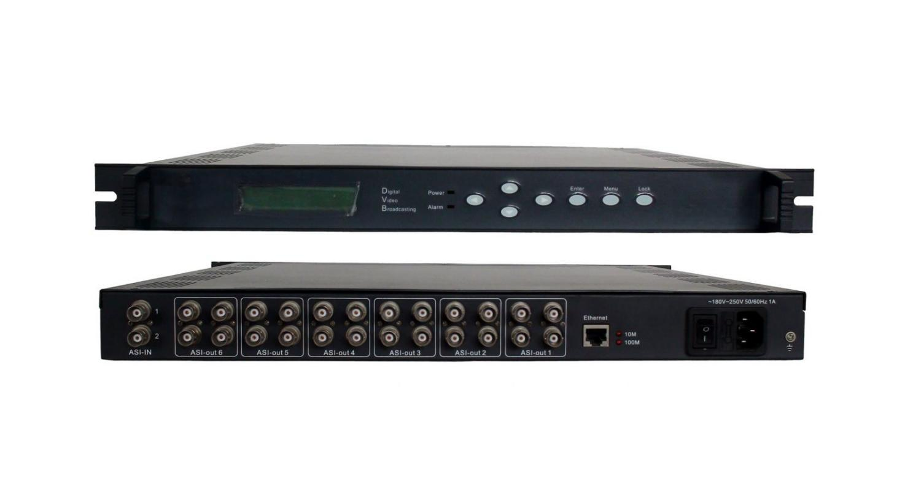
Product Overview
The FUQ-4455A is a high-density mux-modulating device that generates up to 48 DVB-C, 32 DVB-T, and 28 ISDB-T non-adjacent carriers from 128 IP inputs via 3 GE/SFP ports and 2 GE ports, plus 32 IP inputs via 10 FE ports, with 2 ASI inputs and 1 USB Player for TS file playback. Incoming TS over UDP/RTP streams are multiplexed with PID remapping, accurate PCR adjusting, and automatic PSI/SI table generation, then modulated and output as RF across 50MHz–960MHz alongside mirrored IP (MPTS) output. The 1RU chassis delivers MER ≥40dB across all modulation standards, with carrier count upgradeable by license and full control via Web-based network management. This platform is engineered for next-generation DTV broadcasting headend systems, cable operators, and terrestrial network deployments requiring multi-standard support in a compact footprint.
Key Features
- Supports 128 IP inputs via 3 GE/SFP ports (Data1–3) and 2 GE ports (Data4 input, Data5 bi-directional) at max 840Mbps per channel
- Accepts 32 IP inputs via 10 FE ports plus 2 ASI inputs (BNC) and 1 USB Player for TS file re-mux
- Delivers 48 DVB-C, 32 DVB-T, or 28 ISDB-T non-adjacent carriers with ISDB-T/DVB-T/DVB-C modulation dynamic switching in one device
- Compliant with ARIB STD-B31, ETSI EN300 744, DVB-C (EN 300 429), and ITU-T J.83 A/B/C; QPSK/16QAM/64QAM/128QAM/256QAM constellation support
- Provides mirrored IP (MPTS) output over UDP/RTP unicast/multicast with IGMP V2/V3 on Data5 bi-directional port
- RF output range 50MHz–960MHz with 1kHz stepping, output level -20dBm to +1dBm, MER ≥40dB
- Per-channel PID remapping (auto/manual), accurate PCR adjusting, and automatic PSI/SI table generation with up to 256 PIDs per channel
- License-upgradable carrier numbers configurable before order; Web-based network management for system control

Inner Principle Chart
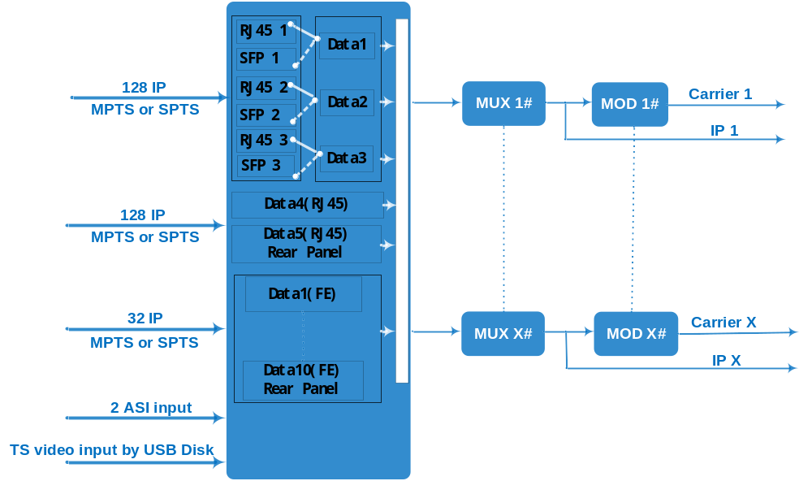
Carrier Setting Illustration:

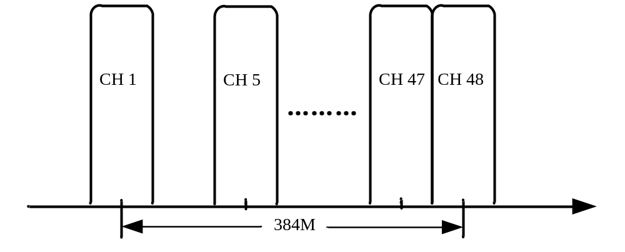
Specifications
Input | Input | 28 ISDB-T &32 DVB-T & 48 DVB-C carriers: Max 128 IP input through Date1-Date5, 100/1000M Ethernet Port (Date1-Date3 are SFP interface optional). Each Data port can input max 128 IP.  Max 32 IP input through Date1-Date10 (FE port, Rear panel), 100M Ethernet Port, Each Data port can input max 32 IP.
Input | Input | 2ASI input, BNC interface
Input |  | 1 USB Player input for re-mux (“xxx.ts” video)
Input | Transport Protocol | TS over UDP/RTP, unicast and multicast, IGMP V2/V3
Input | Transmission Rate | Max 840Mbps for each input channel
Mux | Input Channel | 128(or 32)
Mux | Output Channel | 28(ISDB-T) or 32 (DVB-T)or 48(DVB-C)
Mux | Max PIDs | 256 per channel
Mux | Functions | PID remapping(auto/manually optional)
Mux | Functions | PCR accurate adjusting
Mux | Functions | PSI/SI table automatically generating
Modulation  Parameters (ISDB-T) | Channel | 16/20/24/28(License gradable)
Modulation  Parameters (ISDB-T) | Modulation Standard | ARIB STD-B31
Modulation  Parameters (ISDB-T) | Constellation | QPSK, 16QAM, 64QAM
Modulation  Parameters (ISDB-T) | Bandwidth | 6MHz
Modulation  Parameters (ISDB-T) | Transmission Mode | 2K/4K/8K
Modulation  Parameters (ISDB-T) | Code rate | 1/2, 2/3, 3/4, 5/6, 7/8
RF Output (ISDB-T) | Interface | F typed output port for 28 non-adjacent carriers
RF Output (ISDB-T) | RF Range | 50~960MHz, 1kHz stepping
RF Output (ISDB-T) | Output Level | -20dBm~1dBm(87~108dbµV), 0.1dB stepping
RF Output (ISDB-T) | MER | ≥ 40dB
RF Output (ISDB-T) | ACL | -50 dBc
Modulation  Parameters (DVB-T) | Channel | 16/20/24/28/32(License gradable)
Modulation  Parameters (DVB-T) | Modulation Standard | ETSI EN300 744
Modulation  Parameters (DVB-T) | Constellation | QPSK/16QAM/64QAM
Modulation  Parameters (DVB-T) | Bandwidth | 6/7/8 MHz
Modulation  Parameters (DVB-T) | Transmission Mode | 2K/4K/8K
Modulation  Parameters (DVB-T) | Code rate | 1/2,2/3,3/4,5/6,7/8
RF Output (DVB-T) | Interface | F typed output port for 32 non-adjacent carriers
RF Output (DVB-T) | RF Range | 50~960MHz, 1kHz stepping
RF Output (DVB-T) | Output Level | -20dBm~0dBm(87~107dbµV), 0.1dB stepping
RF Output (DVB-T) | MER | ≥ 40dB
RF Output (DVB-T) | ACL | -55 dBc
Modulation  Parameters (DVB-C) | Constellation | J.83A | Constellation :16/32/64/128/256QAM
Modulation  Parameters (DVB-C) | Constellation | J.83A | Bandwidth :8M
Modulation  Parameters (DVB-C) | Constellation | J.83B/C | Constellation :64/256QAM
Modulation  Parameters (DVB-C) | Constellation | J.83B/C | Bandwidth :6M
Modulation  Parameters (DVB-C) | QAM Channel | 32/36/40/44/48(License gradable)
Modulation  Parameters (DVB-C) | Symbol Rate | 5.0~7.0Msps, 1ksps stepping. 5057Ksps (J.83B, 64QAM) ; 5361Ksps (J.83B, 256QAM)
Modulation  Parameters (DVB-C) | Constellation | 16, 32, 64 , 128, 256QAM
RF Output (DVB-C) | Interface | F typed output port for 48 non-adjacent carriers
RF Output (DVB-C) | RF Range | 50~960MHz, 1kHz stepping
RF Output (DVB-C) | Output Level | -20dBm~-3dBm(87~104dbµV), 0.1dB stepping
RF Output (DVB-C) | MER | ≥ 40dB
RF Output (DVB-C) | ACL | 50~960MHz, 1kHz stepping
TS output | 28&32&48 IP output over UDP/RTP, unicast/multicast, Data1 100/1000M Ethernet Ports
System | Web-based Network management
General | Demission | 420mm×440mm×44.5mm (WxLxH)
General | Temperature | 0~45℃(operation), -20~80℃(storage)
General | Power Supply | AC100V±10%, 50/60Hz or AC 220V±10%,50/60Hz

Order Guide
Modulation combination | DVB-C/DVB-T | DVB-C/ISDB-T | DVB-T/ISDB-T
Carrier support (Increase every four carriers) | 32~48/16~32 | 32~48/16~28 | 16~32/16~28

Modulation | Carrier number(Increase every four carriers by license)
DVB-C | 32 | 36 | 40 | 44 | 48
DVB-T | 16 | 20 | 24 | 28 | 32
ISDB-T | 16 | 20 | 24 | 28 | /
Note: | Different combination of carrier number can be selected, Need to be confirmed before an order

About Us
FMUSER is a company specializing in broadcasting and television transmission systems and integrating hotel IPTV systems. The company was established in 2009 and has served over 180 countries worldwide. More than 20,000 television stations, radio stations, and hotel clients from different.

Contact:Tomleequan Email：sales@fmuser.com whatsapp: +8613922702227

