FMUSER FUQ-4455B IP QAM Modulator 192 IP Inputs UDP-RTP DVB-C EN300-429 ITU-T J.83 A-B-C PID Remapping PCR Adjusting IPTV Cable TV Headend
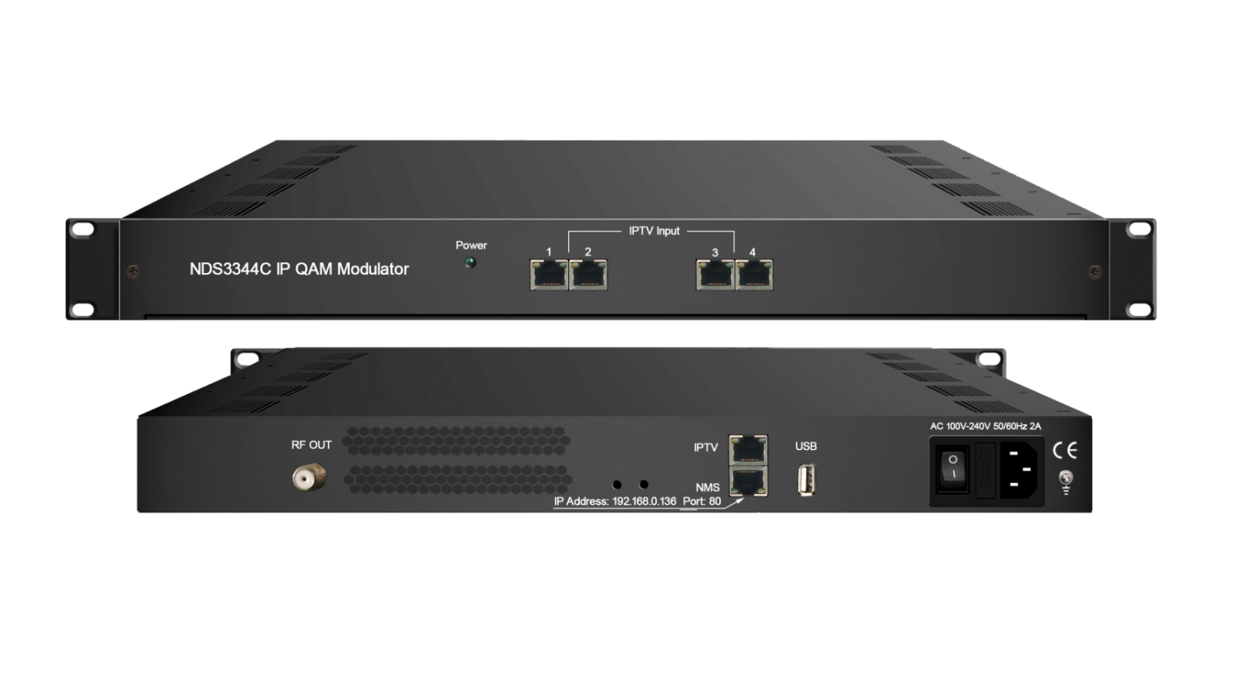Product overview
The FUQ-4455B IP QAM Modulator integrates multiplexing, scrambling, and modulation, processing 192 IP inputs via 4×FE and 1×GE ports to output 4 DVB-C RF carriers. It handles SPTS/MPTS streams using UDP/RTP, with PID remapping and PSI/SI editing for compliance. Features web-based control and USB upgrades in a compact chassis. Ideal for IPTV systems and cable TV headends, enabling flexible integration.
Key Features
Handles High-Capacity IP Inputs: Supports 192 SPTS/MPTS streams via UDP/RTP with 4×FE and 1×GE ports.FMUSER FUQ-4455B IP QAM Modulator 192 IP Inputs UDP-RTP DVB-C EN300-429 ITU-T J.83 A-B-C PID Remapping PCR Adjusting IPTV Cable TV HeadendSupports Precision Signal Control: Enables PID remapping, PCR adjusting, and PSI/SI editing for DVB-C standards.FMUSER FUQ-4455B IP QAM Modulator 192 IP Inputs UDP-RTP DVB-C EN300-429 ITU-T J.83 A-B-C PID Remapping PCR Adjusting IPTV Cable TV HeadendGenerates Multi-Standard RF Output: Delivers 4 adjacent QAM carriers (30MHz–1000MHz) meeting EN 300 429/ITU-T J.83 A/B/C.FMUSER FUQ-4455B IP QAM Modulator 192 IP Inputs UDP-RTP DVB-C EN300-429 ITU-T J.83 A-B-C PID Remapping PCR Adjusting IPTV Cable TV HeadendFeatures Unified Management: Includes web-based control, USB upgrades, and IPTV Sync/NTP synchronization.
Working Principle
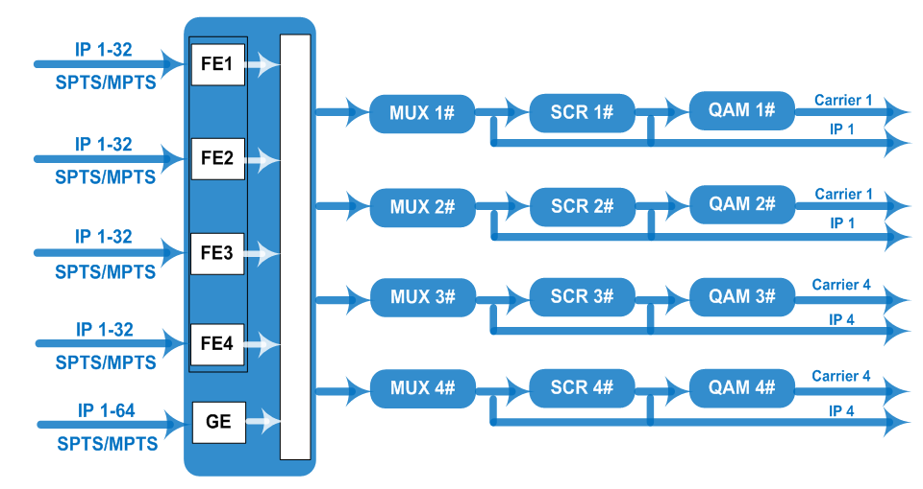

Specifications

Input | 128 IP (SPTS/MPTS) input over UDP/RTP, 4*100M Ethernet port, and  64 IP (SPTS/MPTS) input over UDP/RTP, 1*100/1000M Ethernet ports
Multiplexing | Maximum PID Remapping | 748 per input channel
Multiplexing | Function | PID remapping (automatically or manually)
Multiplexing | Function | Accurate PCR adjusting
Multiplexing | Function | Generate PSI/SI table automatically
Scrambling | Maximum simulcrypt CA | 4
Scrambling | Standard | ETSI 101 197, ETSI 103 197
Scrambling | Connection | Local/remote connection
Modulation | QAM Channel | 1 F typed output port for 4 carriers, 75Ω
Modulation | Standard | EN300 429/ITU-T J.83A/B/C
Modulation | MER | ≥40db
Modulation | RF Frequency | 30~1000 MHz, 1kHz stepping
Modulation | RF Output level | -10dBm~+0dBm, 0.1dB stepping
Modulation | FEC | RS (204, 188)
Modulation | Symbol Rate | 5.0Msps~9.0Msps, 1ksps stepping
Modulation |  | J.83A | J.83B | J.83C
Modulation | Constellation | 16/32/64/128/256QAM | 64/256 QAM | 64/256 QAM
Modulation | Bandwidth | 8M | 6M | 6M
Stream Out | 4 IP (SPTS/MPTS) output over UDP, 1*1000M Ethernet port (IPTV Port)
System | Web-based Network management
System | Chinese and English Language
System | Web and USB software upgrade
General | Dimension | 430mm×180mm×44mm (W*L*H)
General | Temperature | 0~45℃(Operation) ; -20~80℃(Storage)
General | Power | AC 100V±1050/60Hz; AC 220V±10%, 50/60HZ

About Us
FMUSER is a company specializing in broadcasting and television transmission systems and integrating hotel IPTV systems. The company was established in 2009 and has served over 180 countries worldwide. More than 20,000 television stations, radio stations, and hotel clients from different.
FMUSER FUQ-4455B IP QAM Modulator 192 IP Inputs UDP-RTP DVB-C EN300-429 ITU-T J.83 A-B-C PID Remapping PCR Adjusting IPTV Cable TV Headend Contact:Tomleequan Email：sales@fmuser.com whatsapp: +8613922702227

