FMUSER FUQ-4459AB-CD Quad-Channel DVB-T-DVB-C Modulator 128 IP Inputs 4 MPTS IP Outputs BISS Descrambling Web-Based NMS Control for Digital Broadcast Networks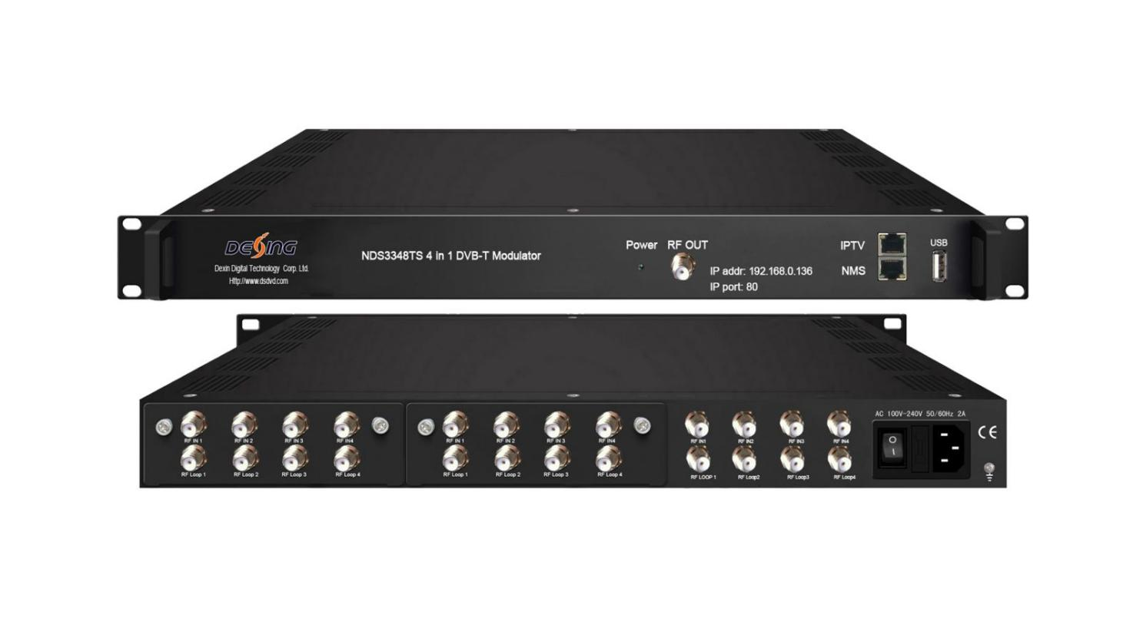Product overview
The FUQ-4459AB/CD series are professional quad-channel modulators supporting 12× DVB-S2/T tuner inputs and 128 IP (UDP/RTP) streams. They perform MPTS multiplexing and DVB-T/C modulation (EN300744/J.83A/B) with BISS Mode 1/E descrambling. Featuring 1RU rack-mount design and web-based NMS control, these devices are ideal for multi-format headend systems, IP-to-RF conversion, and secure satellite-to-terrestrial redistribution.
Key feature
Complies with DVB-T EN300744 (TS) and DVB-C J.83A/B (CS) standards

FU-4459TS DVB-T Principle Chart
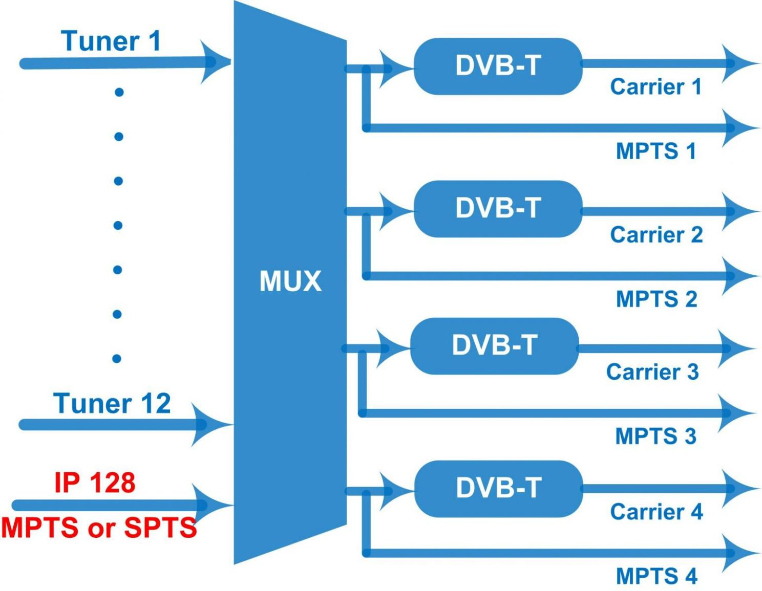
FU-4459CS DVB-C Principle Chart
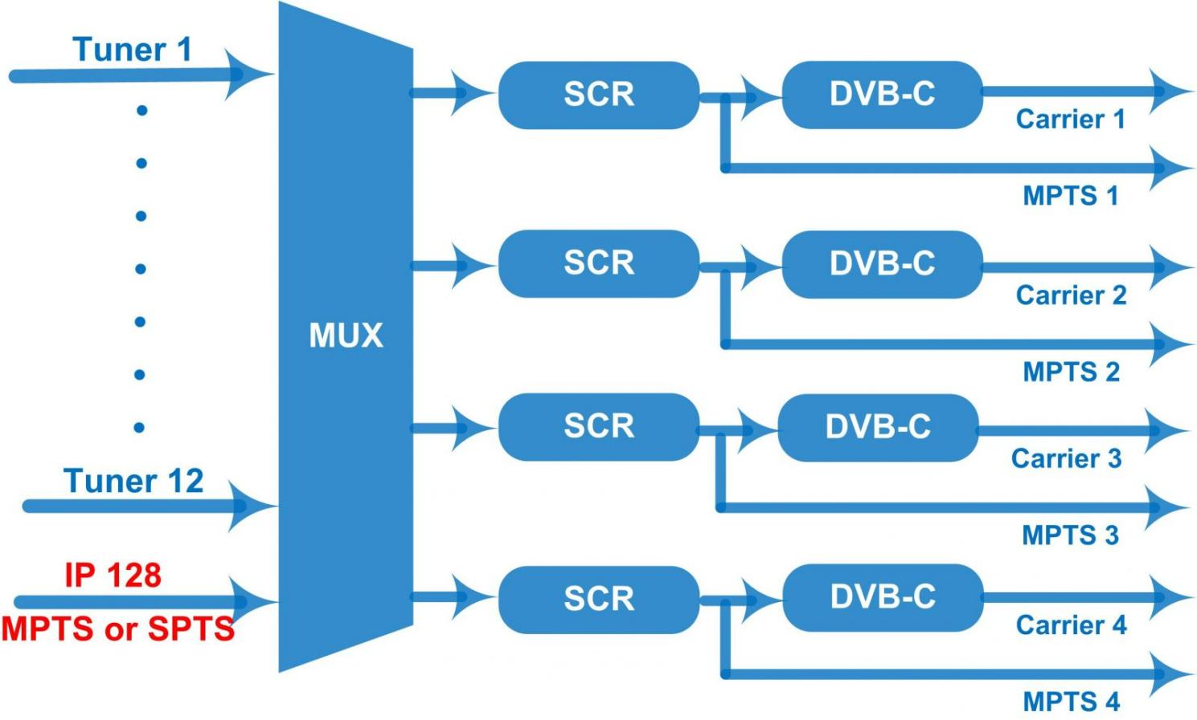

Specifications
Input | 12 DVB-S2 FTA Tuner input ports---Version I  12 DVB-T Tuner input ports---Version II  8 DVB-S2 FTA tuner+ 4 DVB-T tuner input---Version III  8 DVB-T FTA tuner+4 DVB-S2 tuner input---Version IV  128 IP(SPTS/MPTS) input over UDP and RTP, RJ45, 1000M/100M Unicast/Multicast
Tuner Section | DVB-S | Input Frequency |  | 950-2150MHz
Tuner Section | DVB-S | Symbol rate |  | 2-45Msps
Tuner Section | DVB-S | Signal Strength |  | -65~-25dBm
Tuner Section | DVB-S | FEC Demodulation |  | 1/2, 2/3, 3/4, 5/6, 7/8 QPSK
Tuner Section | DVB-S2 | Input Frequency |  | 950-2150MHz
Tuner Section | DVB-S2 | Symbol rate |  | QPSK 1~45Mbauds; 8PSK 2~30Mbauds
Tuner Section | DVB-S2 | Code rate |  | 1/2, 3/5, 2/3, 3/4, 4/5, 5/6, 8/9, 9/10
Tuner Section | DVB-S2 | Constellation |  | QPSK, 8PSK
Tuner Section | DVB-T/(T) | Input Frequency |  | 30MHz ~999.999 MHz
Tuner Section | DVB-T/(T) | Bandwidth |  | 6M, 7M, 8M
BISS descrambling | Mode 1, Mode E (Up to 850Mbps) (descramble individual program)
Multiplexing | Maximum PID Remapping |  | 256 per input channel
Multiplexing | Function |  | PID remapping
Multiplexing |  |  | A/V PID filtering (for FU-4459TS)
Multiplexing |  |  | Accurate PCR adjusting
Multiplexing |  |  | Generate PSI/SI table automatically
Modulation | DVB-T |  | Standard | EN300744
Modulation |  |  | FFT mode | 2K,
Modulation |  |  | Bandwidth | 6M, 7M, 8M
Modulation |  |  | Constellation | QPSK, 16QAM, 64QAM
Modulation |  |  | Guard Interval | 1/4, 1/8, 1/16, 1/32
Modulation |  |  | FEC | 1/2, 2/3, 3/4, 5/6, 7/8
Modulation |  |  | MER | ≥42 dB
Modulation |  |  | RF frequency | 50~960MHz, 1KHz step
Modulation |  |  | RF out | 4*DVB-T adjacent carriers combined output, 40M total bandwidth limitation
Modulation |  |  | RF output level | -28~ -3 dBm (79~105 dbµV), 0.1db step
Modulation | DVB-C |  | Standard | J.83A (DVB-C), J.83B,
Modulation |  |  | MER | ≥43dB
Modulation |  |  | RF frequency | 50~960MHz, 1KHz step
Modulation |  |  | RF output level | -25~ -1dbm (82~106 dbµV), 0.1db step
Modulation |  |  | Symbol rate | 5.000~7.000Msps adjustable
Modulation |  |  | RF Out | 4*DVB-C adjacent carriers combined output, 40M total bandwidth limitation
Modulation |  |  |  | J.83A | J.83B
Modulation |  |  | Constellation | 16/32/64/128/ 256 QAM | 64/ 256 QAM
Modulation |  |  | Bandwidth | 8M | 6M
Stream out | 4*MPTS over UDP and RTP out , RJ45, 1000M/100M, Unicast/Multicast
System | web-based NMS support
System | Ethernet software upgrading
General | Dimension  (W*D*H) |  | 482mm×300mm×44.5mm
General | Temperature |  | 0~45℃(Operation) ; -20~80℃(Storage)
General | Power |  | AC 100V±1050/60Hz; AC 220V±10%, 50/60HZ

About Us
FMUSER is a company specializing in broadcasting and television transmission systems and integrating hotel IPTV systems. The company was established in 2009 and has served over 180 countries worldwide. More than 20,000 television stations, radio stations, and hotel clients from different.

Contact:Tomleequan Email：sales@fmuser.com whatsapp: +8613922702227

