FMUSER FUQ-4459B DVB-C Modulator 8 Tuner Inputs 128 IP Inputs UDP-RTP 4 RF Outputs DVB-C-DVB-C-T-S-S2-S2X-ISDB-T-ATSC Multi-Mode Scrambling BISS Descrambling Web-Based NMS for Broadcast and CATV 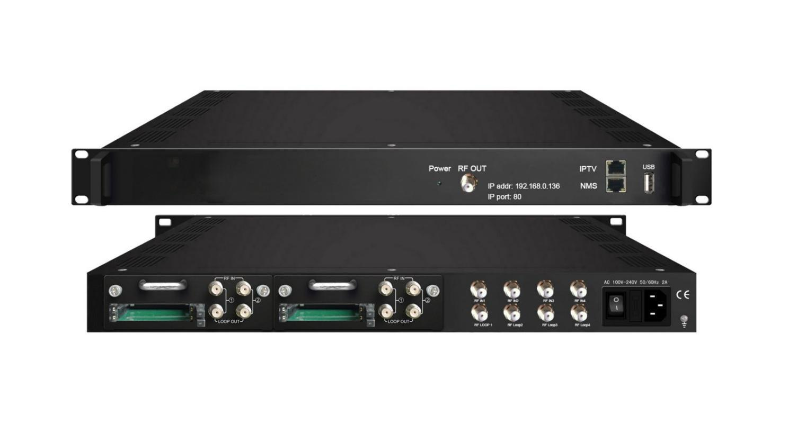Its production is stopped temporarily, and the date for resuming production is not fixed yet.

Product overview
The FMUSER FUQ-4459D is a DVB-C modulator with 8 tuner inputs, 128 IP inputs via UDP/RTP, and 4 non-adjacent carrier outputs. It integrates multiplexing, scrambling, and modulation functions, supporting BISS descrambling. Managed through web-based NMS, this device is ideal for digital broadcasting networks, enabling flexible signal processing and secure content delivery.
Key feature
Supports multi-mode tuner inputs for DVB-C, DVB-T, DVB-S/S2/S2X, ATSC, and ISDB-T with CAM slots.
Handles up to 128 IP streams via UDP/RTP protocols.
Features integrated multiplexing, scrambling, and DVB-C modulation for 4 carrier outputs.
Enables BISS descrambling for secure decryption.
Facilitates remote management via web-based NMS.

Principle Chart
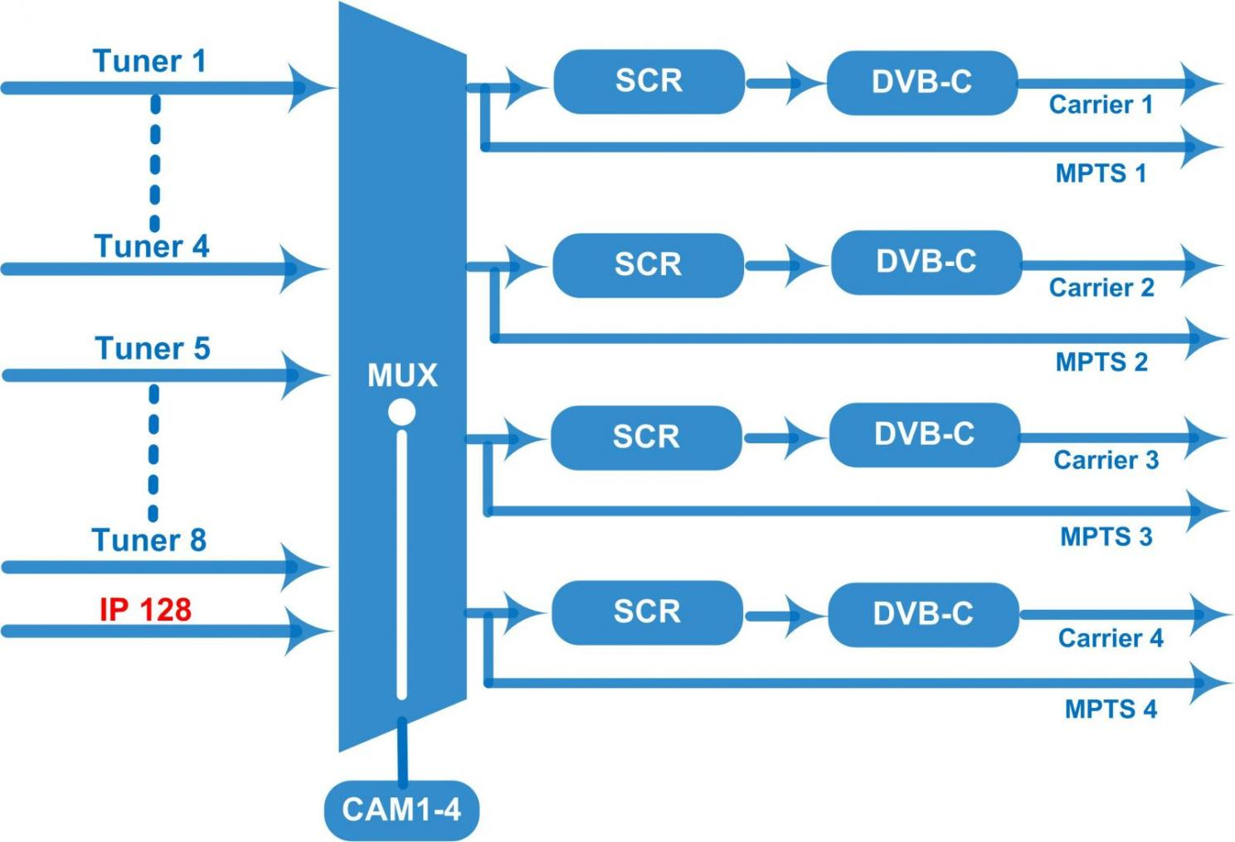

Specifications
Input | 4 Tuner (DVB-C/T/(T)/S/S2/S2X/ISDBT optional) + 4 Tuner with CAM (DVB-C/T/(T)/S/S2/S2X/ATSC/ISDBT optional)  128 IP(SPTS/MPTS) input over UDP and RTP, RJ45, 1000M/100M , Unicast/Multicast
Tuner Section | Multi-mode tuners switchable  (New) | DVB-C |  |  | Input Frequency | 60~890 MHz
Tuner Section | Multi-mode tuners switchable  (New) |  |  |  | Standard | J.83A, J.83C |  | J.83B
Tuner Section | Multi-mode tuners switchable  (New) |  |  |  | Constellation | 16/32/64/128/256 QAM |  | 64/256 QAM
Tuner Section | Multi-mode tuners switchable  (New) | DVB-T/(T) |  |  | Input Frequency | 60~890 MHz
Tuner Section | Multi-mode tuners switchable  (New) |  |  |  | Bandwidth | 6/7/8 M
Tuner Section | Multi-mode tuners switchable  (New) | ISDB-T |  |  | Input Frequency | 60~890 MHz
Tuner Section | Version 1 | DVB-S |  |  | Input Frequency | 950-2150MHz
Tuner Section | Version 1 |  |  |  | Symbol rate | 0.5~45Msps
Tuner Section | Version 1 |  |  |  | Signal Strength | -65~-25dBm
Tuner Section | Version 1 |  |  |  | FEC | 1/2, 2/3, 3/4, 5/6, 7/8 QPSK
Tuner Section | Version 1 | DVB-S2 |  |  | Input Frequency | 950 ~2150MHz
Tuner Section | Version 1 |  |  |  | Symbol rate | QPSK: 1~45 Msps; 8PSK: 0.5~45 Msps
Tuner Section | Version 1 |  |  |  | FEC | 1/2, 3/5, 2/3, 3/4, 4/5, 5/6, 8/9, 9/10
Tuner Section | Version 1 |  |  |  | Constellation | QPSK, 8PSK
Tuner Section | Version 2  (New) | DVB-S |  |  | Input Frequency | 950 ~2150MHz
Tuner Section | Version 2  (New) |  |  |  | Symbol rate | 0.5~45Msps
Tuner Section | Version 2  (New) |  |  |  | Signal Strength | - 65- -25dBm
Tuner Section | Version 2  (New) |  |  |  | FEC | 1/2, 2/3, 3/4, 5/6, 7/8
Tuner Section | Version 2  (New) |  |  |  | Constellation | QPSK
Tuner Section | Version 2  (New) |  |  |  | Max input bitrate | ≤129Mbps
Tuner Section | Version 2  (New) | DVB-S2 |  |  | Input Frequency | 950 ~2150MHz
Tuner Section | Version 2  (New) |  |  |  | Symbol rate | QPSK/8PSK /16APSK :0.5~45 Msps  32APSK: 0.5~40Msps;
Tuner Section | Version 2  (New) |  |  |  | FEC | QPSK: 1/2, 3/5, 2/3, 3/4, 4/5, 5/6, 8/9, 9/10  8PSK: 3/5, 2/3, 3/4, 5/6, 8/9, 9/10  16APSK: 2/3, 3/4, 4/5, 5/6, 8/9, 9/10  32APSK: 3/4, 4/5, 5/6, 8/9, 9/10
Tuner Section | Version 2  (New) |  |  |  | Constellation | QPSK, 8PSK, 16APSK, 32APSK
Tuner Section | Version 2  (New) |  |  |  | Max input bitrate | ≤129 Mbps
Tuner Section | Version 2  (New) | DVB-S2X |  |  | Input Frequency | 950 ~2150MHz
Tuner Section | Version 2  (New) |  |  |  | Symbol rate | QPSK/8PSK /16APSK :0.5~45 Msps  8APSK/32APSK: 0.5~40Msps
Tuner Section | Version 2  (New) |  |  |  | FEC | QPSK: 1/2, 3/5, 2/3, 3/4, 4/5, 5/6, 8/9, 9/10, 13/45, 9/20, 11/20  8PSK: 3/5, 2/3, 3/4, 5/6, 8/9, 9/10  8APSK: 5/9-L, 26/45-L  16APSK: 2/3, 3/4, 4/5, 5/6, 8/9, 9/10, 1/2-L, 8/15-L, 5/9-L, 26/45, 3/5, 3/5-L, 28/45, 23/36 , 2/3-L, 25/36, 13/18, 7/9, 77/90  32APSK: 3/4, 4/5, 5/6, 8/9, 2/3-L, 32/45, 11/15, 7/9
Tuner Section | Version 2  (New) |  |  |  | Constellation | QPSK, 8PSK, 8APSK, 16APSK, 32APSK
Tuner Section | Version 2  (New) |  |  |  | Max input bitrate | ≤129 Mbps
Tuner Section |  | ATSC-T |  |  | Input Frequency | 54~858MHz
Tuner Section |  |  |  |  | Bandwidth | 6M
Tuner Section |  |  |  |  | Constellation | 8VSB
Descrambling | CAM/CI |  |  |  | 4 sets
BISS Descrambling | Mode 1, Mode E (descramble individual program)
Multiplexing | Maximum PID Remapping |  | 256 per input channel
Multiplexing | Function |  | A/V PID filtering
Multiplexing |  |  | PID Remapping
Multiplexing |  |  | Accurate PCR adjusting
Multiplexing |  |  | Generate PSI/SI table automatically
Scrambling | Maximum simulcrypt CA |  | 4
Scrambling | Standard |  | ETR289, ETSI 101 197, ETSI 103 197
Scrambling | Connection |  | Local/remote connection
Modulation | DVB-C |  | Standard |  | J.83A (DVB-C), J.83B,
Modulation |  |  | MER |  | ≥43dB
Modulation |  |  | RF frequency |  | 50~960MHz, 1KHz step
Modulation |  |  | RF output level |  | -25~ -1dbm(83~107 dbµV), 0.1db step
Modulation |  |  | Symbol rate |  | 5.000~7.000Msps adjustable
Modulation |  |  | RF Out |  | 4*DVB-C non-adjacent carriers combined output, 40M total bandwidth limitation
Modulation |  |  | Constellation |  | J.83A |  | J.83B
Modulation |  |  |  |  | 16/32/64/128/256QAM |  | 64/256 QAM
Modulation |  |  | Bandwidth |  | 8M |  | 6M
Stream out | 4*MPTS over UDP and RTP out (RJ45, 1000M/100M Unicast/Multicast)
System | web-based NMS support
System | Ethernet software upgrading
General | Dimension |  |  | 482mm×300mm×44.5mm (W*D*H)
General | Temperature |  |  | 0~45℃(Operation) ; -20~80℃(Storage)
General | Power |  |  | AC 100V±1050/60Hz; AC 220V±10%, 50/60HZ

About Us
FMUSER is a company specializing in broadcasting and television transmission systems and integrating hotel IPTV systems. The company was established in 2009 and has served over 180 countries worldwide. More than 20,000 television stations, radio stations, and hotel clients from different.

Contact:Tomleequan Email：sales@fmuser.com whatsapp: +8613922702227

