FMUSER FUQ-4459E Modulator 1536 IP Input - 48 QAM Output 3 GE Ports DVB-C Multiplexing Scrambling CA Headend TV Systems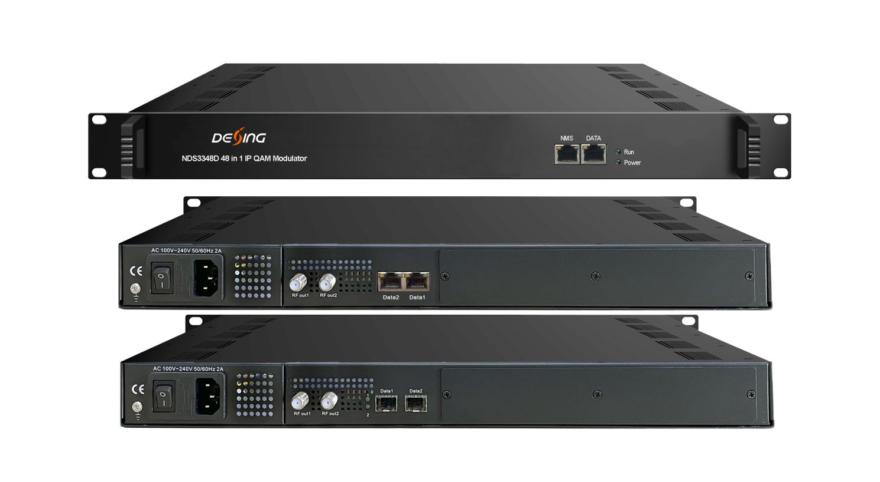Product Overview
The FMUSER FUQ-4459E is a multiplexing, scrambling, and modulating device with max 1536 IP inputs via three GE ports and 48 QAM outputs through dual RF ports. It processes signals through multiplexing, scrambling, and modulation, including PID remapping and RS (204,188) encoding. Featuring web-based management, this device is ideal for CATV headend systems and broadcast video distribution.
Key feature
- Handles max 1536 IP streams through three GE ports (SFP optional).
- Supports 6 simulcrypt CAs and 12 scrambling channels for security.
- Features PID remapping (up to 512 per channel), RS (204,188) encoding, and accurate PCR adjusting.
- Delivers 48 non-adjacent QAM carriers (50MHz–960MHz) and 48 IP outputs over UDP/RTP/RTSP.
- Provides web-based network management for configuration.
Inner Principle Chart
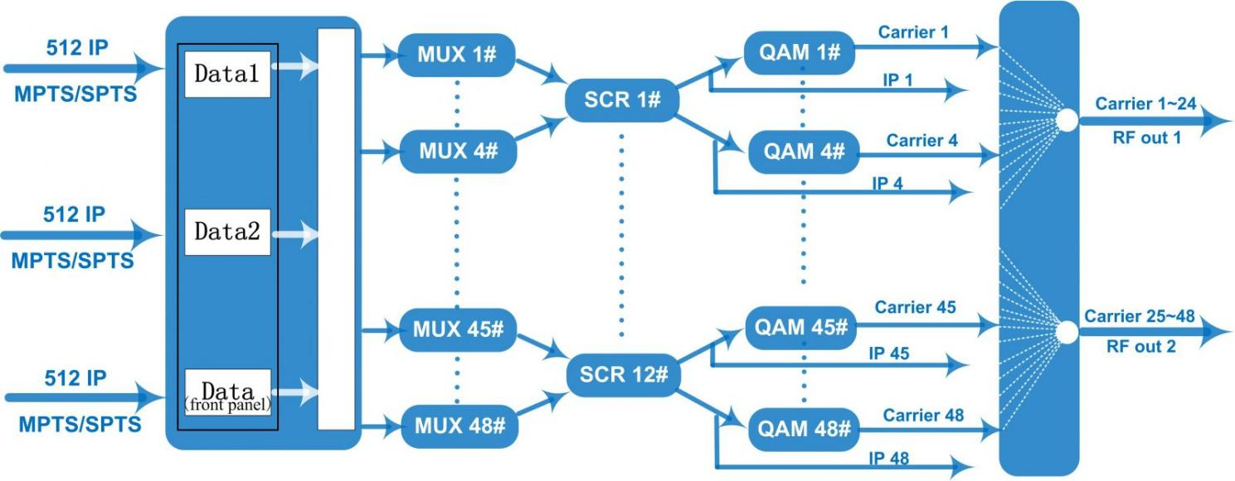

Carrier Setting Illustration
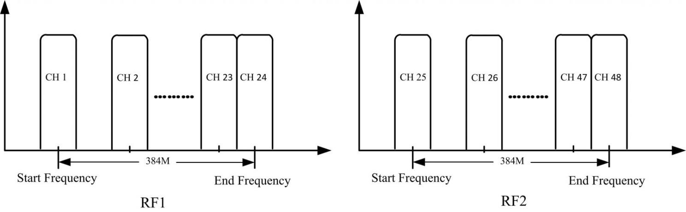

Specifications
Input | Input |  | Max 1536 IP in thru 3 GE ports [Data 1 & Data 2 bi-directional ports, Data port (located on front panel), each port can input max 512 IP]  100/1000M self-adaption Ethernet Port (SFP interface optional)
Input | Transport Protocol |  | TS over UDP/RTP, unicast and multicast, IGMP V2/V3
Input | Transmission Rate |  | Max 840Mbps for each GE input
Mux | Input Channel |  | 1536
Mux | Output Channel |  | 48
Mux | Max PIDs Remapping |  | 512 per output channel
Mux | Functions |  | PID remapping (auto/manually optional)
Mux |  |  | PCR accurate adjusting
Mux |  |  | PSI/SI table automatically generating
Scrambling  Parameters | Max simulcrypt CA |  | 6
Scrambling  Parameters | Scramble Standard |  | ETR289, ETSI 101 197, ETSI 103 197
Scrambling  Parameters | Scramble Channel |  | 12
Scrambling  Parameters | Connection |  | Local/remote connection
Modulation  Parameters | DVB-C Modulator Sectioon |  | J.83A | Constellation :16/32/64/128/256QAM
Modulation  Parameters |  |  | J.83A | Bandwidth :8M
Modulation  Parameters |  |  | J.83B/C | Constellation :64/256QAM
Modulation  Parameters |  |  | J.83B/C | Bandwidth :6M
Modulation  Parameters | QAM Channel |  | 48 non-adjacent carrier
Modulation  Parameters | Modulation Standard |  | EN300 429/ITU-T J.83A/B/C
Modulation  Parameters | Symbol Rate |  | 3600~7000Ksps, 1ksps stepping  5057Ksps (J.83B, 64QAM)  5361Ksps (J.83B, 256QAM)
Modulation  Parameters | Constellation |  | 16, 32, 64 , 128, 256QAM
Modulation  Parameters | FEC |  | RS (204, 188)
RF Output | Interface |  | 2 F type output ports for 48 carriers, 75Ω  Carrier 1~24 out thru RF1, 25~48 thru RF2
RF Output | RF Range |  | 50~960MHz, 1kHz stepping
RF Output | Output Level |  | -20dBm~+10dBm(87~117dbµV), 0.1dB stepping
RF Output | MER |  | ≥ 40dB
TS output | 48 IP output over UDP/RTP/RTSP, unicast/multicast, 2*100/1000M self-adaption, Ethernet Ports (SFP).  IP 1~24 out thru Data1, IP 25~48 out thru Data2.
System | Network management software (NMS) supporting
General | Demission | 420mm×440mm×44.5mm (WxLxH)
General | Weight | 3kg
General | Temperature | 0~45℃(operation), -20~80℃(storage)
General | Power Supply | AC 100V±10%, 50/60Hz or AC 220V±10%, 50/60Hz
General | Consumption | 15.4W

About Us
FMUSER is a company specializing in broadcasting and television transmission systems and integrating hotel IPTV systems. The company was established in 2009 and has served over 180 countries worldwide. More than 20,000 television stations, radio stations, and hotel clients from different.

Contact:Tomleequan Email：sales@fmuser.com whatsapp: +8613922702227

