FMUSER FUQ-4459R DVB-T Modulator 8 Tuner Inputs 4 RF Outputs DVB-C-T-S-S2-S2X-ISDB-T-ATSC IP UDP-RTP CAM BISS Descrambling Headend IPTV Cable TV 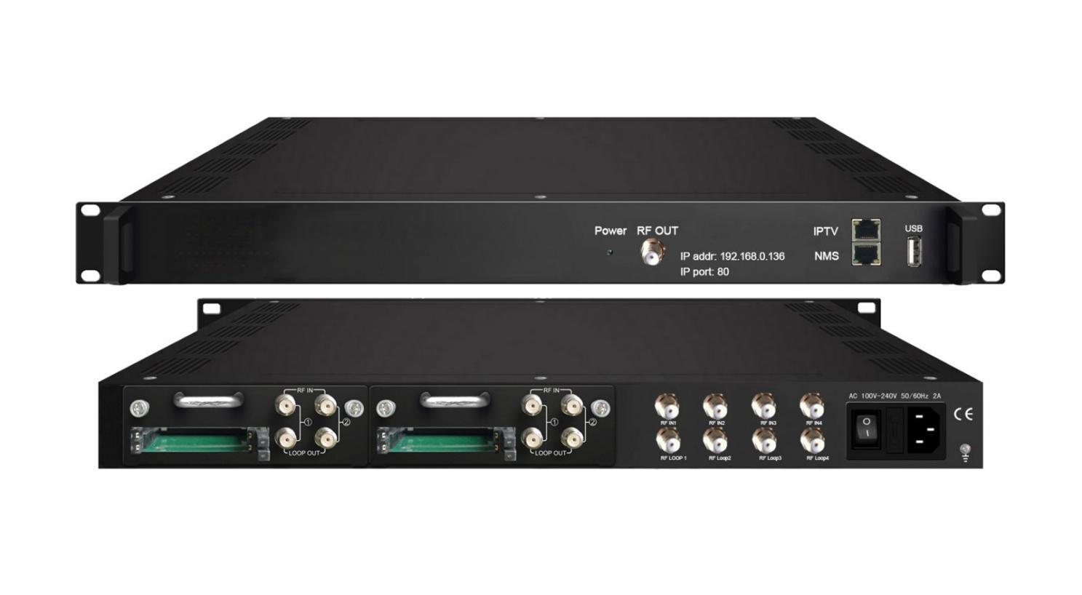Its production is stopped temporarily, and the date for resuming production is not fixed yet.

Product overview
The FMUSER FUQ-4459R is a high-performance DVB-T modulator with 8 tuner inputs and one RF output port, delivering 4 non-adjacent carriers. It processes signals by modulating them to DVB-T standards and supports IP input/output via UDP/RTP protocols. Features include CAM/CI descrambling and web-based NMS for remote management, ideal for broadcast transmission, IPTV headends, and cable TV systems.FU-4459T can be upgraded and controlled through network system, which allows it widely used in digital broadcasting network and provide good signals for scientific laboratory and DVB-T STB.

Key feature
Supports 8 tuner inputs with optional DVB-C/T/S/S2/S2X/ISDBT/ATSC standards and CAM slots.
Provides up to 128 IP inputs via UDP/RTP protocols (Version 1 only).
Features BISS descrambling and CAM/CI support.
Includes web-based NMS for remote control and upgrades.

Principle Chart
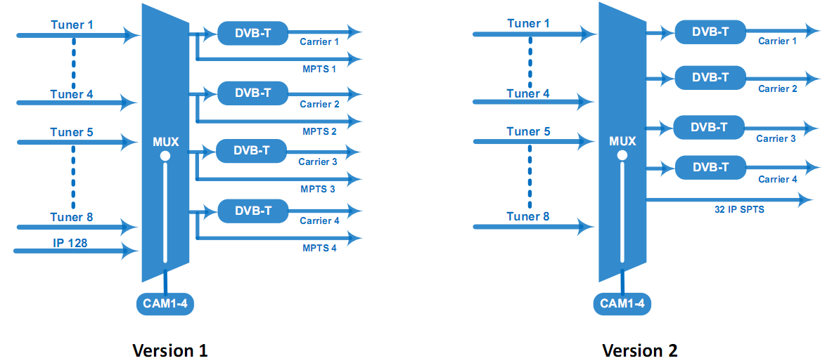

Specifications
Input | 4 Tuner (DVB-C/T/(T)/S/S2/S2X/ISDBT optional) + 4 Tuner with CAM (DVB-C/T/(T)/S/S2/S2X/ATSC/ISDBT optional);  128 IP (SPTS/MPTS) input over UDP and RTP, RJ45, 1000M/100M, Unicast/Multicast (IP input is for Version 1 only)
Tuner Section | Multi-mode tuners switchable  (New) | DVB-C | Input Frequency |  | 60 ~890 MHz
Tuner Section | Multi-mode tuners switchable  (New) | DVB-C | Standard |  | J.83A, J.83C | J.83B
Tuner Section | Multi-mode tuners switchable  (New) | DVB-C | Constellation |  | 16/32/64/128/256 QAM | 64/256 QAM
Tuner Section | Multi-mode tuners switchable  (New) | DVB-T/(T) | Input Frequency |  | 60 ~890 MHz
Tuner Section | Multi-mode tuners switchable  (New) | DVB-T/(T) | Bandwidth |  | 6/7/8 M
Tuner Section | Multi-mode tuners switchable  (New) | ISDB-T | Input Frequency |  | 60 ~890 MHz
Tuner Section | DVB-S/S2 Tuner | DVB-S | Input Frequency |  | 950~150MHz
Tuner Section | DVB-S/S2 Tuner | DVB-S | Symbol rate |  | 0.5~45Msps
Tuner Section | DVB-S/S2 Tuner | DVB-S | Signal Strength |  | -65~-25dBm
Tuner Section | DVB-S/S2 Tuner | DVB-S | FEC Demodulation |  | 1/2, 2/3, 3/4, 5/6, 7/8 QPSK
Tuner Section | DVB-S/S2 Tuner | DVB-S2 | Input Frequency |  | 950~2150MHz
Tuner Section | DVB-S/S2 Tuner | DVB-S2 | Symbol rate |  | QPSK: 1~45 Msps; 8PSK: 0.5~45Msps
Tuner Section | DVB-S/S2 Tuner | DVB-S2 | Code rate |  | 1/2, 3/5, 2/3, 3/4, 4/5, 5/6, 8/9, 9/10
Tuner Section | DVB-S/S2 Tuner | DVB-S2 | Constellation |  | QPSK, 8PSK
Tuner Section | DVB-S/S2/S2X Tuner  (New) | DVB-S | Input Frequency |  | 950~2150MHz
Tuner Section | DVB-S/S2/S2X Tuner  (New) | DVB-S | Symbol rate |  | 0.5~45Msps
Tuner Section | DVB-S/S2/S2X Tuner  (New) | DVB-S | Signal Strength |  | - 65- -25dBm
Tuner Section | DVB-S/S2/S2X Tuner  (New) | DVB-S | FEC |  | 1/2, 2/3, 3/4, 5/6, 7/8
Tuner Section | DVB-S/S2/S2X Tuner  (New) | DVB-S | Constellation |  | QPSK
Tuner Section | DVB-S/S2/S2X Tuner  (New) | DVB-S | Max input bitrate |  | ≤129 Mbps
Tuner Section | DVB-S/S2/S2X Tuner  (New) | DVB-S2 | Input Frequency |  | 950~2150MHz
Tuner Section | DVB-S/S2/S2X Tuner  (New) | DVB-S2 | Symbol rate |  | QPSK/8PSK /16APSK: 0.5~45 Msps  32APSK: 0.5~40Msps;
Tuner Section | DVB-S/S2/S2X Tuner  (New) | DVB-S2 | FEC |  | QPSK: 1/2, 3/5, 2/3, 3/4, 4/5, 5/6, 8/9, 9/10  8PSK: 3/5, 2/3, 3/4, 5/6, 8/9, 9/10  16APSK: 2/3, 3/4, 4/5, 5/6, 8/9, 9/10  32APSK: 3/4, 4/5, 5/6, 8/9, 9/10
Tuner Section | DVB-S/S2/S2X Tuner  (New) | DVB-S2 | Constellation |  | QPSK, 8PSK, 16APSK, 32APSK
Tuner Section | DVB-S/S2/S2X Tuner  (New) | DVB-S2 | Max input bitrate |  | ≤129 Mbps
Tuner Section | DVB-S/S2/S2X Tuner  (New) | DVB-S2X | Input Frequency |  | 950~2150MHz
Tuner Section | DVB-S/S2/S2X Tuner  (New) | DVB-S2X | Symbol rate |  | QPSK/8PSK /16APSK: 0.5~45 Msps  8APSK: 0.5~40Msps  32APSK: 0.5~40Msps
Tuner Section | DVB-S/S2/S2X Tuner  (New) | DVB-S2X | FEC |  | QPSK: 1/2, 3/5, 2/3, 3/4, 4/5, 5/6, 8/9, 9/10, 13/45, 9/20, 11/20  8PSK: 3/5, 2/3, 3/4, 5/6, 8/9, 9/10  8APSK: 5/9-L, 26/45-L  16APSK: 2/3, 3/4, 4/5, 5/6, 8/9, 9/10, 1/2-L, 8/15-L, 5/9-L, 26/45, 3/5, 3/5-L, 28/45, 23/36 , 2/3-L, 25/36, 13/18, 7/9, 77/90  32APSK: 3/4, 4/5, 5/6, 8/9, 2/3-L, 32/45, 11/15, 7/9
Tuner Section | DVB-S/S2/S2X Tuner  (New) | DVB-S2X | Constellation |  | QPSK, 8PSK, 8APSK, 16APSK, 32APSK
Tuner Section | DVB-S/S2/S2X Tuner  (New) | DVB-S2X | Max input bitrate |  | ≤129 Mbps
Tuner Section | ATSC-T |  | Input Frequency |  | 54~858MHz
Tuner Section |  |  | Bandwidth |  | 6M
Descrambling | CAM/CI |  | 4 sets
BISS Descrambling | Mode 1, Mode E (descramble individual program)
Multiplexing | Maximum PID Remapping |  | 256 per input channel
Multiplexing | Function |  | A/V PID filtering
Multiplexing |  |  | PID Remapping
Multiplexing |  |  | Accurate PCR adjusting
Multiplexing |  |  | Generate PSI/SI table automatically
Modulation | DVB-T |  | Standard | EN300744
Modulation |  |  | FFT mode | 2K
Modulation |  |  | Bandwidth | 6M, 7M, 8M
Modulation |  |  | Constellation | QPSK, 16QAM, 64QAM
Modulation |  |  | Guard Interval | 1/4, 1/8, 1/16, 1/32
Modulation |  |  | Code Rate | 1/2, 2/3, 3/4, 5/6, 7/8
Modulation |  |  | MER | ≥42 dB
Modulation |  |  | RF frequency | 50~960MHz, 1KHz step
Modulation |  |  | RF out | 4*DVB-T non-adjacent carriers combined output, 40M total bandwidth limitation
Modulation |  |  | RF output level | -28~ -3 dBm (79~104 dbµV), 0.1db step
Stream out | UDP and RTP protocol (RJ45, 1000M/100M Unicast/Multicast)  4*MPTS out --- Version 1 ;  32*SPTS out ---Version 2
System | Web-based NMS support
System | Ethernet software upgrading
General | Dimension |  | 482mm×300mm×44.5mm (W*D*H)
General | Temperature |  | 0~45℃(Operation) ; -20~80℃(Storage)
General | Power |  | AC 100V±1050/60Hz; AC 220V±10%, 50/60HZ

Order Guide
 | Version 1 | Version 2
IP input | 128 SPTS/MPTS input | N/A
IP output | 4 MPTS output | 32 SPTS output

About Us
FMUSER is a company specializing in broadcasting and television transmission systems and integrating hotel IPTV systems. The company was established in 2009 and has served over 180 countries worldwide. More than 20,000 television stations, radio stations, and hotel clients from different.

Contact:Tomleequan Email：sales@fmuser.com whatsapp: +8613922702227

