FMUSER FUQ-4475 IP QAM Modulator 512 IP Inputs 64 QAM Dual RF Outputs GE Interface DVB-C ITU-T J.83 A-B-C Multiplexing Scrambling Web-Based Management for Broadcast Headends 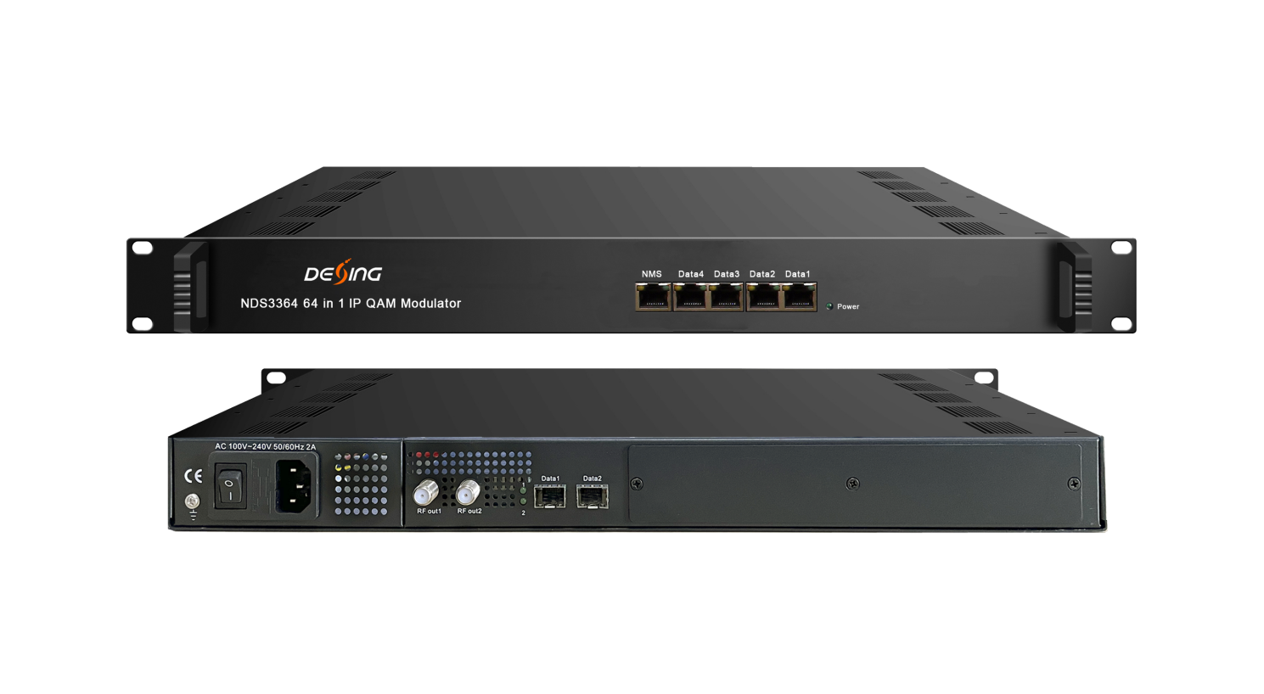Product Overview
The FMUSER FUQ-4475 modulator converts IP signals to RF outputs, supporting up to 512 IP inputs via 6 GE ports and 64 QAM carriers through dual RF interfaces. It processes streams with multiplexing, scrambling, and modulation to DVB-C standards. Featuring web-based management, this device is ideal for broadcast headends and cable television distribution systems.
Key feature
Enables web-based control for network configuration.
Inner Principle Chart
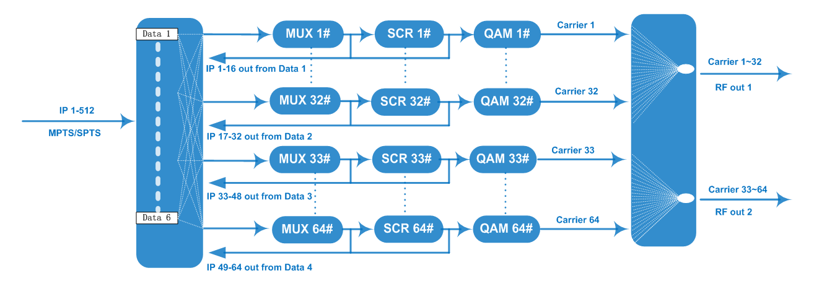

Carrier Setting Illustration
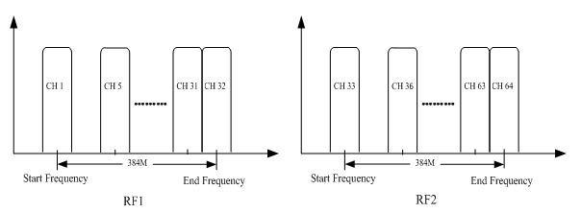

Specifications
Input | Input |  | Max 512 IP inputs from 6*100/1000M Ethernet Port (4*RJ45, 2*SFP)
Input | Transport Protocol |  | TS over UDP/RTP, unicast and multicast, IGMP V2/V3
Input | Transmission Rate |  | Max 840Mbps for each GE input
Mux | Input Channel |  | 512
Mux | Output Channel |  | 64
Mux | Max PIDs |  | 256 per channel
Mux | Functions |  | PID remapping(auto/manually optional)
Mux |  |  | PCR accurate adjusting
Mux |  |  | PSI/SI table automatically generating
Scrambling  Parameters | Max simulscrypt CA |  | 6
Scrambling  Parameters | Scramble Standard |  | ETR289, ETSI 101 197, ETSI 103 197
Scrambling  Parameters | Connection |  | Local/remote connection
Modulation  Parameters | Modulation Standard |  | EN300 429/ITU-T J.83A/B/C
Modulation  Parameters | Constellation |  | J.83A | Constellation :16/32/64/128/256QAM
Modulation  Parameters |  |  | J.83A | Bandwidth :8M
Modulation  Parameters |  |  | J.83B/C | Constellation :64/256QAM
Modulation  Parameters |  |  | J.83B/C | Bandwidth :6M
Modulation  Parameters | QAM Channel |  | 64 non-adjacent carriers  384Mbps bandwidth for each RF interface
Modulation  Parameters | Symbol Rate |  | 5.0~7.0Msps, 1ksps stepping  5057Ksps (J.83B, 64QAM) ; 5361Ksps (J.83B, 256QAM)
Modulation  Parameters | Constellation |  | 16, 32, 64 , 128, 256QAM
Modulation  Parameters | FEC |  | RS (204, 188)
RF Output | Interface |  | 2 F type output ports for 64 carriers, 75Ω
RF Output | RF Range |  | 50~960MHz, 1kHz stepping
RF Output | Output Level |  | -20dBm~+10dBm(87~117dbµV), 0.1dB stepping
RF Output | MER |  | ≥ 40dB
TS output | 64 IP output over UDP/RTP/RTSP, unicast/multicast, 4*100/1000M Ethernet Ports (each port for 16 IP outputs)
System | Web-based Network management
General | Demission | 420mm×440mm×44.5mm (WxLxH)
General | Temperature | 0~45℃(operation), -20~80℃(storage)
General | Power Supply | AC 100V±10%, 50/60Hz or AC 220V±10%, 50/60Hz

About Us
FMUSER is a company specializing in broadcasting and television transmission systems and integrating hotel IPTV systems. The company was established in 2009 and has served over 180 countries worldwide. More than 20,000 television stations, radio stations, and hotel clients from different.

Contact:Tomleequan Email：sales@fmuser.com whatsapp: +8613922702227

