FMUSER FUQ-4512E Modulator 1 ASI Input to RF Output DVB-S QPSK RS Coding Convolution Interleaving Web-Based NMS for Broadcasting and Satellite Applications
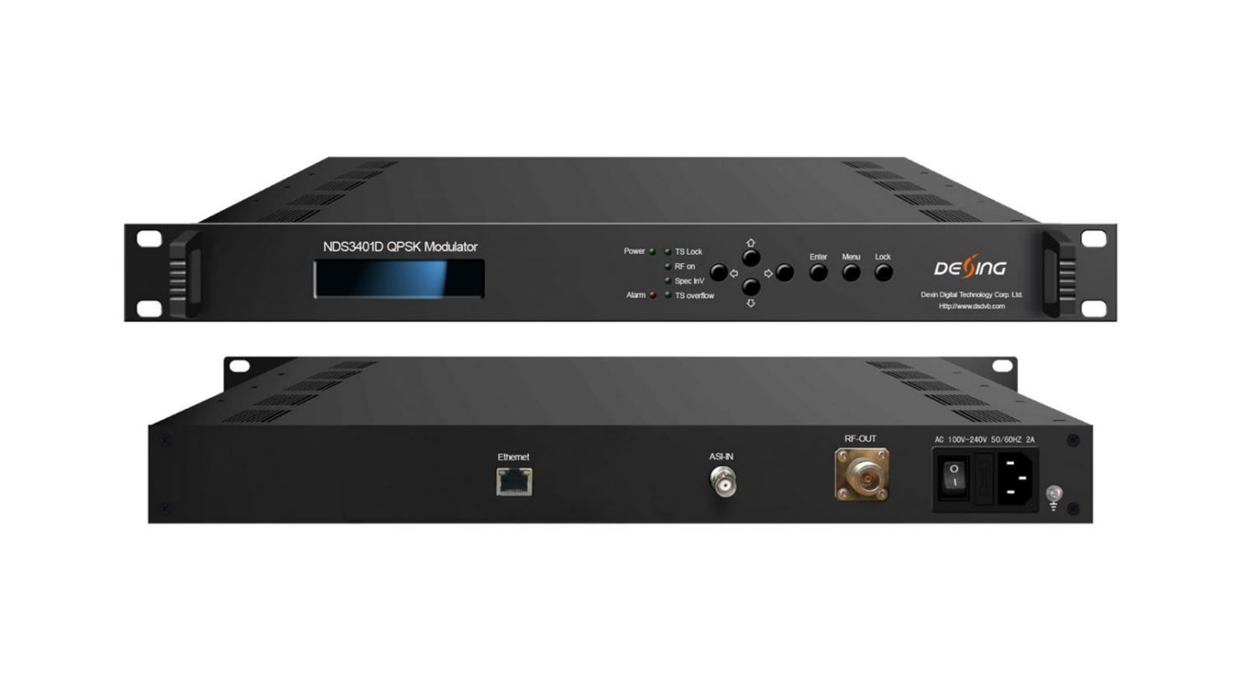Product overview
The FMUSER FUQ-4512E modulator performs QPSK modulation with 1 ASI input and RF output. It employs energy diffusion, RS coding, convolution interleaving, and pre-modulated baseband shaping for high transmission performance. Controlled via web-based NMS for local and remote operation, it is suitable for broadcasting, interactive services, and broadband satellite applications.
Key feature
Complies with DVB-S (EN300421) standard,
Supports 1 ASI input,
Features QPSK constellations,
Provides RF output range: 950-2150MHz with 10kHz stepping,
Offers web-based NMS for control
Principle Chart
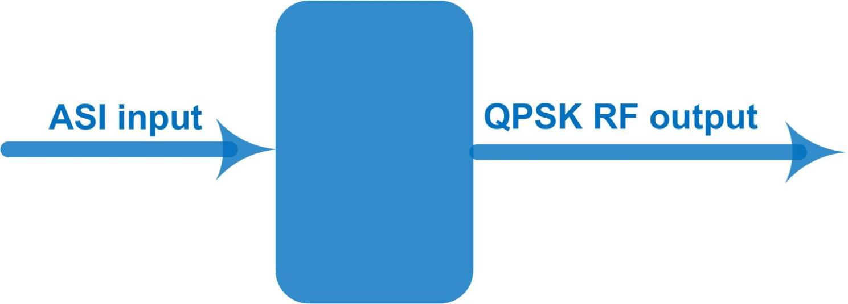

Specifications

ASI Input | 1×ASI input, BNC interface
RF Output | RF Range | 950 ~ 2150 MHz, 10KHz stepping
RF Output | Output Level | -10.0 dBm~-41.5 dBm,0.5dBm Stepping
RF Output | MER | ≥26dB
RF Output | Connector | N type, Impedance 50Ω
RF Output | Outer coding | RS Coding
RF Output | Inner coding | Convolution
RF Output | Constellation | QPSK
RF Output | FEC/Convolution Rate | 1/2,2/3, 3/4, 5/6, 7/8
RF Output | Roll-off Factor | 0.35
RF Output | Symbol Rate | 0.05~45Msps
System | Web-based NMS
System | Language: English
System | Ethernet software upgrade
Miscellaneous | Dimension | 482mm×245mm×44mm (W*D*H)
Miscellaneous | Temperature | 0~45℃(operation), -20~80℃ (storage)
Miscellaneous | Power | AC 100-240V, 50Hz-60Hz 2A

About Us
FMUSER is a company specializing in broadcasting and television transmission systems and integrating hotel IPTV systems. The company was established in 2009 and has served over 180 countries worldwide. More than 20,000 television stations, radio stations, and hotel clients from different.

Contact:Tomleequan Email：sales@fmuser.com whatsapp: +8613922702227

