FMUSER FUQ-4513A DVB-S-S2 Modulator 1-4 ASI Ports IP Input to DVB-S-S2 RF Output BISS Scrambling EN302307 Standard for Secure Satellite Broadcasting
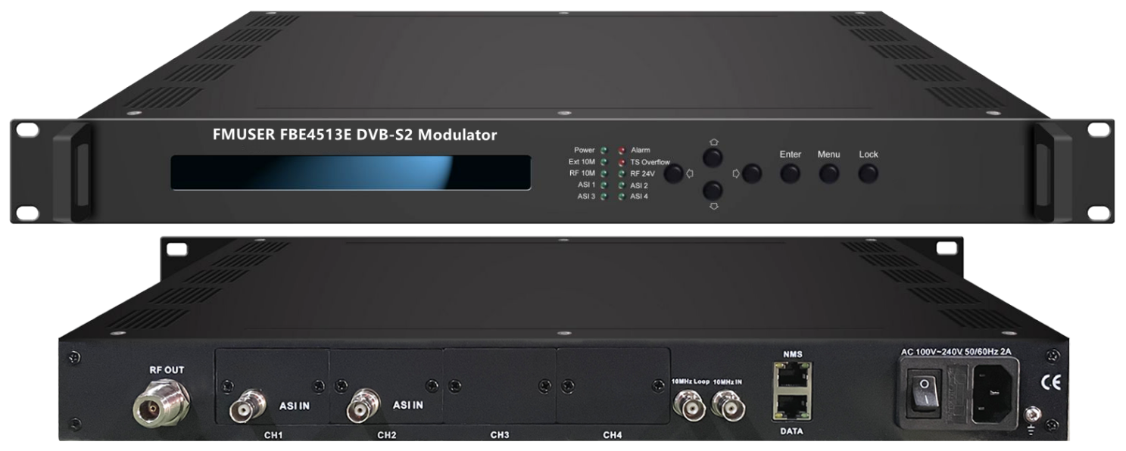

Product overview
The FMUSER FBE4513E is a DVB-S2 modulator that converts ASI and IP inputs to DVB-S/S2 RF output, featuring BISS scrambling for secure distribution. It processes signals by modulating them according to EN302307 standards. Controlled via Web-server NMS and front-panel LCD, it is ideal for broadcasting and interactive services.
Key feature
Complies with DVB-S2 (EN302307) and DVB-S (EN300421) standards.
Supports ASI and IP inputs (1000/100M) for flexible integration.
Features BISS scrambling for secure program distribution.
Provides RF output at 950-2150MHz with 10KHz stepping and MER≥40dB.
Enables control via Web-server NMS and front-panel LCD.
Principle Chart

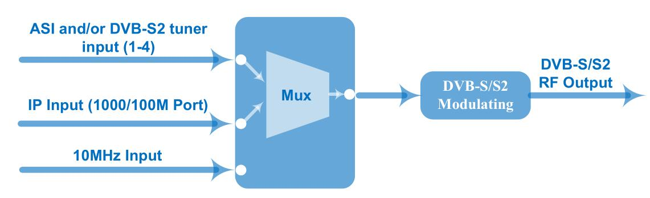

Specifications

IP Input | 1*IP Input (RJ45, 1000/100M TS Over UDP)
ASI Input | Supporting both188/204 Byte Packet TS Input
ASI Input | 1-4 ASI Inputs (Connector: BNC, Impedance 75Ω)
Tuner Input  (0-4 inputs optional)
  DVB-S | Input Frequency | 950~2150MHz
  DVB-S | Symbol rate | 0.5~45Msps
  DVB-S | Signal Strength | - 65- -25dBm
  DVB-S | FEC | 1/2, 2/3, 3/4, 5/6, 7/8
  DVB-S | Constellation | QPSK
  DVB-S | Max input bitrate | ≤160 Mbps
  DVB-S2 | Input Frequency | 950~2150MHz
  DVB-S2 | Symbol rate | QPSK/8PSK /16APSK :0.5~45 Msps  32APSK: 0.5~40Msps
  DVB-S2 | FEC | QPSK: 1/2, 3/5, 2/3, 3/4, 4/5, 5/6, 8/9, 9/10  8PSK: 3/5, 2/3, 3/4, 5/6, 8/9, 9/10  16APSK: 2/3, 3/4, 4/5, 5/6, 8/9, 9/10  32APSK: 3/4, 4/5, 5/6, 8/9, 9/10
  DVB-S2 | Constellation | QPSK, 8PSK, 16APSK, 32APSK
  DVB-S2 | Max input bitrate | ≤160 Mbps
  DVB-S2X | Input Frequency | 950~2150MHz
  DVB-S2X | Symbol rate | QPSK/8PSK /16APSK :0.5~45 Msps  8APSK/32APSK: 0.5~40Msps
  DVB-S2X | FEC | QPSK: 1/2, 3/5, 2/3, 3/4, 4/5, 5/6, 8/9, 9/10, 13/45, 9/20, 11/20  8PSK: 3/5, 2/3, 3/4, 5/6, 8/9, 9/10  8APSK: 5/9-L, 26/45-L  16APSK: 2/3, 3/4, 4/5, 5/6, 8/9, 9/10, 1/2-L, 8/15-L, 5/9-L, 26/45, 3/5, 3/5-L, 28/45, 23/36 , 2/3-L, 25/36, 13/18, 7/9, 77/90  32APSK: 3/4, 4/5, 5/6, 8/9, 2/3-L, 32/45, 11/15, 7/9
  DVB-S2X | Constellation | QPSK/8PSK/8APSK/16APSK/32APSK
  DVB-S2X | Max input bitrate | ≤160 Mbps
Multiplexing | Maximum PID Remapping |  | 128 input per channel
Multiplexing | Function |  | PID remapping (automatically or manually)
Multiplexing |  |  | Accurate PCR adjusting
Multiplexing |  |  | Edit PSI/SI tables (PAT/PMT/SDT/CAT/NIT)
10MHz Reference Clock | 1*External 10MHz Input (BNC Interface); 1*Inner 10MHz Reference clock
RF Output | RF Range: 950 ~ 2150 MHz, 10KHz stepping
RF Output | Output Level Attenuation：-26 ~ 0 dBm，0.5dBm Stepping
RF Output | MER≥40dB
RF Output | Connector: N type, Impedance 50Ω; N to F adapter
Channel Coding and Modulation | Standard | DVB-S |  | DVB-S2
Channel Coding and Modulation | Outer coding | RS Coding |  | BCH Coding
Channel Coding and Modulation | Inner coding | Convolution |  | LDPC Coding
Channel Coding and Modulation | Constellation | QPSK |  | QPSK,8PSK, 16APSK,32APSK
Channel Coding and Modulation | FEC/ Convolution Rate | 1/2, 2/3, 3/4, 5/6, 7/8 |  | QPSK: 1/2, 3/5, 2/3, 3/4, 4/5, 5/6, 8/9, 9/10  8PSK: 3/5, 2/3, 3/4, 5/6, 8/9, 9/10  16APSK: 2/3, 3/4, 4/5, 5/6, 8/9, 9/10  32APSK: 3/4, 4/5, 5/6, 8/9, 9/10
Channel Coding and Modulation | Roll-off Factor | 0.2, 0.25, 0.35 |  | 0.2, 0.25, 0.35
Channel Coding and Modulation | Symbol Rate | 0.05~45Msps |  | 0.05~40Msps (32APSK);  0.05~45 Msps (16APSK/8PSK/QPSK)
BISS Scramble | Mode 0, mode 1, mode E
System | Web-server NMS
System | Language: English
System | Ethernet software upgrade
System | 24V power output through RF output port
Miscellaneous | Dimension | 482mm×410mm×44mm
Miscellaneous | Temperature | 0~45℃(operation), -20~80℃ (storage)
Miscellaneous | Power | 100-240VAC±10%, 50Hz-60Hz

Order Guide
 | FU-4513E (New version) | FU-4513E (Old version) | FU-4513F | FU-4514 | FU-4514F
Input | 1 IP (100/1000M) input, ASI and/or DVB-S2 tuner inputs for re-mux or pass through | 1 IP (100M) or 1 ASI pass through alternative
DVB-S/S2 out | ● | ● | ● | ● | ●
DVB- S2X out |  |  |  | ● | ●
QPSK, 8PSK | ● | ● | ● | ● | ●
16APSK, 32APSK | ● | ● |  | ● | ●
8APSK-L,16APSK-L,32APSK-L |  |  |  | ● | ●
RF output (950-2150MHz) | ● | ● |  | ●
IF output ( 50-960MHz) |  |  | ● |  | ●
Mux | ●

About Us
FMUSER is a company specializing in broadcasting and television transmission systems and integrating hotel IPTV systems. The company was established in 2009 and has served over 180 countries worldwide. More than 20,000 television stations, radio stations, and hotel clients from different.

Contact:Tomleequan Email：sales@fmuser.com whatsapp: +8613922702227

