FMUSER FUQ-4514 DVB-S-S2-S2X Modulator 4 ASI + 1 IP Input to RF Output DVB-S-S2-S2X Standards BISS Scrambling Satellite Broadcasting 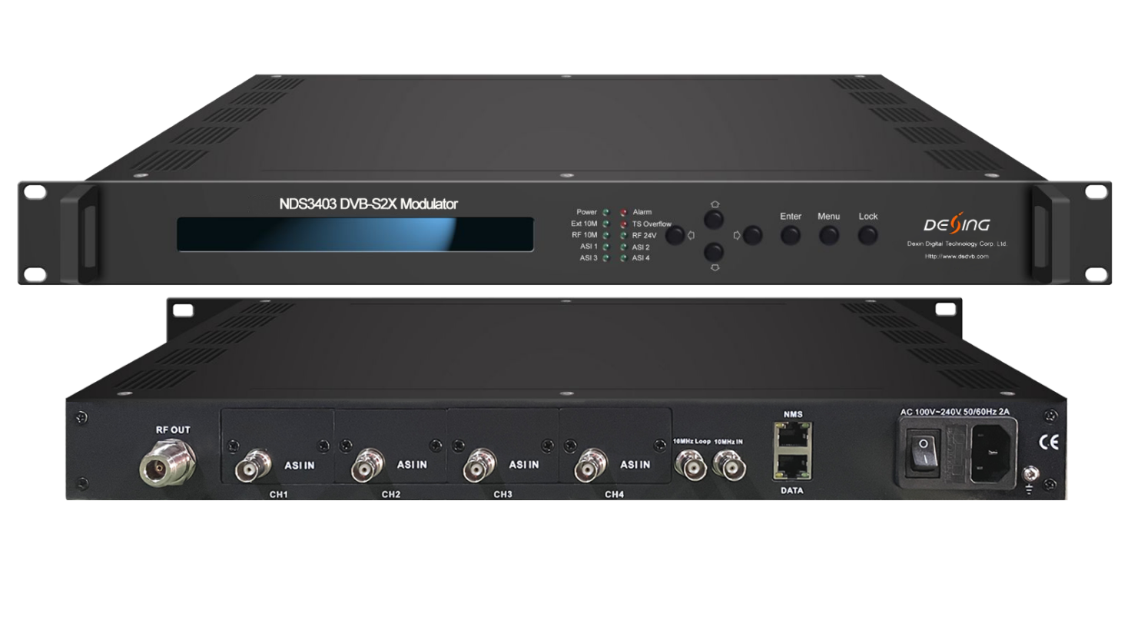Product overview
The FMUSER FUQ-4514 is a DVB-S/S2/S2X modulator with 4 ASI inputs and 1 IP input, outputting RF signals. It converts ASI and IP inputs to digital RF output, featuring BISS scrambling for secure distribution. Controlled via NMS software and LCD, it supports broadcasting and satellite applications.
Key feature
Supports full compliance with DVB-S, DVB-S2, and DVB-S2X standards (EN300 421, EN302 307, EN302 307-2).
Features 4 ASI inputs with backup and 1 IP input (1000/100M) for flexible re-muxing.
Includes BISS scrambling (Mode 0/1/E) for secure content distribution.
Offers Web-server NMS for local/remote control and SFN TS transmission support.
Equipped with constant temperature crystal oscillator (0.1ppm stability) and 24V power output via RF port.
Principle Chart
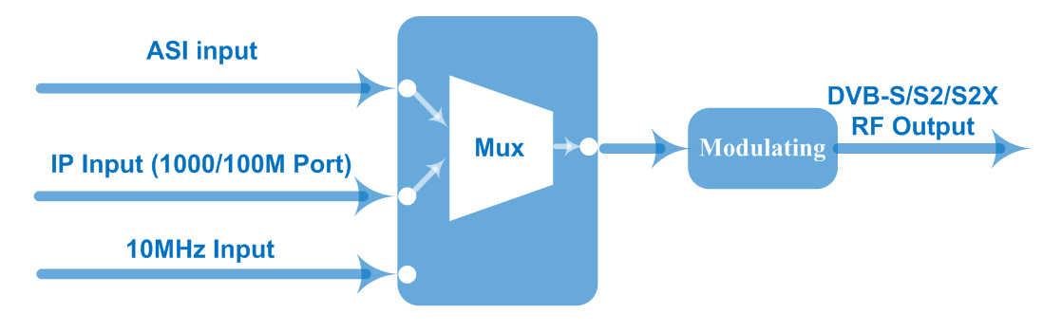

Specifications
ASI Input | Supporting both188/204 Byte Packet TS Input
ASI Input | 4 ASI Inputs, Supporting Backup
ASI Input | Connector: BNC, Impedance 75Ω
IP Input | 1*IP Input (RJ45, 1000/100M TS Over UDP)
10MHz Input | 1*10MHz Input (BNC Interface)
Multiplexing | Maximum PID Remapping |  |  | 128 input per channel
Multiplexing | Function |  |  | PID remapping (automatically or manually)
Multiplexing |  |  |  | Accurate PCR adjusting
Multiplexing |  |  |  | Edit PSI/SI tables (PAT/PMT/SDT/CAT/NIT)
RF Output | RF Range: 950 ~ 2150 MHz, 10KHz step
RF Output | Output Level Attenuation：-27.5 dBm~-1.5 dBm，0.5dB Step
RF Output | MER≥40dB
RF Output | Connector: N type, impedance 50Ω
Channel Coding  and Modulation | Standard | DVB-S |  | DVB-S2 | DVB-S2X
Channel Coding  and Modulation | Outer coding | RS Coding |  | BCH Coding | BCH Coding
Channel Coding  and Modulation | Inner coding | Convolution |  | LDPC Coding | LDPC Coding
Channel Coding  and Modulation | Constellation | QPSK |  | QPSK,8PSK,  16APSK,32APSK | QPSK,8PSK,  8APSK, 16APSK, 32APSK
Channel Coding  and Modulation | FEC/ Convolution Rate | 1/2, 2/3, 3/4, 5/6, 7/8 |  | QPSK: 1/2, 3/5, 2/3, 3/4, 4/5, 5/6, 8/9, 9/10  8PSK: 3/5, 2/3, 3/4, 5/6, 8/9, 9/10  16APSK: 2/3, 3/4, 4/5, 5/6, 8/9, 9/10  32APSK: 3/4, 4/5, 5/6, 8/9, 9/10 | QPSK: 1/2, 3/5, 2/3, 3/4, 4/5, 5/6, 8/9, 9/10, 13/45, 9/20, 11/20  8PSK: 3/5, 2/3, 3/4, 5/6, 8/9, 9/10  , 23/36, 25/36, 13/18  8APSK: 5/9-L, 26/45-L  16APSK: 2/3, 3/4, 4/5, 5/6, 8/9, 9/10  , 1/2-L, 8/15-L, 5/9-L, 26/45, 3/5, 3/5-L, 28/45, 23/36 , 2/3-L, 25/36, 13/18, 7/9, 77/90  32APSK: 3/4, 4/5, 5/6, 8/9, 9/10, 2/3-L, 32/45, 11/15, 7/9
Channel Coding  and Modulation | Roll-off Factor | 0.2,0.25,0.35 |  | 0.2, 0.25, 0.35 | 0.05, 0.10, 0.15, 0.2, 0.25, 0.35
Channel Coding  and Modulation | Symbol Rate | 0.05~45Msps |  | 0.05~40Msps (32APSK);  0.05~45Msps (QPSK/8PSK/16APSK) | 0.05~40Msps (8APSK /32APSK)  0.05~45 Msps (8PSK/QPSK/16APSK)
BISS Scramble | Mode 1, Mode E, Mode 0
System | Web-server NMS
System | Language: English
System | Ethernet software upgrade
System | 24V power output through RF output port
Miscellaneous | Dimension |  | 482mm×410mm×44mm
Miscellaneous | Temperature |  | 0~45℃(operation), -20~80℃ (storage)
Miscellaneous | Power |  | 100-240VAC±10%,50Hz-60Hz

Order Guide
 | FU-4513E | FU-4513F | FU-4514 | FU-4514F
DVB-S/S2 | ● | ● | ● | ●
DVB- S2X |  |  | ● | ●
RF output (950-2150MHz) | ● |  | ●
IF output ( 50- 960MHz) |  | ● |  | ●

CID TEST SAMPLE ILLUSTRATION
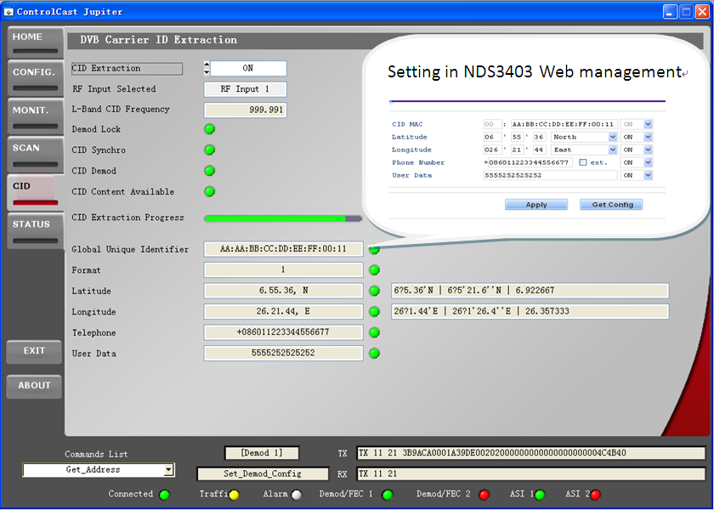

About Us
FMUSER is a company specializing in broadcasting and television transmission systems and integrating hotel IPTV systems. The company was established in 2009 and has served over 180 countries worldwide. More than 20,000 television stations, radio stations, and hotel clients from different.

Contact:Tomleequan Email：sales@fmuser.com whatsapp: +8613922702227

