FMUSER FUQ-4514G DVB-S2X IF Modulator 4 ASI + 1 IP Input 1 IF Output ASI-IP to DVB-S-S2-S2X BISS Scrambling Web-server Control for Broadcasting and Satellite Communications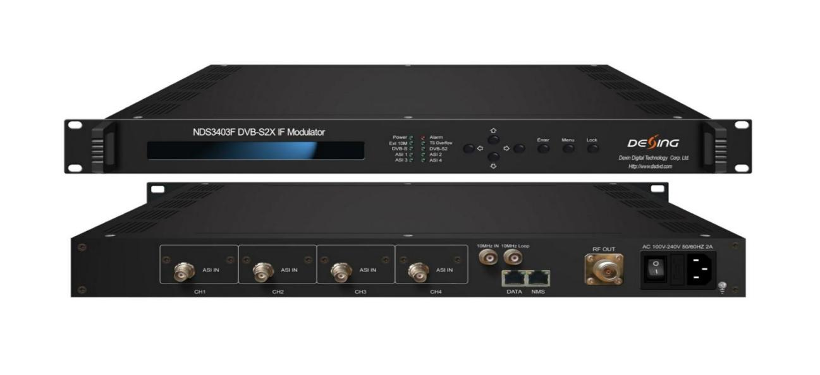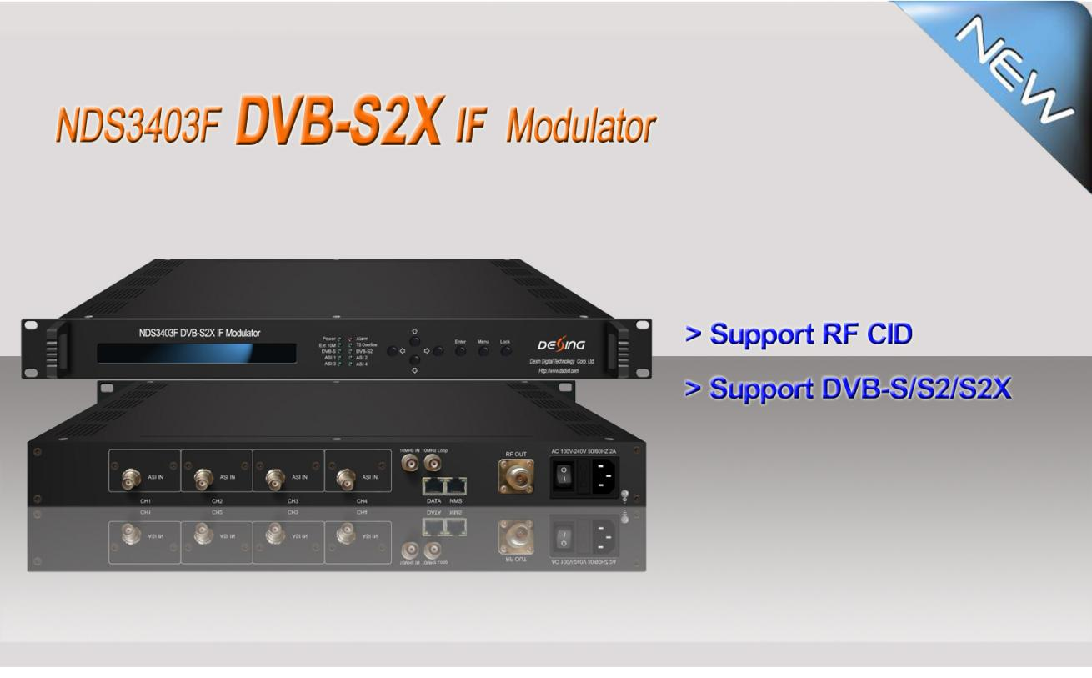
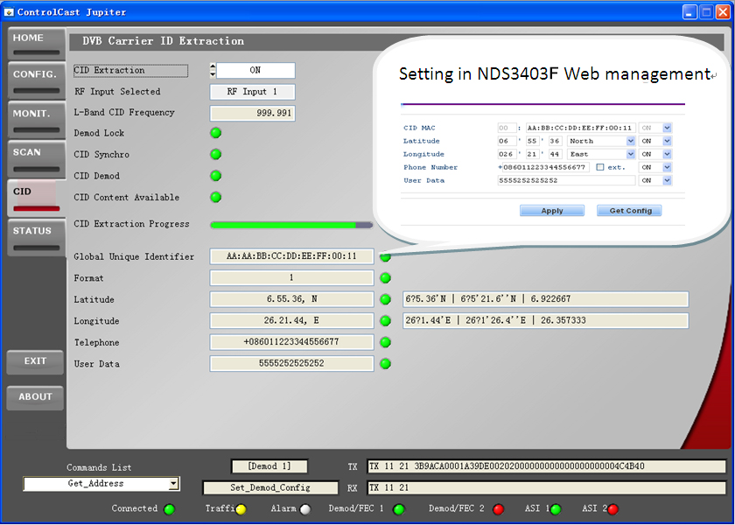
Product overview
FMUSER FUQ-4514G is a DVB-S2X compliant IF modulator that converts ASI and IP inputs to digital DVB-S/S2/S2X IF output. It modulates signals and applies BISS scrambling for secure distribution. Control is enabled via Web-server NMS and front panel LCD. Ideal for broadcasting, interactive services, and satellite applications.
Key feature
Complies with DVB-S, DVB-S2, and DVB-S2X standards.
Supports 4 ASI inputs with hot backup and IP input.
Features BISS scrambling for secure content protection.
Enables control via Web-server NMS and front panel LCD.
Output frequency: 50-960MHz with 1KHz stepping.
Principle Chart
FMUSER FUQ-4514G is a DVB-S2X compliant IF modulator that converts ASI and IP inputs to digital DVB-S/S2/S2X IF output. It modulates signals and applies BISS scrambling for secure distribution. Control is enabled via Web-server NMS and front panel LCD. Ideal for broadcasting, interactive services, and satellite applications.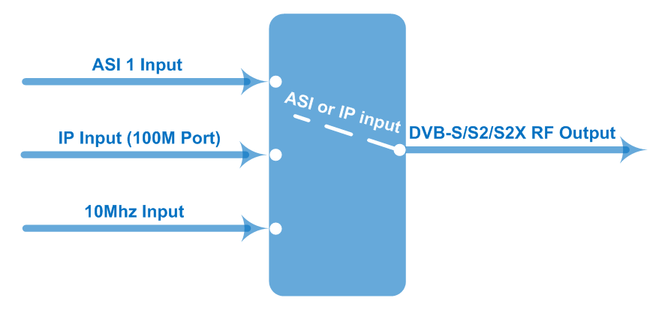
FMUSER FUQ-4514G is a DVB-S2X compliant IF modulator that converts ASI and IP inputs to digital DVB-S/S2/S2X IF output. It modulates signals and applies BISS scrambling for secure distribution. Control is enabled via Web-server NMS and front panel LCD. Ideal for broadcasting, interactive services, and satellite applications.Specifications
FMUSER FUQ-4514G is a DVB-S2X compliant IF modulator that converts ASI and IP inputs to digital DVB-S/S2/S2X IF output. It modulates signals and applies BISS scrambling for secure distribution. Control is enabled via Web-server NMS and front panel LCD. Ideal for broadcasting, interactive services, and satellite applications.FMUSER FUQ-4514G is a DVB-S2X compliant IF modulator that converts ASI and IP inputs to digital DVB-S/S2/S2X IF output. It modulates signals and applies BISS scrambling for secure distribution. Control is enabled via Web-server NMS and front panel LCD. Ideal for broadcasting, interactive services, and satellite applications.ASI Input | Supporting both188 Byte Packet TS Input
 | 4 ASI Inputs ( 3 ASI for backup)
 | Connector: BNC, Impedance 75Ω
IP Input | 1*IP Input (RJ45, 100M TS Over UDP)
10MHz Input | 1*10MHz Input (BNC Interface)
IF Output | Range:50 ~ 960 MHz, 1KHz step
IF Output | Output Level Attenuation: -28.5dBm~+3 dBm, 0.5dB Step
IF Output | MER≥40dB
IF Output | Connector: N type, impedance 50Ω
Channel Coding  and Modulation | Standard | DVB-S |  | DVB-S2 | DVB-S2X
Channel Coding  and Modulation | Outer coding | RS Coding |  | BCH Coding | BCH Coding
Channel Coding  and Modulation | Inner coding | Convolution |  | LDPC Coding | LDPC Coding
Channel Coding  and Modulation | Constellation | QPSK |  | QPSK,8PSK,  16APSK,32APSK | QPSK,8PSK,  8APSK, 16APSK, 32APSK
Channel Coding  and Modulation | FEC/ Convolution Rate | 1/2, 2/3, 3/4, 5/6, 7/8 |  | QPSK: 1/2, 3/5, 2/3, 3/4, 4/5, 5/6, 8/9, 9/10  8PSK: 3/5, 2/3, 3/4, 5/6, 8/9, 9/10  16APSK: 2/3, 3/4, 4/5, 5/6, 8/9, 9/10  32APSK: 3/4, 4/5, 5/6, 8/9, 9/10 | QPSK: 1/2, 3/5, 2/3, 3/4, 4/5, 5/6, 8/9, 9/10, 13/45, 9/20, 11/20  8PSK: 3/5, 2/3, 3/4, 5/6, 8/9, 9/10  , 23/36, 25/36, 13/18  8APSK: 5/9-L, 26/45-L  16APSK: 2/3, 3/4, 4/5, 5/6, 8/9, 9/10  , 1/2-L, 8/15-L, 5/9-L, 26/45, 3/5, 3/5-L, 28/45, 23/36 , 2/3-L, 25/36, 13/18, 7/9, 77/90  32APSK: 3/4, 4/5, 5/6, 8/9, 9/10, 2/3-L, 32/45, 11/15, 7/9
Channel Coding  and Modulation | Roll-off Factor | 0.2,0.25,0.35 |  | 0.2, 0.25, 0.35 | 0.05, 0.10, 0.15, 0.2, 0.25, 0.35
Channel Coding  and Modulation | Symbol Rate | 0.05~45Msps |  | 0.05~40Msps (32APSK);  0.05~45Msps (16APSK/8PSK/QPSK) | 0.05~40Msps(32APSK,32APSK-L);  0.05~45 Mbps (16APSK/8PSK/QPSK/16APSK-L/8APSK-L)
Channel Coding  and Modulation | BISS Scramble | Mode 1, Mode E
System | Web-server NMS
System | Language: English
System | Ethernet software upgrade
Miscellaneous | Dimension |  | 482mm×410mm×44mm
Miscellaneous | Temperature |  | 0~45℃(operation), -20~80℃ (storage)
Miscellaneous | Power |  | 100-240VAC±10%,50Hz-60Hz
FMUSER FUQ-4514G is a DVB-S2X compliant IF modulator that converts ASI and IP inputs to digital DVB-S/S2/S2X IF output. It modulates signals and applies BISS scrambling for secure distribution. Control is enabled via Web-server NMS and front panel LCD. Ideal for broadcasting, interactive services, and satellite applications.Order Guide
FMUSER FUQ-4514G is a DVB-S2X compliant IF modulator that converts ASI and IP inputs to digital DVB-S/S2/S2X IF output. It modulates signals and applies BISS scrambling for secure distribution. Control is enabled via Web-server NMS and front panel LCD. Ideal for broadcasting, interactive services, and satellite applications.FMUSER FUQ-4514G is a DVB-S2X compliant IF modulator that converts ASI and IP inputs to digital DVB-S/S2/S2X IF output. It modulates signals and applies BISS scrambling for secure distribution. Control is enabled via Web-server NMS and front panel LCD. Ideal for broadcasting, interactive services, and satellite applications.FMUSER FUQ-4514G is a DVB-S2X compliant IF modulator that converts ASI and IP inputs to digital DVB-S/S2/S2X IF output. It modulates signals and applies BISS scrambling for secure distribution. Control is enabled via Web-server NMS and front panel LCD. Ideal for broadcasting, interactive services, and satellite applications. | FU-4513E | FU-4513F | FU-4514 | FU-4514F
DVB-S/S2 | ● | ● | ● | ●
DVB- S2X | FMUSER FUQ-4514G is a DVB-S2X compliant IF modulator that converts ASI and IP inputs to digital DVB-S/S2/S2X IF output. It modulates signals and applies BISS scrambling for secure distribution. Control is enabled via Web-server NMS and front panel LCD. Ideal for broadcasting, interactive services, and satellite applications. | FMUSER FUQ-4514G is a DVB-S2X compliant IF modulator that converts ASI and IP inputs to digital DVB-S/S2/S2X IF output. It modulates signals and applies BISS scrambling for secure distribution. Control is enabled via Web-server NMS and front panel LCD. Ideal for broadcasting, interactive services, and satellite applications. | ● | ●
RF output (950-2150MHz) | ● | FMUSER FUQ-4514G is a DVB-S2X compliant IF modulator that converts ASI and IP inputs to digital DVB-S/S2/S2X IF output. It modulates signals and applies BISS scrambling for secure distribution. Control is enabled via Web-server NMS and front panel LCD. Ideal for broadcasting, interactive services, and satellite applications. | ● | FMUSER FUQ-4514G is a DVB-S2X compliant IF modulator that converts ASI and IP inputs to digital DVB-S/S2/S2X IF output. It modulates signals and applies BISS scrambling for secure distribution. Control is enabled via Web-server NMS and front panel LCD. Ideal for broadcasting, interactive services, and satellite applications.
IF output ( 50- 960MHz) | FMUSER FUQ-4514G is a DVB-S2X compliant IF modulator that converts ASI and IP inputs to digital DVB-S/S2/S2X IF output. It modulates signals and applies BISS scrambling for secure distribution. Control is enabled via Web-server NMS and front panel LCD. Ideal for broadcasting, interactive services, and satellite applications. | ● | FMUSER FUQ-4514G is a DVB-S2X compliant IF modulator that converts ASI and IP inputs to digital DVB-S/S2/S2X IF output. It modulates signals and applies BISS scrambling for secure distribution. Control is enabled via Web-server NMS and front panel LCD. Ideal for broadcasting, interactive services, and satellite applications. | ●
FMUSER FUQ-4514G is a DVB-S2X compliant IF modulator that converts ASI and IP inputs to digital DVB-S/S2/S2X IF output. It modulates signals and applies BISS scrambling for secure distribution. Control is enabled via Web-server NMS and front panel LCD. Ideal for broadcasting, interactive services, and satellite applications.FMUSER FUQ-4514G is a DVB-S2X compliant IF modulator that converts ASI and IP inputs to digital DVB-S/S2/S2X IF output. It modulates signals and applies BISS scrambling for secure distribution. Control is enabled via Web-server NMS and front panel LCD. Ideal for broadcasting, interactive services, and satellite applications.

About Us
FMUSER is a company specializing in broadcasting and television transmission systems and integrating hotel IPTV systems. The company was established in 2009 and has served over 180 countries worldwide. More than 20,000 television stations, radio stations, and hotel clients from different.

Contact:Tomleequan Email：sales@fmuser.com whatsapp: +8613922702227

