FMUSER FUQ-4515 Satellite Modem 1x Ethernet Port IP Input-Output DVB-S2-DVB-S TCP Acceleration High-Speed Two-Way Transmission for Satellite Networks 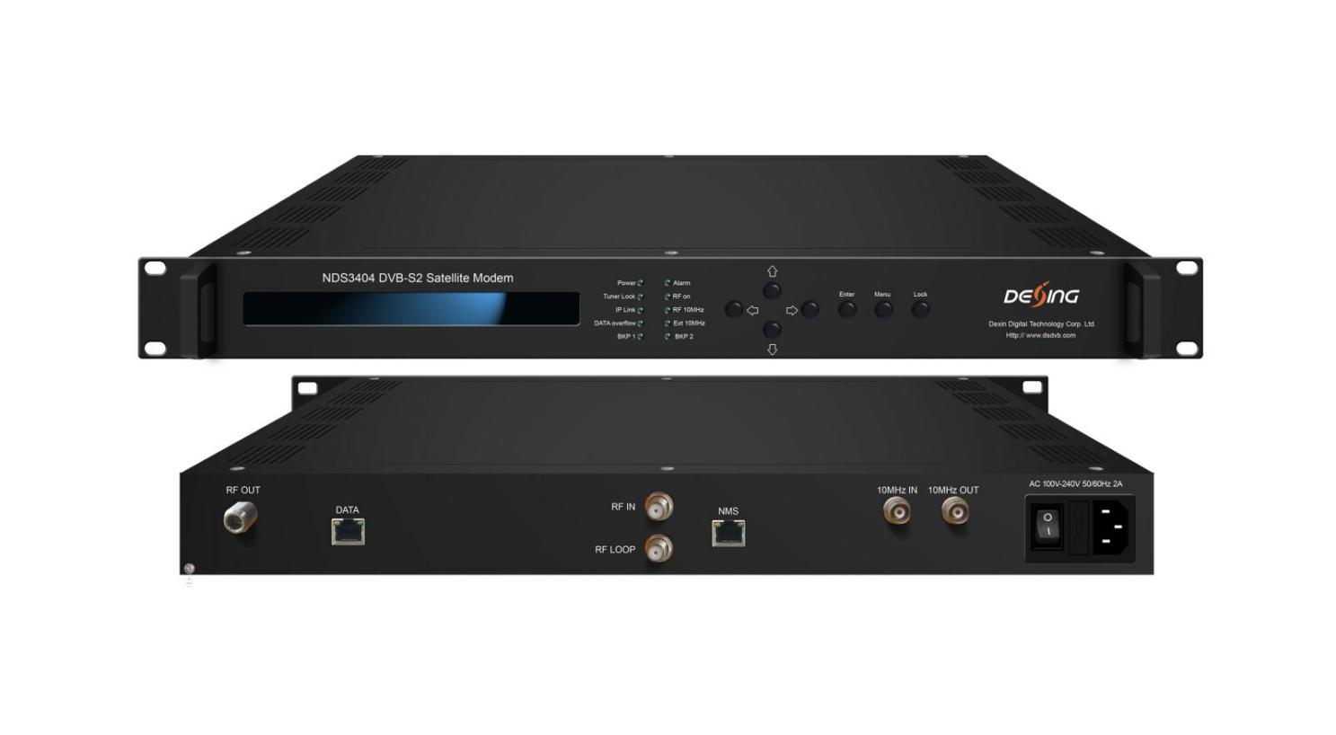Product Overview
The FMUSER FUQ-4515 is a two-way DVB-S2 satellite modem for efficient IP data transmission over satellite. It modulates and demodulates IP signals using TCP acceleration to optimize performance. Featuring web-based NMS with LCD and keyboard support, it simplifies management. Ideal for satellite networks in broadcast, enterprise, and remote data services.
Key feature
Supports DVB-S2 and legacy DVB-S standards for efficient satellite communication.
Embedded TCP acceleration optimizes high-speed links and heavy traffic.
High throughput up to 100 Mbps for upstream and downstream operations.
Web-based NMS operation with LCD and keyboard support for easy management.
Principle Chart
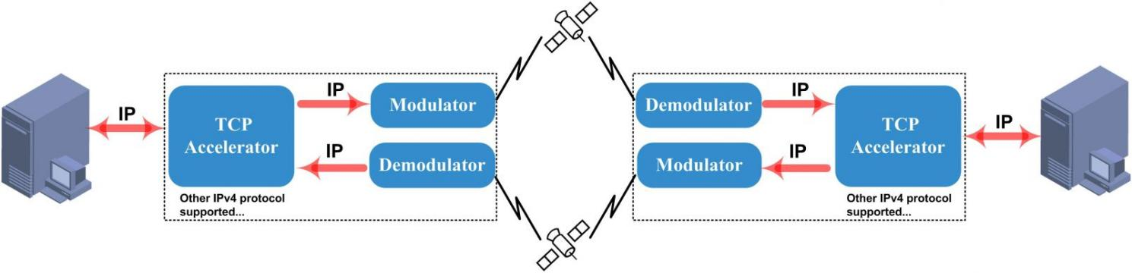

Specifications

Input/Output | IP input/output over IPv4 (TCP/UDP/ICMP…) protocol  1 tuner in and 1 RF out
Tuner Section | DVB-S2 | Input Frequency | 950-2150MHz
Tuner Section | DVB-S2 | Symbol rate | QPSK 1~45Mbauds;  8PSK 2~30Mbauds
Tuner Section | DVB-S2 | Code rate | 1/2, 3/5, 2/3, 3/4, 4/5, 5/6, 8/9, 9/10
Tuner Section | DVB-S2 | Constellation | QPSK, 8PSK
RF output | RF Range | 950 ~ 2150 MHz, 10KHz step
RF output | Output Level Attenuation | 0 dBm~-31.5 dBm, 0.5dB Step
RF output | MER | ≥40dB
RF output | Connector | N type, impedance 50Ω
Modulation | Standard | DVB-S2
Modulation | Outer coding | BCH Coding
Modulation | Inner coding | LDPC Coding
Modulation | Constellation | QPSK,8PSK,16APSK,32APSK
Modulation | FEC/ Convolution Rate | QPSK: 1/2, 3/5, 2/3, 3/4, 4/5, 5/6, 8/9, 9/10  8PSK: 3/5, 2/3, 3/4, 5/6, 8/9, 9/10  16APSK: 2/3, 3/4, 4/5, 5/6, 8/9, 9/10  32APSK: 3/4, 4/5, 5/6, 8/9, 9/10
Modulation | Roll-off Factor | 0.2, 0.25, 0.35
Modulation | Symbol Rate | 0.05~40Msps (32APSK);  0.05~45Msps (QPSK/8PSK/16APSK)
System | LCD/keyboard operating, web-based NMS manage
System | Language: English/Chinese
System | Ethernet software & hardware upgrade
Miscellaneous | Dimension | 482mm×328mm×44mm (W× L× H)
Miscellaneous | Temperature | 0~45℃ (work), -20~80℃（Storage）
Miscellaneous | Power | AC 100V-220V±10%, 50/60Hz

About Us
FMUSER is a company specializing in broadcasting and television transmission systems and integrating hotel IPTV systems. The company was established in 2009 and has served over 180 countries worldwide. More than 20,000 television stations, radio stations, and hotel clients from different.

Contact:Tomleequan Email：sales@fmuser.com whatsapp: +8613922702227

