FMUSER FUQ-4618Px Modular IP to ASI Gateway 512 SPTS-MPTS Input UDP-RTP Output DVB-ASI Dual Gigabit Ethernet PSI-SI Editing Broadcast Headends CATV Systems 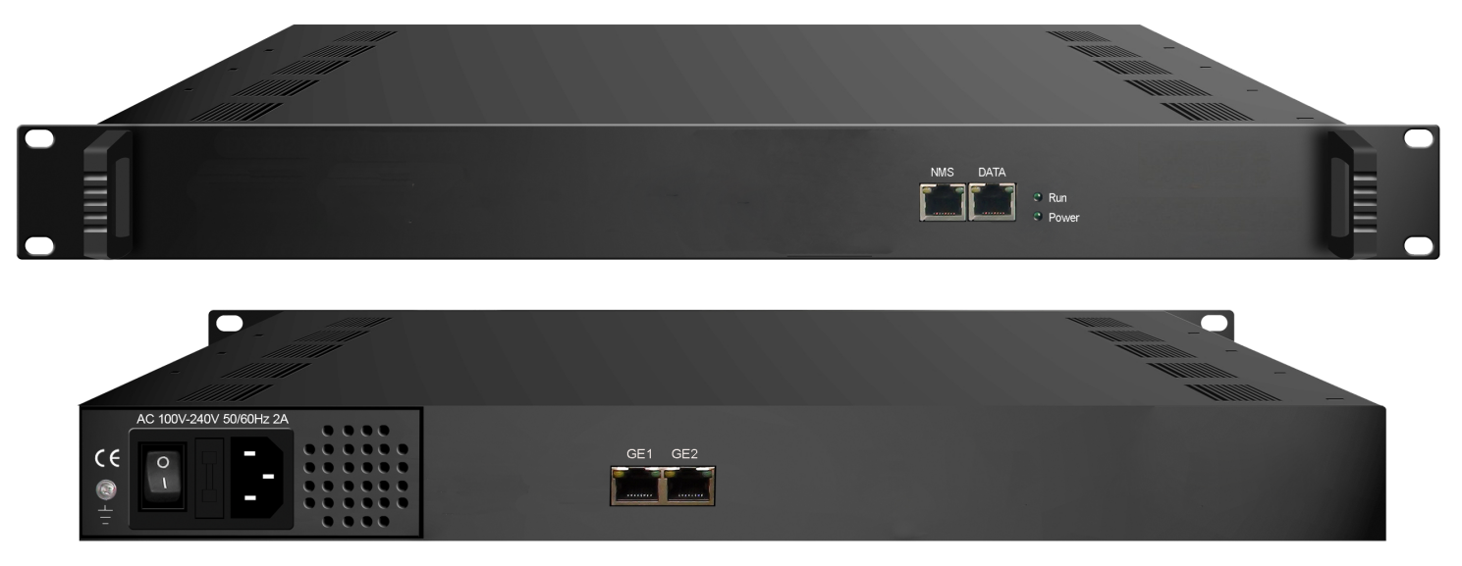Product overview
The FMUSER FUQ-4618Px is a 1U modular IP Gateway converting IP streams to DVB-ASI via 3 hot-swappable cards. Each card processes 512 SPTS/MPTS streams through UDP/RTP with CA filtering and PCR correction. Features dual Gigabit Ethernet ports (1 input + 1 output) and web-based PSI/SI editing. Ideal for broadcast headends, CATV systems, and IP contribution networks requiring high-density conversion.

Key feature
Low 20W power consumption with 0-45°C operating temperature range
Specifications
Input | 512 SPTS or MPTS IP input over UDP, RTP, Unicast and Multicast (per card)
Output | 512 SPTS IP output UDP, RTP, Unicast and Multicast (per card)
Multiplexing | Support CA PID filtering, PID re-mapping
Multiplexing | Support accurate PCR adjusting
Multiplexing | Support PSI/SI rebuilding and editing
General | Dimension(WxLxH) | 482mm×410mm×44mm
General | Weight | 3.6kg
General | Temperature | 0~45℃(working )，-20~80℃(storage)
General | Power supply | 100~240VAC，50/60Hz
General | consumption | 20W

Working Principle (per daughter card)

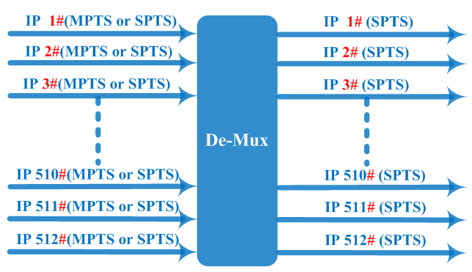

About Us
FMUSER is a company specializing in broadcasting and television transmission systems and integrating hotel IPTV systems. The company was established in 2009 and has served over 180 countries worldwide. More than 20,000 television stations, radio stations, and hotel clients from different.

Contact:Tomleequan Email：sales@fmuser.com whatsapp: +8613922702227

