FMUSER FUQ-4618Ry IP to ASI Gateway 12-Channel IP Input UDP Output DVB-ASI Dual Gigabit Ethernet PCR Restoration Jitter Resistance Professional Headend Solution 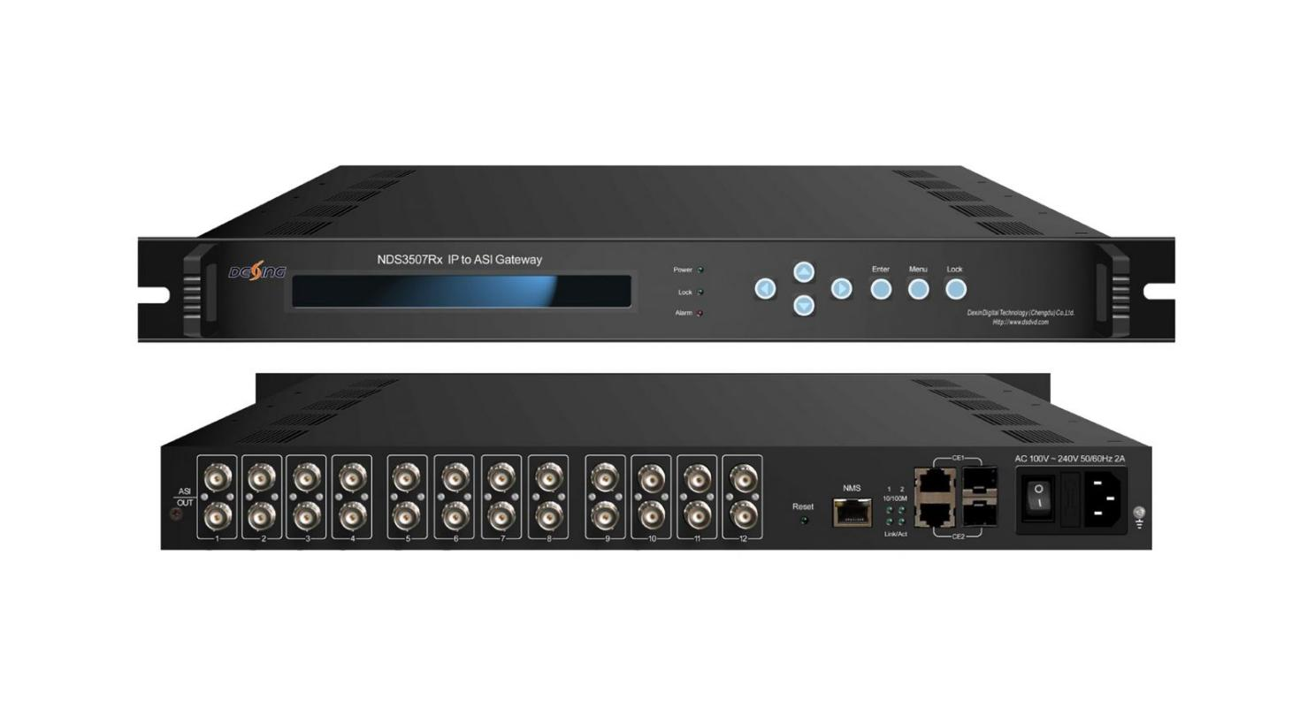Product overview
The FUQ-4618Ry is a 12-channel IP-to-ASI gateway converting UDP/IP streams to DVB-ASI via dual Gigabit Ethernet inputs (RJ45/SFP). It processes MPTS/SPTS with PCR timing restoration and jitter correction for stable TS streams. The 1U rack-mount unit supports local LCD control and SNMP monitoring. Ideal for broadcast headends requiring high-density IP migration and cable TV systems upgrading legacy ASI infrastructure.
Key feature
Offers local LCD/keypad control and SNMP remote monitoring
Specifications
Interface | Input | 12 IP (MPTS/SPTS)over UDP, unicast and multicast, two 1000M input interfaces, RJ45/SFP
Interface | Output | 12 ASI output, and each channel output with two BNC interfaces
Transmitting protocol | Input | TS over UDP
Transmitting protocol | Output | DVB-ASI
Bit-rate |  | Max of each channel is 108Mbps, Max total bit-rate is 840Mbps
Miscellaneous | Dimension  (W×L×H) | 482mm×410mm×44mm
Miscellaneous | Weight | 4kg
Miscellaneous | Temperature | 0~45℃(operation)，-20~80℃(storage)
Miscellaneous | Power | 100~240VAC，50/60Hz
Miscellaneous | Consumption | 22W

Principle chart
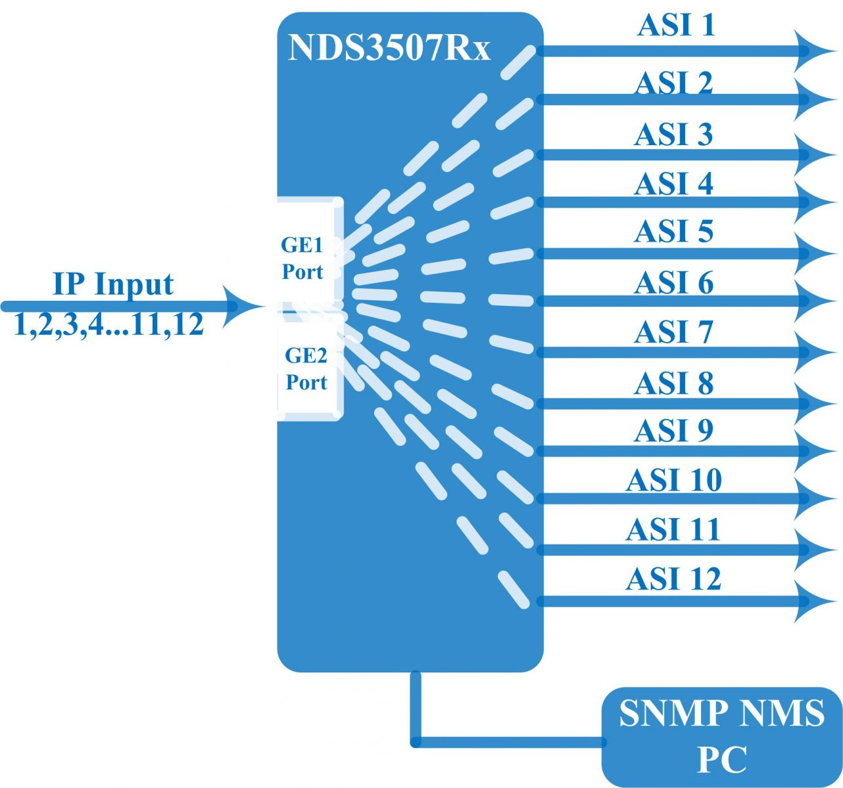

About Us
FMUSER is a company specializing in broadcasting and television transmission systems and integrating hotel IPTV systems. The company was established in 2009 and has served over 180 countries worldwide. More than 20,000 television stations, radio stations, and hotel clients from different.

Contact:Tomleequan Email：sales@fmuser.com whatsapp: +8613922702227

