FUQ-4618SY 12-Channel IP to ASI Gateway with Dual Gigabit Inputs/DVB-ASI Outputs for Broadcast Transmission 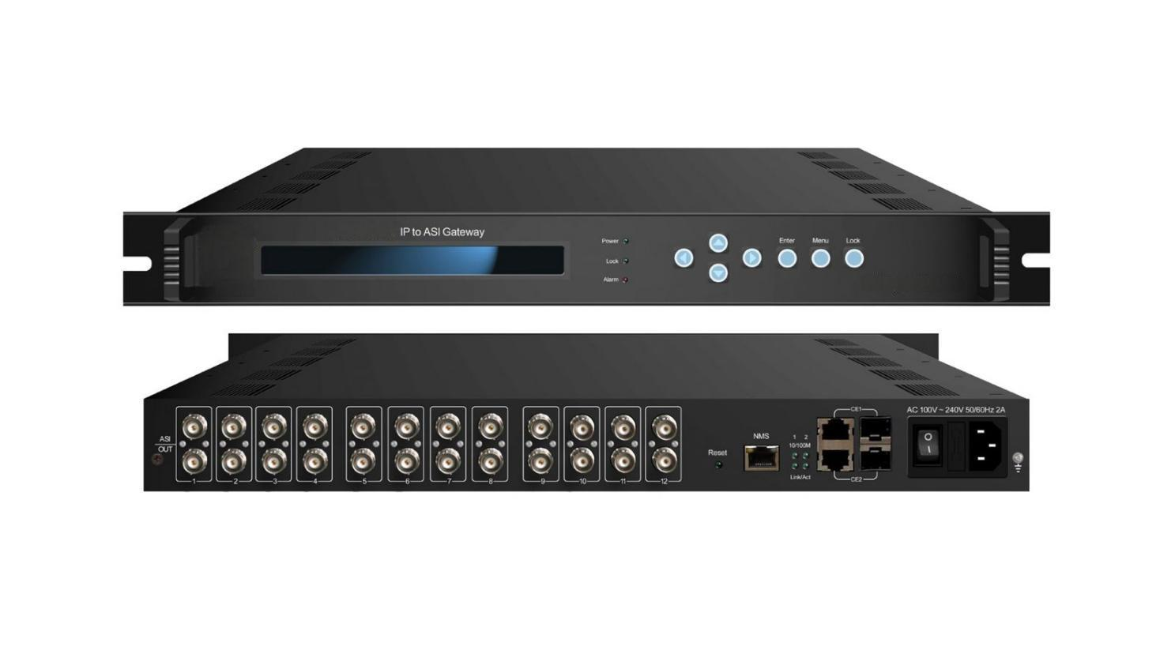
Product overview
The FUQ-4618SY converts UDP/IP streams to DVB-ASI signals via 12 output channels, each with dual BNC interfaces. It processes MPTS/SPTS inputs through dual Gigabit Ethernet ports (RJ45/SFP), ensuring 840Mbps throughput with PCR restoration. This 1U rack-mount device supports SNMP/LCD control for broadcast centers and IPTV headends requiring stable TS stream conversion.
Key feature
Remote management via SNMP or local LCD controlSpecifications
Interface | Input | 12 IP (MPTS/SPTS)over UDP, unicast and multicast, two 1000M input interfaces, RJ45/SFP
Interface | Output | 12 ASI output, and each channel output with two BNC interfaces
Transmitting protocol | Input | TS over UDP
Transmitting protocol | Output | DVB-ASI
Bit-rate |  | Max of each channel is 108Mbps, Max total bit-rate is 840Mbps
Miscellaneous | Dimension  (W×L×H) | 482mm×410mm×44mm
Miscellaneous | Weight | 4kg
Miscellaneous | Temperature | 0~45℃(operation)，-20~80℃(storage)
Miscellaneous | Power | 100~240VAC，50/60Hz
Miscellaneous | Consumption | 22W

Principle chart
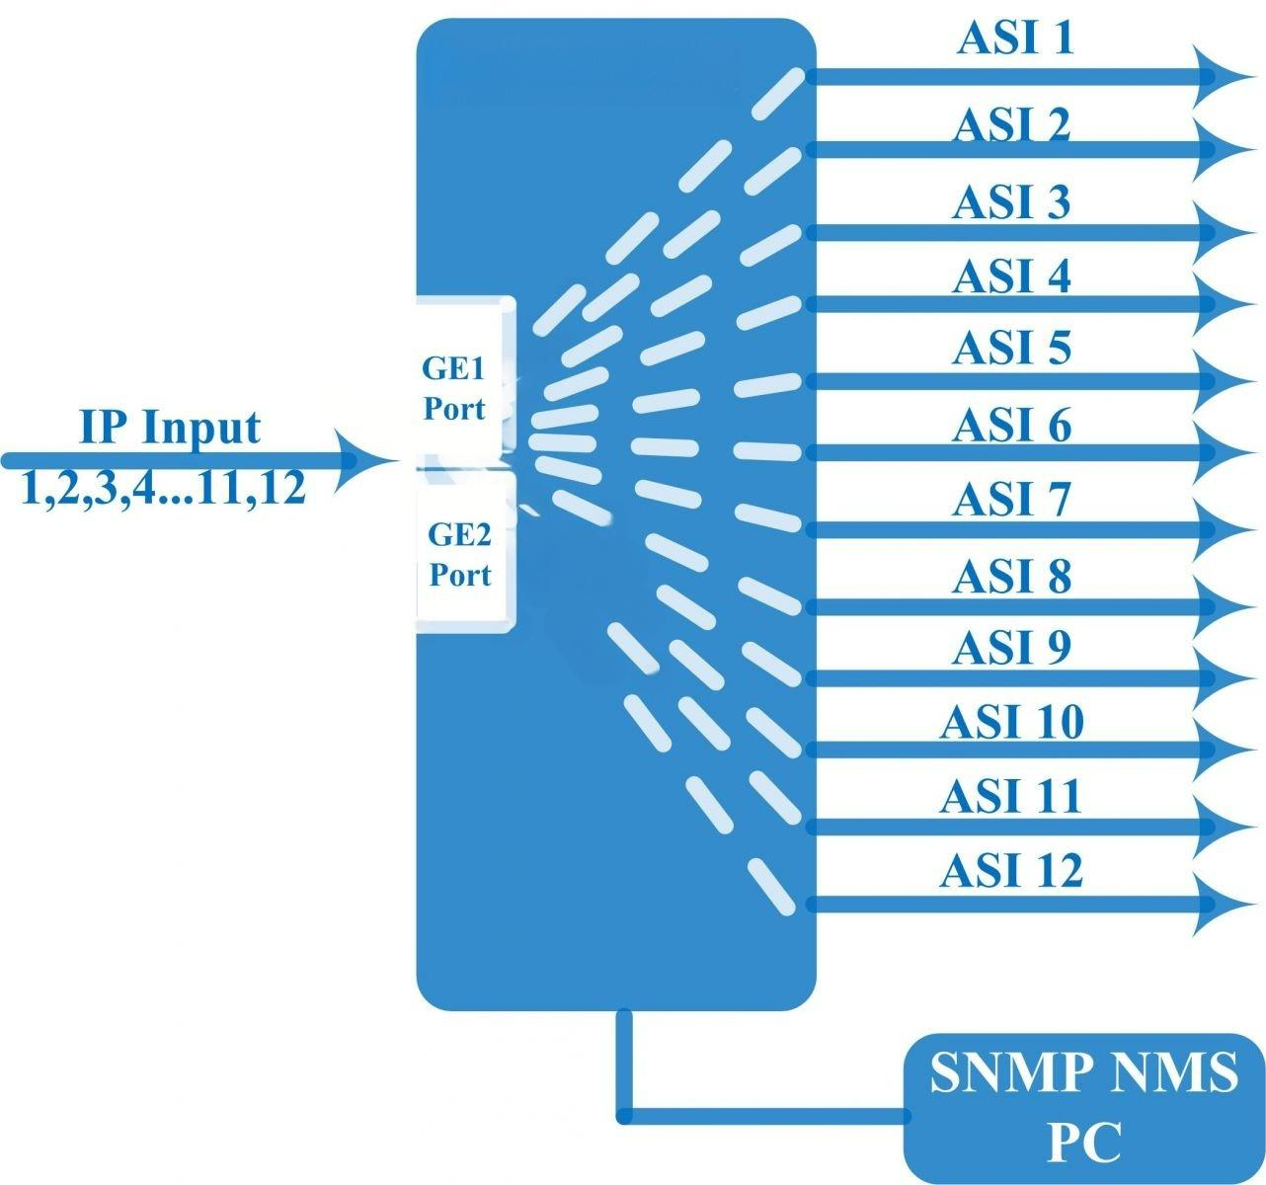

About Us
FMUSER is a company specializing in broadcasting and television transmission systems and integrating hotel IPTV systems. The company was established in 2009 and has served over 180 countries worldwide. More than 20,000 television stations, radio stations, and hotel clients from different.

Contact:Tomleequan Email：sales@fmuser.com whatsapp: +8613922702227

