FFMUSER FUQ-4619A FUQ-4619B IPTV Gateway Server 7 IP Input Channels SRT-HTTP-UDP-RTP-RTSP-HLS to SRT-HTTP-UDP-HLS-RTMP Protocol Conversion Web-Based NMS Hotel TV CATV System
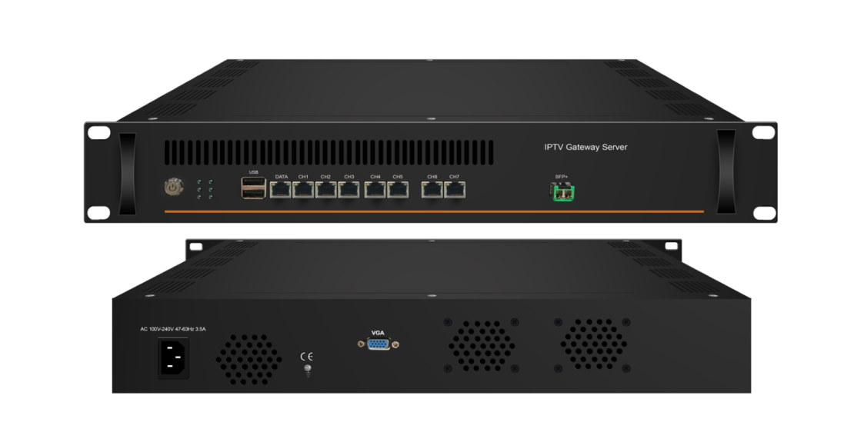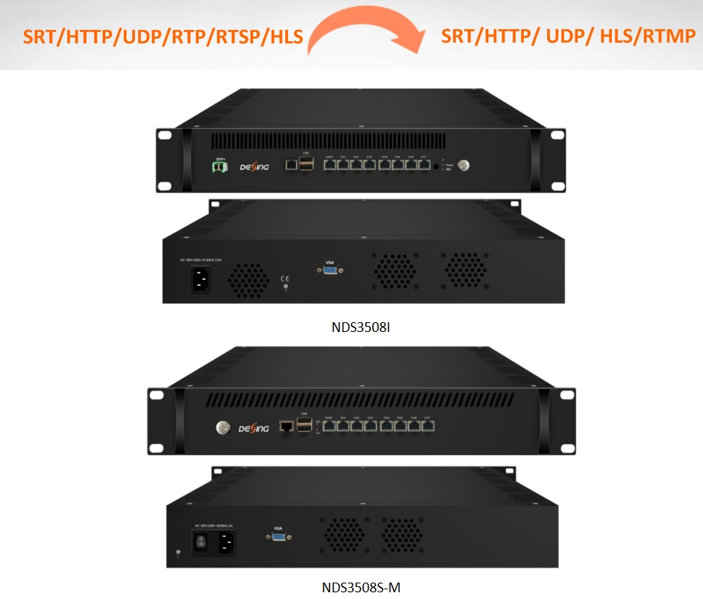
Product overview
The FMUSER FUQ-4619A/FUQ-4619B IPTV Gateway Server integrates an IP Gateway and IPTV server for protocol conversion and streaming media distribution. It handles inputs such as SRT, HTTP, UDP, RTP, RTSP, and HLS, converting to outputs including SRT, HTTP, UDP, HLS, and RTMP. Managed via web-based NMS through the DATA port, it suits small CATV headend systems and hotel TV applications for efficient media delivery.
Key feature
Integrated Design: Combines IP Gateway and IPTV server in one unit for streamlined operation.
Protocol Conversion: Converts inputs like SRT, HTTP, UDP, RTP, RTSP, and HLS to outputs such as SRT, HTTP, UDP, HLS, and RTMP.
IPTV Functionality: Supports live channels, VOD, hotel services, and customizable interfaces via FMUSER IPTV APK.
Web Management: Controlled through web-based NMS for easy configuration and monitoring.
IP Protocol Conversion
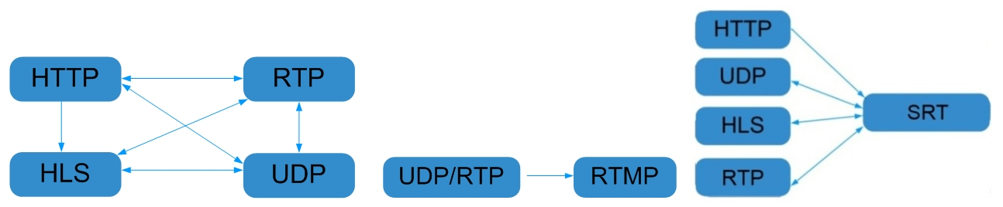

General Principle Chart
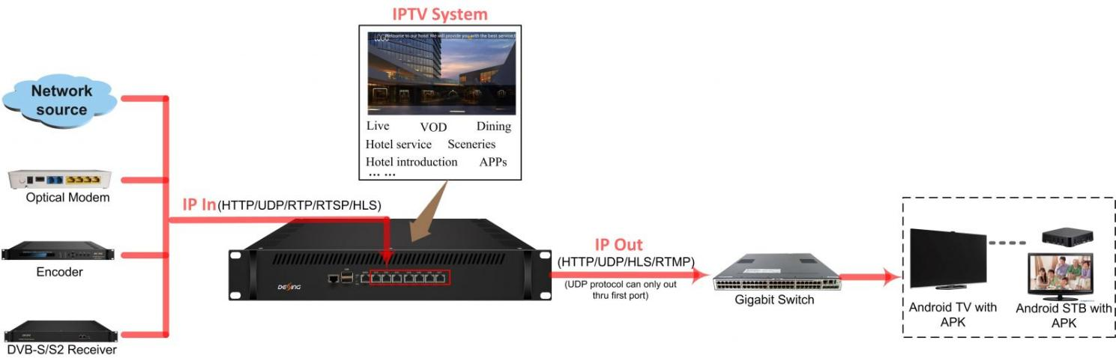

Specifications
IP Input | DATA CH 1-7 (1000M) ports: IP input over SRT, HTTP, UDP (SPTS), RTP (SPTS), RTSP (over UDP, payload: mpeg TS) and HLS
IP Input | TS files uploading through Web management
IP output | First Data port (1000M): IP out over SRT, HTTP (Unicast), UDP (SPTS, Multicast) HLS and RTMP (Program source should be H.264 and AAC encoding)
IP output | DATA CH 1-7 (1000M) ports: IP out over HTTP/HLS/RTMP (Unicast)  SFP+ output 10000M (for FU-4619S-I and FU-4619I)
System | Channel switching time with FMUSER’ STB: HTTP (1-3s), HLS (0.4-0.7s)
System | Play programs with APK downloaded android STB and TV
System | About 80 HD/SD programs (Bitrate at 2Mbps) when HTTP/RTP/RTSP/HLS is converted into UDP (Multicast), the actual application shall prevail, and suggest maximum 80% CPU utilization
System | IPTV system function | support Live channel, VOD, Hotel introduction, Dining, Hotel service, APPS, scenery introduction and so on (Please install FMUSER IPTV APK)
System | IPTV system main interface | support adding scrolling caption, welcome words, pictures, advertisement, video, music (Please install FMUSER IPTV APK)
System | web-based NMS management thru DATA port
General | Demission | 482.6mm×328mm×88mm (WxLxH)
General | Temperature | 0~45℃(operation), -20~80℃(storage)
General | Power Supply | AC100V±10%, 50/60Hz or AC 220V±10%, 50/60Hz

Test data for reference:
Protocol Conversion | Programs | Bitrate | Terminals |  | CPU Utilization
Protocol Conversion | Programs | Bitrate | FU-4619S-M | FU-4619I | CPU Utilization
HTTP/RTP/RTSP/HLS to UDP | 80 | 2M | --- | --- | 55%
HTTP to HTTP | 30 | 2M | 300 | 600 | 80%
HTTP to HTTP | 50 | 2M | 160 | 320 | 80%
HTTP to HLS | 50 | 2M | 400 | 800 | 46%
UDP to HLS | 50 | 2M | 400 | 800 | 50%
UDP to HLS | 80 | 2M | 300 | 600 | 72%
UDP to HTTP | 50 | 2M | 240 | 480 | 50%
UDP to SRT | 50 | 2M | --- | --- | 50%
UDP to SRT | 50 | 2M | --- | --- | 75%

Order Guide:
Model No. | Feature | SFP+ | Memory | CPU | Solid-State Disk (SSD) | Mechanical Hard Disk
FU-4619F-M | Gateway+IPTV server | / | 8G | i5/i7 (3rd Generation) | 120G/240G random | /
FU-4619S-M | Gateway+IPTV server | / | 8G | i5/i7 (3rd Generation) | 120G/240G random | 4T
FU-4619S-I | Gateway+IPTV server | 1 | 8G | i3 (6th Generation) | 120G/240G random | /
FU-4619I | Gateway+IPTV server | 1 | 16G | i7 (6th Generation) | 120G/240G random | 4T

About Us
FMUSER is a company specializing in broadcasting and television transmission systems and integrating hotel IPTV systems. The company was established in 2009 and has served over 180 countries worldwide. More than 20,000 television stations, radio stations, and hotel clients from different.

Contact:Tomleequan Email：sales@fmuser.com whatsapp: +8613922702227

