FMUSER FUQ-4619B ASI to IP Gateway 8 ASI Inputs to 20/32/256 SPTS Outputs UDP-RTP-RTSP Protocol BISS Descrambling IP Null Packet Filtering for Broadcast IPTV Systems 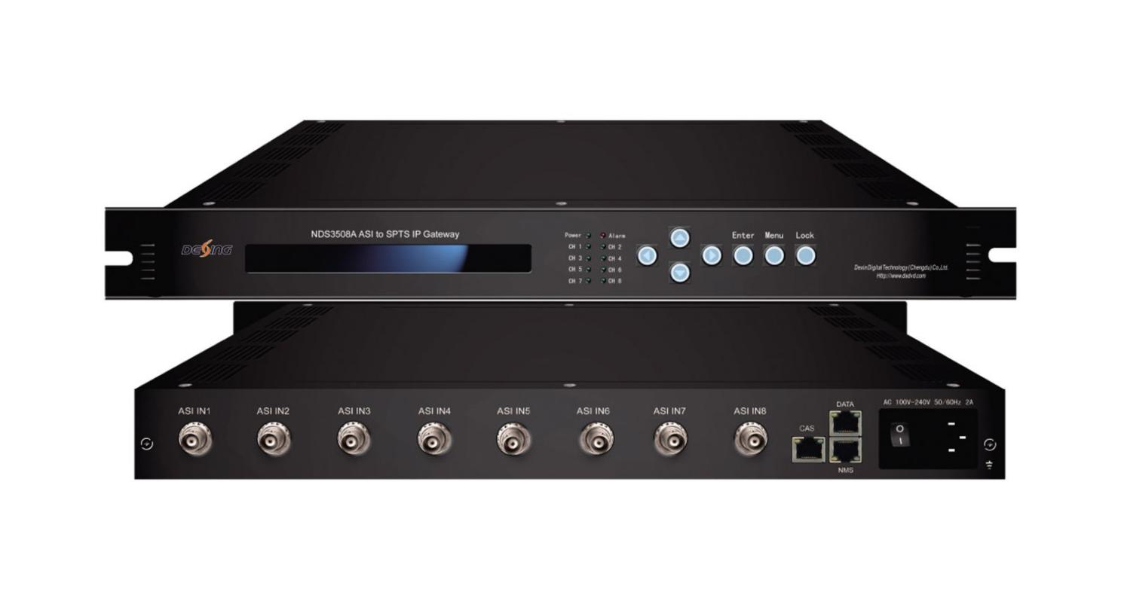Product overview

The FUQ-4619B ASI to IP Gateway converts 8 ASI inputs to IP outputs, supporting SPTS streams with BISS descrambling over UDP/RTP protocols. It processes signals by descrambling and filtering for efficient IP conversion. Controlled via SNMP for network management, this device suits broadcast head-end systems and IPTV distribution networks.
Key feature
Supports 8-channel ASI input for conversion to SPTS streams.
Provides BISS descrambling (Mode 1/E) with 120Mbps throughput.
Features 1 GE output with configurable bit-rates: 400Mbps or 800Mbps.
Includes IP null packet filtering and multi-protocol support (UDP, RTP/RTSP, unicast/multicast).
Principle Chart

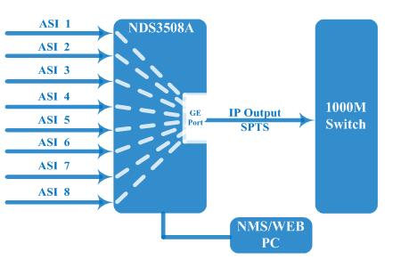

Specification

Input | 8 ASI input
Output | 1 GE output, UDP, RTP/RTSP protocol, unicast and Multicast  256 SPTS output — Without BISS function and IP null packet filter  32 SPTS output — Without BISS function  20 SPTS output — With BISS function
BISS descrambling | Mode 1, Mode E
Transmission Bit-rate |  | Maximum total bit-rate is 400Mbps—256 SPTS output
 |  | Maximum total bit-rate is 800Mbps—32/20 SPTS output
General | Dimension(WxLxH) | 482mm×410mm×44mm
General | Weight | 3.6kg
General | Temperature | 0~45℃(working )，-20~80℃(storage)
General | Power supply | 100~240VAC，50/60Hz
General | consumption | 20W

About Us
FMUSER is a company specializing in broadcasting and television transmission systems and integrating hotel IPTV systems. The company was established in 2009 and has served over 180 countries worldwide. More than 20,000 television stations, radio stations, and hotel clients from different.

Contact:Tomleequan Email：sales@fmuser.com whatsapp: +8613922702227

