FMUSER FUQ-4619B ASI to IP Gateway 8-Channel ASI Input 1 GE IP Output UDP-RTP-RTSP BISS Descrambling SPTS Conversion for Broadcast Headend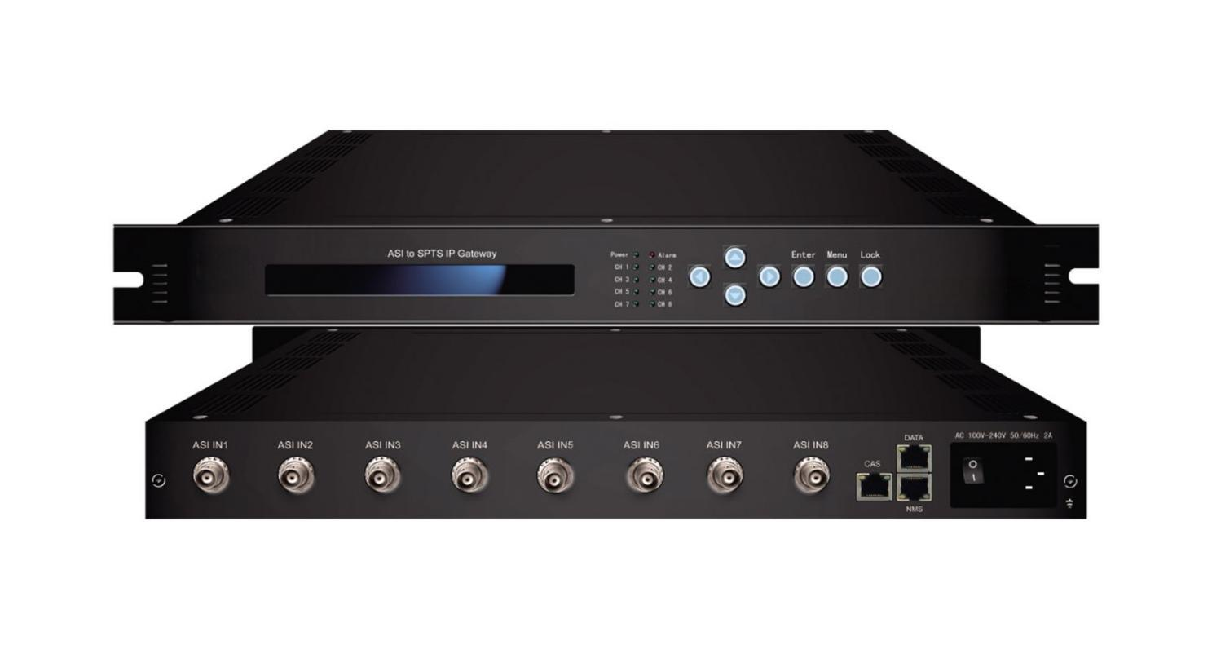
Product overview

The FUQ-4619B ASI to IP Gateway converts 8x ASI signals to IP streams (UDP/RTP/RTSP) with BISS Mode 1/E descrambling. It processes inputs into SPTS outputs (256/32/20 modes) at up to 800Mbps via 1 GE port. This 1RU rack-mount device supports dual control via LCD/keyboard or SNMP/Web. Ideal for satellite content distribution and multi-platform IPTV headends requiring secure, high-throughput conversion.
Key feature
Dual control via LCD/keyboard and SNMP/Web interfaces
Principle Chart

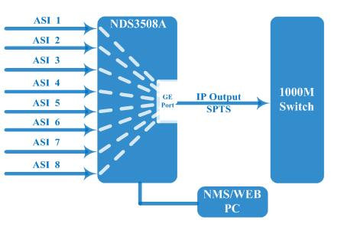

Specification

Input | 8 ASI input
Output | 1 GE output, UDP, RTP/RTSP protocol, unicast and Multicast  256 SPTS output — Without BISS function and IP null packet filter  32 SPTS output — Without BISS function  20 SPTS output — With BISS function
BISS descrambling | Mode 1, Mode E
Transmission Bit-rate |  | Maximum total bit-rate is 400Mbps—256 SPTS output
 |  | Maximum total bit-rate is 800Mbps—32/20 SPTS output
General | Dimension(WxLxH) | 482mm×410mm×44mm
General | Weight | 3.6kg
General | Temperature | 0~45℃(working )，-20~80℃(storage)
General | Power supply | 100~240VAC，50/60Hz
General | consumption | 20W

About Us
FMUSER is a company specializing in broadcasting and television transmission systems and integrating hotel IPTV systems. The company was established in 2009 and has served over 180 countries worldwide. More than 20,000 television stations, radio stations, and hotel clients from different.

Contact:Tomleequan Email：sales@fmuser.com whatsapp: +8613922702227

