FMUSER FUQ-4619B IPTV Gateway with 8 IP Data Ports and Modulator 16 DVB-C-8 DVB-T-6 ISDBT RF Outputs IP to RF Conversion DVB-C-T-ISDBT-ATSC Standards Web NMS Management for CATV Headends and IPTV Systems
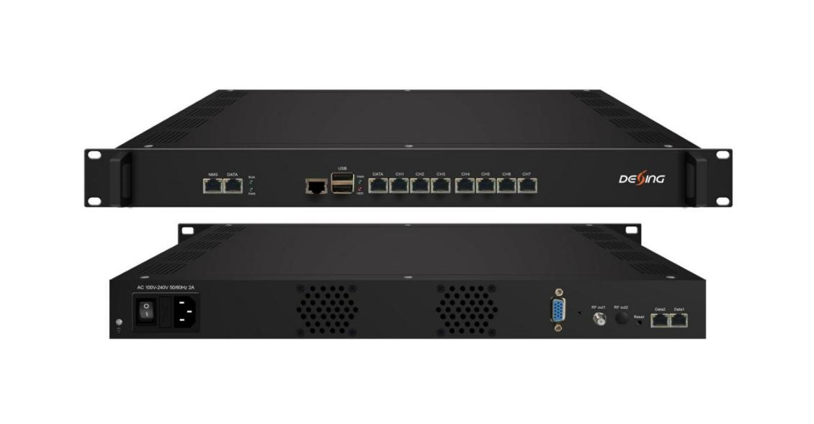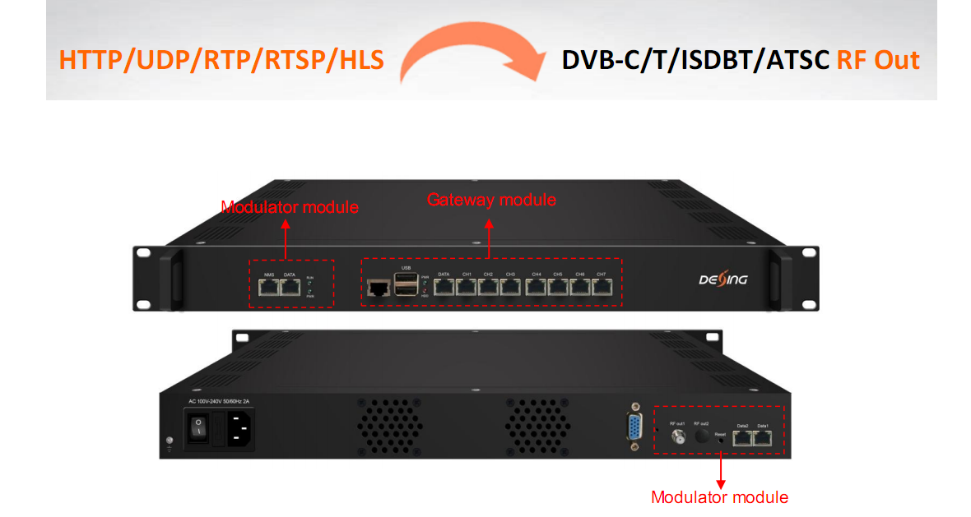
Product overview
The FMUSER FUQ-4619B combines an IPTV gateway with 8 data ports and a modulator for direct IP-to-RF conversion. It processes IP streams from protocols like HTTP/UDP/RTP to RF outputs compliant with DVB-C/T/ISDBT/ATSC standards. Managed via web-based NMS, this solution is ideal for CATV headends and IPTV/OTT systems for efficient program redistribution.
Key feature
Enables centralized control via web-based NMS and TS file upload.
IP Protocol Conversion
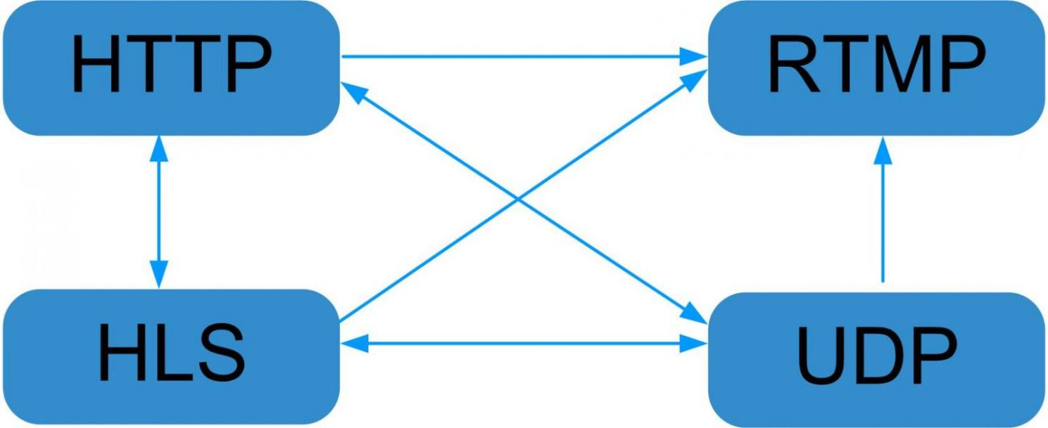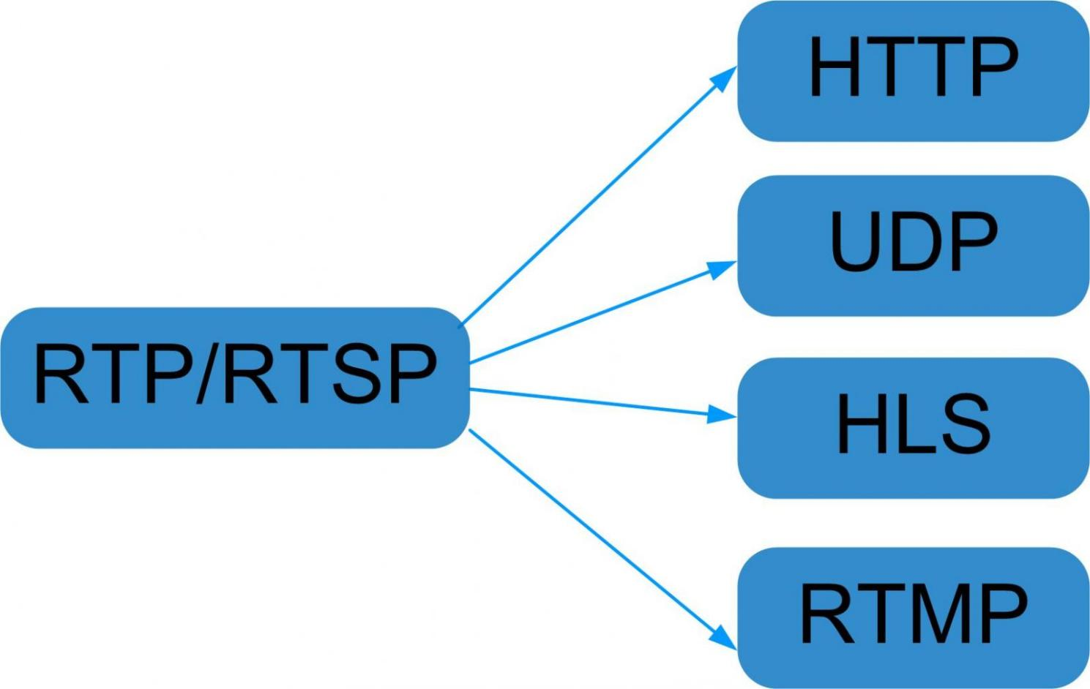

Principle Chart
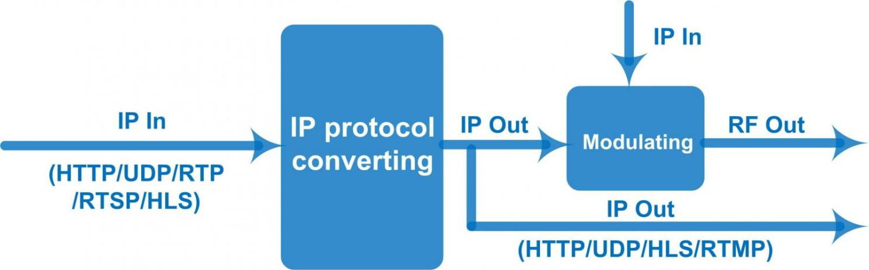
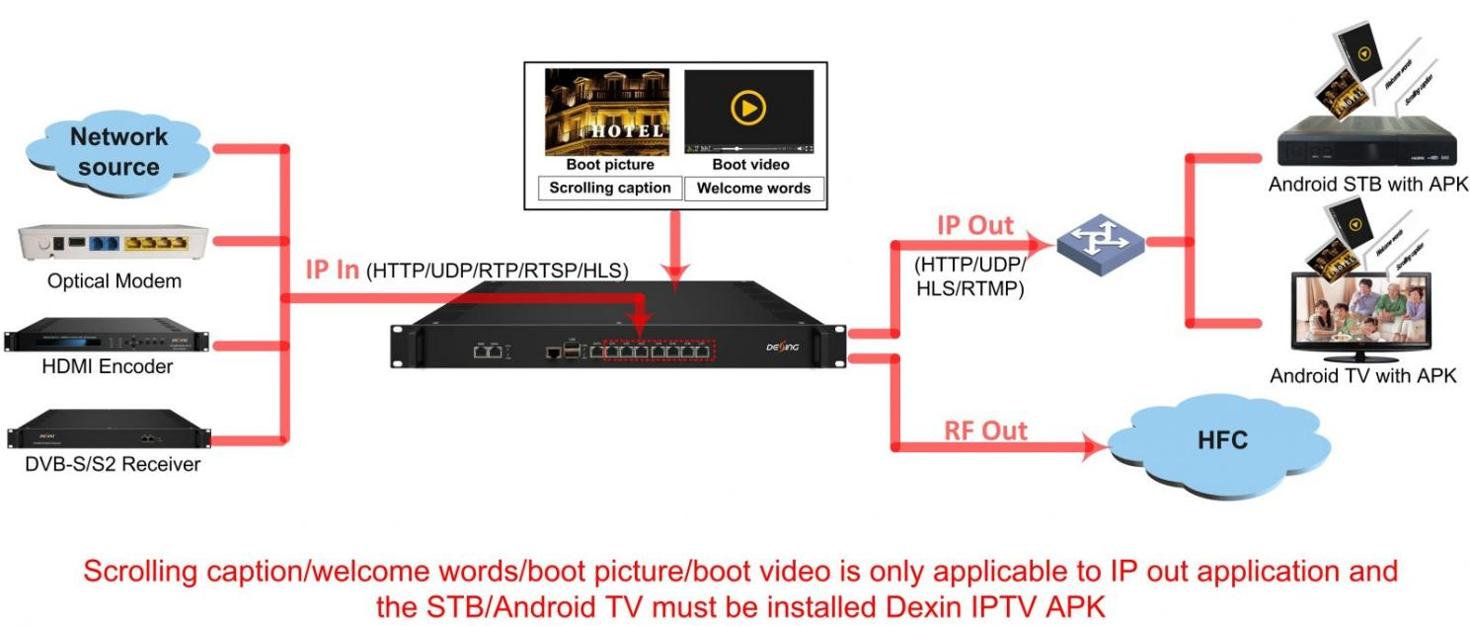

Specifications
IPTV gateway module
Input | IP input thru CH 1-7(1000M) over HTTP, UDP(SPTS), RTP(SPTS), RTSP (over UDP, payload: mpeg TS) and HLS
Input | TS files uploading through Web management
IP output | IP out thru DATA port (1000M) over HTTP (Unicast), UDP(SPTS, Multicast) HLS and RTMP (Program source should be H.264 and AAC encoding)  IP out thru CH 1-7(1000M) over HTTP/ HLS/RTMP (Unicast)
System | Memory: 4G
System | Solid-State Disk(SSD): 16G
System | Channel switching time with FMUSER’ STB: HTTP (1-3s), HLS (0.4-0.7s)
System | Support adding scrolling caption, welcome words, boot picture and boot video (this function is only applicable to IP out application and the STB/Android TV must be installed FMUSER IPTV APK)
System | Support downloading FMUSER IPTV APK directly from this module
System | Play programs with APK downloaded android STB and TV, maximum 150 terminals
System | Support about 80 HD/SD programs (Bitrate: 2Mbps) When HTTP/RTP/RTSP/HLS is converted into UDP (Multicast), the actual application shall prevail, and suggest maximum 80% CPU utilization
System | web-based NMS management thru module’s DATA port

Modulator module (Taking FMUSER’s DX316/DX308T/DX306I/DX308AT modulator module as examples)
Input | DX316 (DVB-C) | 512 IP (MPTS/SPTS) input over UDP/RTP, 2 100/1000M Ethernet Port
Input | DX308T (DVB-T) | 256 IP (MPTS/SPTS) input over UDP/RTP, 2 100/1000M Ethernet Port
Input | DX306I (ISDBT) | 192 IP (MPTS/SPTS) input over UDP/RTP, 2 100/1000M Ethernet Port
Input | DX308AT (ATSC) | 256 IP (MPTS/SPTS) input over UDP/RTP, 2 100/1000M Ethernet Port
Multiplexing |  | DVB-C |  | DVB-T/ ATSC |  | ISDBT
Multiplexing | Input Channel | 512 |  | 256 |  | 192
Multiplexing | Output Channel | 16 |  | 8 |  | 6
Multiplexing | Max PIDs | 180 per channel
Multiplexing | Functions | PID remapping(auto/manually optional)
Multiplexing | Functions | PCR accurate adjusting
Multiplexing | Functions | PSI/SI table automatically generating
Scrambling  Parameters (for DVB-C) | Max simulscrypt CA | 4
Scrambling  Parameters (for DVB-C) | Scramble Standard | ETR289, ETSI 101 197, ETSI 103 197
Scrambling  Parameters (for DVB-C) | Connection | Local/remote connection
Modulation  Parameters | DVB-C |  | J.83A |  | J.83B
Modulation  Parameters | DVB-C | Constellation | 16/32/64/128/256QAM |  | 64QAM/ 256QAM
Modulation  Parameters | DVB-C | Bandwidth | 8M |  | 6M
Modulation  Parameters | DVB-C | Standard | EN300 429/ITU-T J.83A/B(DVB-C)
Modulation  Parameters | DVB-C | Symbol rate | 5.0~7.0Msps, 1ksps stepping
Modulation  Parameters | DVB-C | QAM channel | 16 non-adjacent carrier outputs within 192M bandwidth
Modulation  Parameters | DVB-C | RF frequency | 50~960MHz, 1KHz step
Modulation  Parameters | DVB-C | RF output level | -20~+10dBm, 0.1dB step
Modulation  Parameters | DVB-C | MER | ≥ 40dB
Modulation  Parameters | DVB-C | FEC | RS (204, 188)
Modulation  Parameters | DVB-T | Standard | ETSI EN300 744
Modulation  Parameters | DVB-T | Constellation | QPSK/16QAM/64QAM
Modulation  Parameters | DVB-T | Bandwidth | 6/7/8 MHz
Modulation  Parameters | DVB-T | Trans mode | 2K/4K/8K
Modulation  Parameters | DVB-T | FEC | 1/2, 2/3, 3/4, 5/6, 7/8
Modulation  Parameters | DVB-T | MER | ≥ 40dB
Modulation  Parameters | DVB-T | RF frequency | 50~960MHz, 1kHz stepping
Modulation  Parameters | DVB-T | RF output Level | -20~+10dBm, 0.5dB stepping
Modulation  Parameters | DVB-T | RF out channel | 8 non-adjacent carrier outputs within 192M bandwidth
Modulation  Parameters | ISDBT | Standard | ARIB STD-B31
Modulation  Parameters | ISDBT | Bandwidth | 6M
Modulation  Parameters | ISDBT | Constellation | QPSK, 16QAM, 64QAM
Modulation  Parameters | ISDBT | Guard Interval | 1/32, 1/16, 1/8, 1/4
Modulation  Parameters | ISDBT | Transmission Mode | 2K, 4K, 8K
Modulation  Parameters | ISDBT | Code rate | 1/2, 2/3, 3/4, 5/6, 7/8
Modulation  Parameters | ISDBT | MER | ≥ 40dB
Modulation  Parameters | ISDBT | RF frequency | 50~960MHz, 1KHz step
Modulation  Parameters | ISDBT | RF output level | -20dBm~+10dBm, 0.1dB stepping
Modulation  Parameters | ISDBT | RF out | 6 non-adjacent carrier outputs within 192M bandwidth
Modulation  Parameters | ATSC | Standard | ATSC A/53
Modulation  Parameters | ATSC | Bandwidth | 6M
Modulation  Parameters | ATSC | Constellation | 8VSB
Modulation  Parameters | ATSC | FEC | RS(208 188)+Trellis
Modulation  Parameters | ATSC | MER | ≥40dB
Modulation  Parameters | ATSC | RF frequency | 50~960MHz, 1kHz step
Modulation  Parameters | ATSC | RF output level | -20dBm~+10dBm, 0.5dB stepping
Modulation  Parameters | ATSC | RF out | 8 non-adjacent carrier outputs within 192M bandwidth
TS output | 16 (DVB-C)/ 8(DVB-T/ ATSC)/ 6(ISDBT) IP output over UDP/RTP/RTSP, unicast/multicast, 2*100/1000M Ethernet Ports (Data 1/2)
System | web-based NMS management thru module’s NMS port

General | Demission | 482mm×324mm×44mm (WxLxH)
General | Temperature | 0~45℃(operation), -20~80℃(storage)
General | Power Supply | AC 100V±10%, 50/60Hz or AC 220V±10%, 50/60Hz

About Us
FMUSER is a company specializing in broadcasting and television transmission systems and integrating hotel IPTV systems. The company was established in 2009 and has served over 180 countries worldwide. More than 20,000 television stations, radio stations, and hotel clients from different.

Contact:Tomleequan Email：sales@fmuser.com whatsapp: +8613922702227

