FMUSER FUQ-4619C Tuner to IP Gateway 16 Tuner Inputs 2 ASI Inputs DVB-S-S2-S2X 4 IP Outputs UDP-RTP-RTSP BISS Descrambling Multiplexing Broadcast Headends 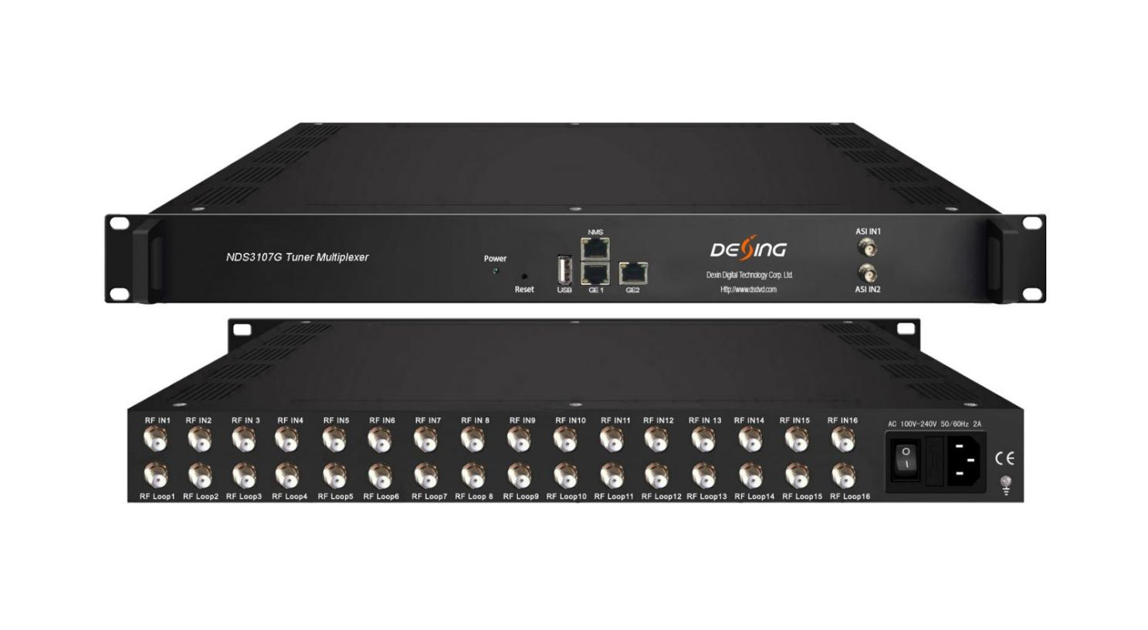Product overview
The FMUSER FUQ-4619C V2 is a tuner to IP gateway with 16 tuner inputs and 2 ASI inputs for IP MPTS output. It multiplexes signals and applies BISS descrambling with PSI/SI management. Controlled via web interface, it suits digital TV head-end systems for broadcasting.
Key feature
Supports up to 16 tuner inputs with DVB-S/S2/S2X standards and 2 ASI inputs.
Features embedded BISS descrambling with bit rate up to 80Mbps per channel.
Provides 4 IP outputs over UDP/RTP/RTSP and 2 GE mirrored outputs.
Enables PID filtering, re-mapping, and PSI/SI editing.
Working Principle
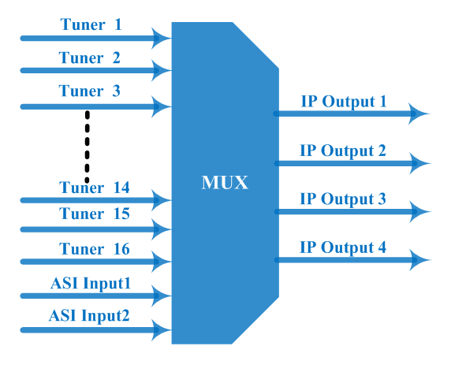

Specifications

Input | 16 tuners input, (DVB-C, DVB-T/(T), ISDBT, S/S2/S2X, ATSC optional), F type  2 ASI input, BNC interface
Tuner Section |  | DVB-C | Input Frequency |  |  | 30 ~1000 MHz
Tuner Section |  | DVB-C | Standard |  |  | J.83A(DVB-C), J.83B, J.83C
Tuner Section |  | DVB-C | Constellation |  |  | 16/32/64/128/256 QAM
Tuner Section |  | DVB-T/(T) | Input Frequency |  |  | 30 ~1000 MHz
Tuner Section |  | DVB-T/(T) | Bandwidth |  |  | 6/7/8 M
Tuner Section | Version 1 | DVB-S | Input Frequency |  |  | 950~2150MHz
Tuner Section | Version 1 | DVB-S | Symbol rate |  |  | 1~45 Msps
Tuner Section | Version 1 | DVB-S | FEC |  |  | 1/2, 2/3, 3/4, 5/6, 7/8
Tuner Section | Version 1 | DVB-S | Constellation |  |  | QPSK
Tuner Section | Version 1 | DVB-S | Signal Strength |  |  | - 65~ -25dBm
Tuner Section | Version 1 | DVB-S | Max input bitrate |  |  | ≤120 Mbps
Tuner Section | Version 1 | DVB-S2 | Input Frequency |  |  | 950~2150MHz
Tuner Section | Version 1 | DVB-S2 | Symbol rate |  |  | 1~45 Msps
Tuner Section | Version 1 | DVB-S2 | FEC |  |  | 1/2, 3/5, 2/3, 3/4, 4/5, 5/6, 8/9, 9/10
Tuner Section | Version 1 | DVB-S2 | Constellation |  |  | QPSK, 8PSK
Tuner Section | Version 1 | DVB-S2 | Max input bitrate |  |  | ≤120 Mbps
Tuner Section | Version 2  (New) | DVB-S | Input Frequency |  |  | 950~2150MHz
Tuner Section | Version 2  (New) | DVB-S | Symbol rate |  |  | 0.5~45Msps
Tuner Section | Version 2  (New) | DVB-S | Signal Strength |  |  | - 65- -25dBm
Tuner Section | Version 2  (New) | DVB-S | FEC |  |  | 1/2, 2/3, 3/4, 5/6, 7/8
Tuner Section | Version 2  (New) | DVB-S | Constellation |  |  | QPSK
Tuner Section | Version 2  (New) | DVB-S | Max input bitrate |  |  | ≤120 Mbps
Tuner Section | Version 2  (New) | DVB-S2 | Input Frequency |  |  | 950~2150MHz
Tuner Section | Version 2  (New) | DVB-S2 | Symbol rate |  |  | QPSK/8PSK /16APSK :0.5~45 Msps  32APSK: 0.5~40Msps;
Tuner Section | Version 2  (New) | DVB-S2 | FEC |  |  | QPSK: 1/2, 3/5, 2/3, 3/4, 4/5, 5/6, 8/9, 9/10  8PSK: 3/5, 2/3, 3/4, 5/6, 8/9, 9/10  16APSK: 2/3, 3/4, 4/5, 5/6, 8/9, 9/10  32APSK: 3/4, 4/5, 5/6, 8/9, 9/10
Tuner Section | Version 2  (New) | DVB-S2 | Constellation |  |  | QPSK, 8PSK, 16APSK, 32APSK
Tuner Section | Version 2  (New) | DVB-S2 | Max input bitrate |  |  | ≤120 Mbps
Tuner Section | Version 2  (New) | DVB-S2X | Input Frequency |  |  | 950~2150MHz
Tuner Section | Version 2  (New) | DVB-S2X | Symbol rate |  |  | QPSK/8PSK /16APSK :0.5~45 Msps  8APSK/32APSK: 0.5~40Msps
Tuner Section | Version 2  (New) | DVB-S2X | FEC |  |  | QPSK: 1/2, 3/5, 2/3, 3/4, 4/5, 5/6, 8/9, 9/10, 13/45, 9/20, 11/20  8PSK: 3/5, 2/3, 3/4, 5/6, 8/9, 9/10  8APSK: 5/9-L, 26/45-L  16APSK: 2/3, 3/4, 4/5, 5/6, 8/9, 9/10, 1/2-L, 8/15-L, 5/9-L, 26/45, 3/5, 3/5-L, 28/45, 23/36 , 2/3-L, 25/36, 13/18, 7/9, 77/90  32APSK: 3/4, 4/5, 5/6, 8/9, 2/3-L, 32/45, 11/15, 7/9
Tuner Section | Version 2  (New) | DVB-S2X | Constellation |  |  | QPSK, 8PSK, 8APSK, 16APSK, 32APSK
Tuner Section | Version 2  (New) | DVB-S2X | Max input bitrate |  |  | ≤120 Mbps
Tuner Section |  | ISDB-T | Input Frequency |  |  | 30~1000MHz
Tuner Section |  | ATSC | Input Frequency |  |  | 50 MHz~960MHz
Tuner Section |  | ATSC | Bandwidth |  |  | 6M
Tuner Section |  | ATSC | Constellation |  |  | 8VSB
Re-multiplex |  | PID re-mapping
 |  | PCR accurate adjusting
 |  | Automatic generating PSI/SI table
PID |  | Output range |  |  | 0x0000—0x1FFF
 |  | PID transparent |  |  | Any PID transparent and mapping achievable
 |  | Amount of output PID per input |  |  | 128
BISS descrambling |  | Mode 1, Mode E (Up to 850Mbps) (descramble individual program)
Output |  | 4 IP (MPTS) output over UDP and RTP/RTSP protocol through GE1 and GE2 port, Unicast and Multicast
System |  | Remote management |  | Web-server Management
 |  | Language |  | English
 |  | Upgrade |  | USB, web management
Miscellaneous |  | Dimension |  | 482mm×410mm×44mm (W×L×H)
 |  | Approx weight |  | 3.5kg
 |  | Environment |  | 0~45℃(work)；-20~80℃（Storage）
 |  | Power requirements |  | 100~240VAC, 50/60Hz
 |  | Power consumption |  | 20W

Tuner Input Options:

- 8 DVB-C Tuners + 8 ATSC Tuners
- 8 DVB-S2/S2X Tuners + 8 DVB-(T) Tuners
- 8 DVB- S2/S2X Tuners + 8 ISDB-T Tuners
- 16 DVB-S/S2/S2X/DVB-C/(T) /ISDB-T/ATSC Tuners

About Us
FMUSER is a company specializing in broadcasting and television transmission systems and integrating hotel IPTV systems. The company was established in 2009 and has served over 180 countries worldwide. More than 20,000 television stations, radio stations, and hotel clients from different.

Contact:Tomleequan Email：sales@fmuser.com whatsapp: +8613922702227

