FUQ-4619C Tuner to IP Gateway 24 Tuners 2 ASI 1 USB Inputs DVB-S-S2-S2X DVB-C-T-T2 ISDB-T 1024 SPTS 27 MPTS IP Streaming BISS Descrambling Web GUI Broadcast Headend 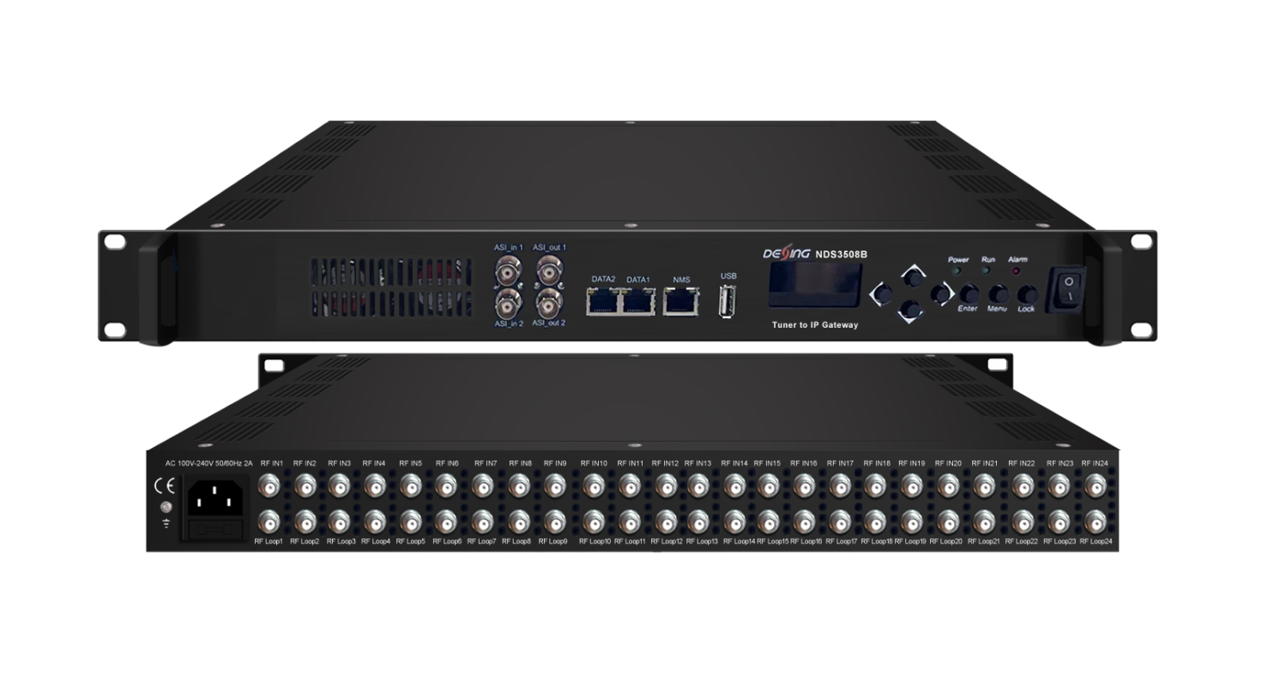Product overview
The FUQ-4619C Tuner to IP Gateway converts signals from 24 FTA tuners, 2 DVB-ASI inputs, and 1 USB input into IP outputs. It processes signals with switchable MPTS (bypass) or SPTS modes and embedded BISS descrambling. Managed via Web GUI, it delivers up to 1024 SPTS streams over UDP/RTP/RTSP. This 1RU device is ideal for broadcast headends and IPTV distribution requiring flexible signal conversion.
Key feature
Supports 24 multi-standard tuners (switchable DVB-S/S2/S2X, DVB-C/T/T2, ISDB-T) plus 2 ASI inputs and 1 USB input.
Integrates BISS descrambling for Mode 1 and Mode E on tuner inputs.
Provides switchable MPTS/SPTS outputs (27 MPTS with Null PKT Filter or 1024 SPTS over dual DATA ports via UDP/RTP/RTSP).
Enables Web-based management for configuration, PID filtering, remapping, and updates.
Includes DiSEqC support for satellite signal control.
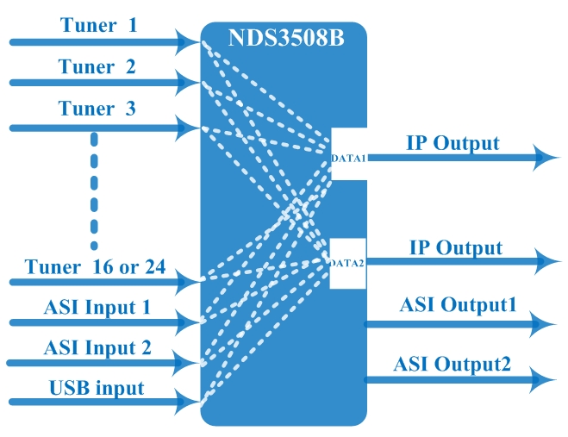

Specifications
Input |  | 24 tuners inputs +2 ASI inputs +1 USB inputs
Satellite | DVB-S | Frequency In |  | 950~2150MHz
Satellite | DVB-S | Symbol rate |  | 0.5~45Msps
Satellite | DVB-S | Signal Strength |  | - 65- -25dBm
Satellite | DVB-S | FEC |  | 1/2, 2/3, 3/4, 5/6, 7/8
Satellite | DVB-S | Constellation |  | QPSK
Satellite | DVB-S | Max input bitrate |  | ≤125 Mbps
Satellite | DVB-S2 | Frequency In |  | 950~2150MHz
Satellite | DVB-S2 | Symbol rate |  | QPSK/8PSK /16APSK :0.5~45 Msps  32APSK: 0.5~34Msps;
Satellite | DVB-S2 | FEC |  | QPSK: 1/2, 3/5, 2/3, 3/4, 4/5, 5/6, 8/9, 9/10  8PSK: 3/5, 2/3, 3/4, 5/6, 8/9, 9/10  16APSK: 2/3, 3/4, 4/5, 5/6, 8/9, 9/10  32APSK: 3/4, 4/5, 5/6, 8/9, 9/10
Satellite | DVB-S2 | Constellation |  | QPSK, 8PSK, 16APSK, 32APSK
Satellite | DVB-S2 | Max input bitrate |  | ≤125 Mbps
Satellite | DVB-S2X | Frequency In |  | 950~2150MHz
Satellite | DVB-S2X | Symbol rate |  | QPSK/8PSK /16APSK :0.5~45 Msps  8APSK: 0.5~40Msps  32APSK: 0.5~34Msps
Satellite | DVB-S2X | FEC |  | QPSK: 1/2, 3/5, 2/3, 3/4, 4/5, 5/6, 8/9, 9/10, 13/45, 9/20, 11/20  8PSK: 3/5, 2/3, 3/4, 5/6, 8/9, 9/10  8APSK: 5/9-L, 26/45-L  16APSK: 2/3, 3/4, 4/5, 5/6, 8/9, 9/10, 1/2-L, 8/15-L, 5/9-L, 26/45, 3/5, 3/5-L, 28/45, 23/36 , 2/3-L, 25/36, 13/18, 7/9, 77/90  32APSK: 3/4, 4/5, 5/6, 8/9, 9/10, 2/3-L, 32/45, 11/15, 7/9
Satellite | DVB-S2X | Constellation |  | QPSK, 8PSK, 8APSK, 16APSK, 32APSK
Satellite | DVB-S2X | Max input bitrate |  | ≤125 Mbps
Multi-Mode Switchable Tuner Inputs | DVB-C | Standard |  | J.83A(DVB-C), J.83B, J.83C
Multi-Mode Switchable Tuner Inputs | DVB-C | Frequency In |  | 50~960MHz
Multi-Mode Switchable Tuner Inputs | DVB-C | Constellation |  | 16/32/64/128/256 QAM
Multi-Mode Switchable Tuner Inputs | DVB-T/T2 | Frequency In |  | 50~960MHz
Multi-Mode Switchable Tuner Inputs | DVB-T/T2 | Bandwidth |  | 6/7/8 M bandwidth
Multi-Mode Switchable Tuner Inputs | ISDB-T | Frequency In |  | 50~960MHz
BISS Descrambling |  | Mode 1, Mode E
Output |  | 1024 SPTS IP output over UDP and RTP/RTSP protocol through DATA1 and DATA2 port (IP address and port number of DATA1 and DATA2 are different) , Unicast and Multicast
 |  | 27 MPTS IP output (for Tuner/ASI/USB bypass) over UDP and RTP/RTSP protocol through DATA1 and DATA2 port, Unicast and Multicast
 |  | 2 ASI outputs(MPTS out mode only, mirror ports to output the same one TS)
System |  | Web based management
 |  | Ethernet software upgrade
Miscellaneous |  | Dimension | 482mm×270mm×44mm (W×L×H)
 |  | Environment | 0~45℃(work); -20~80℃（Storage）
 |  | Power requirements | 100~240VAC, 50/60Hz

About Us
FMUSER is a company specializing in broadcasting and television transmission systems and integrating hotel IPTV systems. The company was established in 2009 and has served over 180 countries worldwide. More than 20,000 television stations, radio stations, and hotel clients from different.

Contact:Tomleequan Email：sales@fmuser.com whatsapp: +8613922702227

