FMUSER FUQ-4619C Tuner-to-IP Gateway 16-24 DVB-S-S2-S2X Inputs 1 ASI 1 USB Output UDP-RTP-RTSP IP Streaming BISS Descrambling Broadcast IPTV Headend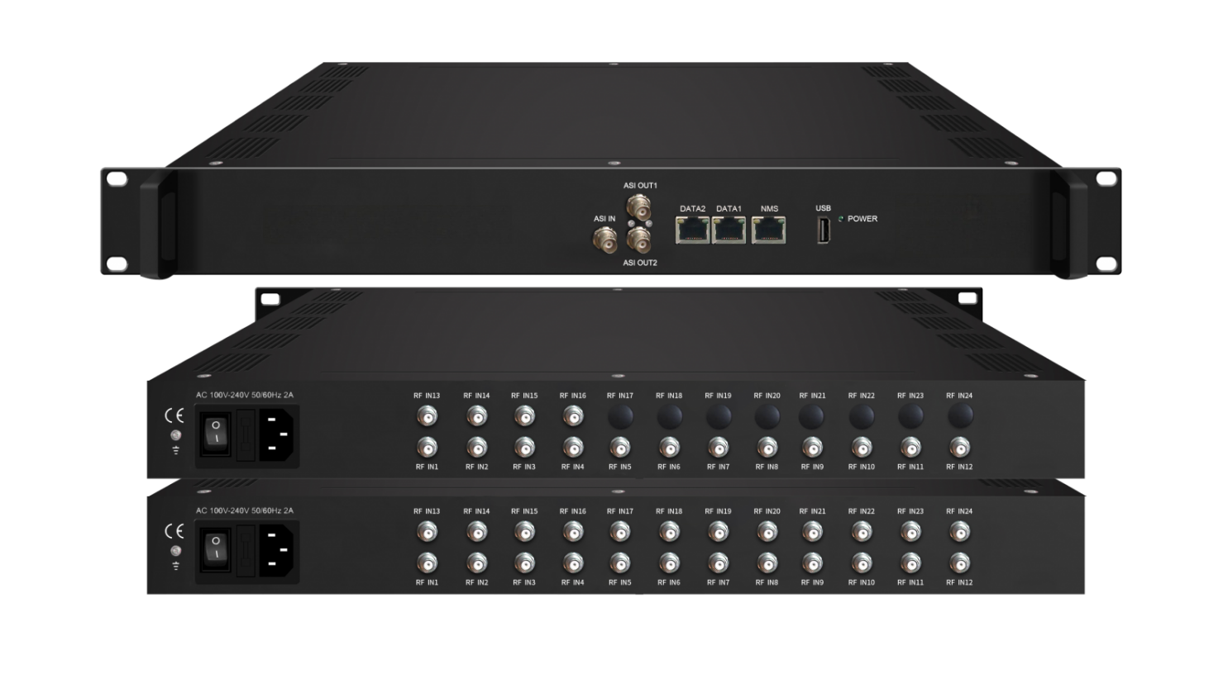Product overview
The FUQ-4619C Tuner-to-IP Gateway converts 16-24 DVB-S/S2/S2X tuner inputs, 1 ASI, and 1 USB signals into IP streams via UDP/RTP/RTSP. It processes signals with BISS descrambling, DiSEqC control, and PID filtering, delivering up to 26 MPTS or 1024 SPTS streams through dual Gigabit Ethernet ports. This 1RU rack-mountable device features web-based management, ideal for broadcast headends and IPTV multiscreen distribution.
Key feature
Web-based configuration and Ethernet firmware upgrades for remote management
Working Principle
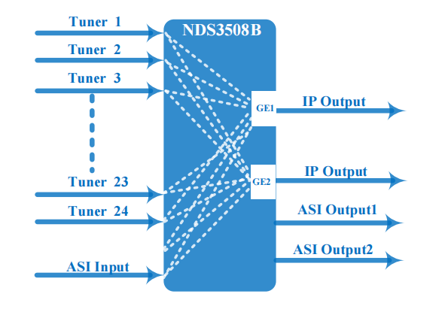

Specifications
Input | 16 or 24 tuners input +1 ASI input +1 USB input---SPTS/MPTS output
Satellite | DVB-S | Frequency In |  | 950~2150MHz
Satellite | DVB-S | Symbol rate |  | 0.5~45Msps
Satellite | DVB-S | Signal Strength |  | - 65- -25dBm
Satellite | DVB-S | FEC |  | 1/2, 2/3, 3/4, 5/6, 7/8
Satellite | DVB-S | Constellation |  | QPSK
Satellite | DVB-S | Max input bitrate |  | ≤125 Mbps
Satellite | DVB-S2 | Frequency In |  | 950~2150MHz
Satellite | DVB-S2 | Symbol rate |  | QPSK/8PSK /16APSK :0.5~45 Msps  32APSK: 0.5~34Msps;
Satellite | DVB-S2 | FEC |  | QPSK: 1/2, 3/5, 2/3, 3/4, 4/5, 5/6, 8/9, 9/10  8PSK: 3/5, 2/3, 3/4, 5/6, 8/9, 9/10  16APSK: 2/3, 3/4, 4/5, 5/6, 8/9, 9/10  32APSK: 3/4, 4/5, 5/6, 8/9, 9/10
Satellite | DVB-S2 | Constellation |  | QPSK, 8PSK, 16APSK, 32APSK
Satellite | DVB-S2 | Max input bitrate |  | ≤125 Mbps
Satellite | DVB-S2X | Frequency In |  | 950~2150MHz
Satellite | DVB-S2X | Symbol rate |  | QPSK/8PSK /16APSK :0.5~45 Msps  8APSK: 0.5~40Msps  32APSK: 0.5~34Msps
Satellite | DVB-S2X | FEC |  | QPSK: 1/2, 3/5, 2/3, 3/4, 4/5, 5/6, 8/9, 9/10, 13/45, 9/20, 11/20  8PSK: 3/5, 2/3, 3/4, 5/6, 8/9, 9/10  8APSK: 5/9-L, 26/45-L  16APSK: 2/3, 3/4, 4/5, 5/6, 8/9, 9/10, 1/2-L, 8/15-L, 5/9-L, 26/45, 3/5, 3/5-L, 28/45, 23/36 , 2/3-L, 25/36, 13/18, 7/9, 77/90  32APSK: 3/4, 4/5, 5/6, 8/9, 9/10, 2/3-L, 32/45, 11/15, 7/9
Satellite | DVB-S2X | Constellation |  | QPSK, 8PSK, 8APSK, 16APSK, 32APSK
Satellite | DVB-S2X | Max input bitrate |  | ≤125 Mbps
BISS Descrambling | Mode 1, Mode E (Up to 850Mbps) (descramble individual program)
Output | 1024 SPTS IP output over UDP and RTP/RTSP protocol through GE1 and GE2 port (IP address and port number of GE1 and GE2 are different) , Unicast and Multicast
Output | 26 MPTS IP output (for Tuner/ASI/USB pass-through) over UDP and RTP/RTSP protocol through GE1 and GE2 port, Unicast and Multicast
Output | 2 ASI output
System | Web based management
System | Ethernet software upgrade
Miscellaneous | Dimension |  | 482mm×230mm×44mm (W×L×H)
Miscellaneous | Approx weight |  | 2.5 kg
Miscellaneous | Environment |  | 0~45℃(work); -20~80℃（Storage）
Miscellaneous | Power requirements |  | 100~240VAC, 50/60Hz
Miscellaneous | Power consumption |  | 20W

About Us
FMUSER is a company specializing in broadcasting and television transmission systems and integrating hotel IPTV systems. The company was established in 2009 and has served over 180 countries worldwide. More than 20,000 television stations, radio stations, and hotel clients from different.

Contact:Tomleequan Email：sales@fmuser.com whatsapp: +8613922702227

