FMUSER FUQ-4619C Tuner to IP Gateway 24x Tuner 2x ASI 1x USB Input DVB-S-S2-S2X DVB-C-T-T2-ISDB-T Output 1024x SPTS 27x MPTS IP Streaming BISS Descrambling Broadcast IPTV Distribution 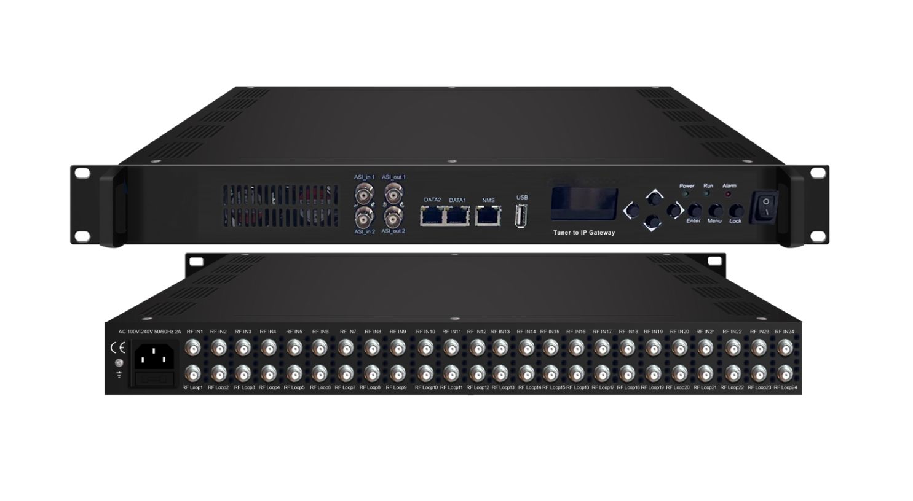Product overview
The FUQ-4619C Tuner to IP Gateway converts 24 FTA tuner inputs (supporting DVB-S/S2/S2X, DVB-C/T/T2, and ISDB-T), 2 ASI inputs, and 1 USB TS playback into IP streams. It processes signals through MPTS bypass or SPTS conversion with PID filtering/remapping, delivering outputs via UDP/RTP/RTSP protocols. This 1RU rack-mount device features web-based control for DiSEqC management and BISS Mode 1/E descrambling. Ideal for satellite-to-IP redistribution, multicast IPTV systems, and broadcast monitoring with 900Mbps throughput.
Key feature
Web-based management: Controls DiSEqC, firmware upgrades, and stream configurations via GUI
Working Principle
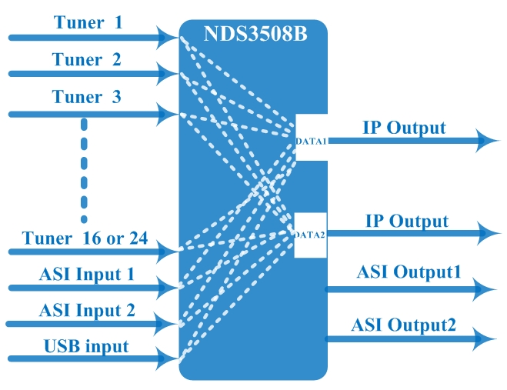

Specifications
Input |  | 24 tuners inputs +2 ASI inputs +1 USB inputs
Satellite | DVB-S | Frequency In |  | 950~2150MHz
Satellite | DVB-S | Symbol rate |  | 0.5~45Msps
Satellite | DVB-S | Signal Strength |  | - 65- -25dBm
Satellite | DVB-S | FEC |  | 1/2, 2/3, 3/4, 5/6, 7/8
Satellite | DVB-S | Constellation |  | QPSK
Satellite | DVB-S | Max input bitrate |  | ≤125 Mbps
Satellite | DVB-S2 | Frequency In |  | 950~2150MHz
Satellite | DVB-S2 | Symbol rate |  | QPSK/8PSK /16APSK :0.5~45 Msps  32APSK: 0.5~34Msps;
Satellite | DVB-S2 | FEC |  | QPSK: 1/2, 3/5, 2/3, 3/4, 4/5, 5/6, 8/9, 9/10  8PSK: 3/5, 2/3, 3/4, 5/6, 8/9, 9/10  16APSK: 2/3, 3/4, 4/5, 5/6, 8/9, 9/10  32APSK: 3/4, 4/5, 5/6, 8/9, 9/10
Satellite | DVB-S2 | Constellation |  | QPSK, 8PSK, 16APSK, 32APSK
Satellite | DVB-S2 | Max input bitrate |  | ≤125 Mbps
Satellite | DVB-S2X | Frequency In |  | 950~2150MHz
Satellite | DVB-S2X | Symbol rate |  | QPSK/8PSK /16APSK :0.5~45 Msps  8APSK: 0.5~40Msps  32APSK: 0.5~34Msps
Satellite | DVB-S2X | FEC |  | QPSK: 1/2, 3/5, 2/3, 3/4, 4/5, 5/6, 8/9, 9/10, 13/45, 9/20, 11/20  8PSK: 3/5, 2/3, 3/4, 5/6, 8/9, 9/10  8APSK: 5/9-L, 26/45-L  16APSK: 2/3, 3/4, 4/5, 5/6, 8/9, 9/10, 1/2-L, 8/15-L, 5/9-L, 26/45, 3/5, 3/5-L, 28/45, 23/36 , 2/3-L, 25/36, 13/18, 7/9, 77/90  32APSK: 3/4, 4/5, 5/6, 8/9, 9/10, 2/3-L, 32/45, 11/15, 7/9
Satellite | DVB-S2X | Constellation |  | QPSK, 8PSK, 8APSK, 16APSK, 32APSK
Satellite | DVB-S2X | Max input bitrate |  | ≤125 Mbps
Multi-Mode Switchable Tuner Inputs | DVB-C | Standard |  | J.83A(DVB-C), J.83B, J.83C
Multi-Mode Switchable Tuner Inputs | DVB-C | Frequency In |  | 50~960MHz
Multi-Mode Switchable Tuner Inputs | DVB-C | Constellation |  | 16/32/64/128/256 QAM
Multi-Mode Switchable Tuner Inputs | DVB-T/T2 | Frequency In |  | 50~960MHz
Multi-Mode Switchable Tuner Inputs | DVB-T/T2 | Bandwidth |  | 6/7/8 M bandwidth
Multi-Mode Switchable Tuner Inputs | ISDB-T | Frequency In |  | 50~960MHz
BISS Descrambling |  | Mode 1, Mode E
Output |  | 1024 SPTS IP output over UDP and RTP/RTSP protocol through DATA1 and DATA2 port (IP address and port number of DATA1 and DATA2 are different) , Unicast and Multicast
 |  | 27 MPTS IP output (for Tuner/ASI/USB bypass) over UDP and RTP/RTSP protocol through DATA1 and DATA2 port, Unicast and Multicast
 |  | 2 ASI outputs(MPTS out mode only, mirror ports to output the same one TS)
System |  | Web based management
 |  | Ethernet software upgrade
Miscellaneous |  | Dimension | 482mm×270mm×44mm (W×L×H)
 |  | Environment | 0~45℃(work); -20~80℃（Storage）
 |  | Power requirements | 100~240VAC, 50/60Hz

About Us
FMUSER is a company specializing in broadcasting and television transmission systems and integrating hotel IPTV systems. The company was established in 2009 and has served over 180 countries worldwide. More than 20,000 television stations, radio stations, and hotel clients from different.

Contact:Tomleequan Email：sales@fmuser.com whatsapp: +8613922702227

