FUQ-4619C IP Gateway 24-Tuner DVB-S-DVB-S2-DVB-S2X Input, 1024 SPTS 26 MPTS IP Output Dual GE Ports BISS Descrambling Broadcast Headend IPTV Delivery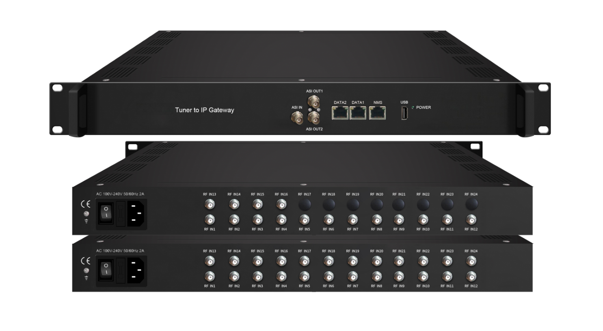
Product overview
The FUQ-4619C IP gateway receives DVB-S/S2/S2X signals via 24 tuners or optional ASI/USB inputs. It converts satellite feeds into 26 MPTS or 1024 SPTS IP streams through dual GE ports, featuring BISS descrambling and PID filtering. The 1RU rack-mount unit supports web-based control with DiSEqC compatibility. Ideal for broadcast contribution links, IPTV headends, and multi-screen delivery systems requiring high-density satellite-to-IP conversion.
Key feature
Web Control: Browser-based management with DiSEqC 1.0/1.2 support for LNB configurationWorking Principle
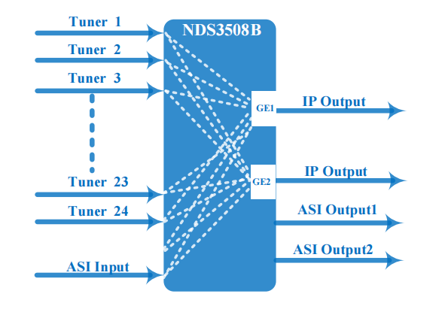

Specifications
Input | 16 or 24 tuners input +1 ASI input +1 USB input---SPTS/MPTS output
Satellite | DVB-S | Frequency In |  | 950~2150MHz
Satellite | DVB-S | Symbol rate |  | 0.5~45Msps
Satellite | DVB-S | Signal Strength |  | - 65- -25dBm
Satellite | DVB-S | FEC |  | 1/2, 2/3, 3/4, 5/6, 7/8
Satellite | DVB-S | Constellation |  | QPSK
Satellite | DVB-S | Max input bitrate |  | ≤125 Mbps
Satellite | DVB-S2 | Frequency In |  | 950~2150MHz
Satellite | DVB-S2 | Symbol rate |  | QPSK/8PSK /16APSK :0.5~45 Msps  32APSK: 0.5~34Msps;
Satellite | DVB-S2 | FEC |  | QPSK: 1/2, 3/5, 2/3, 3/4, 4/5, 5/6, 8/9, 9/10  8PSK: 3/5, 2/3, 3/4, 5/6, 8/9, 9/10  16APSK: 2/3, 3/4, 4/5, 5/6, 8/9, 9/10  32APSK: 3/4, 4/5, 5/6, 8/9, 9/10
Satellite | DVB-S2 | Constellation |  | QPSK, 8PSK, 16APSK, 32APSK
Satellite | DVB-S2 | Max input bitrate |  | ≤125 Mbps
Satellite | DVB-S2X | Frequency In |  | 950~2150MHz
Satellite | DVB-S2X | Symbol rate |  | QPSK/8PSK /16APSK :0.5~45 Msps  8APSK: 0.5~40Msps  32APSK: 0.5~34Msps
Satellite | DVB-S2X | FEC |  | QPSK: 1/2, 3/5, 2/3, 3/4, 4/5, 5/6, 8/9, 9/10, 13/45, 9/20, 11/20  8PSK: 3/5, 2/3, 3/4, 5/6, 8/9, 9/10  8APSK: 5/9-L, 26/45-L  16APSK: 2/3, 3/4, 4/5, 5/6, 8/9, 9/10, 1/2-L, 8/15-L, 5/9-L, 26/45, 3/5, 3/5-L, 28/45, 23/36 , 2/3-L, 25/36, 13/18, 7/9, 77/90  32APSK: 3/4, 4/5, 5/6, 8/9, 9/10, 2/3-L, 32/45, 11/15, 7/9
Satellite | DVB-S2X | Constellation |  | QPSK, 8PSK, 8APSK, 16APSK, 32APSK
Satellite | DVB-S2X | Max input bitrate |  | ≤125 Mbps
BISS Descrambling | Mode 1, Mode E (Up to 850Mbps) (descramble individual program)
Output | 1024 SPTS IP output over UDP and RTP/RTSP protocol through GE1 and GE2 port (IP address and port number of GE1 and GE2 are different) , Unicast and Multicast
Output | 26 MPTS IP output (for Tuner/ASI/USB pass-through) over UDP and RTP/RTSP protocol through GE1 and GE2 port, Unicast and Multicast
Output | 2 ASI output
System | Web based management
System | Ethernet software upgrade
Miscellaneous | Dimension |  | 482mm×230mm×44mm (W×L×H)
Miscellaneous | Approx weight |  | 2.5 kg
Miscellaneous | Environment |  | 0~45℃(work); -20~80℃（Storage）
Miscellaneous | Power requirements |  | 100~240VAC, 50/60Hz
Miscellaneous | Power consumption |  | 20W

About Us
FMUSER is a company specializing in broadcasting and television transmission systems and integrating hotel IPTV systems. The company was established in 2009 and has served over 180 countries worldwide. More than 20,000 television stations, radio stations, and hotel clients from different.

Contact:Tomleequan Email：sales@fmuser.com whatsapp: +8613922702227

