FMUSER FUQ-4619C V3 IP Gateway 24 RF Tuner Inputs DVB-T-T2-C-S-S2 Standards UDP-RTP Output Web-Based NMS Control for Broadcast Headend 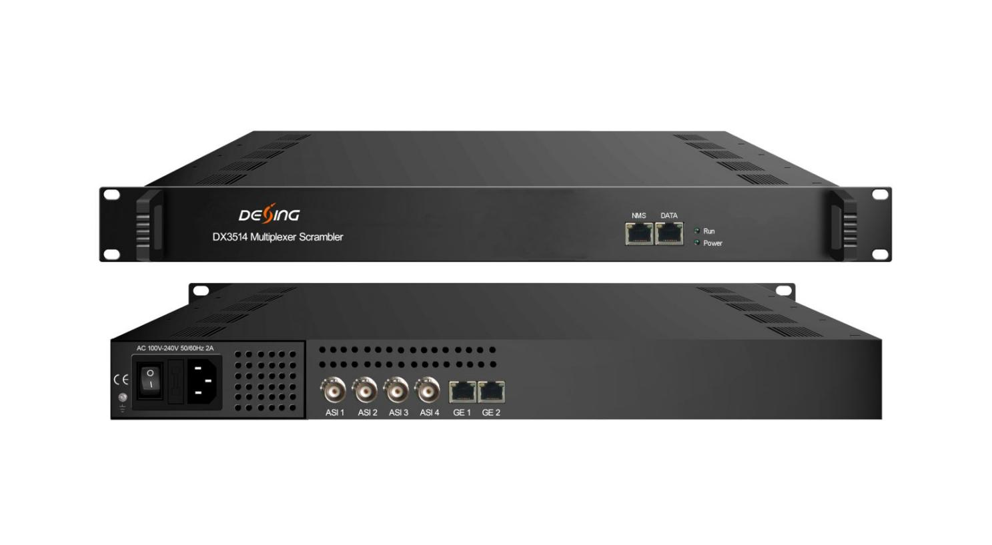Product Overview
The FMUSER FUQ-4619C V3 converts 24 RF tuner inputs to IP streams via UDP/RTP output. It processes DVB-T/T2/C/S/S2 signals with QPSK/QAM/COFDM modulation. This 1RU rack-mount device features web-based NMS control. Ideal for broadcasters transitioning to IP infrastructure and multi-format headend systems.It has the functions of supporting auto-generation of PSI/SI information, PID re-mapping, service filtering and PCR adjusting. In conclusion, its high integration and cost effective design make this device widely used in the CATV Broadcasting system.

Key feature
1RU rack-mount design with 10/100/1000Mbps Ethernet
Inner Principle Chart
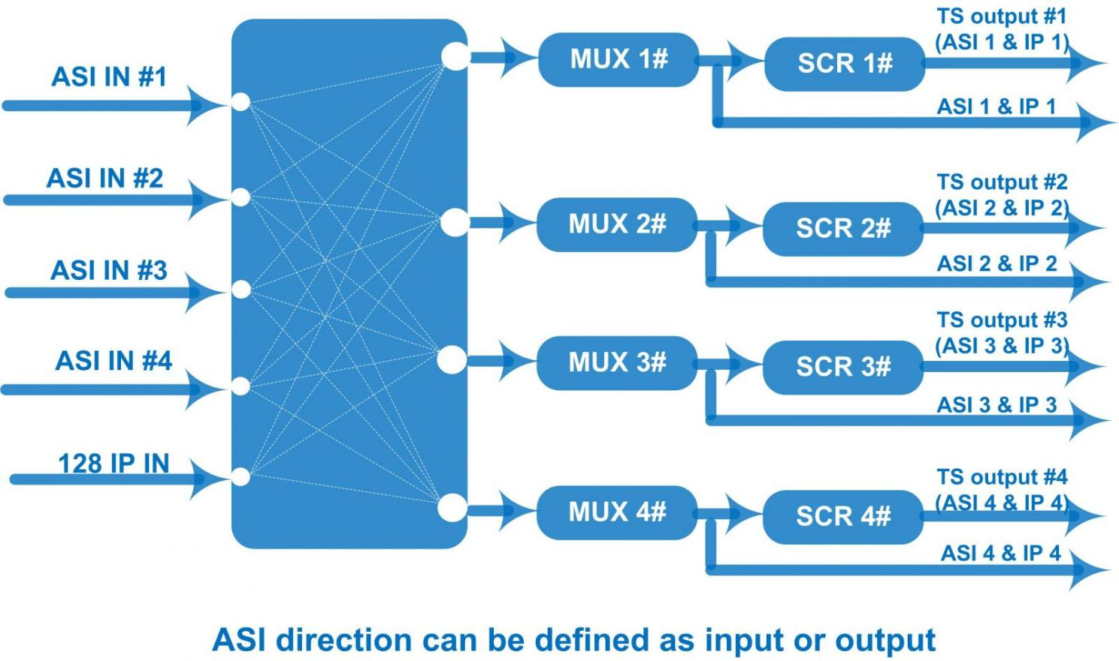

Specifications
Input / Output | 4 bi-direction ASI ports: max 4 ASI input/output, BNC 75Ω  3 bi-direction Data ports (RJ45): 128 IP input over UDP/RTP  4 IP (MPTS) output over UDP/RTP/RTSP  100/1000Mbps self-adaption
Input / Output | Input Packet format: 204/188 self-adaption
Input / Output | ASI: Max output bit-rate: 200Mbps (Each channel)
Mux | Max PIDs |  | 512 per channel
Mux | Functions |  | PID re-mapping
Mux |  |  | PCR accurate adjusting
Mux |  |  | Automatic generating PSI/SI table
Mux | PID transparent |  | Any PID transparent and mapping achievable
Scrambling  Parameters | Max simulcrypt CA |  | 4
Scrambling  Parameters | Scramble Standard |  | ETR289, ETSI 101 197, ETSI 103 197
Scrambling  Parameters | Scramble Channel |  | 1
Scrambling  Parameters | Connection |  | Local/remote connection
System | Web-based management
System | Language: English and Chinese
System | Ethernet software upgrade
General | Dimensions | 482mm×300mm×44mm (WxLxH)
General | Weight | 3.5kg
General | Temperature | 0~45℃(operation), -20~80℃(storage)
General | Power supply | AC 110V±10%, 50/60Hz Or AC 220V±10%, 50/60Hz
General | Consumption | ≤40W

About Us
FMUSER is a company specializing in broadcasting and television transmission systems and integrating hotel IPTV systems. The company was established in 2009 and has served over 180 countries worldwide. More than 20,000 television stations, radio stations, and hotel clients from different.

Contact:Tomleequan Email：sales@fmuser.com whatsapp: +8613922702227

