FUQ-4619X-Y IPTV Gateway 8 Data Ports SRT-HTTP-UDP-RTP-RTSP-HLS-RTMP IP Protocol Conversion Web-Based NMS Commercial IPTV & Android STB Deployment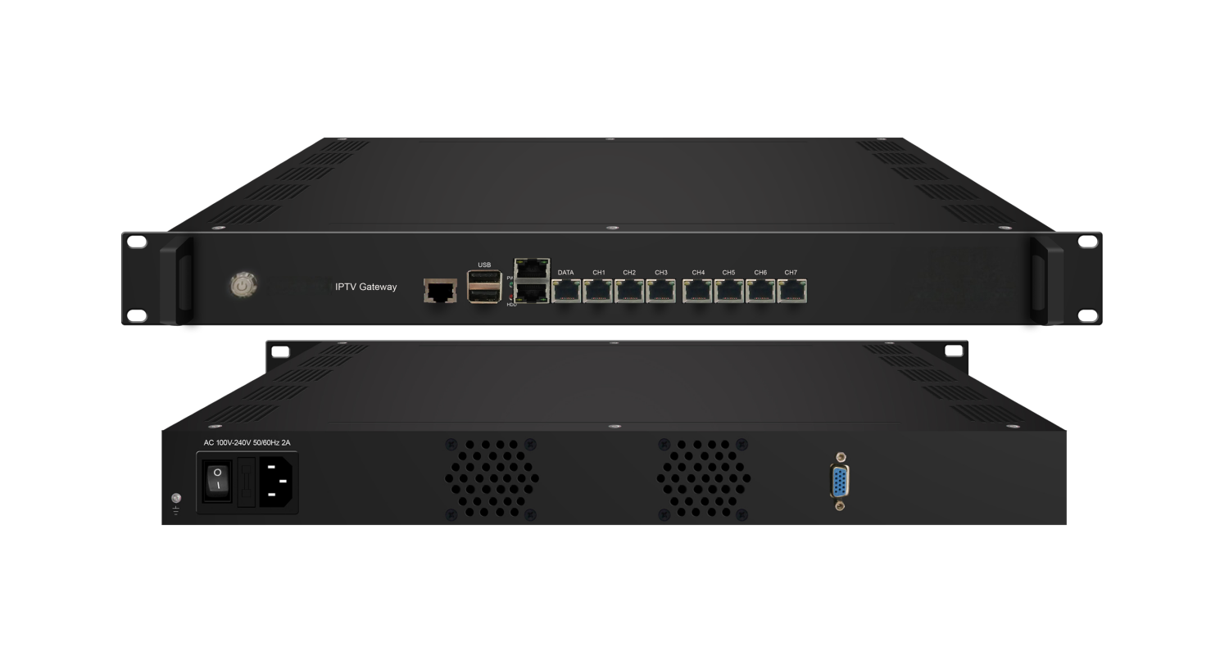
Product overview
The FUQ-4619X-Y IPTV Gateway converts and distributes IP streams via 8 data ports, supporting input protocols (SRT/HTTP/UDP/RTP/RTSP/HLS) and output formats (SRT/HTTP/UDP/HLS/RTMP). It processes TS files through web uploads and delivers ~80 HD/SD programs via UDP multicast with ≤80% CPU load. This 1RU rack-mount device features web-based NMS control and is ideal for commercial IPTV services and Android STB/TV deployments (150+ terminals).
Key feature
Anti-jitter & customization: Stabilizes streams and allows APK-based branding
IP Protocol Conversion
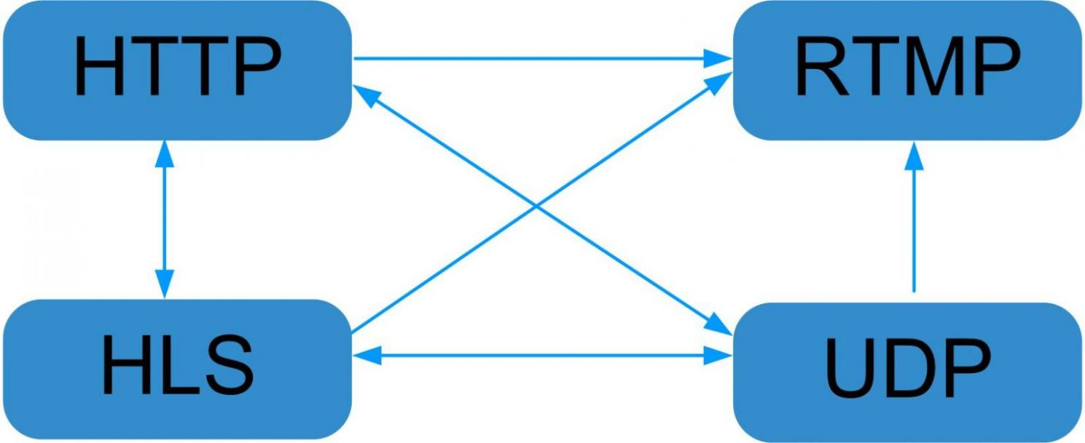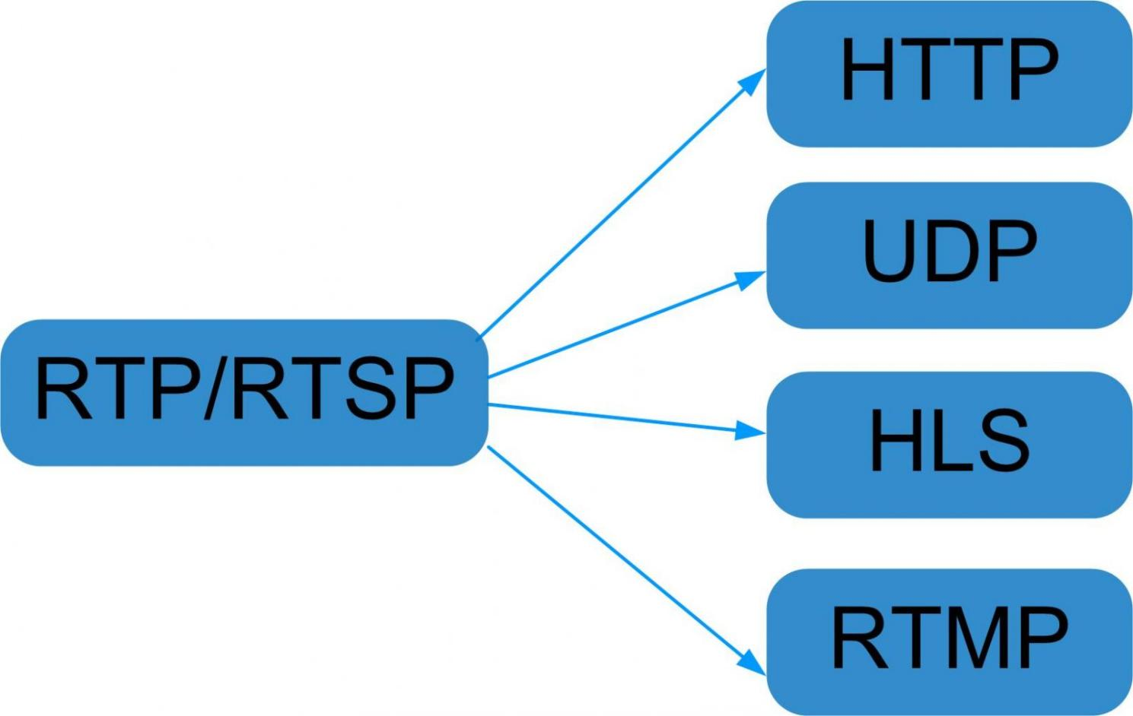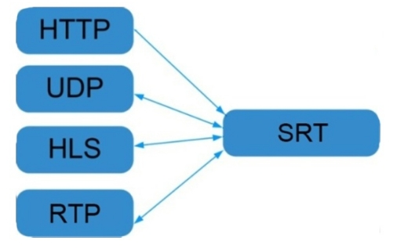

General Principle Chart

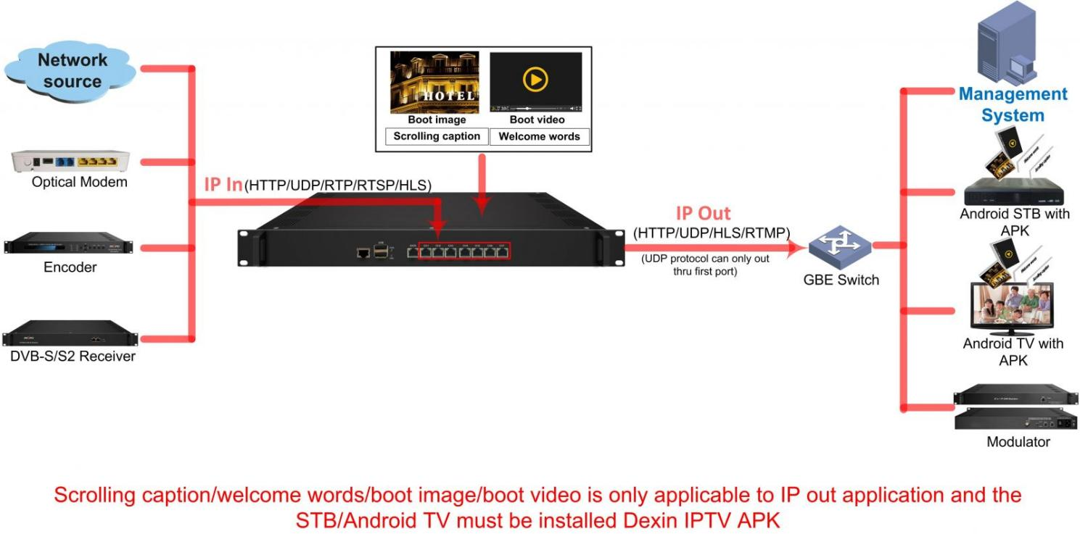

Specifications
Input | IP input thru CH 1-7(1000M) over SRT, HTTP, UDP(SPTS), RTP(SPTS), RTSP (over UDP, payload: mpeg TS) and HLS
Input | TS files uploading through Web management
IP output | IP out thru Data port (1000M) over SRT,HTTP (Unicast), UDP(SPTS, Multicast) HLS and RTMP(Program source should be H.264 and AAC encoding)
System | Memory: | 8G
System | Solid-State Disk(SSD): 120G (240G optional)
System | Channel switching time with FMUSER’ STB: HTTP (1-3s), HLS (0.4-0.7s)
System | Support adding scrolling caption, welcome words, boot image and boot video (this function is only applicable to IP out application and the STB/Android TV must be installed FMUSER IPTV APK)
System | Play programs with APK downloaded android STB and TV, maximum 150 terminals(See details in below Test data for reference)
System | Support about 80 HD/SD programs (Bitrate:2Mbps) When SRT/HTTP/RTP/RTSP/HLS is converted into UDP (Multicast), the actual application shall prevail, and suggest maximum 80% CPU utilization
System | web-based NMS management thru DATA port
General | Demission | 482mm×324mm×44mm (WxLxH)
General | Temperature | 0~45℃(operation), -20~80℃(storage)
General | Power Supply | AC100V±10%, 50/60Hz or AC 220V±10%, 50/60Hz

Test data for reference:
Protocol conversion | Programs | Bitrate | Terminals | CPU utilization
HTTP/RTP/RTSP/HLS to UDP | 80 | 2M | --- | 55%
HTTP to HTTP | 30 | 2M | 300 | 80%
HTTP to HTTP | 50 | 2M | 160 | 80%
HTTP to HLS | 50 | 2M | 400 | 46%
UDP to HLS | 50 | 2M | 400 | 50%
UDP to HLS | 80 | 2M | 300 | 72%
UDP to HTTP | 50 | 2M | 240 | 50%
UDP to SRT | 50 | 2M | --- | 50%
UDP to SRT | 80 | 2M | --- | 75%

Order Guide:
 |  | 3508F-M | 3508S-M | 3508I
Size |  | 1U | 2U | 2U
Hardware | Memory | 8G | 8G | 16G
Hardware | Solid-State Disk(SSD) | 120G SSD | 120G SSD | 120G SSD
Hardware | Mechanical Hard Disk | / | 4T SATA | 4T SATA
Data Port Number |  | 8 | 8 | 9
10G Port (SFP+) |  | / | / | SFP+
Middleware |  | live+IPTV | live+IPTV | live+IPTV
load capacity | Input Channels | HD（8M）*40 | HD（8M）*40 | HD（8M）*60
load capacity | User Number | 120 | 120 | 600
VOD load |  | ≤20 | ≤50 | ≤50

About Us
FMUSER is a company specializing in broadcasting and television transmission systems and integrating hotel IPTV systems. The company was established in 2009 and has served over 180 countries worldwide. More than 20,000 television stations, radio stations, and hotel clients from different.

Contact:Tomleequan Email：sales@fmuser.com whatsapp: +8613922702227

