FMUSER FUQ-4633 HD Encoder Modulator 1 HDMI Input DVB-T RF Output MPEG-4 AVC/H.264 Encoding All-in-One Signal Conversion for Broadcast Security Hospitality
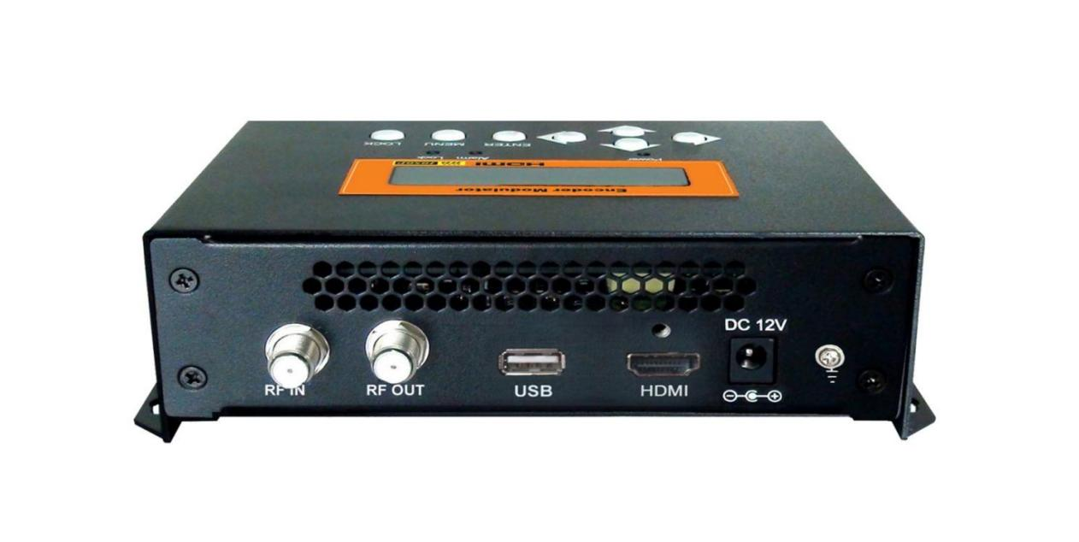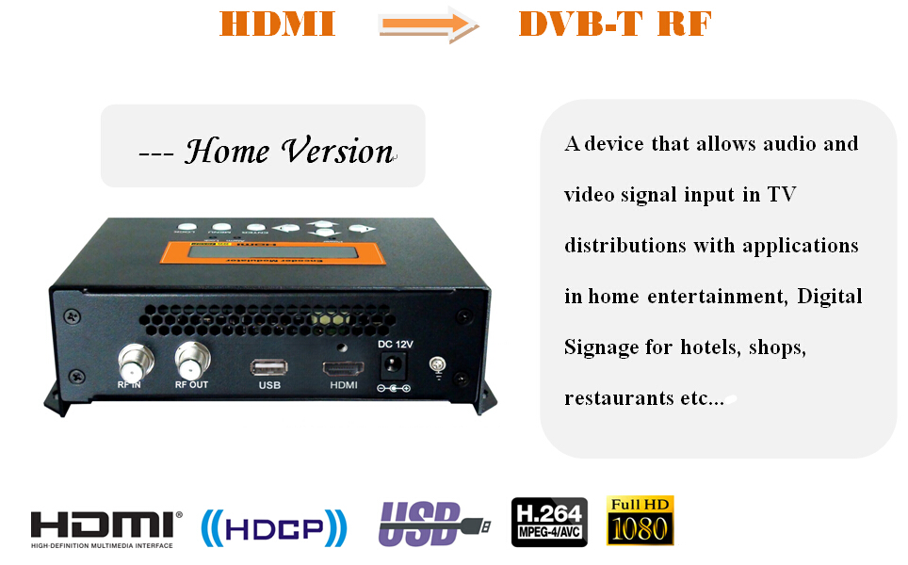

Product overview
The FMUSER FUQ-4633 HD Encoder Modulator integrates 1 HDMI input and RF output with MPEG-4 AVC/H.264 encoding and DVB-T modulation. It processes audio/video signals by encoding and modulating them for RF transmission. This device is ideal for home entertainment, surveillance systems, and commercial applications like hotel digital signage.
Key feature
- Supports H.264 video encoding with auto detect for MP@L 3.0/3.1/4.0.
- Features MPEG-1 Layer 2 and MPEG-2 AAC audio encoding.
- Provides RF output at 142.5-858 MHz with adjustable level from -14 to +6 dBm.
- Includes 1 HDMI input for simplified source connectivity.
- Enables system upgrades via USB port with external disk support.
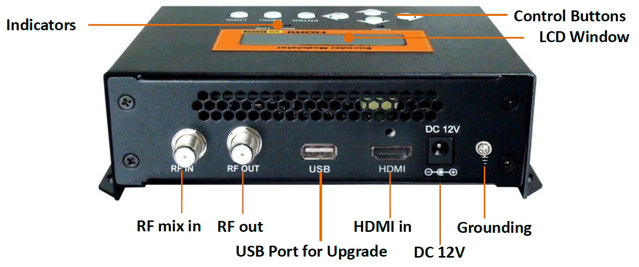

System Connection
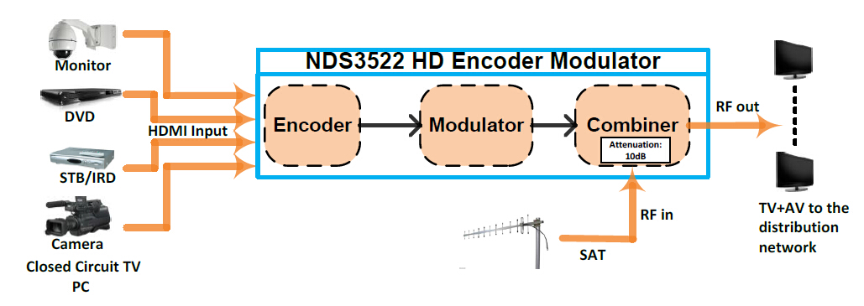

Technical Specifications
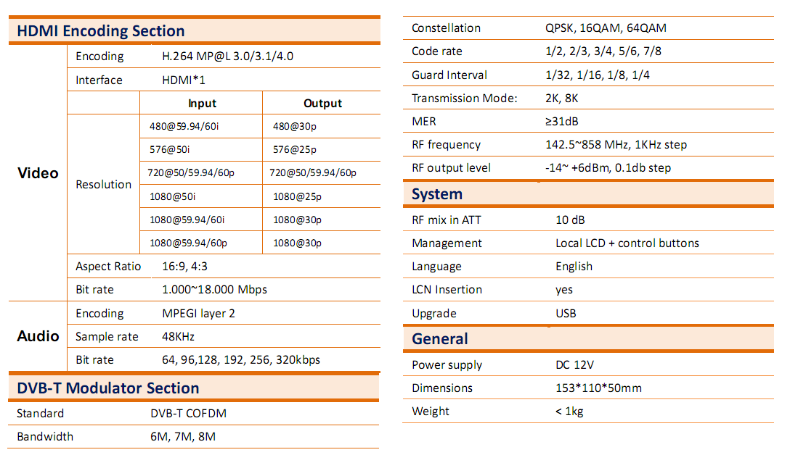

Typical Applications


Main Technical Comparison between FU-4633 and FU-4667 (HD, DVB-T Version)
Items | FU-4633 | FU-4667 (HD, DVB-T )
Interface | HDMI | HDMI/YPbPr/CVBS/S-Video
Video Encoding | H.264 MP@L 3.0/3.1/4.0  Auto detect and configure | H.264 BP/MP/HP@L 3.0/3.1/3.2/4.0/4.1/4.2  Profile and level can be manually set
Resolutions | Input and output scanning format and frame rate change | Input and output scanning format and frame rate keep the same
Audio Encoding | MPEGI layer 2, MPEG-2 AAC | MPEG1 Layer II, MPEG2-AAC, MPEG4-AAC
MER | ≥31dB | ≥42dB
RF Frequency | 142.5~858 MHz | 30~960MHz
Output Level | -14~ +6dBm | -16~ -36dBm
USB (External USB Disk) | System upgrade | System upgrade, TS record and playback

About Us
FMUSER is a company specializing in broadcasting and television transmission systems and integrating hotel IPTV systems. The company was established in 2009 and has served over 180 countries worldwide. More than 20,000 television stations, radio stations, and hotel clients from different.

Contact:Tomleequan Email：sales@fmuser.com whatsapp: +8613922702227

