FMUSER FUQ-4633B HD Encoder Modulator HDMI Input to RF Output MPEG2 Encoding Multi-Standard DVB-C-T-ATSC-ISDB-T Modulation Web-NMS Control for TV Distribution and Surveillance
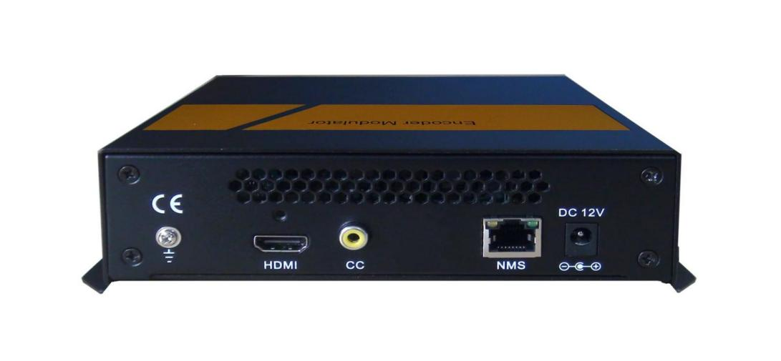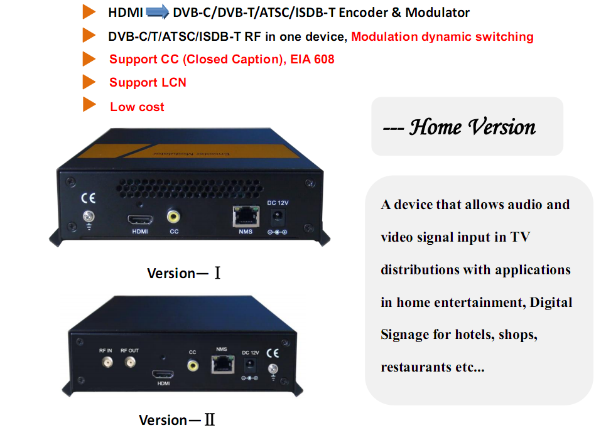
Product overview
The FMUSER FUQ-4633D is an HD Encoder Modulator that accepts HDMI input signals and outputs RF signals. It performs MPEG2 encoding and modulation to convert audio/video signals into broadcast-ready formats. Available in compact sizes (e.g., 20314452mm or 18011039.5mm), it supports management via Web or NMS. Ideal for TV distribution in home entertainment, surveillance, and commercial applications.
Key feature
Supports MPEG2 video encoding at 1.000-20.000 Mbps and audio in MPEG1 layer 2, AAC, AC3 formats.
Features multi-standard modulation including DVB-C, DVB-T, ATSC, ISDB-T with RF frequency 100-1000MHz and level -63 to -16dBm.
Offers flexible management via Web or NMS, with upgrade options.
Accepts HDMI input from sources like STBs, satellite receivers, CCTV cameras.
Compact design with dimensions 20314452mm or 18011039.5mm for space efficiency.
System Connection

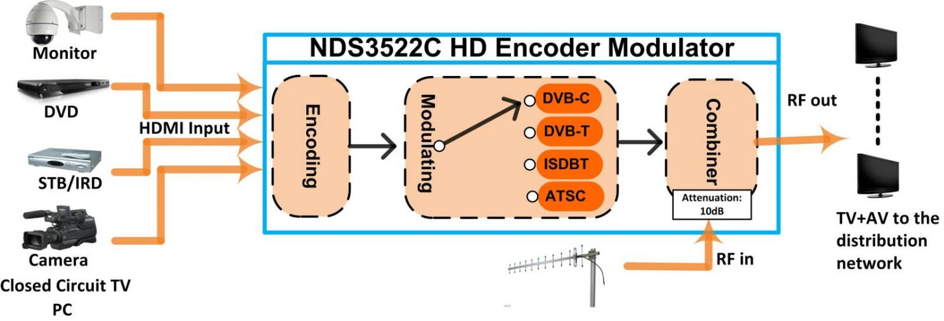
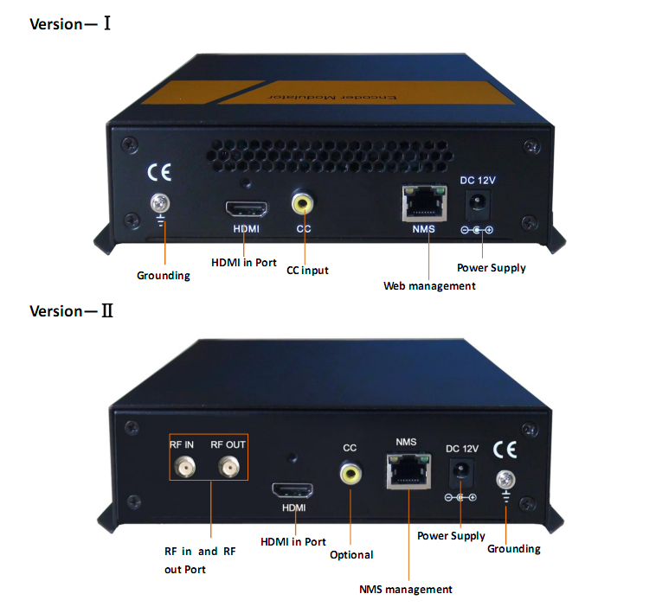

Technical Specifications
HDMI Encoding Section
Video | Encoding |  |  | MPEG2
Video | Interface |  |  | HDMI*1
Video | Input |  |  | Output
Video | 480@59.94/60i |  |  | 480@30p
Video | 576@50i |  |  | 576@25p
Video | 720@50/59.94/60p |  |  | 720@25/30p
Video | 1080@50i |  |  | 1080@25p
Video | 1080@59.94/60i |  |  | 1080@30p
Video | 1080@50p |  |  | 1080@25p
Video | 1080@59.94/60p |  |  | 1080@30p
Video | Aspect Ratio |  |  | 16:9
Video | Bit rate |  |  | 1.000~20.000 Mbps
Audio | Encoding |  |  | MPEGI layer 2, AAC, AC3
Audio | Sample rate 48KHz
Audio | Bit rate |  |  | MPEGI layer 2（192kbps）
Audio |  |  |  | AAC（VBR）
Audio |  |  |  | AC3（128kbps）
DVB-C Modulator Section
Standard |  |  | J.83A (DVB-C), J.83B
MER |  |  | ≥35dB
RF frequency |  |  | 100-1000MHz, 1KHz step
RF output level |  |  | -63~ -16dBm, 1dB step
Symbol rate |  |  | 3.000~7.000Msps adjustable
 |  | J.83A |  |  | J.83B
Constellation |  | 16/32/64/128/ 256 QAM |  |  | 64/ 256 QAM
Bandwidth |  | 8M |  |  | 6M
DVB-T Modulator Section
Standard |  | DVB-T COFDM
Bandwidth |  | 2M, 3M, 4M, 5M, 6M, 7M, 8M (Version—Ⅰ)  6M, 7M, 8M (Version—Ⅱ)
Constellation |  | QPSK, 16QAM, 64QAM
Code rate |  | 1/2, 2/3, 3/4, 5/6, 7/8
Guard Interval |  | 1/32, 1/16, 1/8, 1/4
Transmission Mode: |  | 2K, 8K
MER |  | ≥35dB
RF frequency |  | 100-1000MHz, 1KHz step
RF output level |  | -63~ -16dBm, 1dB step
ISDB Modulator Section
Standard |  | ARIB STD-B31
Constellation |  | QPSK, 16QAM, 64QAM
Guard Interval |  | 1/32, 1/16, 1/8, 1/4
Transmission Mode |  | 2K, 4K, 8K
Code rate |  | 1/2, 2/3, 3/4, 5/6, 7/8
RF frequency |  | 100~1000MHz, 1KHz step
RF output level |  | -63~ -16dBm, 1dB step
ATSC Modulator Section
Standard |  | ATSC A/53
Constellation |  | 8 VSB
RF output level |  | -63~-16dBm (44~91 dBµV), 1dB step
MER |  | ≥35dB
RF frequency |  | 100~1000MHz, 1KHz step
RF output level |  | -63~ -16dBm, 1dB step
System
Management |  | Web (Version—Ⅰ)  NMS (Version—Ⅱ)
Language |  | English
Upgrade |  | Web update (Version—Ⅰ)  ST Link utility (Version—Ⅱ)
General
Power supply |  | DC 12V
Dimensions |  | 203*144*52mm (Version—Ⅰ)  180*110*39.5mm (Version—Ⅱ)
Weight |  | < 1kg

Comparison
Device | CC input | Management | Upgrade
FU-4633C (Version—Ⅰ) | √ | Web | Web
FU-4633C (Version—Ⅱ) | Optional | NMS | ST Link utility



About Us
FMUSER is a company specializing in broadcasting and television transmission systems and integrating hotel IPTV systems. The company was established in 2009 and has served over 180 countries worldwide. More than 20,000 television stations, radio stations, and hotel clients from different.

Contact:Tomleequan Email：sales@fmuser.com whatsapp: +8613922702227

