FMUSER FUQ-4633C HDMI-CVBS Input HD-SD Encoder Modulator ISDB-T-DVB-T Dual Standard H.264 Encoding RF Output for Surveillance Digital Signage 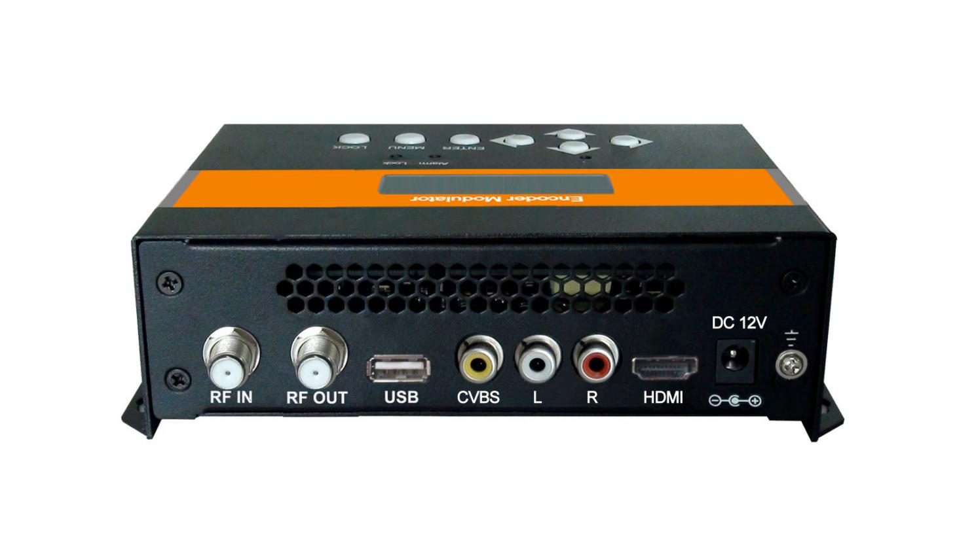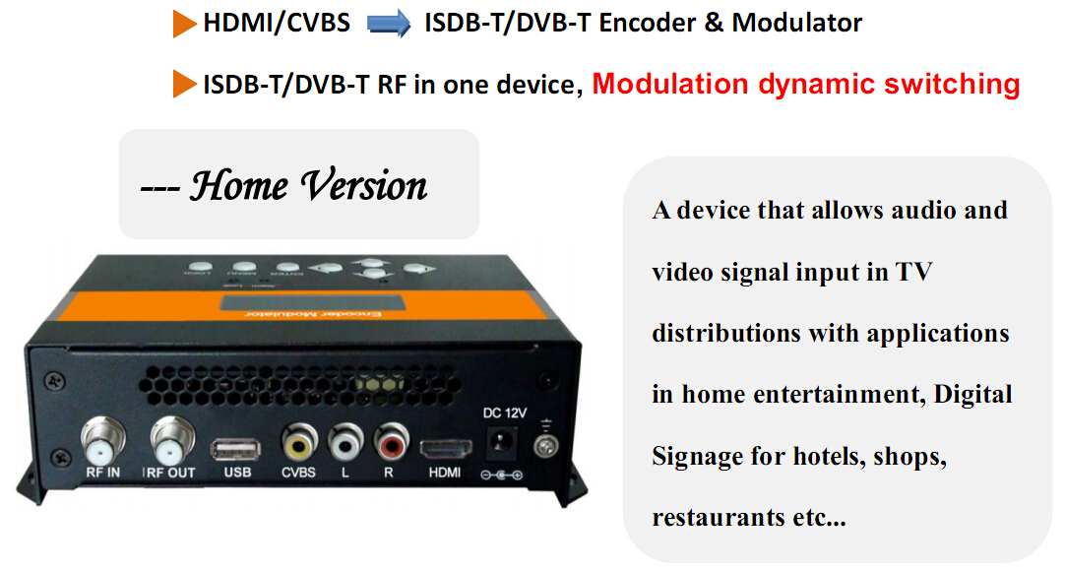

Product overview
The FMUSER FUQ-4633C is an HD/SD encoder modulator that accepts HDMI and CVBS inputs and outputs ISDB-T or DVB-T RF signals. It encodes video using H.264 MPEG-4 AVC and modulates for RF transmission. With local LCD control and USB upgrade, it supports easy configuration. Ideal for home entertainment, surveillance systems, and digital signage broadcasting.
Key feature
- Supports dual-standard modulation: ISDB-T (ARIB STD-B31) and DVB-T (COFDM) with 6M/7M/8M bandwidths.
- Features H.264 MPEG-4 AVC video encoding at 1.000-18.000 Mbps and MPEG-1 Layer 2 audio at 48KHz.
- Accepts HDMI and CVBS inputs, handling resolutions up to 1080p/i.
- Provides adjustable RF output with 150-950MHz frequency range and -47 to 0 dBm level.
- Includes local LCD management and USB upgrade for system maintenance.
System Connection

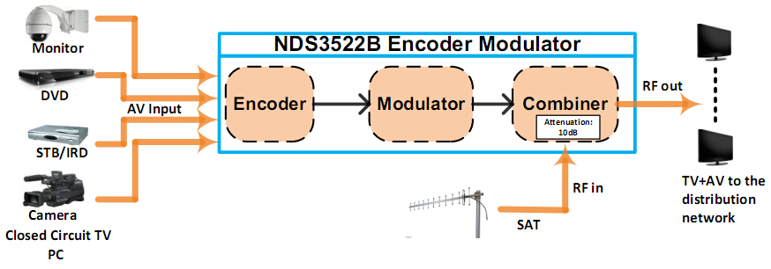

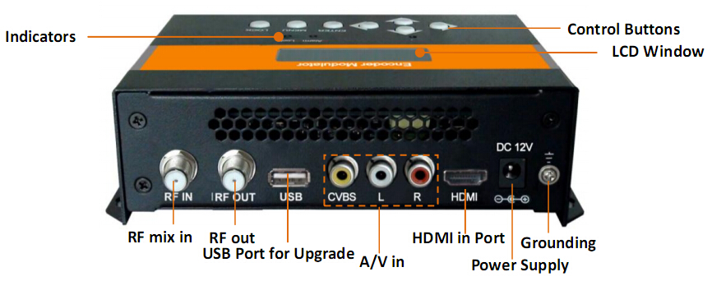

Technical Specifications

HDMI Encoding Section
Video | Encoding |  | H.264 MP@L 3.0/3.1/4.0
Video | Interface |  | HDMI*1
Video |  |  | Input |  | Output
Video | Resolution |  | 480@59.94/60p |  | 480@60p
Video |  |  | 480@59.94/60i |  | 480@30p
Video |  |  | 576@50i |  | 576@25p
Video |  |  | 720@50/59.94/60p |  | 720@50/59.94/60p
Video |  |  | 1080@50i |  | 1080@25p
Video |  |  | 1080@59.94/60i |  | 1080@30p
Video |  |  | 1080@59.94/60p |  | 1080@30p
Video | Aspect Ratio |  | 16:9, 4:3
Video | Bit rate |  | 1.000~18.000 Mbps
Audio | Encoding |  | MPEGI layer 2
Audio | Sample rate |  | 48KHz
 | Bit rate |  | 64, 96,128, 192, 256, 320kbps
CVBS Encoding Section
Video | Encoding |  |  | H.264 MP@L 3.0
Video | Interface |  |  | CVBS*1 (RCA)
Video | Resolution |  |  | Input |  | Output
Video |  |  |  | 480@60p |  | 480@60p
Video |  |  |  | 480@60i |  | 480@30p
Video |  |  |  | 576@50p |  | 576@50p
Video |  |  |  | 576@50i |  | 576@25p
Video | Aspect Ratio |  |  | 4:3
Video | Bit rate |  |  | 1.000~18.000 Mbps
Audio | Encoding |  |  | MPEGI layer 2
Audio | Interface |  |  | Analog Stereo/Mono (Unbalanced RCA)
Audio | Sample rate |  |  | 48KHz
Audio | Bit rate |  |  | 64, 96,128, 192, 256, 320kbps
ISDB-T Modulator Section
Standard |  | ARIB STD-B31
Bandwidth |  | 6M
Constellation |  | QPSK, 16QAM, 64QAM
Guard Interval |  | 1/32, 1/16, 1/8, 1/4
Transmission Mode |  | 2K, 4K, 8K
MER |  | ≥30dB
RF frequency |  | 150~950MHz, 0.1MHz step
RF output level |  | -47~ 0 dBm (60~107 dbµV), 1db step
DVB-T Modulator Section
Standard |  | DVB-T COFDM
Bandwidth |  | 6M, 7M, 8M
Constellation |  | QPSK, 16QAM, 64QAM
Code rate |  | 1/2, 2/3, 3/4, 5/6, 7/8
Guard Interval |  | 1/32, 1/16, 1/8, 1/4
Transmission Mode: |  | 2K, 8K
MER |  | ≥31dB
RF frequency |  | 150~950 MHz,0. 1KHz step
RF output level |  | -47~ 0 dBm (60~107 dbµV), 1db step
System
RF mix in ATT |  | 10 dB
Management |  | Local LCD + control buttons
Language |  | English
Upgrade |  | USB
General
Power supply |  | DC 12V
Dimensions |  | 183*110*50mm
Weight |  | < 1kg

Typical Applications

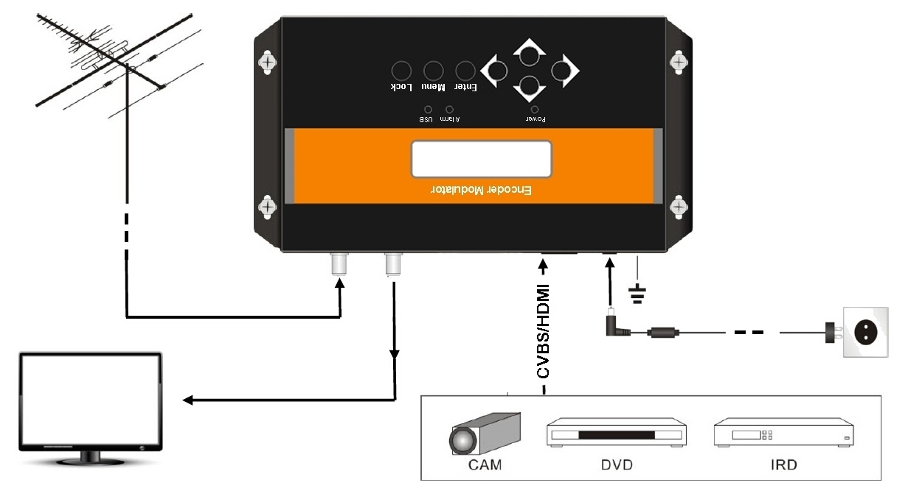
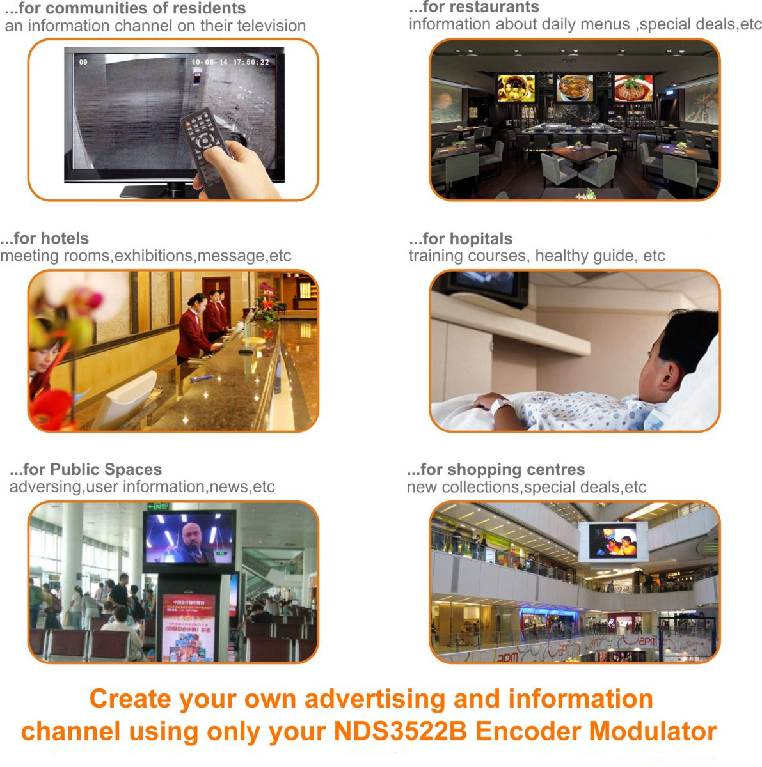

About Us
FMUSER is a company specializing in broadcasting and television transmission systems and integrating hotel IPTV systems. The company was established in 2009 and has served over 180 countries worldwide. More than 20,000 television stations, radio stations, and hotel clients from different.

Contact:Tomleequan Email：sales@fmuser.com whatsapp: +8613922702227

