FMUSER FUQ-4635 HD-SD Encoder Modulator HDMI-CVBS Input DVB-T RF Output MPEG-4 AVC-H264 Integrated Encoding Modulation for Home Entertainment Surveillance Hotel Digital Signage
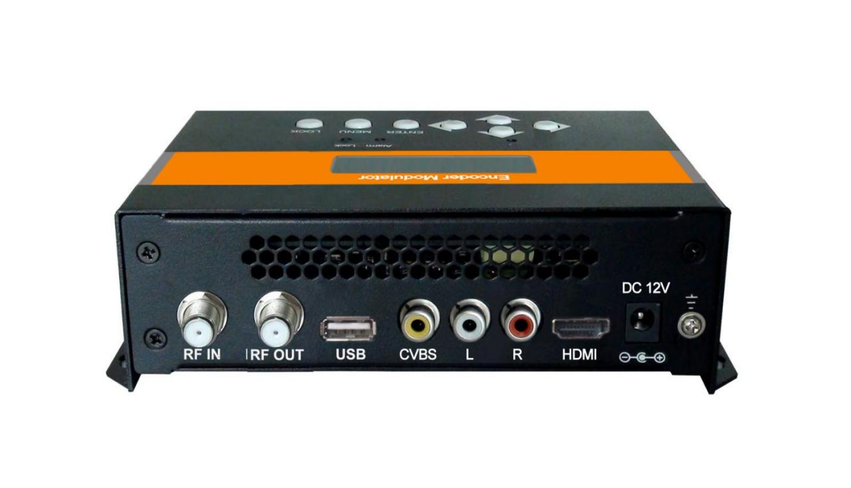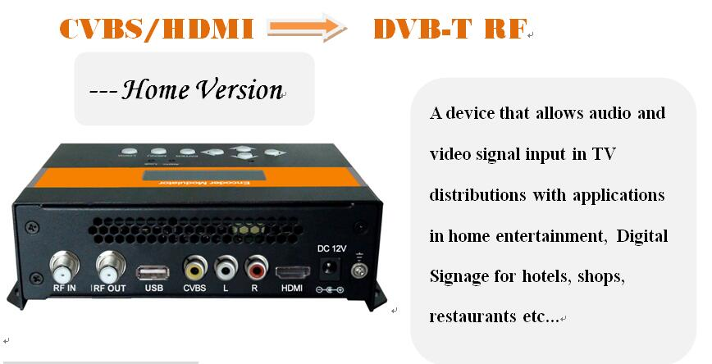

Product overview
The FMUSER FUQ-4635 HD/SD Encoder Modulator integrates MPEG-4 AVC/H.264 encoding and modulation to convert audio/video signals. It handles inputs from STB, satellite receivers, CCTV cameras, and antenna into DVB-T RF output. Designed for consumer electronics, it suits home entertainment, surveillance control, and hotel digital signage.

Key feature
Integrated MPEG-4 AVC/H.264 encoding and modulation for DVB-T RF output.
Supports multiple input sources including STB, satellite receivers, and CCTV cameras.
Offers flexible model options: CVBS input (SD), HDMI input (HD), or HDMI+CVBS input (SD&HD).
Designed for applications in home entertainment, surveillance control, and hotel digital signage.

System Connection
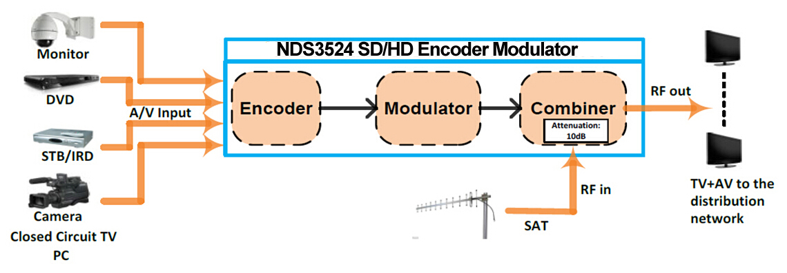

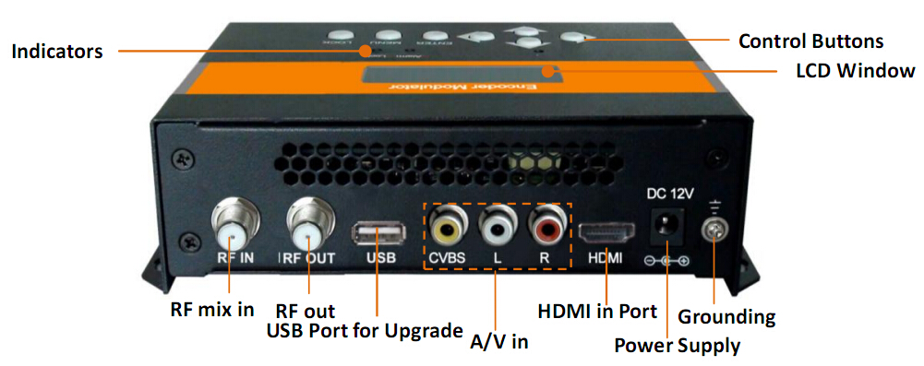
Technical Specifications
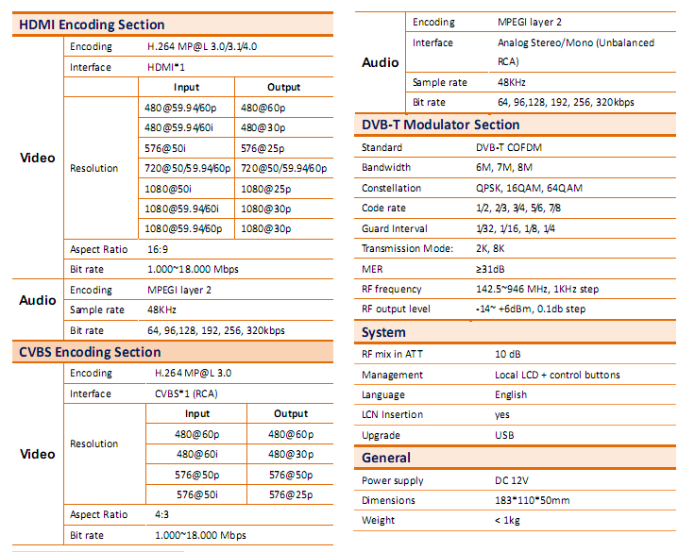

Order information
 | SD | HD | SD&HD
FU-4635(CVBS input only) | √
FU-4635(HDMI input only) |  | √
FU-4635(HDMI+CVBS input) |  |  | √

Typical Applications
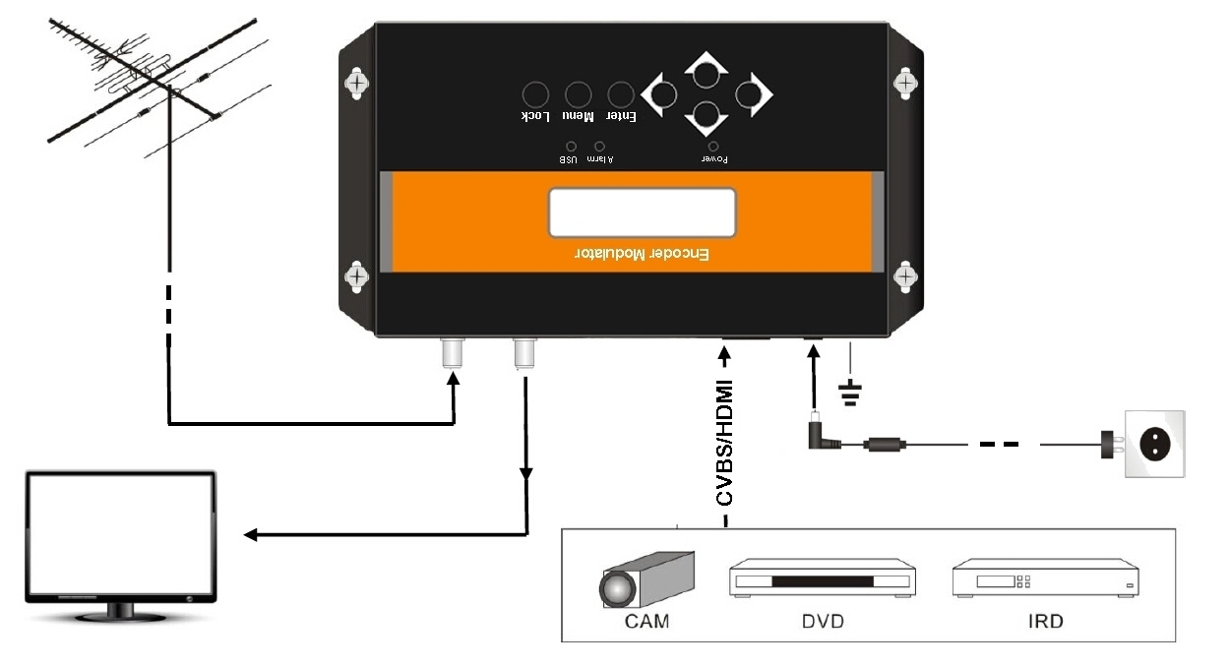


About Us
FMUSER is a company specializing in broadcasting and television transmission systems and integrating hotel IPTV systems. The company was established in 2009 and has served over 180 countries worldwide. More than 20,000 television stations, radio stations, and hotel clients from different.

Contact:Tomleequan Email：sales@fmuser.com whatsapp: +8613922702227

