FMUSER FUQ-4635B Encoder Modulator 1-4-8 HDMI Inputs MPEG2 Encoding Multi-Standard RF DVB-C-DVB-T-ATSC-ISDB-T-DTMB Web NMS Control Broadcast Systems Cable TV Headend 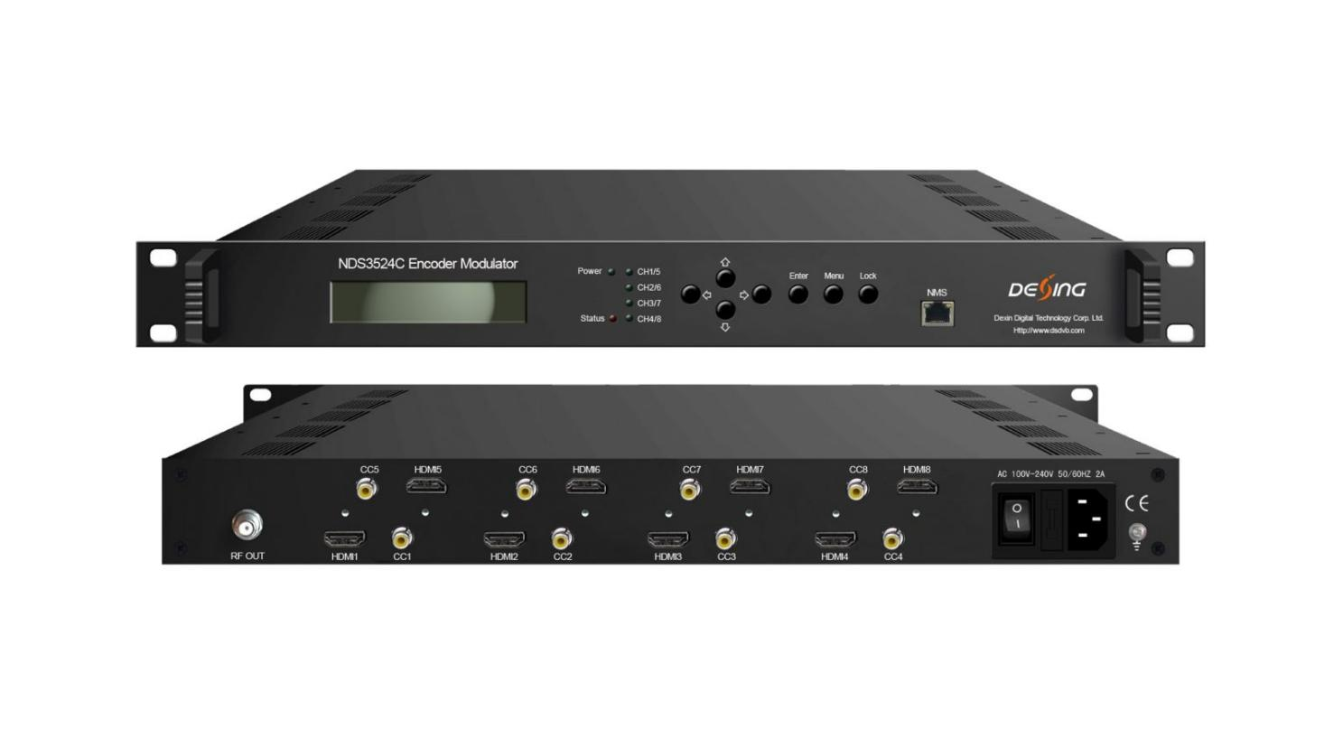Product Overview
The FUQ-4635D Encoder Modulator integrates MPEG2 encoding and modulation, supporting scalable 1/4/8 HDMI inputs and multi-standard RF outputs including DVB-C, DVB-T, ATSC, ISDB-T, and DTMB. It converts audio/video signals into encoded and modulated RF formats. This device features a modular design and web-based NMS for control. Ideal for broadcast systems and cable TV headends.
Key feature
Supports scalable 1/4/8 HDMI inputs for flexible source integration.
Features MPEG2 video encoding with resolutions up to 1080p/i, 720p, 576i, and 480i.
Offers low latency operation from 50ms to 1000ms.
Provides multi-standard RF output including DVB-C, DVB-T, ATSC, ISDB-T, and DTMB with dynamic switching.
Includes web-based NMS for easy control and updates.

Inner Principle Chart

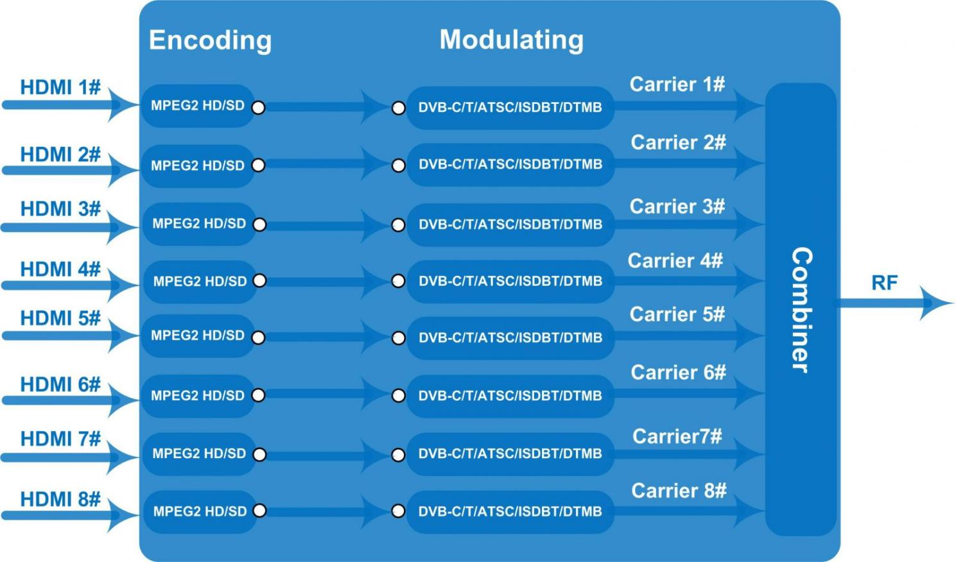

Specifications
HDMI Encoding Section
Input |  | Interface | HDMI*1/4/8
Video |  | Encoding | MPEG2
 |  | Input | Output
 |  | 480@59.94/60i | 480@30p
 |  | 576@50i | 576@25p
 |  | 720@50/59.94/60p | 720@25/30p
 |  | 1080@50i | 1080@25p
 |  | 1080@59.94/60i | 1080@30p
 |  | 1080@50p | 1080@25p
 |  | 1080@59.94/60p | 1080@30p
 |  | Bit-rate | 2.000~20.000 Mbps
 |  | GOP | 1~60
 |  | Rate Control | VBR
 |  | Aspect Ratio | 16 :9
Audio |  | Encoding | MPEGI layer 2,MPEG-2 AAC, AC3
 |  | Sample rate | 48KHz
 |  | Bit rate | MPEGI layer 2 (128kbps)
 |  | Bit rate | MPEG-2 AAC (VBR)
 |  | Bit rate | AC3 (128kbps)
DVB-C Modulator Section
Standard |  | J.83A (DVB-C), J.83B
MER |  | ≥35dB
RF frequency |  | 100-1000MHz, 1KHz step
RF output level |  | -48~ -10dBm, 1dB step
Symbol rate |  | 3.000~7.000Msps adjustable
 |  | J.83A | J.83B
Constellation |  | 16/32/64/128/256QAM | 64/ 256QAM
Bandwidth |  | 8M | 6M
DVB-T Modulator Section
Standard |  | DVB-T COFDM
Bandwidth |  | 2M, 3M, 4M, 5M, 6M, 7M, 8M
Constellation |  | QPSK, 16QAM, 64QAM
Code rate |  | 1/2, 2/3, 3/4, 5/6, 7/8
Guard Interval |  | 1/32, 1/16, 1/8, 1/4
Transmission Mode |  | 2K, 8K
MER |  | ≥35dB
RF frequency |  | 100-1000MHz, 1KHz step
RF output level |  | -48~ -10dBm, 1dB step
ISDB Modulator Section
Standard |  | ARIB STD-B31
Constellation |  | QPSK, 16QAM, 64QAM
Guard Interval |  | 1/32, 1/16, 1/8, 1/4
Transmission Mode |  | 2K, 4K, 8K
Code rate |  | 1/2, 2/3, 3/4, 5/6, 7/8
RF frequency |  | 100~1000MHz, 1KHz step
RF output level |  | -48~ -10dBm, 1dB step
ATSC Modulator Section
Standard |  | ATSC A/53
Constellation |  | 8 VSB
RF output level |  | -48~ -10dBm, 1dB step
MER |  | ≥35dB
RF frequency |  | 100~1000MHz, 1KHz step
DTMB Modulator Section
RF frequency |  | 100-1000MHz, 1KHz step
RF output level |  | -48~ -10dBm, 1dB step
Transmission Mode |  | S-0.8-4QAM-595, S-0.8-16QAM-595, M-0.4-16QAM-945V,  M-0.6-16QAM-945V, M-0.6-64QAM-420V, M-0.6-64QAM-945V,  M-0.8-16QAM-420V, M-0.8-16QAM-945V, M-0.8-64QAM-420V,
System
Management | Web
Language | English
Upgrade | Web update
General
Power supply | AC 100V±10%, 50/60Hz or AC 220V±10%, 50/60Hz
Dimensions | 482*328*44.5mm
Temperature | 0~45℃(operation),  -20~80℃(storage)

Technical Comparison
 | FU-4653A | FU-4653I | FU-4635C
Chipset | Vixs | Hisilicon | VATek
Stream Input | 1*ASI input for re-mux | 1 DVB-C tuner | N/A
IP Input | N/A | 128*IP | N/A
Video Channel | 4* HDMI/SDI input optional | 4/8/12*HDMI input optional | 1/4/8*HDMI input optional
Video Encode | MPEG2 & MPEG4 AVC/H.264 | MPEG-4 AVC/H.264 | MPEG2
Video Bit Rate | 0.8~19Mbps for H.264 encoding  1~19Mbps for MPEG-2 encoding | 1Mbps~13Mbps each channel  (Bit rate is with a high fluctuation, suitable for cable system, not suitable for satellite uplink) | 2~20Mbps each channel
Resolution | Up to 1920*1080@50P/60P (MPEG4 AVC/H.264)  Up to 1920*1080@50I/60I (MPEG2 HD) | Up to 1920*1080@50P/60P | Up to 1920*1080@50P/60P
Audio Encode | MPEG1 Layer 2, MPEG2-AAC, MPEG4-AAC,  AC3 2.0 (Optional) | MPEG-1 Layer 2 | MPEGI layer 2, MPEG2-AAC, AC3
Audio Gain | N/A | Yes | N/A
OSD Function | N/A | Yes | N/A
CC Input | CC (Closed Caption)for SDI interface (Optional), EIA608, EIA708 | N/A | CC (Closed Caption), EIA 608
Low Latency | Yes | N/A | Yes
ASI output | Yes | N/A | N/A
IP output | 4 SPTS or 1 MPTS output | 4 MPTS IP output | N/A
Modulating | 4*DVB-C/2* DVB-T/4*ATSC-T  /1/2*ISDB-T RF out | 4*DVB-C/DVB-T RF out | 4/8*DVB-C/T/ATSC/ISDB-T RF out in one device, Modulation dynamic switching
RF Frequency | 30~960MHz, 1KHz step | 50~960MHz, 1KHz step | 100-1000MHz, 1KHz step

About Us
FMUSER is a company specializing in broadcasting and television transmission systems and integrating hotel IPTV systems. The company was established in 2009 and has served over 180 countries worldwide. More than 20,000 television stations, radio stations, and hotel clients from different.

Contact:Tomleequan Email：sales@fmuser.com whatsapp: +8613922702227

