FMUSER FUQ-4635S HDMI Encoder Modulator 4 HDMI Inputs 2 RF DVB-C-T Outputs MPEG-4 AVC H.264 CATV Headend IPTV System

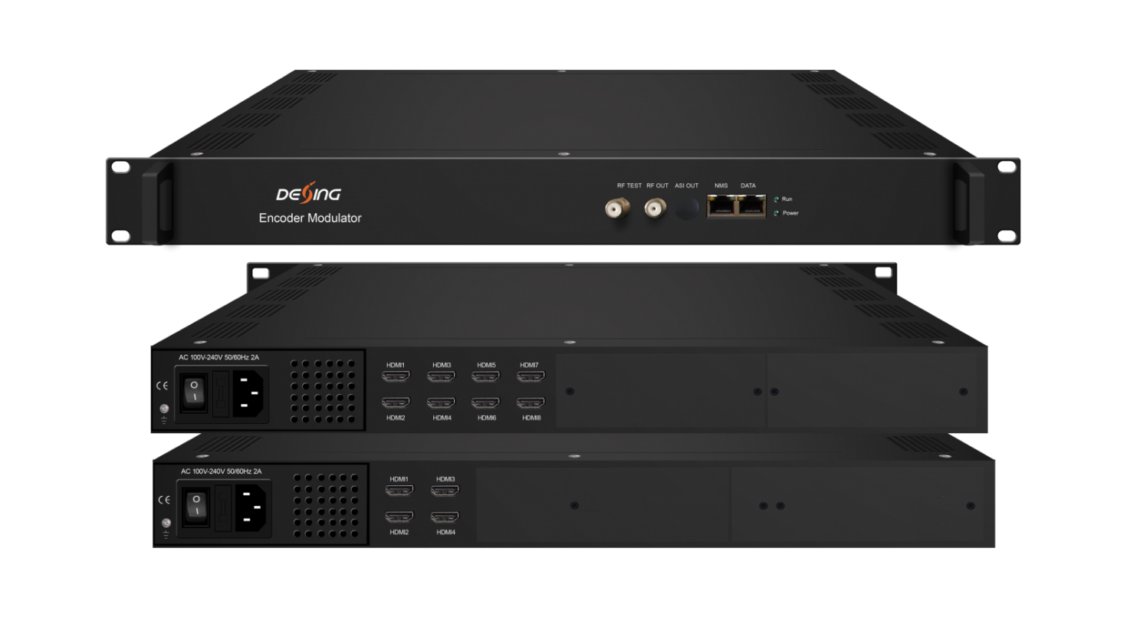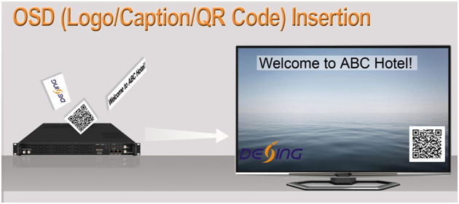

Product Overview
The FUQ-4635S/FUQ-4639S integrates MPEG-4 AVC/H.264 encoding and DVB-C/T modulation in a 1RU chassis, supporting 4/8 HDMI inputs, 64/128 IP streams, and 2/4 RF carriers. It processes signals with PID remapping and PSI/SI editing, delivering MPTS via Gigabit Ethernet. Controlled via web interface, this unit is designed for hotel TV systems, CATV headends, and multi-dwelling unit deployments.
Key feature
Provides web-based control for configuration and monitoring

Principle Chart
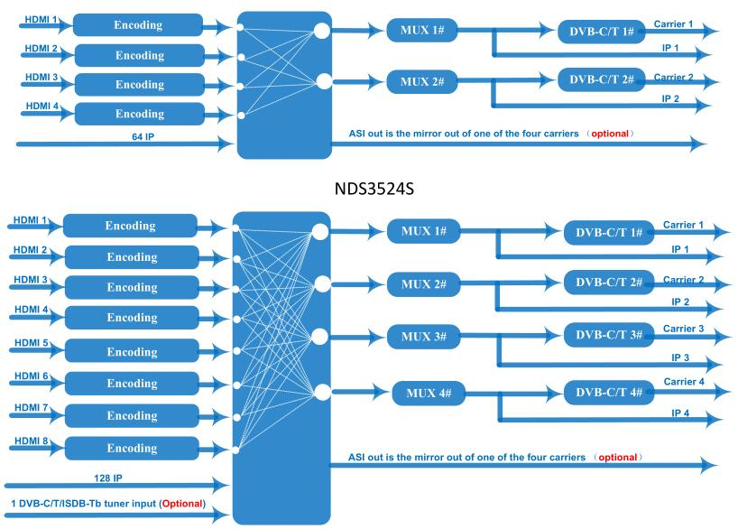

Technical Specification
Input | 4/8 HDMI inputs;  64/128 IP inputs;  1 DVB-C/T/ISDB-Tb tuner input for re-mux (Optional for FU-4639S with DVB-C RF out version)
Video | Encoding | MPEG-4 AVC/H.264
Video | Resolution | In-put |  | 1920×1080_60P, 1920×1080_60i,  1920×1080_50P, 1920×1080_50i,  1280×720_60P, 1280×720_50P,  720×576_50i,720×480_60i,
Video | Resolution | Out-put |  | 1920×1080_30P, 1920×1080_25P,  1280×720_30P, 1280×720_25P,  720×576_25P,720×480_30P,
Video | Bit-rate | 1Mbps~13Mbps each channel
Video | Rate Control | CBR/VBR
Audio | Encoding | MPEG-1 Layer 2, LC-AAC, HE-AAC and AC3 Pass Through
Audio | Sampling rate | 48KHz
Audio | Resolution | 24-bit
Audio | Audio Gain | 0-255 Adjustable
Audio | MPEG-1 Layer 2 bit-rate | 48/56/64/80/96/112/128/160/192/224/256/320/384 kbps
Audio | LC-AAC bit-rate | 48/56/64/80/96/112/128/160/192/224/256/320/384 kbps
Audio | HE-AAC bit-rate | 48/56/64/80/96/112/128 kbps
Multiplexing | Maximum PID  Remapping | 180 input per channel
Multiplexing | Function | PID remapping ( automatically or manually)
Multiplexing | Function | Generate PSI/ SI table automatically
Scrambling  (optional for FU-4639S with DVB-C RF out version) | Maximum simulcrypt CA | 4
 | Standard | ETR289, ETSI 101 197, ETSI 103 197
 | Connection | Local/remote connection
Modulation | DVB-C | RF out |  |  | 2/4*RF DVB-C out (2/4 carriers combined output), F type interface
Modulation | DVB-C | Standard |  |  | EN300 429/ITU-T J.83A/B
Modulation | DVB-C | MER |  |  | ≥40db
Modulation | DVB-C | RF frequency |  |  | 50~960MHz, 1KHz step
Modulation | DVB-C | RF output level |  |  | -25~-1dBm (82~105 dbµV), 0.1dBm
Modulation | DVB-C | Symbol Rate |  |  | 5.0Msps~7.0Msps, 1ksps stepping
Modulation | DVB-C |  |  |  | J.83A | J.83B
Modulation | DVB-C | Constellation |  |  | 16/32/64/128/256QAM | 64/256 QAM
Modulation | DVB-C | Bandwidth |  |  | 8M | 6M
Modulation | DVB-T | RF out |  |  | 2/4*RF COFDM DVB-T out (2/4 carriers combined output) ,F type interface
Modulation | DVB-T | Standard |  |  | EN300744
Modulation | DVB-T | FFT mode |  |  | 2K,
Modulation | DVB-T | Bandwidth |  |  | 6M, 7M, 8M
Modulation | DVB-T | Constellation |  |  | QPSK, 16QAM, 64QAM
Modulation | DVB-T | Guard Interval |  |  | 1/4, 1/8, 1/16, 1/32
Modulation | DVB-T | FEC |  |  | 1/2, 2/3, 3/4, 5/6, 7/8
Modulation | DVB-T | MER |  |  | ≥42 dB
Modulation | DVB-T | RF frequency |  |  | 50~960MHz, 1KHz step
Modulation | DVB-T | RF output level |  |  | -28~ -3 dBm (77~97 dbµV), 0.1db step
Stream output | 2/4 IP MPTS output over UDP/RTP/RTSP, 1*1000M Base-T Ethernet interface
System function | Network management(WEB)
System function | Chinese and English language
System function | Ethernet software upgrade
Miscellaneous | Dimension (W×L×H) |  | 482mm×328mm×44mm
Miscellaneous | Environment |  | 0~45℃(work)；-20~80℃（Storage）
Miscellaneous | Power requirements |  | AC 110V± 10%, 50/60Hz, AC 220 ±10%,50/60Hz

Order Guide
 | FU-4635S | FU-4639S (DVB-C Out) | FU-4639S (DVB-T Out)
HDMI input | 4 | 8 | 8
IP input | 64 | 128 | 128
1 DVB-C/T/ISDB-Tb tuner input | N/A | Option as order | N/A
Scrambling function | N/A | Option as order | N/A
IP output | 2 MPTS | 4 MPTS | 4 MPTS
DVB-C/T RF output channel | 2 | 4 | 4

About Us
FMUSER is a company specializing in broadcasting and television transmission systems and integrating hotel IPTV systems. The company was established in 2009 and has served over 180 countries worldwide. More than 20,000 television stations, radio stations, and hotel clients from different.

Contact:Tomleequan Email：sales@fmuser.com whatsapp: +8613922702227

