FMUSER FUQ-4637TB Encoder Modulator 16 CVBS Inputs 4 DVB-C-T Outputs MPEG4 AVC-H264 Encoding Multiplexing Web Management for CATV Broadcasting 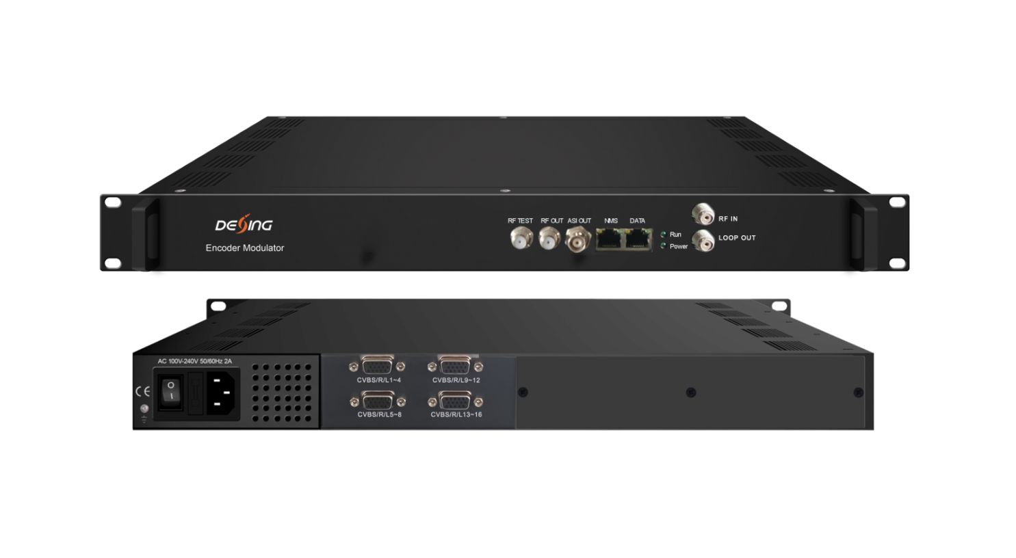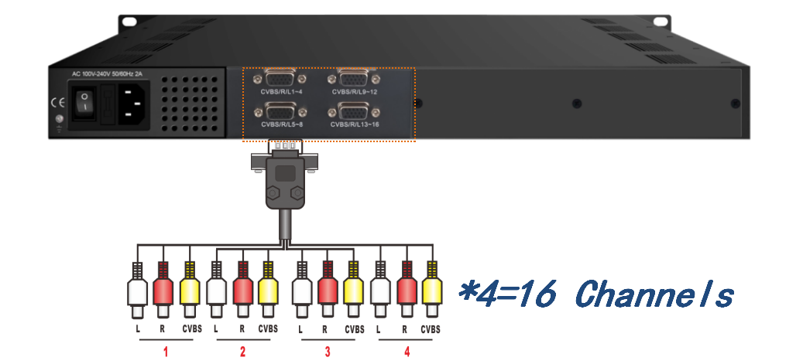
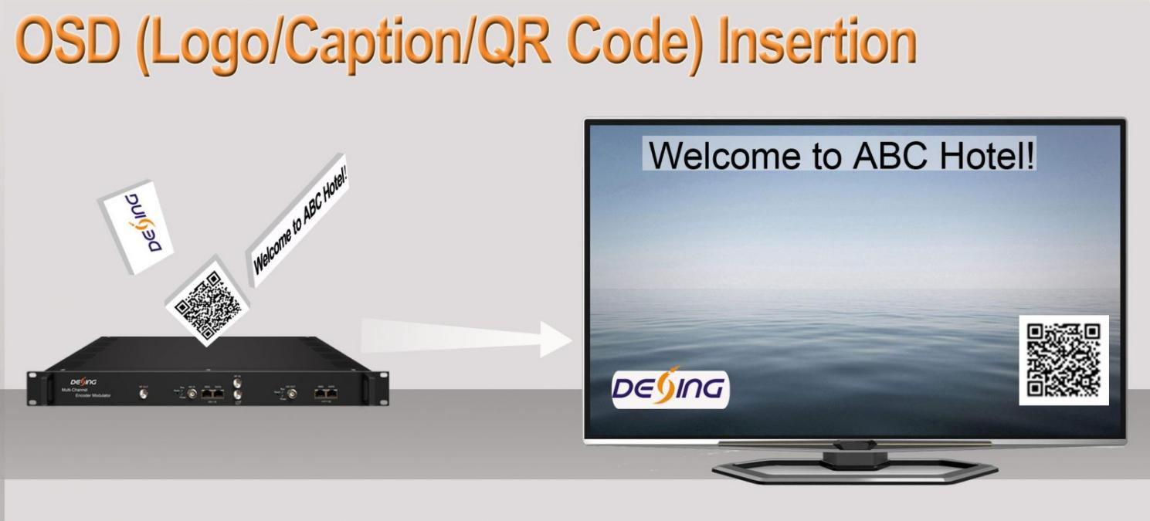
Product Overview
The FMUSER FUQ-4637SB is a cost-effective encoder modulator with 16 CVBS inputs, 128 IP inputs, and 4ch DVB-C/T outputs. It performs MPEG4 AVC/H.264 encoding and multiplexing for signal processing. Controlled via web management, it supports real-time monitoring. Ideal for CATV broadcasting systems in next-gen deployments.
Key feature
Supports 16 CVBS inputs with MPEG4 AVC/H.264 encoding for robust video processing.
Features 128 IP inputs over UDP/RTP for re-mux and 4MPTS IP output, plus optional ASI output.
Provides 4ch DVB-C/T non-adjacent carrier outputs with multiplexing and optional scrambling.
Includes audio encoding (MPEG1 Layer II) with gain adjustment and PSI/SI editing support.
Offers web management for easy control, updates, and bit-rate monitoring.
Principle Chart
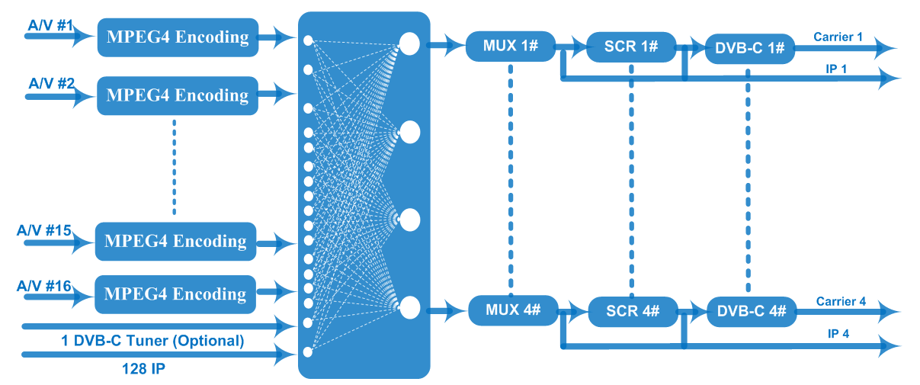
DVB-C RF output

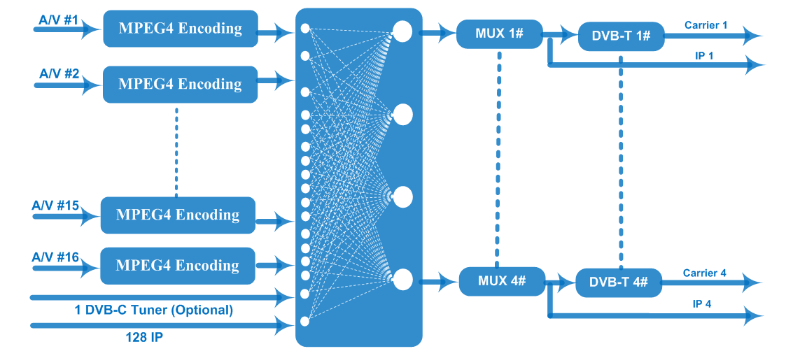
DVB-T RF output

Technical Specification
Input | 16 CVBS inputs , DB15-To-RCA interface  128 IP (100/1000M)input over UDP and RTP protocol  1DVB-C tuner input for re-mux (optional)
Video | Resolution | 720×576i (PAL-B, D, G, H, I), 720×480i (NTSC-M, J)
Video | Encoding | MPEG4 AVC/H.264(HP/MP/BP)
Video | Bit-rate | 1Mbps~5Mbps each channel
Video | Rate Control | CBR/VBR
Video | GOP Structure | IPP (P frame is adjustable)
Audio | Encoding | MPEG-1 Layer 2
Audio | Sampling rate | 48KHz
Audio | Resolution | 24-bit
Audio | Audio Gain | 0-255 adjustable
Audio | Bit-rate | 64/128/192/224/256/320/384Kbps each channel
Modulation | DVB-C | 4* DVB-C non-adjacent carriers  Standard: EN300 429/ITU-T J.83A/B  MER: ≥40dB  RF frequency: 50~960MHz, 1KHz step  RF out level: -20~+3dBm (87~110 dBµV), 0.1dB step  Symbol Rate: 5.0Msps~7.0Msps, 1ksps step
Modulation | DVB-C |  |  | J.83A | J.83B
Modulation | DVB-C | Constellation |  | 16/32/64/128/256QAM | 64/256 QAM
Modulation | DVB-C | Bandwidth |  | 8M | 6M
Modulation | DVB-T | Standard |  | EN300744
Modulation | DVB-T | FFT mode |  | 2K, 4K, 8K
Modulation | DVB-T | Bandwidth |  | 6M, 7M, 8M
Modulation | DVB-T | Constellation |  | QPSK, 16QAM, 64QAM
Modulation | DVB-T | Guard Interval |  | 1/4, 1/8, 1/16, 1/32
Modulation | DVB-T | FEC |  | 1/2, 2/3, 3/4, 5/6, 7/8
Modulation | DVB-T | MER |  | ≥40dB
Modulation | DVB-T | RF frequency |  | 50~960MHz, 1KHz step
Modulation | DVB-T | RF out |  | 4*COFDM DVB-T non-adjacent carriers
Modulation | DVB-T | RF out level |  | -20~+3 dBm (87~110 dBµV), 0.1dB step
Scrambling  (for DVB-C out version) | Max simulscrypt CA | 4
Scrambling  (for DVB-C out version) | Scramble Standard | ETR289, ETSI 101 197, ETSI 103 197
Scrambling  (for DVB-C out version) | Connection | Local/remote connection
Stream output | IP (4*MPTS) output as mirror of 4 carriers over UDP and RTP, 100/1000 Base-T Ethernet interface (Multicast/unicast)  1*ASI output (optional)
System function | Network management (WEB)
System function | Ethernet software upgrade
Miscellaneous | Dimension(W×L×H) |  | 482mm×328mm×44mm
Miscellaneous | Environment |  | 0~45℃(work)；-20~80℃（Storage）
Miscellaneous | Power requirements |  | AC 110V± 10%, 50/60Hz, AC 220 ± 10%, 50/60Hz

About Us
FMUSER is a company specializing in broadcasting and television transmission systems and integrating hotel IPTV systems. The company was established in 2009 and has served over 180 countries worldwide. More than 20,000 television stations, radio stations, and hotel clients from different.

Contact:Tomleequan Email：sales@fmuser.com whatsapp: +8613922702227

