FMUSER FUQ-4647B-N DTV Processor 8-24 HDMI 1 ASI 1 USB 128 IP Inputs to 32 DVB-C 16 DVB-T-ATSC-ISDB-T Outputs HDMI-ASI-USB-IP Interfaces HEVC-H.265 AVC-H.264 Encoding Integrated DVB IPTV Streaming for Terrestrial Cable IPTV Headends
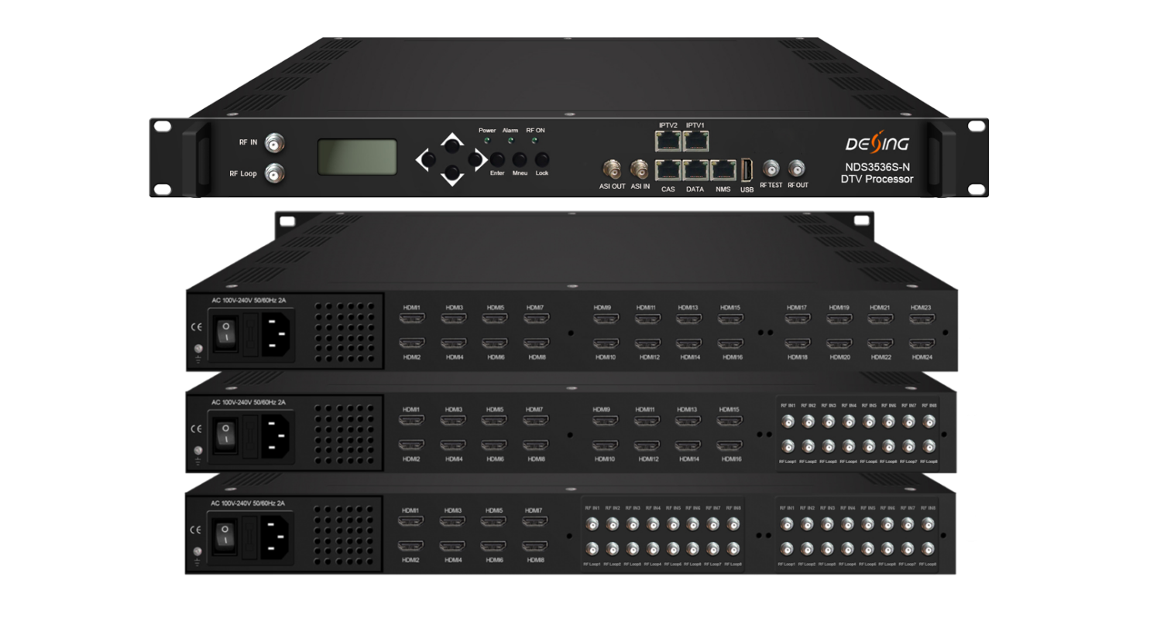Product Overview
The FMUSER FUQ-4647B-P DTV Processor integrates DVB encoding and IPTV streaming in one chassis. It supports inputs including HDMI, ASI, USB, and IP, and outputs for RF and IP streams. With web-based control, it is ideal for broadcast applications in DVB and IPTV environments.
System Application
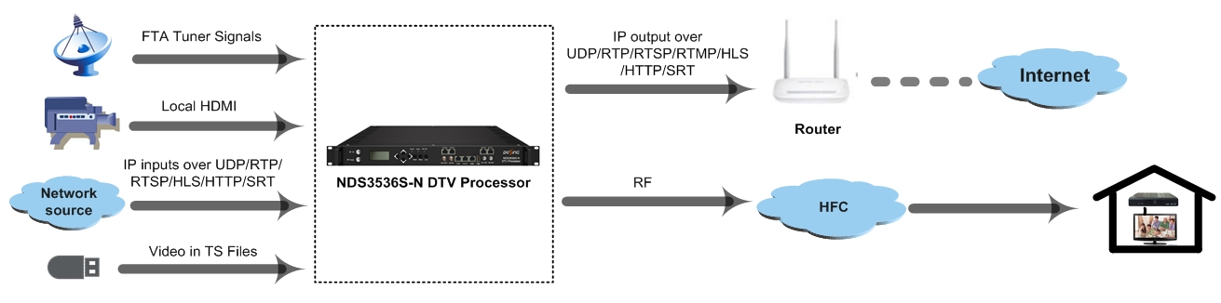

Key feature
Integrated DVB encoding and IPTV streaming in a single unit.
Supports up to 24 HDMI inputs, 1 ASI input, 1 USB player, and 128 IP inputs.
Delivers up to 32-channel RF output for DVB-C/T/ATSC/ISDB-T and IP streaming.
Features HEVC/H.265 and MPEG-4 AVC/H.264 encoding with web-based management.
Working Block
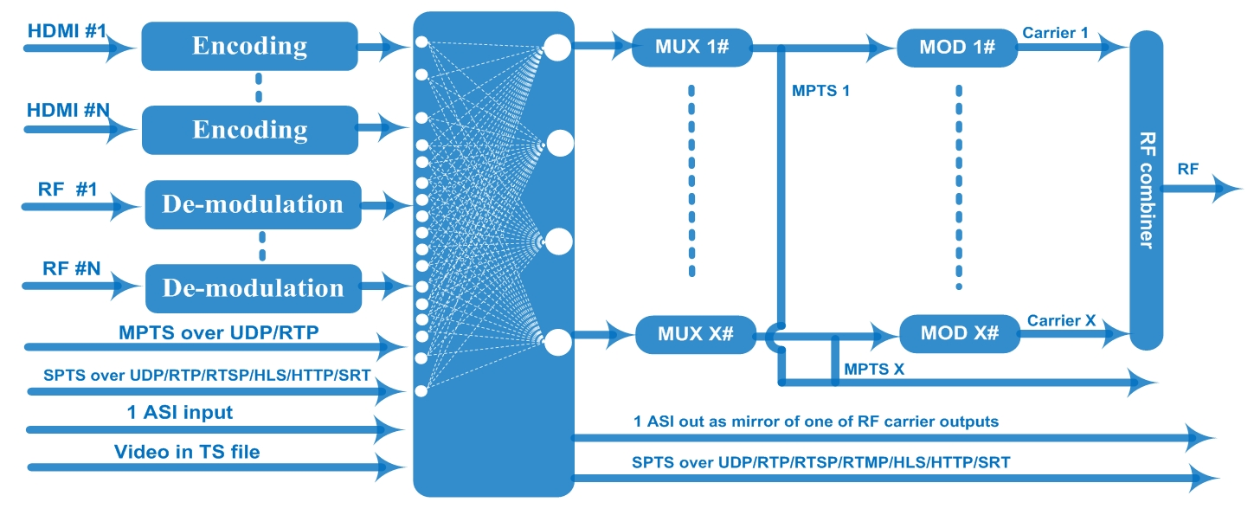

Technical Specifications
Input | 8/16/24 HDMI inputs for option (or HDMI and different Tuner mix input, details pls check below order guide)  1 ASI in for re-mux  1 USB Player input for re-mux (“xxx.ts” video)  128 MPTS IP input over UDP and RTP, GE port, RJ45  SPTS input over UDP/RTP/RTSP/HLS/HTTP/SRT
Video  (HDMI Input) | Resolution | Input |  |  | 1920×1080_60P, 1920×1080_60i,  1920×1080_50P, 1920×1080_50i,  1280×720_60P, 1280×720_50P,  720×576_50i,720×480_60i,
Video  (HDMI Input) | Resolution | Output |  |  | 1920×1080_30P, 1920×1080_25P,  1280×720_30P, 1280×720_25P,  720×576_25P,720×480_30P,
Video  (HDMI Input) | Encoding | HEVC/H.265 & MPEG-4 AVC/H.264
Video  (HDMI Input) | Bit-rate | 1Mbps~13Mbps each channel
Video  (HDMI Input) | Rate Control | CBR/VBR
Video  (HDMI Input) | GOP Structure | IP…P (P Frame adjustment)
Audio  (HDMI Input) | Encoding | MPEG-1 Layer 2, LC-AAC, HE-AAC and AC3 Pass through
Audio  (HDMI Input) | Sampling rate | 48KHz
Audio  (HDMI Input) | Resolution | 24-bit
Audio  (HDMI Input) | Audio Gain | 0-255 Adjustable
Audio  (HDMI Input) | MPEG-1 Layer 2 Bit-rate | 48/56/64/80/96/112/128/160/192/224/256/320/384 kbps
Audio  (HDMI Input) | LC-AAC Bit-rate | 48/56/64/80/96/112/128/160/192/224/256/320/384 kbps
Audio  (HDMI Input) | HE-AAC Bit-rate | 48/56/64/80/96/112/128 kbps
Tuner Section | DVB-S | Input Frequency |  | 950-2150MHz
Tuner Section | DVB-S | Symbol Rate |  | 0.5~45 Msps
Tuner Section | DVB-S | Constellation |  | QPSK
Tuner Section | DVB-S | FEC |  | 1/2, 2/3, 3/4, 5/6, 7/8
Tuner Section | DVB-S2 | Input Frequency |  | 950-2150MHz
Tuner Section | DVB-S2 | Symbol Rate |  | QPSK/8PSK/16APSK: 0.5~45 Msps  32APSK:0.5~40 Msps
Tuner Section | DVB-S2 | Constellation |  | QPSK/8PSK/16APSK/32APSK
Tuner Section | DVB-S2 | FEC |  | QPSK: 1/2, 3/5, 2/3, 3/4, 4/5, 5/6, 8/9,9/10  8PSK: 3/5, 2/3, 3/4, 5/6, 8/9, 9/10  16APSK: 2/3, 3/4, 4/5, 5/6, 8/9, 9/10  32APSK: 3/4, 4/5, 5/6, 8/9
Tuner Section | DVB-S2 | Max input bitrate |  | ≤170 Mbps per tuner
Tuner Section | DVB-S2X | Symbol Rate |  | QPSK/8PSK/16APSK: 0.5~45 Msps;  8APSK/32APSK: 0.5~40 Msps
Tuner Section | DVB-S2X | Constellation |  | QPSK/8PSK/16APSK/8APSK/32APSK
Tuner Section | DVB-S2X | FEC |  | QPSK: 1/2, 3/5, 2/3, 3/4, 4/5, 5/6, 8/9, 9/10, 13/45, 9/20, 11/20  8PSK: 3/5, 2/3, 3/4, 5/6, 8/9, 9/10, 23/36, 25/36, 13/18  8APSK: 5/9-L, 26/45-L  16APSK: 2/3, 3/4, 4/5, 5/6, 8/9, 9/10,1/2-L, 8/15-L, 5/9-L, 26/45, 3/5, 3/5-L, 28/45, 23/36, 2/3-L, 25/36, 13/18, 7/9, 77/90  32APSK: 3/4, 4/5, 5/6, 8/9, 2/3-L, 32/45, 11/15, 7/9
Tuner Section | DVB-S2X | Max input bitrate per tuner |  | ≤170 Mbps
Tuner Section | Signal Strength | -65 ~ -25dBm
Multiplexing | Maximum PID  Remapping | 255 input per channel
Multiplexing | Function | PID remapping ( automatically or manually)
Multiplexing | Function | Accurate PCR adjusting
Multiplexing | Function | Generate PSI/ SI table automatically
Modulation | DVB-C | Standard |  |  | EN300 429/ITU-T J.83A/B
Modulation | DVB-C | RF output channel |  |  | 32 non-adjacent carriers output (maximum bandwidth 384MHz)
Modulation | DVB-C | MER |  |  | ≥40db
Modulation | DVB-C | RF frequency |  |  | 50~960MHz, 1KHz step
Modulation | DVB-C | RF output level |  |  | -20~+1dbm, 0.1db step
Modulation | DVB-C | Symbol Rate |  |  | 5.0Msps~7.0Msps, 1ksps stepping
Modulation | DVB-C |  |  |  | J.83A | J.83B
Modulation | DVB-C | Constellation |  |  | 16/32/64/128/256QAM | 64/256 QAM
Modulation | DVB-C | Bandwidth |  |  | 8M | 6M
Modulation | DVB-T | Standard |  |  | EN300744
Modulation | DVB-T | FFT mode |  |  | 2K,4K, 8K
Modulation | DVB-T | Bandwidth |  |  | 6M, 7M, 8M
Modulation | DVB-T | Constellation |  |  | QPSK, 16QAM, 64QAM
Modulation | DVB-T | Guard Interval |  |  | 1/4, 1/8, 1/16, 1/32
Modulation | DVB-T | Code Rate |  |  | 1/2, 2/3, 3/4, 5/6, 7/8
Modulation | DVB-T | MER |  |  | ≥42 dB
Modulation | DVB-T | RF frequency |  |  | 50~960MHz, 1KHz step
Modulation | DVB-T | RF output channel |  |  | 16 non-adjacent carriers output (maximum bandwidth 192MHz)
Modulation | DVB-T | RF output level |  |  | -20~ +1dBm, 0.1db step
Modulation | ATSC | Standard |  |  | ATSC A/53
Modulation | ATSC | Bandwidth |  |  | 6M
Modulation | ATSC | Constellation |  |  | 8VSB
Modulation | ATSC | FEC |  |  | RS(208 188)+Trellis
Modulation | ATSC | MER |  |  | ≥40dB
Modulation | ATSC | ACL |  |  | -55 dBc
Modulation | ATSC | RF frequency |  |  | 50~960MHz, 1KHz step
Modulation | ATSC | RF output channel |  |  | 16 non-adjacent carriers output (maximum bandwidth 192MHz)
Modulation | ATSC | RF output level |  |  | -20~+3dbm (for all carriers), 0.5db stepping
Modulation | ISDB-T | Standard |  |  | ARIB STD-B31
Modulation | ISDB-T | Bandwidth |  |  | 6M
Modulation | ISDB-T | Constellation |  |  | QPSK, 16QAM, 64QAM
Modulation | ISDB-T | Guard Interval |  |  | 1/32, 1/16, 1/8, 1/4
Modulation | ISDB-T | FFT Mode |  |  | 2K, 4K, 8K
Modulation | ISDB-T | Code rate |  |  | 1/2, 2/3, 3/4, 5/6, 7/8
Modulation | ISDB-T | MER |  |  | ≥40dB
Modulation | ISDB-T | RF frequency |  |  | 50~960MHz, 1KHz step
Modulation | ISDB-T | RF output channel |  |  | 16 non-adjacent carriers output (maximum bandwidth 192MHz)
Modulation | ISDB-T | RF output level |  |  | -20dBm~+1dBm, 0.1dB stepping
MPTS output | 1 ASI output as mirror of one of RF output carriers  32 MPTS output over UDP and RTP/RTSP as mirror of 32 DVB-C carriers(or 16 MPTS output over UDP and RTP/RTSP as mirror of 16 DVB-T/ATSC/ISDB-T carriers for option), 1*1000M Base-T Ethernet interface, GE port
SPTS output | SPTS over UDP/RTP/RTSP/RTMP/HLS/HTTP/SRT
System function | Network management (WEB)
System function | English language
System function | Ethernet software upgrade
Miscellaneous | Dimension (W×L×H) |  | 482mm×328mm×44mm
Miscellaneous | Environment |  | 0~45℃(work)；-20~80℃（Storage）
Miscellaneous | Power requirements |  | AC 110V± 10%, 50/60Hz, AC 220 ± 10%, 50/60Hz

Ordering Guide

Input Section:
 | HDMI | DVB-S2/S2X | DVB-C/T/T2/ISDB-T
Option 1 | 8 | / | /
Option 2 | 16 | / | /
Option 3 | 24 | / | /
Option 4 | 8 | 8 | /
Option 5 | 8 | 16 | /
Option 6 | 16 | 8 | /
Option 7 | 8 | / | 8
Option 8 | 8 | / | 16
Option 9 | 16 | / | 8
Option 10 | 8 | 8 | 8
Option 11 | 16 | 4 | 4

Output Section:
RF output standard | RF carrier channels
DVB-C out | 32
DVB-T out | 16
ATSC out | 16
ISDB-T out | 16

About Us
FMUSER is a company specializing in broadcasting and television transmission systems and integrating hotel IPTV systems. The company was established in 2009 and has served over 180 countries worldwide. More than 20,000 television stations, radio stations, and hotel clients from different.

Contact:Tomleequan Email：sales@fmuser.com whatsapp: +8613922702227

