FMUSER FUQ-4647R HD Encoder Modulator 8-24 HDMI 1 ASI 1 USB 128 IP Input MPEG-4 AVC-H264 Encoding Multiplexing DVB-C-T-ATSC-ISDB-T Output CATV Headend Hotel TV SystemModulator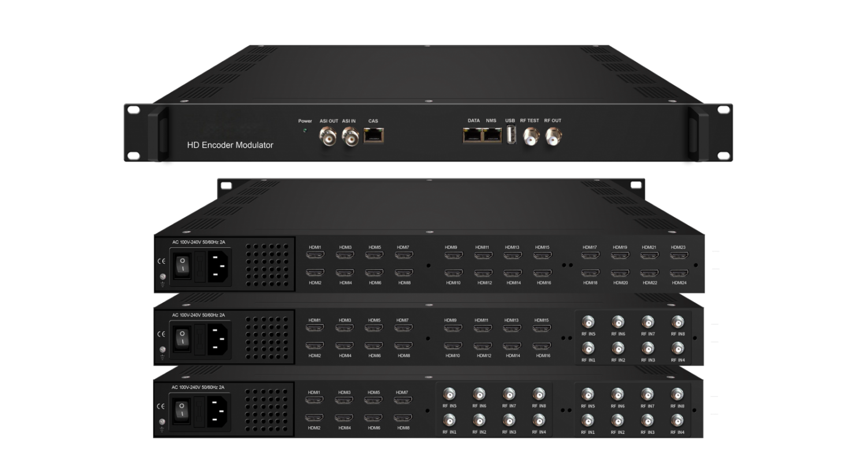
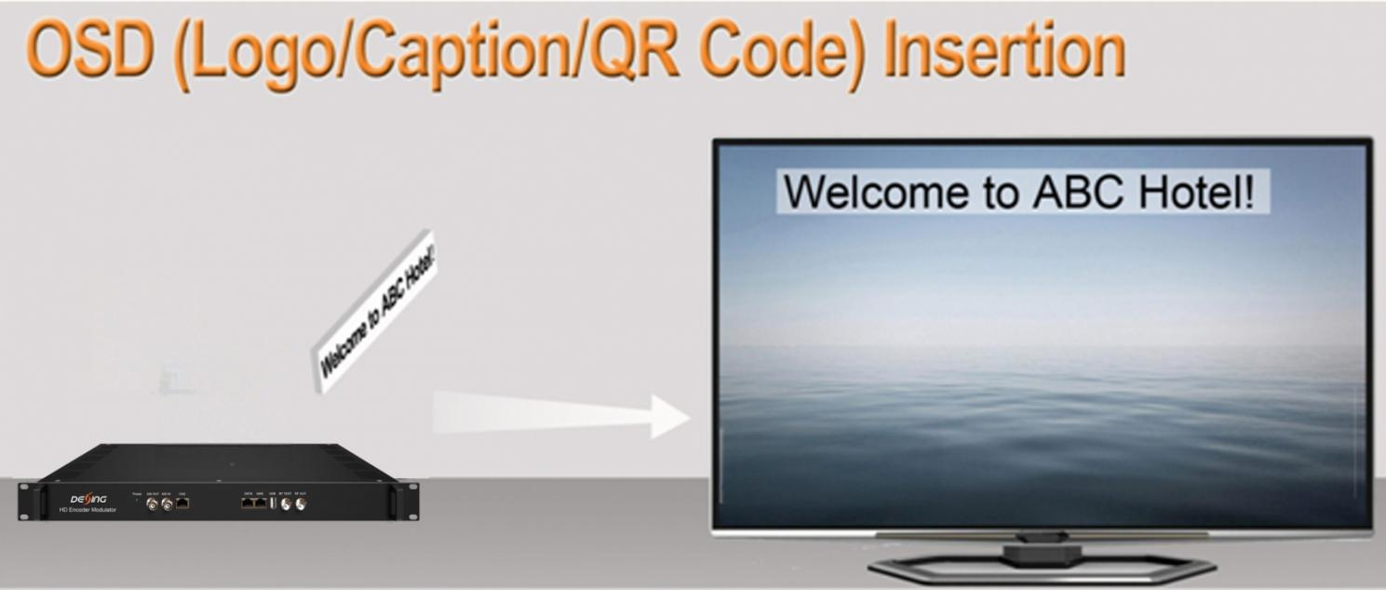
Product Overview
The FMUSER FUQ-4647B is an encoder modulator integrating encoding, multiplexing, and modulation in a 1RU chassis. It processes inputs including 8/16/24 HDMI, 1 ASI, 1 USB player, and 128 IP streams, encoding with MPEG-4 AVC/H.264 and outputting 12 DVB-C RF carriers plus ASI/IP mirrors. Featuring web-based control for remote management, it is ideal for compact CATV headends and hospitality TV systems.

Key feature
Supports multi-format inputs: 8/16/24 HDMI, 1 ASI, 1 USB player, and 128 IP streams via GE port.
Offers flexible modulation: Outputs 12 DVB-C RF carriers (or optional formats) with ≤192MHz bandwidth.
Provides advanced processing: MPEG-4 AVC/H.264 encoding, PID remapping, PCR adjustment, and PSI/SI editing.
Includes dual monitoring: ASI output mirror and MPTS IP streaming via UDP/RTP/RTSP.
Features web-based control for remote management and firmware updates.
Principle Chart
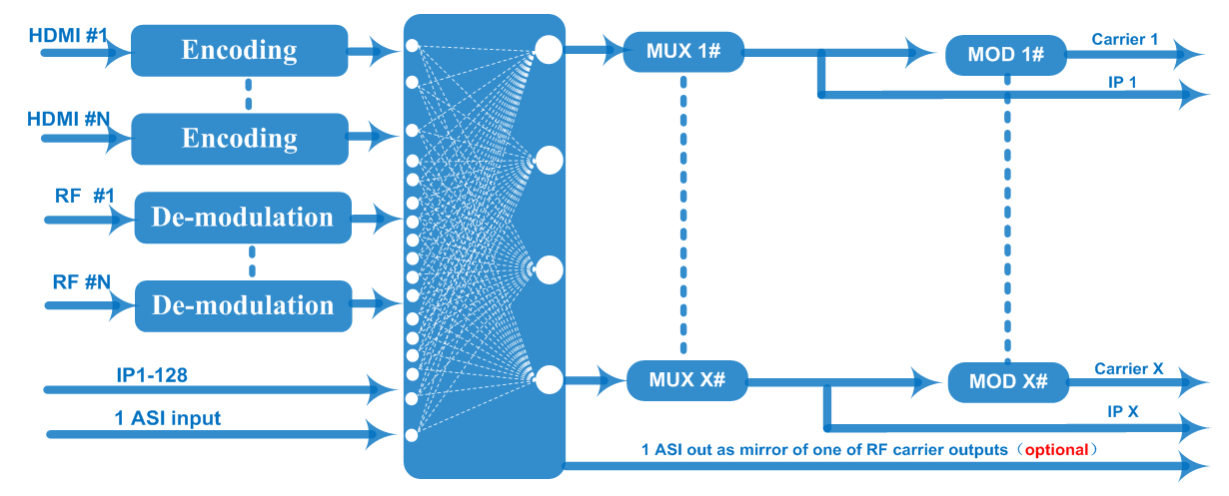

Technical Specifications
Input | 8/16/24 HDMI inputs for option (or HDMI and different Tuner mix input, details pls check below order guide)  1 ASI in for re-mux  1 USB Player input for re-mux (“xxx.ts” video)  128 IP input over UDP and RTP, GE port, RJ45
Video  (HDMI Input) | Resolution | Input |  |  | 1920×1080_60P, 1920×1080_60i,  1920×1080_50P, 1920×1080_50i,  1280×720_60P, 1280×720_50P,  720×576_50i,720×480_60i,
Video  (HDMI Input) | Resolution | Output |  |  | 1920×1080_30P, 1920×1080_25P,  1280×720_30P, 1280×720_25P,  720×576_25P,720×480_30P,
Video  (HDMI Input) | Encoding | MPEG-4 AVC/H.264
Video  (HDMI Input) | Bit-rate | 1Mbps~13Mbps each channel
Video  (HDMI Input) | Rate Control | CBR/VBR
Video  (HDMI Input) | GOP Structure | IP…P (P Frame adjustment, without B Frame )
Audio  (HDMI Input) | Encoding | MPEG-1 Layer 2, LC-AAC, HE-AAC and AC3 Pass through
Audio  (HDMI Input) | Sampling rate | 48KHz
Audio  (HDMI Input) | Resolution | 24-bit
Audio  (HDMI Input) | Audio Gain | 0-255 Adjustable
Audio  (HDMI Input) | MPEG-1 Layer 2 Bit-rate | 48/56/64/80/96/112/128/160/192/224/256/320/384 kbps
Audio  (HDMI Input) | LC-AAC Bit-rate | 48/56/64/80/96/112/128/160/192/224/256/320/384 kbps
Audio  (HDMI Input) | HE-AAC Bit-rate | 48/56/64/80/96/112/128 kbps
Tuner Section | DVB-S | Input Frequency |  | 950-2150MHz
Tuner Section | DVB-S | Symbol Rate |  | 0.5~45 Msps
Tuner Section | DVB-S | Constellation |  | QPSK
Tuner Section | DVB-S | FEC |  | 1/2, 2/3, 3/4, 5/6, 7/8
Tuner Section | DVB-S2 | Input Frequency |  | 950-2150MHz
Tuner Section | DVB-S2 | Symbol Rate |  | QPSK/8PSK/16APSK: 0.5~45 Msps  32APSK:0.5~40 Msps
Tuner Section | DVB-S2 | Constellation |  | QPSK/8PSK/16APSK/32APSK
Tuner Section | DVB-S2 | FEC |  | QPSK: 1/2, 3/5, 2/3, 3/4, 4/5, 5/6, 8/9,9/10  8PSK: 3/5, 2/3, 3/4, 5/6, 8/9, 9/10  16APSK: 2/3, 3/4, 4/5, 5/6, 8/9, 9/10  32APSK: 3/4, 4/5, 5/6, 8/9
Tuner Section | DVB-S2 | Max input bitrate per tuner |  | ≤170 Mbps
Tuner Section | DVB-S2X | Symbol Rate |  | QPSK/8PSK/16APSK: 0.5~45 Msps;  8APSK/32APSK: 0.5~40 Msps
Tuner Section | DVB-S2X | Constellation |  | QPSK/8PSK/16APSK/8APSK/32APSK
Tuner Section | DVB-S2X | FEC |  | QPSK: 1/2, 3/5, 2/3, 3/4, 4/5, 5/6, 8/9, 9/10, 13/45, 9/20, 11/20  8PSK: 3/5, 2/3, 3/4, 5/6, 8/9, 9/10, 23/36, 25/36, 13/18  8APSK: 5/9-L, 26/45-L  16APSK: 2/3, 3/4, 4/5, 5/6, 8/9, 9/10,1/2-L, 8/15-L, 5/9-L, 26/45, 3/5, 3/5-L, 28/45, 23/36, 2/3-L, 25/36, 13/18, 7/9, 77/90  32APSK: 3/4, 4/5, 5/6, 8/9, 2/3-L, 32/45, 11/15, 7/9
Tuner Section | DVB-S2X | Max input bitrate per tuner |  | ≤170 Mbps
Tuner Section | Signal Strength | -65 ~ -25dBm
Multiplexing | Maximum PID  Remapping | 255 input per channel
Multiplexing | Function | PID remapping ( automatically or manually)
Multiplexing | Function | Accurate PCR adjusting
Multiplexing | Function | Generate PSI/ SI table automatically
Modulation | DVB-C | QAM Channel |  |  | 12 non-adjacent carriers output (maximum bandwidth 192MHz)
Modulation | DVB-C | Standard |  |  | EN300 429/ITU-T J.83A/B
Modulation | DVB-C | MER |  |  | ≥40db
Modulation | DVB-C | RF frequency |  |  | 50~960MHz, 1KHz step
Modulation | DVB-C | RF output level |  |  | -20~+3dbm, 0.1db step
Modulation | DVB-C | Symbol Rate |  |  | 5.0Msps~7.0Msps, 1ksps stepping
Modulation | DVB-C |  |  |  | J.83A | J.83B
Modulation | DVB-C | Constellation |  |  | 16/32/64/128/256QAM | 64/256 QAM
Modulation | DVB-C | Bandwidth |  |  | 8M | 6M
Modulation | DVB-T | Standard |  |  | EN300744
Modulation | DVB-T | FFT mode |  |  | 2K,4K, 8K
Modulation | DVB-T | Bandwidth |  |  | 6M, 7M, 8M
Modulation | DVB-T | Constellation |  |  | QPSK, 16QAM, 64QAM
Modulation | DVB-T | Guard Interval |  |  | 1/4, 1/8, 1/16, 1/32
Modulation | DVB-T | FEC |  |  | 1/2, 2/3, 3/4, 5/6, 7/8
Modulation | DVB-T | MER |  |  | ≥42 dB
Modulation | DVB-T | RF frequency |  |  | 50~960MHz, 1KHz step
Modulation | DVB-T | RF out |  |  | 8 (or 16) non-adjacent carriers output (maximum bandwidth 192MHz)
Modulation | DVB-T | RF output level |  |  | -20~ +3dBm, 0.1db step
Modulation | ATSC | Standard |  |  | ATSC A/53
Modulation | ATSC | Bandwidth |  |  | 6M
Modulation | ATSC | Constellation |  |  | 8VSB
Modulation | ATSC | FEC |  |  | RS(208 188)+Trellis
Modulation | ATSC | MER |  |  | ≥40dB
Modulation | ATSC | ACL |  |  | -55 dBc
Modulation | ATSC | RF frequency |  |  | 50~960MHz, 1KHz step
Modulation | ATSC | RF out |  |  | 8 non-adjacent carriers output (maximum bandwidth 192MHz)
Modulation | ATSC | RF output level |  |  | -20~+3dbm (for all carriers), 0.5db stepping
Modulation | ISDB-T | Standard |  |  | ARIB STD-B31
Modulation | ISDB-T | Bandwidth |  |  | 6M
Modulation | ISDB-T | Constellation |  |  | QPSK, 16QAM, 64QAM
Modulation | ISDB-T | Guard Interval |  |  | 1/32, 1/16, 1/8, 1/4
Modulation | ISDB-T | Transmission Mode |  |  | 2K, 4K, 8K
Modulation | ISDB-T | Code rate |  |  | 1/2, 2/3, 3/4, 5/6, 7/8
Modulation | ISDB-T | MER |  |  | ≥40dB
Modulation | ISDB-T | RF frequency |  |  | 50~960MHz, 1KHz step
Modulation | ISDB-T | RF out |  |  | 6 (or 16) non-adjacent carriers output (maximum bandwidth 192MHz)
Modulation | ISDB-T | RF output level |  |  | -20dBm~+3dBm, 0.1dB stepping
Stream output | 1 ASI output as mirror of one of RF output carriers (Optional)  12 MPTS output over UDP and RTP/RTSP as mirror of 12 DVB-C carriers,  8/16 MPTS output over UDP and RTP/RTSP as mirror of 8/16 DVB-T carriers(Optional)  8 MPTS output over UDP and RTP/RTSP as mirror of 8 ATSC carriers(Optional)  6/16 MPTS output over UDP and RTP/RTSP as mirror of 6/16 ISDB-T carriers(Optional)  1*1000M Base-T Ethernet interface, GE port
System function | Network management (WEB)
System function | Chinese and English language
System function | Ethernet software upgrade
Miscellaneous | Dimension (W×L×H) |  | 482mm×328mm×44mm
Miscellaneous | Environment |  | 0~45℃(work); -20~80℃ (Storage)
Miscellaneous | Power requirements |  | AC 110V± 10%, 50/60Hz, AC 220 ± 10%, 50/60Hz

Ordering Information
Input Section:

 | HDMI | DVB-S2/S2X | DVB-C/T/T2/ISDB-T
Option 1 | 8 | / | /
Option 2 | 16 | / | /
Option 3 | 24 | / | /
Option 4 | 8 | 8 | /
Option 5 | 8 | 16 | /
Option 6 | 16 | 8 | /
Option 7 | 8 | / | 8
Option 8 | 8 | / | 16
Option 9 | 16 | / | 8
Option 10 | 8 | 8 | 8
Option 11 | 16 | 4 | 4

Output Section:
RF output standard |  | IP output | RF carrier channels | Scrambling
DVB-C out |  | 12 | 12 | N/A
DVB-T out | V1 | 8 | 8 | N/A
DVB-T out | V2 | 16 | 16 | N/A
ATSC out |  | 8 | 8 | N/A
ISDB-T out | V1 | 6 | 6 | N/A
ISDB-T out | V2 | 16 | 16 | N/A

About Us
FMUSER is a company specializing in broadcasting and television transmission systems and integrating hotel IPTV systems. The company was established in 2009 and has served over 180 countries worldwide. More than 20,000 television stations, radio stations, and hotel clients from different.

Contact:Tomleequan Email：sales@fmuser.com whatsapp: +8613922702227

