FMUSER FUQ-4653 Encoder Modulator 1 HDMI-1 SDI Input Supporting DVB-C-T-ATSC-ISDB-T RF ASI IP Output MPEG2 MPEG4 AVC H.264 Encoding Multiplexing for Broadcast Hospitality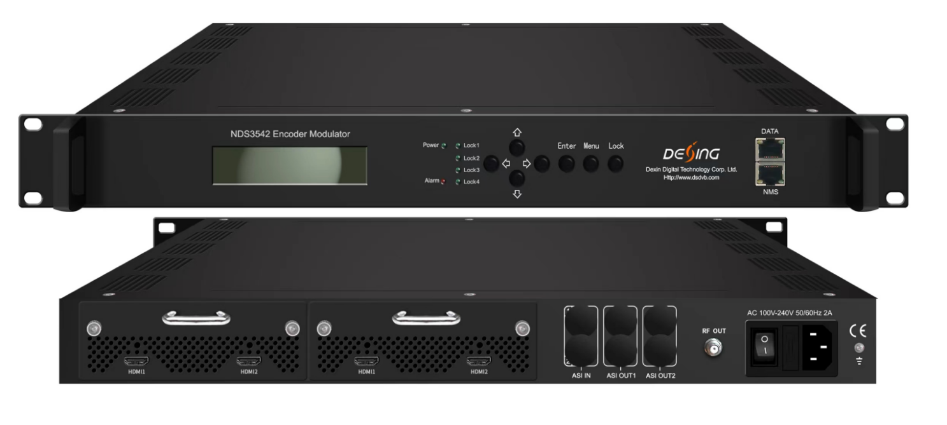
Product Overview
The FUQ-4653 series integrates encoding, multiplexing, and modulation, featuring modular input modules for HDMI and SDI and outputs including ASI and IP. It processes signals by encoding video in MPEG2 or MPEG4 AVC H.264 and audio in formats like MPEG4-AAC and Dolby Digital AC3. With a modular drawer design and web-based NMS for control, it supports MPTS/SPTS streaming for broadcast and public venue applications.
Key feature
Offers Low Delay Encoding: With multiple delay modes for SDI and HDMI inputs.

Technical Specifications
HDMI Input  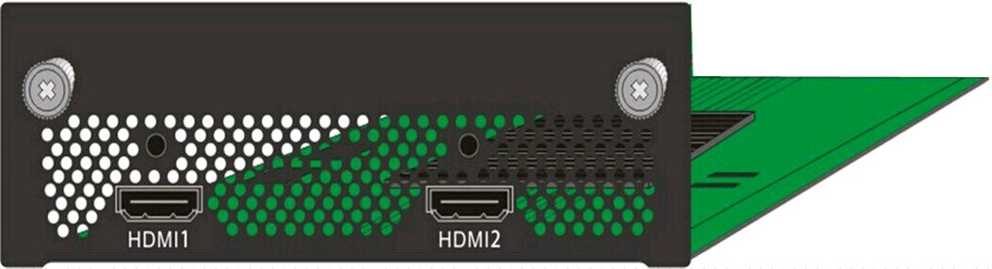 | Video | Input | HDMI*1(the other is backup)
 | Video | Encoding | MPEG2; MPEG4 AVC/H.264
 | Video | Bitrate | 1-19.5Mbps
 | Video | Resolution | 1920*1080_60P, 1920*1080_50P,  (-for MPEG4 AVC/H.264 only)  1920*1080_60i, 1920*1080_50i,  1280*720_60p, 1280*720_50P  720*480_60i, 720*576_50i
 | Video | Low Delay | Normal, Mode 1, Mode 2
 | Video | Chroma | 4:2:0
 | Video | Aspect Ratio | 16:9,4:3
 | Audio | Encoding | MPEG1 Layer II;MPEG 2-AAC; MPEG 4-AAC and Dolby Digital AC3 2.0
 | Audio | Sample rate | 48KHz
 | Audio | Bitrate | 64/96/128/ 192/256/320kbps
HDMI/YPbPr/CVBS 3-in-1 Input  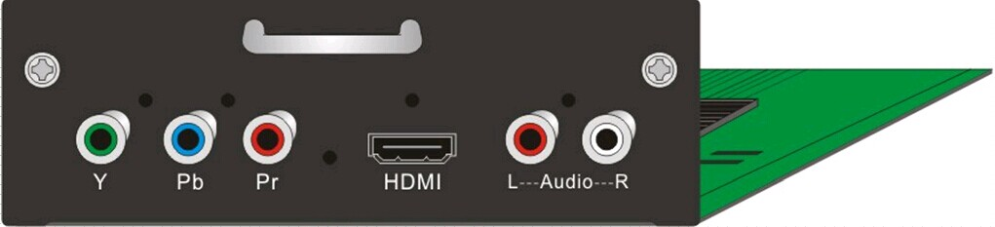  (under developing) | Video  (HDMI) | Encoding | MPEG2; MPEG4 AVC/H.264
 | Video  (HDMI) | Input | HDMI*1
 | Video  (HDMI) | Bitrate | 1-19.5Mbps
 | Video  (HDMI) | Resolution | 1920*1080_60P, 1920*1080_50P,  -for MPEG4 AVC/H.264 only)  1920*1080_60i, 1920*1080_50i,  1280*720_60p, 1280*720_50P  720*480_60i, 720*576_50i
 | Video  (HDMI) | Low Delay | Normal, Mode 1, Mode 2
 | Video  (HDMI) | Chroma | 4:2:0
 | Video  (HDMI) | Aspect Ratio | 16:9,4:3
 | Audio  (HDMI) | Encoding | MPEG1 Layer II ,MPEG2-AAC, MPEG4-AAC  and Dolby Digital AC3 2.0
 | Audio  (HDMI) | Input | HDMI*1
 | Audio  (HDMI) | Sample rate | 48KHz
 | Audio  (HDMI) | Bitrate | 64/96/128/ 192/256/320kbps
 | Video  (YpbPr/ CVBS) | Encoding | MPEG2; MPEG4 AVC/H.264
 | Video  (YpbPr/ CVBS) | Input | YpbPr*1 / CVBS *1
 | Video  (YpbPr/ CVBS) | Bitrate | 1-19.5Mbps
 | Video  (YpbPr/ CVBS) | Resolution | CVBS: 720x576_50i (PAL); 720x480_60i (NTSC)  YpbPr: 1920*1080_60i, 1920*1080_50i;  1280*720_60p, 1280*720_50P
 | Video  (YpbPr/ CVBS) | Low Delay | Normal, Mode 1, Mode 2
 | Video  (YpbPr/ CVBS) | Chroma | 4:2:0
 | Video  (YpbPr/ CVBS) | Aspect Ratio | 16:9, 4:3
 | Audio  (YpbPr/ CVBS) | Encoding | MPEG1 Layer II; MPEG2-AAC; MPEG4-AAC  and Dolby Digital AC3 2.0
 | Audio  (YpbPr/ CVBS) | Interface | 1*Stereo/2*mono
 | Audio  (YpbPr/ CVBS) | Sample rate | 48KHz
 | Audio  (YpbPr/ CVBS) | Bit rate | 64/96/128/ 192/256/320kbps
SDI Input  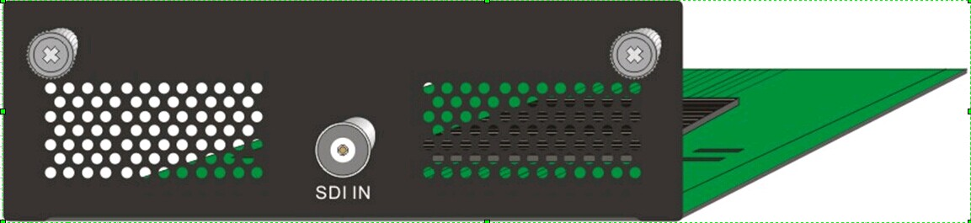 | Video | Encoding | MPEG2; MPEG4 AVC/H.264
 | Video | Input | SDI*1
 | Video | Bitrate | 1-19.5Mbps
 | Video | Resolution | 1920*1080_60P, 1920*1080_50P, (-for MPEG4 AVC/H.264 only)  1920*1080_60i, 1920*1080_50i,  1280*720_60p, 1280*720_50P  720*480_60i, 720*576_50i
 | Video | Low Delay | Normal, Mode 1, Mode 2
 | Video | Chroma | 4:2:0
 | Video | Aspect Ratio | 16:9,4:3
 | Audio | Encoding | MPEG1 Layer II ,MPEG2-AAC, MPEG4-AAC  and Dolby Digital AC3 2.0
 | Audio | Sample rate | 48KHz
 | Audio | Bitrate | 64/96/128/ 192/256/320kbps

Modulator Section | DVB-T (Optional) | Standard | DVB-T COFDM
Modulator Section | DVB-T (Optional) | Bandwidth | 6M, 7M, 8M
Modulator Section | DVB-T (Optional) | Constellation | QPSK, 16QAM, 64QAM
Modulator Section | DVB-T (Optional) | Code rate | 1/2, 2/3, 3/4, 5/6, 7/8.
Modulator Section | DVB-T (Optional) | Guard Interval | 1/32, 1/16, 1/8, 1/4
Modulator Section | DVB-T (Optional) | Transmission Mode | 2K, 4K, 8K
Modulator Section | DVB-T (Optional) | MER | Appx 40dB
Modulator Section | DVB-T (Optional) | RF frequency | 50~960MHz, 1KHz step
Modulator Section | DVB-T (Optional) | RF Out | 4*DVB-T carriers combined output
Modulator Section | DVB-T (Optional) | RF output level | -20 ~ -3dbm, 0.1db step
Modulator Section | DVB-C  (Optional) | Standard | J.83A (DVB-C), J.83B, J.83C
Modulator Section | DVB-C  (Optional) | MER | Appx 40dB
Modulator Section | DVB-C  (Optional) | RF frequency | 50~960MHz, 1KHz step
Modulator Section | DVB-C  (Optional) | RF output level | -20~ +3dbm, 0.1db step
Modulator Section | DVB-C  (Optional) | Symbol rate | 3.000~9.000Msps adjustable
Modulator Section | DVB-C  (Optional) | RF Out | 4*DVB-C carriers combined output
Modulator Section | DVB-C  (Optional) |  | J.83A | J.83B | J.83C
Modulator Section | DVB-C  (Optional) | Constellation | 16/32/64/128/256QAM | 64/ 256 QAM | 64/ 256 QAM
Modulator Section | DVB-C  (Optional) | Bandwidth | 8M | 6M | 6M
Modulator Section | ATSC  (Optional) | Standard | ATSC A/53
Modulator Section | ATSC  (Optional) | RF frequency | 50~960MHz, 1KHz step.
Modulator Section | ATSC  (Optional) | RF Out | 4*ATSC carriers combined output
Modulator Section | ATSC  (Optional) | RF output level | -20~ +3dbm, 0.1db step
Modulator Section | ATSC  (Optional) | Constellation | 8VSB
Modulator Section | ISDB-T (Optional)  (under developing) | Standard | ARIB STD-B31
Modulator Section | ISDB-T (Optional)  (under developing) | Bandwidth | 6M
Modulator Section | ISDB-T (Optional)  (under developing) | Constellation | QPSK, 16QAM, 64QAM
Modulator Section | ISDB-T (Optional)  (under developing) | Guard Interval | 1/32, 1/16, 1/8, 1/4
Modulator Section | ISDB-T (Optional)  (under developing) | Transmission Mode | 2K, 4K, 8K
Modulator Section | ISDB-T (Optional)  (under developing) | MER | Appx 40dB
Modulator Section | ISDB-T (Optional)  (under developing) | RF frequency | 50~960MHz, 1KHz step
Modulator Section | ISDB-T (Optional)  (under developing) | RF Out | 1*ISDBT
Modulator Section | ISDB-T (Optional)  (under developing) | RF output level | -20~ +3dbm, 0.1db step
General | System | Local interface | LCD + control buttons
General | System | Remote management | Web NMS
General | System | Stream Out | 2 ASI out (BNC type, same one TS, mirror as MPTS or SPTS)
General | System | Stream Out | DVB-C/-T/ATSC: IP (4 MPTS & 2 SPTS) out over UDP, RTP/RTSP (4 RF carriers out)  ISDBT: IP (1 MPTS & 2 SPTS) out over UDP, RTP/RTSP (1 RF carrier out)
General | System | DATA Port | 1000M
General | System | NMS interface | RJ45, 100M
General | System | Language | English
General | Physical Specification | Power supply | 100~240VAC, 50/60Hz
General | Physical Specification | Dimensions | 482*242*44mm
General | Physical Specification | Operation temp | 0~45℃

Principle Chart
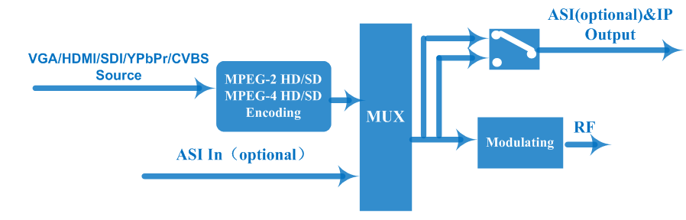

Typical Applications
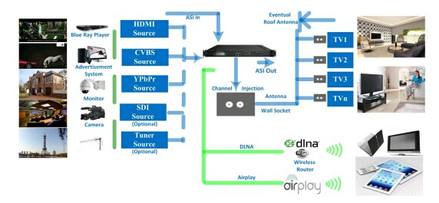

About Us
FMUSER is a company specializing in broadcasting and television transmission systems and integrating hotel IPTV systems. The company was established in 2009 and has served over 180 countries worldwide. More than 20,000 television stations, radio stations, and hotel clients from different.

Contact:Tomleequan Email：sales@fmuser.com whatsapp: +8613922702227

