FMUSER FUQ-4653AB Multi-channel Encoder 8-24 CVBS Input to IP Output MPEG2-MPEG4 AVC-H264 Encoding Multiplexing Digital CATV Satellite Headend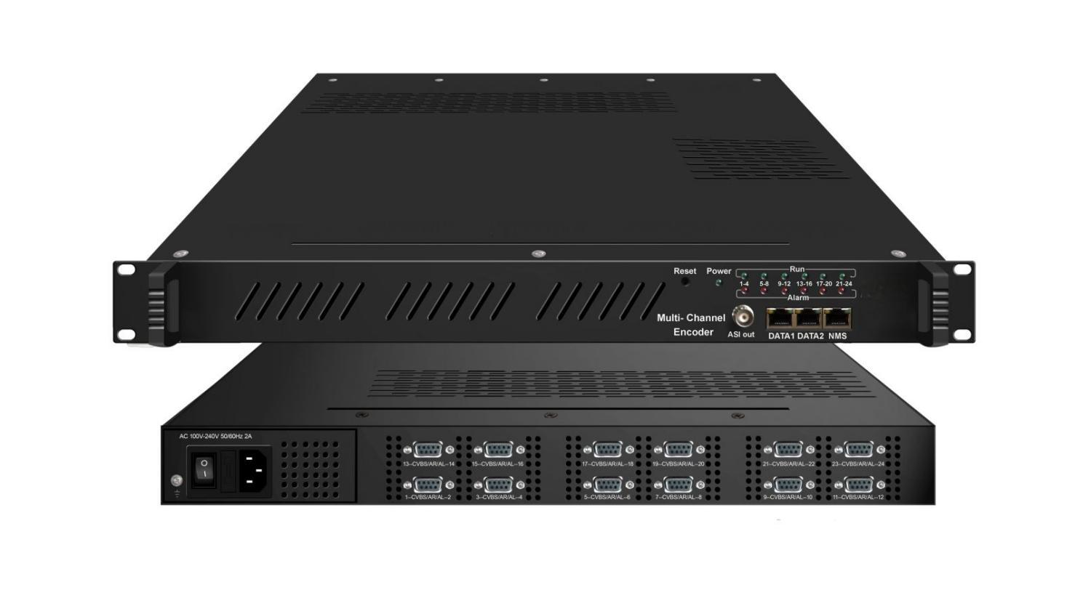

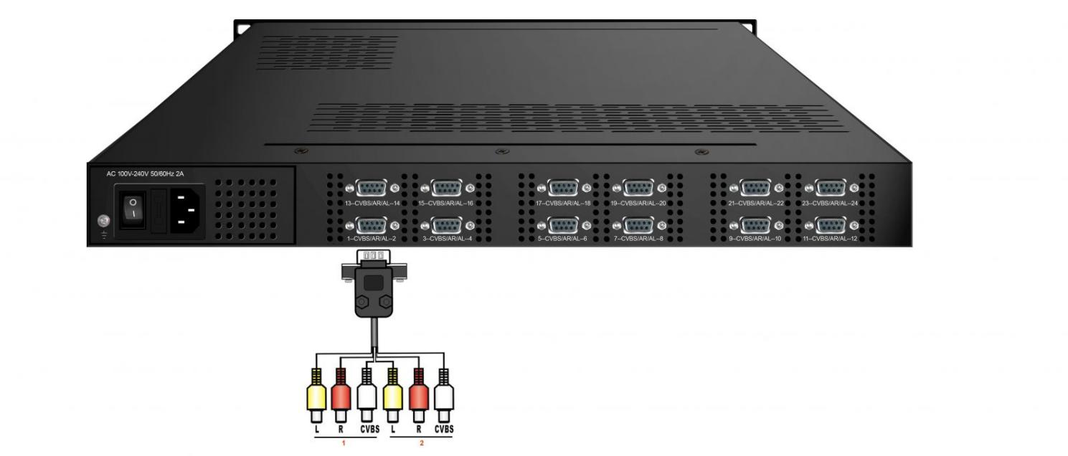

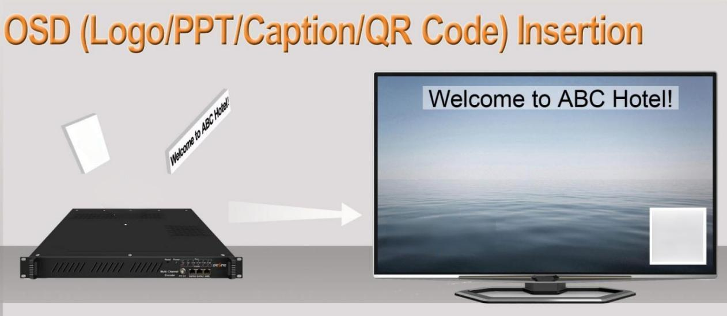
Product Overview
The FUQ-4653AB multi-channel encoder performs MPEG-2 and MPEG4 AVC/H.264 encoding and multiplexing. It converts 8/12/16/24 CVBS inputs into IP output streams. This unit offers optional ASI output and is managed via web interface. It provides cost-effective solutions for digital cable TV headends and satellite broadcasting systems.
Key feature
Integrated MPEG-2 and MPEG4 AVC/H.264 video encoding. Supports 8/12/16/24 CVBS inputs with SPTS or MPTS output. Features MPEG1 Layer 2, LC-AAC, and HE-AAC audio encoding. Delivers IP output via UDP, RTP/RTSP + optional ASI copy. Provides management via web interface for control/updates.
Principle Chart
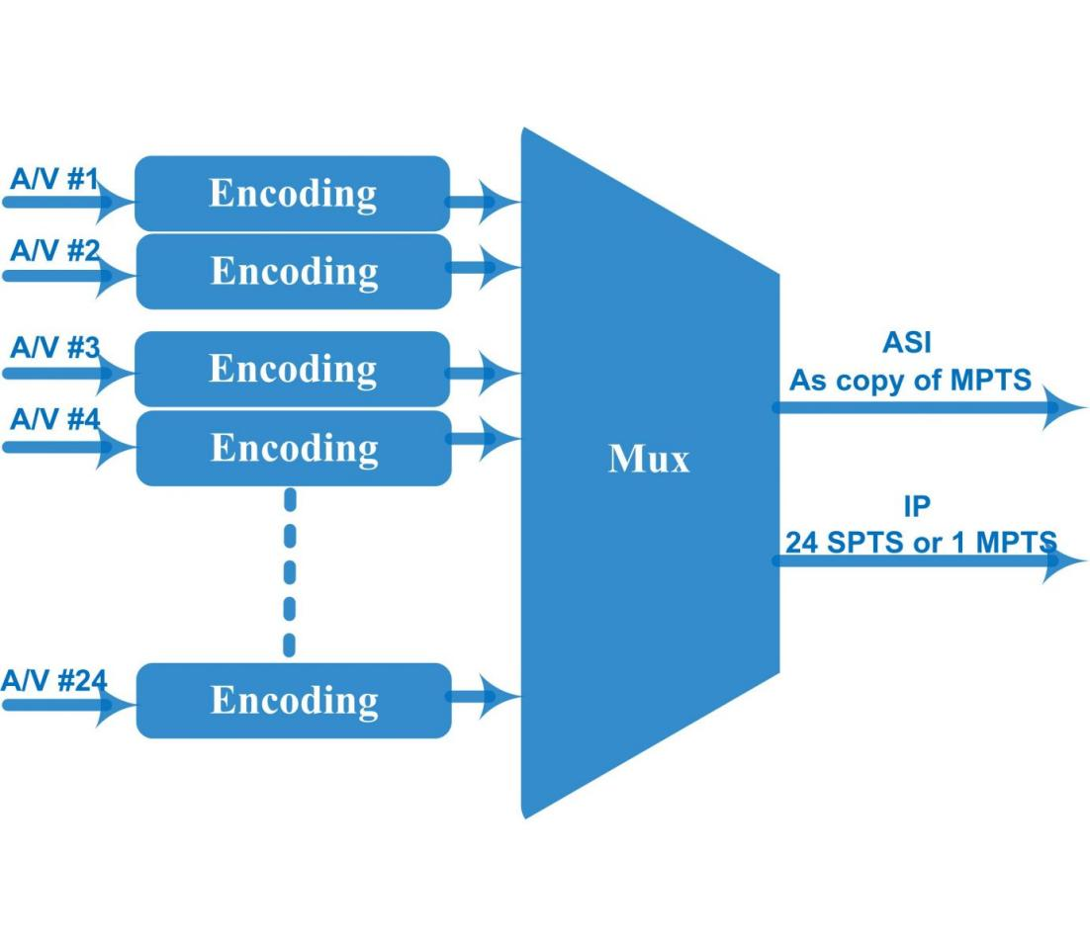

Technical specification
Input | 8/12/16/24 CVBS inputs , RCA interface
Video | Resolution | Input |  | Output
Video | Resolution | 720*576@50i |  | 720*576/352*288/320*240/320*180/  176*144/160*120/160*90@50Hz
Video | Resolution | 720*480@60i |  | 720*480/352*288/320*240/320*180/  176*144/160*120/160*90@60Hz
Video | Encoding | MPEG-2, MPEG4 AVC/H.264
Video | Bit-rate | 0.5~5Mbps
Video | Rate Control | CBR/VBR
Video | GOP Structure | IPPP, IBPBP, IBBPB, IBBBP
Video | Advanced Pretreatment | De-interlacing, noise reduction
Audio | Encoding | MPEG1 Layer 2, LC-AAC, HE-AAC
Audio | Sampling rate | 48KHz
Audio | Bits per sample | 32-bit
Audio | Bit-rate | 48Kbps~384Kbps (each channel)
Multiplexing | Function | PID remapping (automatically or manually)
Multiplexing | Function | Accurate PCR adjusting
Multiplexing | Function | Generate PSI/ SI table automatically
Stream output | 1 ASI out as copy of MPTS  IP output over UDP/RTP/RTSP through Data 1(1000M) or Data 2 (100M) :  8/12 CVBS inputs with 8/12 SPTS and 1 MPTS output  16/24 CVBS inputs with 16/24 SPTS or 1 MPTS output (alternative)
System function | Network management (WEB)
System function | Chinese and English language
System function | Ethernet software upgrade
Miscellaneous | Dimension(W×L×H) |  | 482mm×410mm×44mm
Miscellaneous | Approx weight |  | 8kg
Miscellaneous | Environment |  | 0~45℃(work)；-20~80℃（Storage）
Miscellaneous | Power requirements |  | AC 110V± 10%, 50/60Hz, AC 220 ± 10%, 50/60Hz
Miscellaneous | Power consumption |  | 20W

Order Information
 | FU-4653KB-8 | FU-4653KB-12 | FU-4653KB-16 | FU-4653KB-24
8 CVBS Input | √
12 CVBS Input |  | √
16 CVBS Input |  |  | √
24CVBS Input |  |  |  | √

About Us
FMUSER is a company specializing in broadcasting and television transmission systems and integrating hotel IPTV systems. The company was established in 2009 and has served over 180 countries worldwide. More than 20,000 television stations, radio stations, and hotel clients from different.

Contact:Tomleequan Email：sales@fmuser.com whatsapp: +8613922702227

