FMUSER FUQ-4653B Encoder Modulator 4x HDMI-SDI Inputs MPEG-2-4 AVC Encoding DVB-ATSC-ISDB-T Outputs IP-RF Streaming Broadcast Headend IPTV
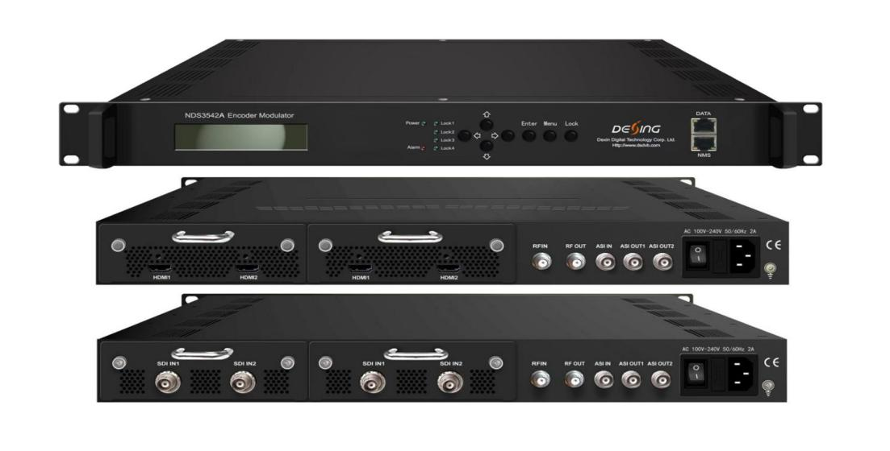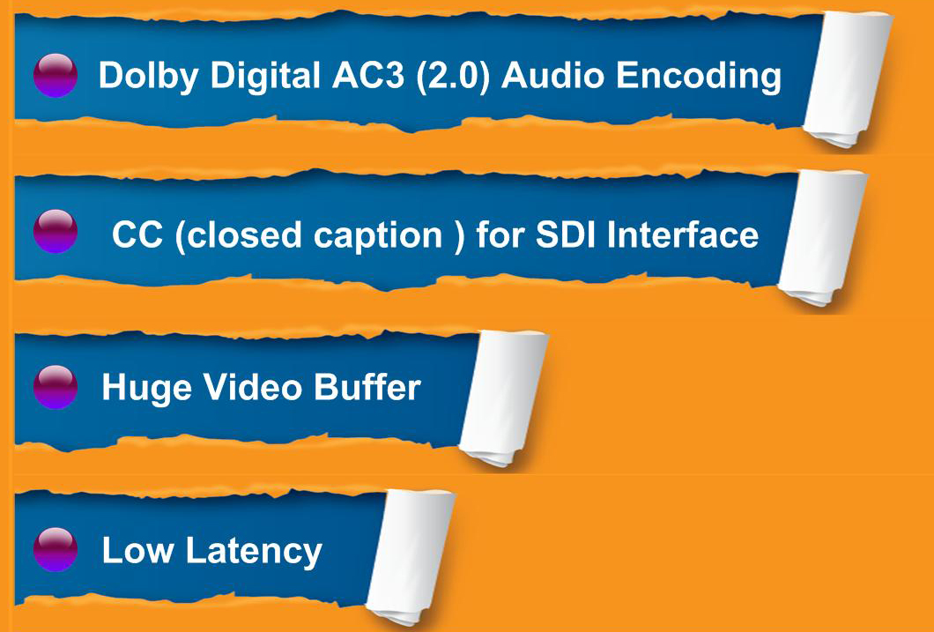
Product overview
The FMUSER FUQ-4653B combines MPEG-2/MPEG-4 AVC encoding and DVB/ATSC/ISDB-T modulation in a 1RU chassis, accepting 4x HDMI/SDI and optional ASI inputs, while delivering IP/UDP/RTP streams or RF output (47-862MHz). It processes signals with <85ms latency in selectable modes and supports MPTS/SPTS IP multiplexing. Compatible with HMS/SMS management systems, this hot-swappable unit is ideal for digital terrestrial TV headends and multi-screen IPTV distribution.
Key feature
Modular design: Hot-swappable encoder/ASI boards with tool-free maintenance
Principle Chart
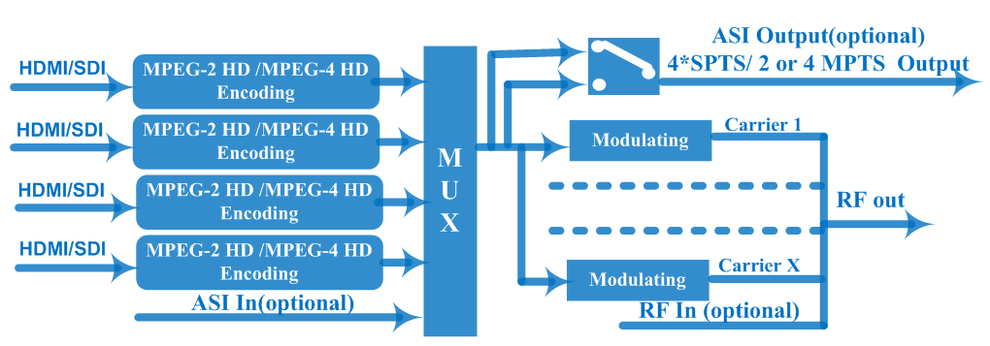

Specifications
HDMI Encoder Board | Video | Input | HDMI*2/board
HDMI Encoder Board | Video | Encoding | MPEG2; MPEG4 AVC/H.264
HDMI Encoder Board | Video | Bitrate | 1-19.5Mbps
HDMI Encoder Board | Video | Resolution | 1920*1080_60P, 1920*1080_50P,  (-for MPEG4 AVC/H.264 only)  1920*1080_60i, 1920*1080_50i,  1280*720_60p, 1280*720_50P  720*480_60i, 720*576_50i
HDMI Encoder Board | Video | Support object resolution  (for downscale conversion) | 1920*1080_60P, 1920*1080_50P,  (-for MPEG4 AVC/H.264 only)  1920*1080_60i, 1920*1080_50i,  1440*1080_60i, 1440*1080_50i,  1280*720_60p, 1280*720_50P  720*480_60i, 720*576_50i
HDMI Encoder Board | Video | Low Delay | Normal, Mode 1, Mode 2, Manual
HDMI Encoder Board | Video | Chroma | 4:2:0
HDMI Encoder Board | Video | Aspect Ratio | 16:9,4:3
HDMI Encoder Board | Audio | Encoding | MPEG1 Layer II;MPEG 2-AAC; MPEG 4-AAC and Dolby Digital AC3 2.0(optional)
HDMI Encoder Board | Audio | Dialog Normalization  Applicable for DD AC3 encoding only) | -31 ~ -1 dB
HDMI Encoder Board | Audio | Sample rate | 48KHz
HDMI Encoder Board | Audio | Bitrate | 64/96/128/ 192/256/320kbps
SDI Encoder Board
  Video | Encoding | MPEG2; MPEG4 AVC/H.264
  Video | Input | SDI*2/board
  Video | Bitrate | 1-19.5Mbps
  Video | Resolution | 1920*1080_60P, 1920*1080_50P,  (-for MPEG4 AVC/H.264 only)  1920*1080_60i, 1920*1080_50i,  1280*720_60p, 1280*720_50P  720*480_60i, 720*576_50i
  Video | Support object resolution  (for downscale conversion) | 1920*1080_60P, 1920*1080_50P,  (-for MPEG4 AVC/H.264 only)  1920*1080_60i, 1920*1080_50i,  1440*1080_60i, 1440*1080_50i,  1280*720_60p, 1280*720_50P  720*480_60i, 720*576_50i
  Video | Low Delay | Normal, Mode 1, Mode 2, Manual
  Video | Chroma | 4:2:0
  Video | Aspect Ratio | 16:9,4:3
  Audio | Encoding | MPEG1 Layer II ,MPEG2-AAC, MPEG4-AAC  and Dolby Digital AC3 2.0(optional)
  Audio | Dialog Normalization  Applicable for DD AC3 encoding only) | -31 ~ -1 dB
  Audio | Sample rate | 48KHz
  Audio | Bitrate | 64/96/128/ 192/256/320kbps
Modulator Section | DVB-T  (Optional) | Standard | DVB-T
Modulator Section | DVB-T  (Optional) | Bandwidth | 6M, 7M, 8M
Modulator Section | DVB-T  (Optional) | Constellation | QPSK, 16QAM, 64QAM
Modulator Section | DVB-T  (Optional) | Code rate | 1/2, 2/3, 3/4, 5/6, 7/8.
Modulator Section | DVB-T  (Optional) | Guard Interval | 1/32, 1/16, 1/8, 1/4
Modulator Section | DVB-T  (Optional) | Transmission Mode | 2K, 4K, 8K
Modulator Section | DVB-T  (Optional) | MER | ≥40dB
Modulator Section | DVB-T  (Optional) | RF frequency | 50~960MHz, 1KHz step
Modulator Section | DVB-T  (Optional) | RF Out | 4*DVB-T carriers(40MHz bandwidth)
Modulator Section | DVB-T  (Optional) | RF output level | -20~ -3dbm, 0.1db step
Modulator Section | DVB-C  (Optional) | Standard | J.83A (DVB-C), J.83B, J.83C
Modulator Section | DVB-C  (Optional) | MER | ≥40dB
Modulator Section | DVB-C  (Optional) | RF frequency | 50~960MHz, 1KHz step
Modulator Section | DVB-C  (Optional) | RF output level | -20~ +3dbm, 0.1db step
Modulator Section | DVB-C  (Optional) | Symbol rate | 3.000~9.000Msps adjustable
Modulator Section | DVB-C  (Optional) | RF Out | 4*DVB-C carriers(40MHz bandwidth)
Modulator Section | DVB-C  (Optional) |  | J.83A | J.83B | J.83C
Modulator Section | DVB-C  (Optional) | Constellation | 16/32/64/128/256QAM | 64/ 256 QAM | 64/ 256 QAM
Modulator Section | DVB-C  (Optional) | Bandwidth | 8M | 6M | 6M
Modulator Section | ATSC  (Optional)  (under developing) | Standard | ATSC A/53
Modulator Section | ATSC  (Optional)  (under developing) | MER | ≥40dB
Modulator Section | ATSC  (Optional)  (under developing) | RF frequency | 50~960MHz, 1KHz step.
Modulator Section | ATSC  (Optional)  (under developing) | RF Out | 4*ATSC carriers
Modulator Section | ATSC  (Optional)  (under developing) | RF output level | -20~ +3dbm, 0.1db step
Modulator Section | ATSC  (Optional)  (under developing) | Constellation | 8VSB
Modulator Section | ISDB-T  (Optional) | Standard | ARIB STD-B31
Modulator Section | ISDB-T  (Optional) | Bandwidth | 6M
Modulator Section | ISDB-T  (Optional) | Constellation | QPSK, 16QAM, 64QAM
Modulator Section | ISDB-T  (Optional) | Guard Interval | 1/32, 1/16, 1/8, 1/4
Modulator Section | ISDB-T  (Optional) | Transmission Mode | 2K, 4K, 8K
Modulator Section | ISDB-T  (Optional) | MER | ≥40dB
Modulator Section | ISDB-T  (Optional) | RF frequency | 50~960MHz, 1KHz step
Modulator Section | ISDB-T  (Optional) | RF Out | 2*ISDBT carriers(30MHz bandwidth)
Modulator Section | ISDB-T  (Optional) | RF output level | -20~ -3dbm, 0.1db step
General | System | Local interface | LCD + control buttons
General | System | Remote management | Web NMS
General | System | Stream Out | 2 ASI out (BNC type, same one mirror out ts as one of 4/2 MPTS outputs and 4 SPTS outputs)
General | System | Stream Out | DVB-C/DVB-T/ATSC: IP (4 MPTS & 4 SPTS) out over UDP, RTP/RTSP  ISDBT: IP (2 MPTS & 4 SPTS) out over UDP, RTP/RTSP
General | System | DATA Port | 1000M
General | System | NMS interface | RJ45, 100M
General | System | Language | English
General | Physical Specification | Power supply | 100~240VAC, 50/60Hz
General | Physical Specification | Dimensions | 482*400*44mm
General | Physical Specification | Operation temperature | 0~45℃

Major Technical Comparison
 | The Former Version | The Current Version（V2）
Bit rate Mode | CBR/VBR option | CBR
Audio Group/Pair option-SDI | No | Yes
Low Delay | Normal/Mode 1/Mode 2 | Normal/Mode 1/Mode 2/Manual
Character Encoding option | No | Yes
DATA Port | 100M port | 1000M port
Frequency Range | 30-960MHz | 50-960MHz
Symbol Rate--DVB-C | 5-9Msps | 3-9Msps
ISDB-T carriers | 1 or 2 carriers for order option | 2 carriers
IP out--DVB-C | 1 MPTS and 4 SPTS | 4 MPTS and 4 SPTS
IP out--DVB-T | 4 SPTS | 4 MPTS and 4 SPTS
DVB-T carriers | 2 carriers | 4 carriers
The other differences are existing Web GUI design and chassis design etc(NMS/DATA port position), no further description here.

Internal Test Report of Latency
The values cover the progress from Encoding → Decoding

Decoding Terminal | Encoding Details |  |  |  |  | Average Latency (ms)
Decoding Terminal | Resolution | Encoding Bit Rate | Low Latency Mode | Signal Source | Encoding Type | Average Latency (ms)
DVB-C HD STB | 1080i@50 | 14M | MODE 1 | HDMI | mpeg2 | 170
 |  |  |  |  | H.264 | 347.5
 |  |  |  | SDI | mpeg2 | 227.5
 |  |  |  |  | H.264 | 367.5
DVB-C HD STB | 1080i@50 | 14M | MODE 2 | HDMI | mpeg2 | 222.5
 |  |  |  |  | H.264 | 395
 |  |  |  | SDI | mpeg2 | 240
 |  |  |  |  | H.264 | 397.5
DVB-C HD STB | 720p@50 | 14M | MODE 1 | HDMI | mpeg2 | 85.75
 |  |  |  |  | H.264 | 237.5
 |  |  |  | SDI | mpeg2 | 127.5
 |  |  |  |  | H.264 | 295
DVB-C HD STB | 720p@50 | 14M | MODE 2 | HDMI | mpeg2 | 182.5
 |  |  |  |  | H.264 | 277.5
 |  |  |  | SDI | mpeg2 | 167.5
 |  |  |  |  | H.264 | 325
DVB-C HD STB | 576i@50 | 14M | MODE 1 | HDMI | mpeg2 | 310
 |  |  |  |  | H.264 | 600
 |  |  |  | SDI | mpeg2 | 330
 |  |  |  |  | H.264 | 620
DVB-C HD STB | 576i@50 | 14M | MODE 2 | HDMI | mpeg2 | 270
 |  |  |  |  | H.264 | 610
 |  |  |  | SDI | mpeg2 | 280
 |  |  |  |  | H.264 | 620

About Us
FMUSER is a company specializing in broadcasting and television transmission systems and integrating hotel IPTV systems. The company was established in 2009 and has served over 180 countries worldwide. More than 20,000 television stations, radio stations, and hotel clients from different.

Contact:Tomleequan Email：sales@fmuser.com whatsapp: +8613922702227

