FMUSER FUQ-4653C Encoder Modulator 4x HDMI-YPbPr-CVBS Inputs Digital RF Output MPEG2-MPEG4 AVC H.264 Encoding DVB-C-DVB-T IP Output Hospitality Broadcasting 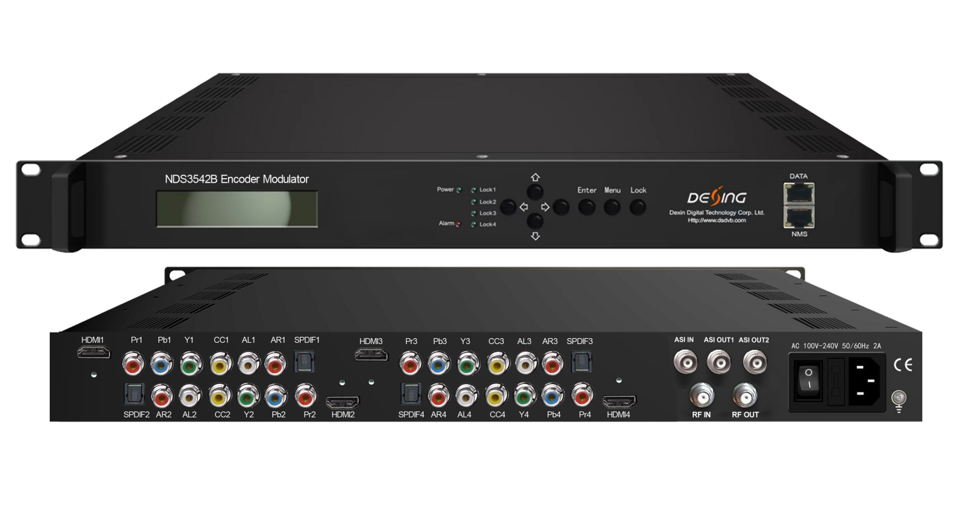Product Overview
The FMUSER FUQ-4653G is an all-in-one encoder modulator with 4x HDMI, YPbPr, and CVBS inputs, converting to digital RF output. It encodes video using MPEG2 and MPEG4 AVC H.264, and modulates signals for distribution. Features include an LCD display and web-based NMS for control. Ideal for public venues, supporting sources like satellite receivers.
Key feature
Integrated MPEG2/MPEG4 AVC H.264 encoding for HD/SD video.
Supports DD AC3, MPEG4-AAC, MPEG2-AAC, and MPEG1 Layer II audio formats.
Features 4x HDMI, YPbPr, and CVBS inputs.
Provides DVB-C, DVB-T, optional ISDB-T, ATSC, ASI, and IP outputs.
Includes web-based NMS for remote monitoring and updates.
Principle Chart
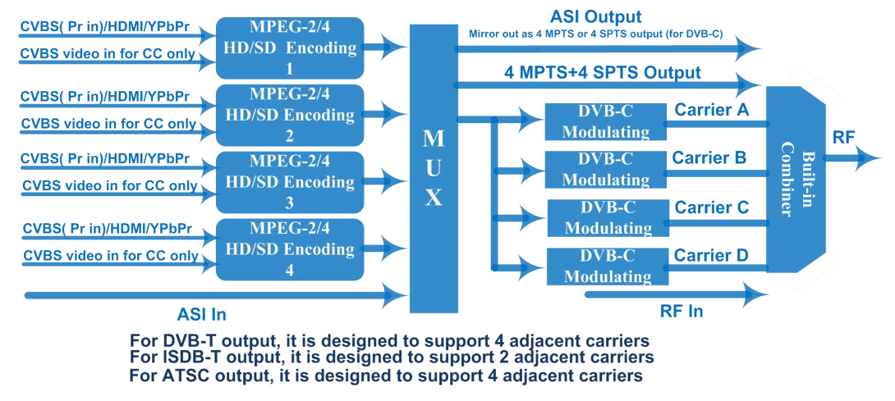

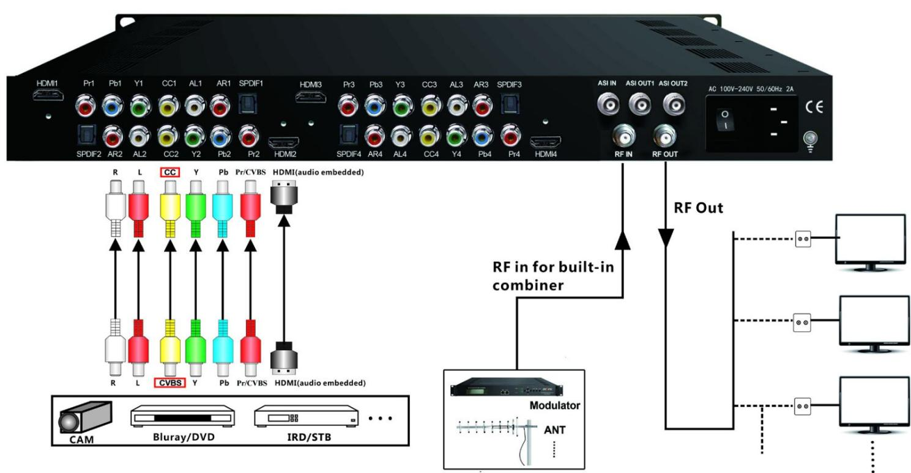

Specifications

Encoder Section | HDMI | Video | Interface | HDMI*4
Encoder Section | HDMI | Video | Encoding | MPEG2; MPEG4 AVC/H.264
Encoder Section | HDMI | Video | Bitrate | 1-19.5Mbps
Encoder Section | HDMI | Video | Resolution | 1920*1080_60P, 1920*1080_50P (-for MPEG4 AVC/H.264 only)  1920*1080_60i, 1920*1080_50i,  1280*720_60p, 1280*720_50P
Encoder Section | HDMI | Video | Low Delay | Normal, Mode 1, Mode 2, Manual
Encoder Section | HDMI | Video | Chroma | 4:2:0
Encoder Section | HDMI | Video | Aspect Ratio | 16:9,4:3
Encoder Section | HDMI | Audio | Interface | HDMI*4 /SPDIF*4/Audio(L/R)*4
Encoder Section | HDMI | Audio | Encoding | MPEG1 Layer II;  MPEG 2-AAC;  MPEG 4-AAC and Dolby Digital AC3 2.0 (optional)
Encoder Section | HDMI | Audio | Dialog Normalization | -31 ~ -1 dB (Applicable for DD AC3 only)
Encoder Section | HDMI | Audio | Sample rate | 48KHz
Encoder Section | HDMI | Audio | Bitrate | 64/96/128/ 192/256/320kbps
Encoder Section | CVBS  /YPbPr | Video | Encoding | MPEG2; MPEG4 AVC/H.264
Encoder Section | CVBS  /YPbPr | Video | Interface | CVBS/YPbPr*4 (RCA)
Encoder Section | CVBS  /YPbPr | Video | Bitrate | 1-19.5Mbps
Encoder Section | CVBS  /YPbPr | Video | Resolution | YPbPr: 1920*1080_60i, 1920*1080_50i,  1280*720_60p, 1280*720_50P  CVBS: 720*480_60i, 720*576_50i
Encoder Section | CVBS  /YPbPr | Video | Low Delay | Normal, Mode 1, Mode 2, Manual
Encoder Section | CVBS  /YPbPr | Video | Chroma | 4:2:0
Encoder Section | CVBS  /YPbPr | Video | Aspect Ratio | 16:9,4:3
Encoder Section | CVBS  /YPbPr | Audio | Encoding | MPEG1 Layer II ,MPEG2-AAC, MPEG4-AAC  and Dolby Digital AC3 2.0 (optional)
Encoder Section | CVBS  /YPbPr | Audio | Interface | HDMI*4 /SPDIF*4/Audio(L/R)*4
Encoder Section | CVBS  /YPbPr | Audio | Dialog Normalization | -31 ~ -1 dB (Applicable for DD AC3 only)
Encoder Section | CVBS  /YPbPr | Audio | Sample rate | 48KHz
Encoder Section | CVBS  /YPbPr | Audio | Bitrate | 64/96/128/ 192/256/320kbps
Encoder Section | Resolution Downscale |  | In Resolution | Available Out Resolution
Encoder Section |  |  | 1920*1080_60P | 1920*1080_60P, 1920*1080_60i, 1440*1080_60i,  1280*720_60p, 720*480_60i
Encoder Section |  |  | 1920*1080_50P | 1920*1080_50P, 1920*1080_50i, 1440*1080_50i,  1280*720_50P, 720*576_50i
Encoder Section |  |  | 1920*1080_60i | 1920*1080_60i, 1440*1080_60i, 720*480_60i
Encoder Section |  |  | 1920*1080_50i | 1920*1080_50i, 1440*1080_50i, 720*576_50i
Encoder Section |  |  | 1280*720_60p | 1280*720_60p, 720*480_60i
Encoder Section |  |  | 1280*720_50P | 1280*720_50P, 720*576_50i
Encoder Section |  |  | 720*480_60i | 720*480_60i
Encoder Section |  |  | 720*576_50i | 720*576_50i
Modulator Section | DVB-T  (Optional) |  | Standard | DVB-T
Modulator Section |  |  | Bandwidth | 6M, 7M, 8M
Modulator Section |  |  | Constellation | QPSK, 16QAM, 64QAM
Modulator Section |  |  | Code rate | 1/2, 2/3, 3/4, 5/6, 7/8
Modulator Section |  |  | Guard Interval | 1/32, 1/16, 1/8, 1/4
Modulator Section |  |  | Transmission Mode | 2K, 4K, 8K
Modulator Section |  |  | MER | About 40dB
Modulator Section |  |  | RF frequency | 50~960MHz, 1KHz step
Modulator Section |  |  | RF Out | 4*DVB-T carriers
Modulator Section |  |  | RF output level | -20~ -9dbm, 0.1db step
Modulator Section | DVB-C  (Optional) |  | Standard | J.83A (DVB-C), J.83B, J.83C
Modulator Section |  |  | MER | About 40dB
Modulator Section |  |  | RF frequency | 50~960MHz, 1KHz step
Modulator Section |  |  | RF output level | -20~ -3dbm, 0.1db step
Modulator Section |  |  | Symbol rate | 3.000~9.000Msps adjustable
Modulator Section |  |  | RF Out | 4*DVB-C carriers
Modulator Section |  |  |  | J.83A | J.83B | J.83C
Modulator Section |  |  | Constellation | 16/32/64/128/256QAM | 64/ 256 QAM | 64/ 256 QAM
Modulator Section |  |  | Bandwidth | 8M | 6M | 6M
Modulator Section | ATSC  (Optional) under developing |  | Standard | ATSC A/53
Modulator Section |  |  | Constellation | 8 VSB
Modulator Section |  |  | MER | About 40dB
Modulator Section |  |  | RF frequency | 50~960MHz, 1KHz step.
Modulator Section |  |  | RF Out | 4*ATSC carriers
Modulator Section |  |  | RF output level | -20~ -9dbm, 0.1db step
Modulator Section |  |  | Constellation | 8VSB
 | ISDB-T  (Optional) under developing |  | Standard | ARIB STD-B31
 |  |  | Bandwidth | 6M
 |  |  | Constellation | QPSK, 16QAM, 64QAM
 |  |  | Guard Interval | 1/32, 1/16, 1/8, 1/4
 |  |  | Transmission Mode | 2K, 4K, 8K
 |  |  | MER | About 40dB
 |  |  | RF frequency | 50~960MHz, 1KHz step
 |  |  | RF Out | 2*ISDBT carriers
 |  |  | RF output level | -20~ -9dbm, 0.1db step
General | System |  | Local interface | LCD + control buttons
General |  |  | Remote management | Web NMS
General |  |  | Stream Out | 2 ASI out (BNC type, the same one mirror ts out as one of 4/2 MPTS outputs and 4 SPTS outputs)
General |  |  | Stream Out | DVB-C/DVB-T/ATSC: IP (4 MPTS & 4 SPTS) out over UDP, RTP/RTSP  ISDBT: IP (2 MPTS & 4 SPTS) out over UDP, RTP/RTSP
General |  |  | DATA Port | 1000M
General |  |  | NMS interface | RJ45, 100M
General |  |  | Language | English
General | Physical Specification |  | Power supply | 100~240VAC, 50/60Hz
General |  |  | Dimensions | 482*400*44mm
General |  |  | Operation temperature | 0~45℃

Major Technical Comparison
 | The Former Version | The Current Version（V2）
DD AC3 (2.0/5.1/7.1) passthrough | Yes | No
Bit rate Mode | CBR/VBR option | CBR
Low Delay | Normal/Mode 1/Mode 2 | Normal/Mode 1/Mode 2/Manual
Character Encoding option | No | Yes
DATA Port | 100M port | 1000M port
Frequency Range | 30-960MHz | 50-960MHz
Symbol Rate--DVB-C | 5-9Msps | 3-9Msps
IP out--DVB-C | 1 MPTS and 4 SPTS | 4 MPTS and 4 SPTS
IP out--DVB-T | 4 SPTS | 4 MPTS and 4 SPTS
DVB-T carriers | 2 carriers | 4 carriers

The other differences are existing Web GUI design and chassis design etc(NMS/DATA port position), no further description here.

About Us
FMUSER is a company specializing in broadcasting and television transmission systems and integrating hotel IPTV systems. The company was established in 2009 and has served over 180 countries worldwide. More than 20,000 television stations, radio stations, and hotel clients from different.

Contact:Tomleequan Email：sales@fmuser.com whatsapp: +8613922702227

