FMUSER FUQ-4653D Encoder Modulator 2x HDMI YPbPr CVBS Input DVB-C ATSC DVB-T ISDB-T Output MPEG2 MPEG4 AVC H.264 Encoding Web NMS Remote Management for Hotel IPTV and Public Venues 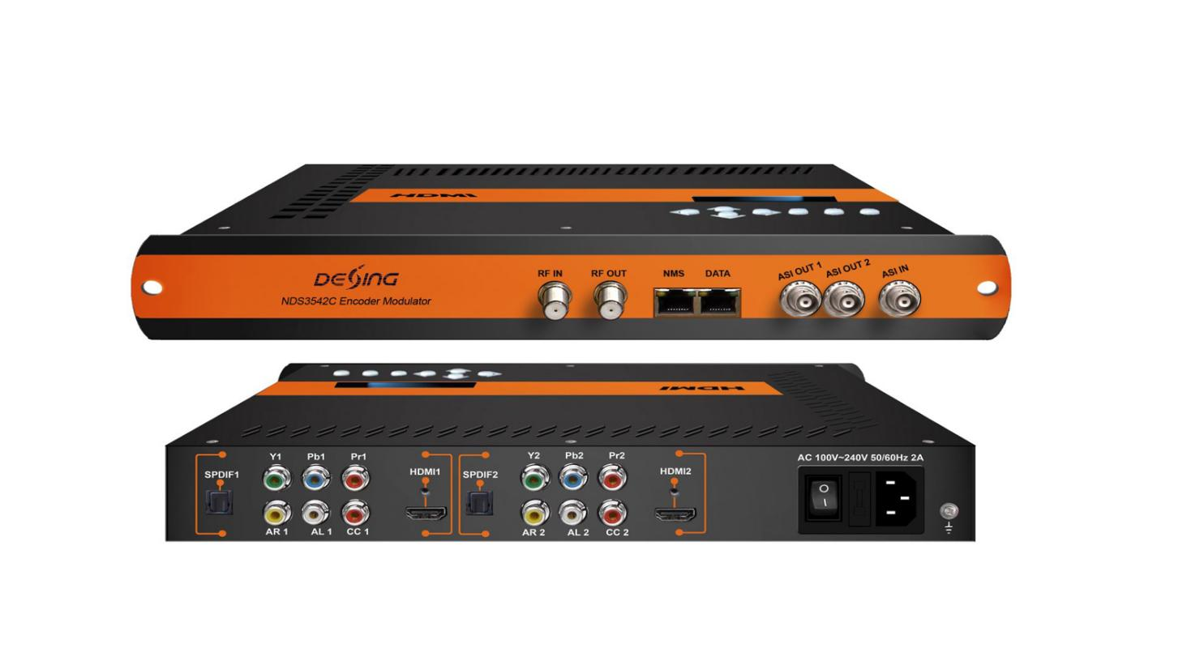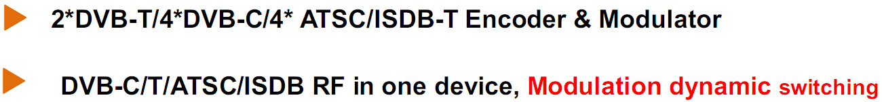

Product Overview
The FMUSER FUQ-4653D is an encoder modulator with MPEG2 HD and MPEG4 HD encoding, featuring inputs: 2x HDMI, YPbPr, CVBS, and outputs: RF, 2x ASI, IP. It converts signals through encoding and modulation for digital broadcasting. Controlled via web-based NMS, it supports remote management and updates. Ideal for hotels, metros, and public venue applications.

Key feature
- Features integrated MPEG2 HD and MPEG4 HD encoding for high-definition processing.
- Supports modulation standards: DVB-C, ATSC, DVB-T, ISDBT with dynamic switching.
- Provides flexible I/O: 2x HDMI/YPbPr/CVBS inputs, 2x ASI outputs, IP streaming over UDP/RTP/RTSP.
- Includes web-based NMS for remote control and firmware updates.
Specifications
Encoding Section
Video (HDMI)
Encoding | MPEG2; MPEG4 AVC/H.264
Interface | HDMI*2
Resolution | 1920*1080_60P, 1920*1080_50P  (For MPEG 4 AVC/H.264 only),  1920*1080_60i, 1920*1080_50i,  1280*720_60p, 1280*720_50P
Low Delay | Normal, Mode 1, Mode 2, Manual
Audio (HDMI)
Encoding | MPEG1 Layer II; MPEG2-AAC; MPEG4-AAC; DD AC3(2.0) optional;  DD AC3 (2.0/5.1/7.1) passthrough
Interface | HDMI*2/SPDIF*2/2*Stereo/4*mono
Sample rate | 48KHz
Bit rate | 64/96/128/ 192/256/320kbps
Video (CVBS/YPbPr)
Encoding | MPEG2; MPEG4 AVC/H.264
Interface | CVBS/YPbPr*2(RCA)
Resolution | CVBS: 720*576_50i, 720*480_60i  YPbPr:1920*1080_60i, 1920*1080_50i;  1280*720_60p, 1280*720_50P
Audio (L/R)
Encoding | MPEG1 Layer II; MPEG2-AAC; MPEG4-AAC; DD AC3(2.0) optional;
Interface | 2*Stereo/4*mono
Sample rate | 48KHz
Bit rate | 64/96/128/ 192/256/320kbps

DVB-C Modulator Section
Standard |  |  | J.83A (DVB-C), J.83B, J.83C
MER |  |  | ≥40dB
RF frequency |  |  | 30~960MHz, 1KHz step
RF output level |  |  | -30~ -10dbm (77~97 dbµV), 0.1db step
Symbol rate |  |  | 5.000~9.000Msps adjustable
RF Out | 4*DVB-C adjacent carriers combined output
 |  | J.83A |  | J.83B | J.83C
Constellation |  | 16/32/64/128/ 256 QAM |  | 64/ 256 QAM | 64/ 256 QAM
Bandwidth |  | 8M |  | 6M | 6M

DVB-T Modulator Section
Standard | EN300744
FFT mode | 2K, 8K
Bandwidth | 6M, 7M, 8M
Constellation | QPSK, 16QAM, 64QAM
Guard Interval | 1/4, 1/8, 1/16, 1/32
FEC | 1/2, 2/3, 3/4, 5/6, 7/8
MER | ≥40dB
RF frequency | 30~960MHz, 1KHz step
RF out | COFDM DVB-T out (2 carriers combined out)
RF output level | -30~ -10dbm (77~97 dbµV), 0.1db step

ATSC Modulator Section
Standard |  | ATSC A/53
Constellation |  | 8 VSB
RF output level |  | -30~ -10dbm (77~97 dbµV), 0.1db step
MER |  | ≥40dB
RF frequency |  | 36~960MHz, 1KHz step
RF Out |  | 4*ATSC adjacent carriers combined output
ISDBT Modulator Section
Standard |  | ARIB STD-B31
Bandwidth |  | 6M
Constellation |  | DQPSK,QPSK, 16QAM, 64QAM
Guard Interval |  | 1/32, 1/16, 1/8, 1/4
Transmission Mode |  | 2K, 4K, 8K
MER |  | ≥40dB
RF frequency |  | 30~960MHz, 1KHz step
RF output level |  | -30~ -10dbm (77~97 dbµV), 0.1db step
RF Out | ISDBT adjacent carriers combined output
System
Local interface |  |  | LCD + control buttons
Remote management |  |  | Web NMS
Stream Out |  |  | 2 separate ASI out (BNC type);  IP (2* SPTS&1*MPTS) over UDP/RTP/RTSP out (RJ45, 100M)  RTSP is only for DVB-C modulation
NMS interface |  |  | RJ45, 1000M
Language |  |  | English
General
Power supply |  |  |  | AC 100V~240V
Dimensions |  |  |  | 333*232*44mm
Weight |  |  |  | 2.5 kg
Operation temperature |  |  |  | 0~45℃

Principle Chart
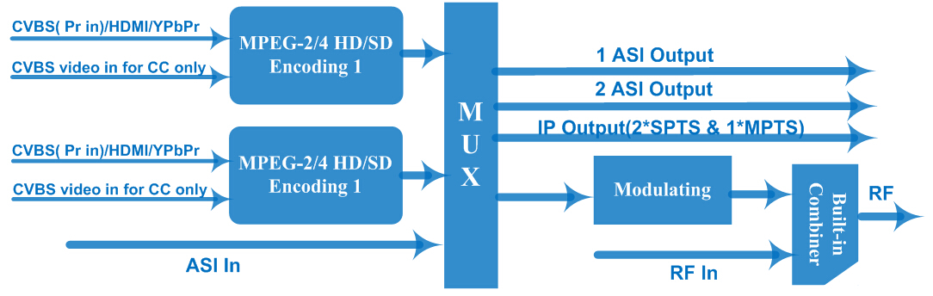

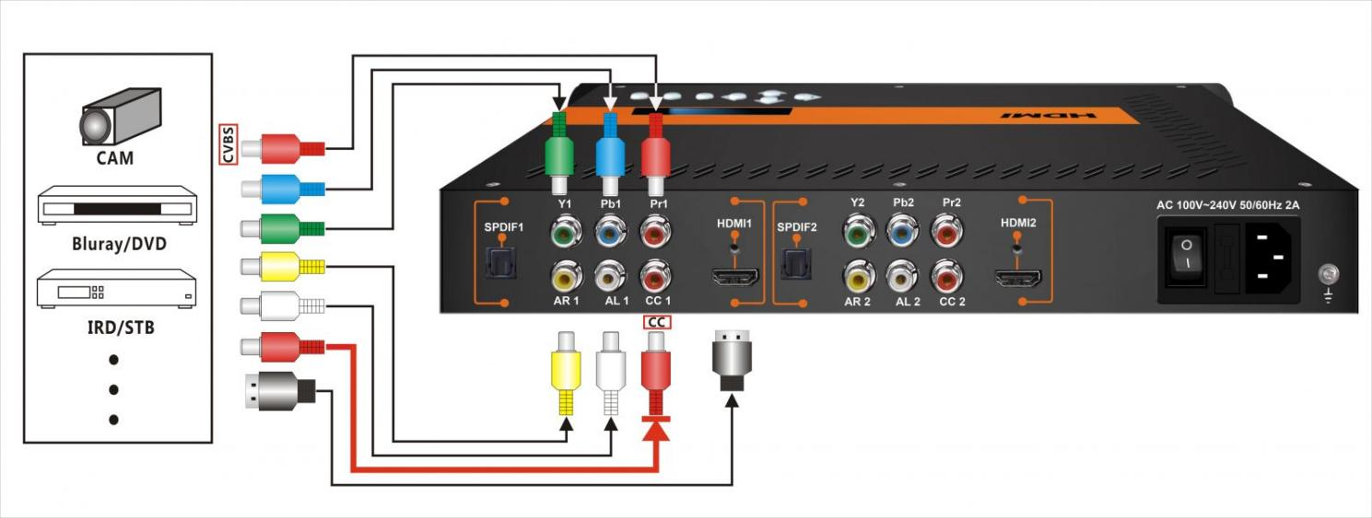

About Us
FMUSER is a company specializing in broadcasting and television transmission systems and integrating hotel IPTV systems. The company was established in 2009 and has served over 180 countries worldwide. More than 20,000 television stations, radio stations, and hotel clients from different.

Contact:Tomleequan Email：sales@fmuser.com whatsapp: +8613922702227

