FMUSER FUQ-4653E Modulator 4 Tuner + 2 ASI Inputs DVB-T-T2-S-S2-S2X to DVB-C RF ASI UDP IP Outputs Integrated Demodulation Transmux Modulation for Broadcast Headends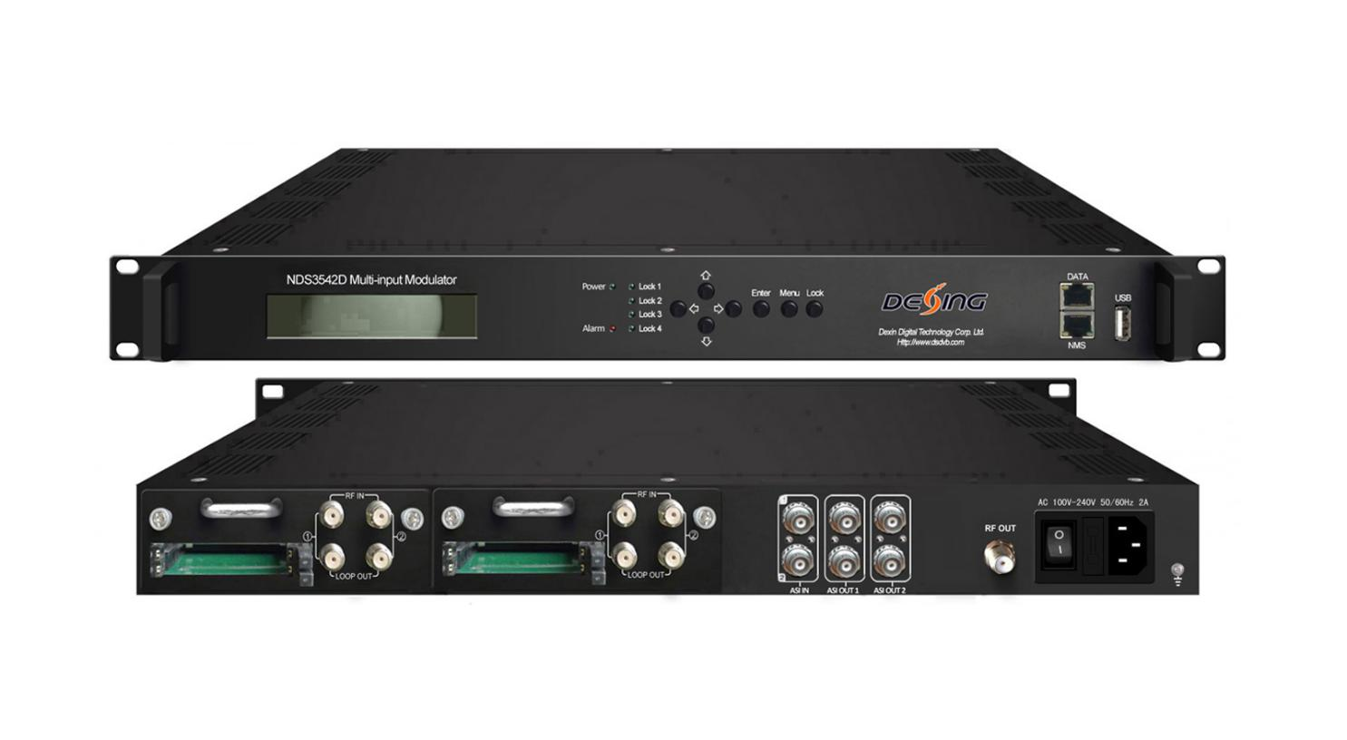Product overview
The FMUSER FUQ-4653E modulator integrates demodulation, trans-mux, and modulation in a 1-U case, supporting 4 tuner inputs for satellite/cable/terrestrial sources and 2 ASI inputs, with outputs including RF, ASI, and UDP IP ports. It processes signals by converting them for distribution, featuring an LCD display, keyboard, and Web NMS for control via web or USB. Ideal for broadcasting headends, cable TV systems, and IP-based content distribution networks.

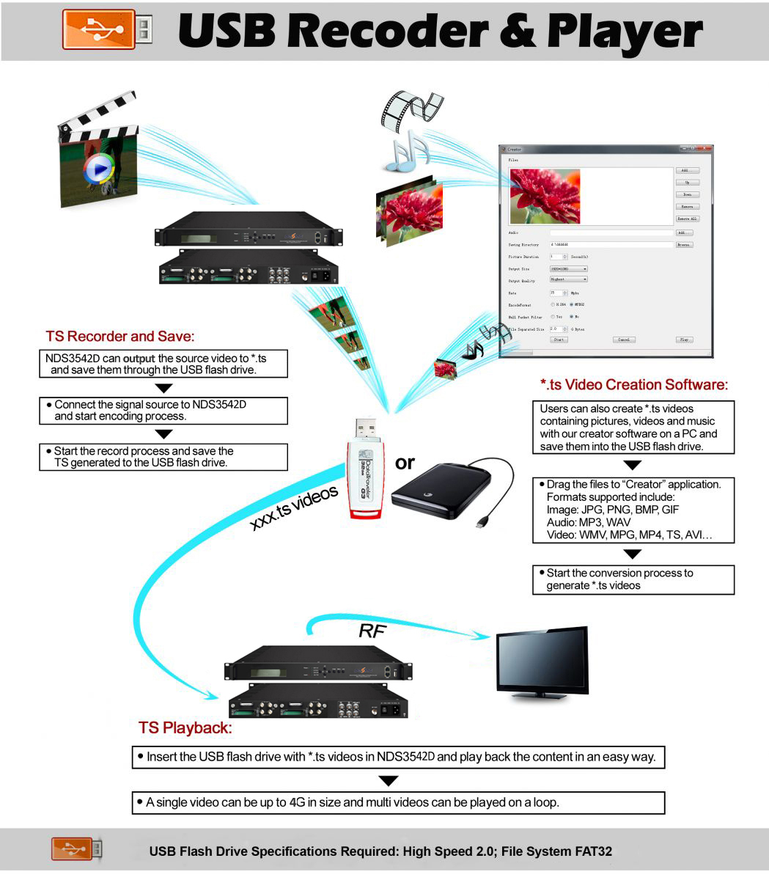

Key feature
Delivers RF outputs (e.g., DVB-T or DVB-C), ASI outputs, and UDP IP outputs (MPTS or SPTS)

Working Principle
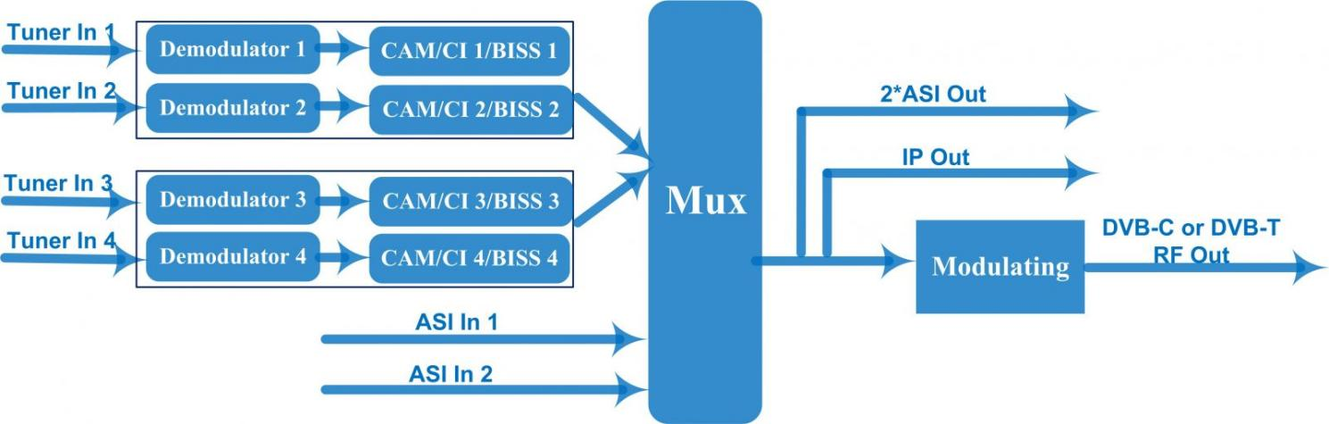

Specifications
Input | 4 Tuner (DVB-T/(T)/S/S2/S2X optional) and 2 ASI input
Tuner Section | DVB-T/(T) |  |  | Input Frequency | 30~1000MHz
Tuner Section |  |  |  | Bandwidth | 6/7/8M
Tuner Section | Version 1 | DVB-S |  | Input Frequency | 950~2150MHz
Tuner Section | Version 1 |  |  | Symbol rate | 1~45 Msps
Tuner Section | Version 1 |  |  | Signal Strength | -65~-25dBm
Tuner Section | Version 1 |  |  | FEC | 1/2, 2/3, 3/4, 5/6, 7/8
Tuner Section | Version 1 |  |  | Constellation | QPSK
Tuner Section | Version 1 |  |  | Max input bitrate | ≤120 Mbps
Tuner Section | Version 1 | DVB-S2 |  | Input Frequency | 950~2150MHz
Tuner Section | Version 1 |  |  | Symbol rate | QPSK 1~45 Msps  8PSK 2~30 Msps
Tuner Section | Version 1 |  |  | FEC | 1/2, 3/5, 2/3, 3/4, 4/5, 5/6, 8/9, 9/10
Tuner Section | Version 1 |  |  | Constellation | QPSK, 8PSK
Tuner Section | Version 1 |  |  | Max input bitrate | ≤120 Mbps
Tuner Section | Version 2  (New) | DVB-S |  | Input Frequency | 950~2150MHz
Tuner Section | Version 2  (New) |  |  | Symbol rate | 0.5~45Msps
Tuner Section | Version 2  (New) |  |  | Signal Strength | - 65- -25dBm
Tuner Section | Version 2  (New) |  |  | FEC | 1/2, 2/3, 3/4, 5/6, 7/8
Tuner Section | Version 2  (New) |  |  | Constellation | QPSK
Tuner Section | Version 2  (New) |  |  | Max input bitrate | ≤160 Mbps
Tuner Section | Version 2  (New) | DVB-S2 |  | Input Frequency | 950~2150MHz
Tuner Section | Version 2  (New) |  |  | Symbol rate | QPSK/8PSK /16APSK: 0.5~45 Msps  32APSK: 0.5~40Msps;
Tuner Section | Version 2  (New) |  |  | FEC | QPSK: 1/2, 3/5, 2/3, 3/4, 4/5, 5/6, 8/9, 9/10  8PSK: 3/5, 2/3, 3/4, 5/6, 8/9, 9/10  16APSK: 2/3, 3/4, 4/5, 5/6, 8/9, 9/10  32APSK: 3/4, 4/5, 5/6, 8/9, 9/10
Tuner Section | Version 2  (New) |  |  | Constellation | QPSK, 8PSK, 16APSK, 32APSK
Tuner Section | Version 2  (New) |  |  | Max input bitrate | ≤160 Mbps
Tuner Section | Version 2  (New) | DVB-S2X |  | Input Frequency | 950~2150MHz
Tuner Section | Version 2  (New) |  |  | Symbol rate | QPSK/8PSK /16APSK :0.5~45 Msps  8APSK/32APSK: 0.5~40Msps
Tuner Section | Version 2  (New) |  |  | FEC | QPSK: 1/2, 3/5, 2/3, 3/4, 4/5, 5/6, 8/9, 9/10, 13/45, 9/20, 11/20  8PSK: 3/5, 2/3, 3/4, 5/6, 8/9, 9/10  8APSK: 5/9-L, 26/45-L  16APSK: 2/3, 3/4, 4/5, 5/6, 8/9, 9/10, 1/2-L, 8/15-L, 5/9-L, 26/45, 3/5, 3/5-L, 28/45, 23/36 , 2/3-L, 25/36, 13/18, 7/9, 77/90  32APSK: 3/4, 4/5, 5/6, 8/9, 2/3-L, 32/45, 11/15, 7/9
Tuner Section | Version 2  (New) |  |  | Constellation | QPSK, 8PSK, 8APSK, 16APSK, 32APSK
Tuner Section | Version 2  (New) |  |  | Max input bitrate | ≤160 Mbps
Multiplexing | Maximum PID Remapping |  |  | 128per input channel
Multiplexing | Function |  |  | PID remapping (automatically or manually)
Multiplexing |  |  |  | Accurate PCR adjusting
Multiplexing |  |  |  | Generate PSI/SI table automatically
Modulation | DVB-C |  |  | Standard | J.83A(DVB-C), J.83B, J.83C
Modulation |  |  |  | MER | ≥40dB
Modulation |  |  |  | RF frequency | 30~999MHz, 1KHz step
Modulation |  |  |  | RF output level | -20~0dbm(87~107 dbµV),0.1db step
Modulation |  |  |  | Symbol rate | 5.0Msps-9.0Msps, 1ksps stepping
Modulation |  |  |  | RF Out | 4*DVB-C carriers output
Modulation |  |  |  |  | J.83A | J.83B | J.83C
Modulation |  |  |  | Constellation | 16/32/64/128/256QAM | 64/256 QAM | 64/256 QAM
Modulation |  |  |  | Bandwidth | 8M | 6M | 6M
Modulation | DVB-T |  |  | Bandwidth | 6M, 7M, 8M
Modulation |  |  |  | Constellation | QPSK, 16QAM, 64QAM
Modulation |  |  |  | Code rate | 1/2, 2/3, 3/4, 5/6, 7/8
Modulation |  |  |  | Guard Interval | 1/32, 1/16, 1/8, 1/4
Modulation |  |  |  | Transmission Mode | 2K, 8K
Modulation |  |  |  | MER | ≥40dB
Modulation |  |  |  | RF frequency | 30~999MHz, 1KHz step
Modulation |  |  |  | RF Out | 2*DVB-T carriers output
Modulation |  |  |  | RF output level | -20~0dbm(87~107 dbµV),0.1db step
TS Output | 2 ASI out as mirror of 2 RF carriers (BNC type)  2 MPTS over UDP out (RJ45, 100/1000M self-adaption) (for DVB-T RF out)  4 MPTS over UDP out (RJ45, 100/1000M self-adaption) (for DVB-C RF out) ---versionⅠ  8 SPTS over UDP out (RJ45, 100/1000M self-adaption) (for DVB-C RF out) --- versionⅡ
System | Local interface |  | LCD + control buttons
System | Remote management |  | Web NMS
System | Language |  | English and Chinese
System | Upgrading |  | Web and USB
General | Dimension |  | 482mm×300mm×44.5mm(W*D*H)
General | Weight |  | 3.7kg
General | Temperature |  | 0~45℃(Operation) ; -20~80℃(Storage)
General | Power |  | AC 100V±1050/60Hz; AC 220V±10%, 50/60HZ
General | Consumption |  | 25W

About Us
FMUSER is a company specializing in broadcasting and television transmission systems and integrating hotel IPTV systems. The company was established in 2009 and has served over 180 countries worldwide. More than 20,000 television stations, radio stations, and hotel clients from different.

Contact:Tomleequan Email：sales@fmuser.com whatsapp: +8613922702227

